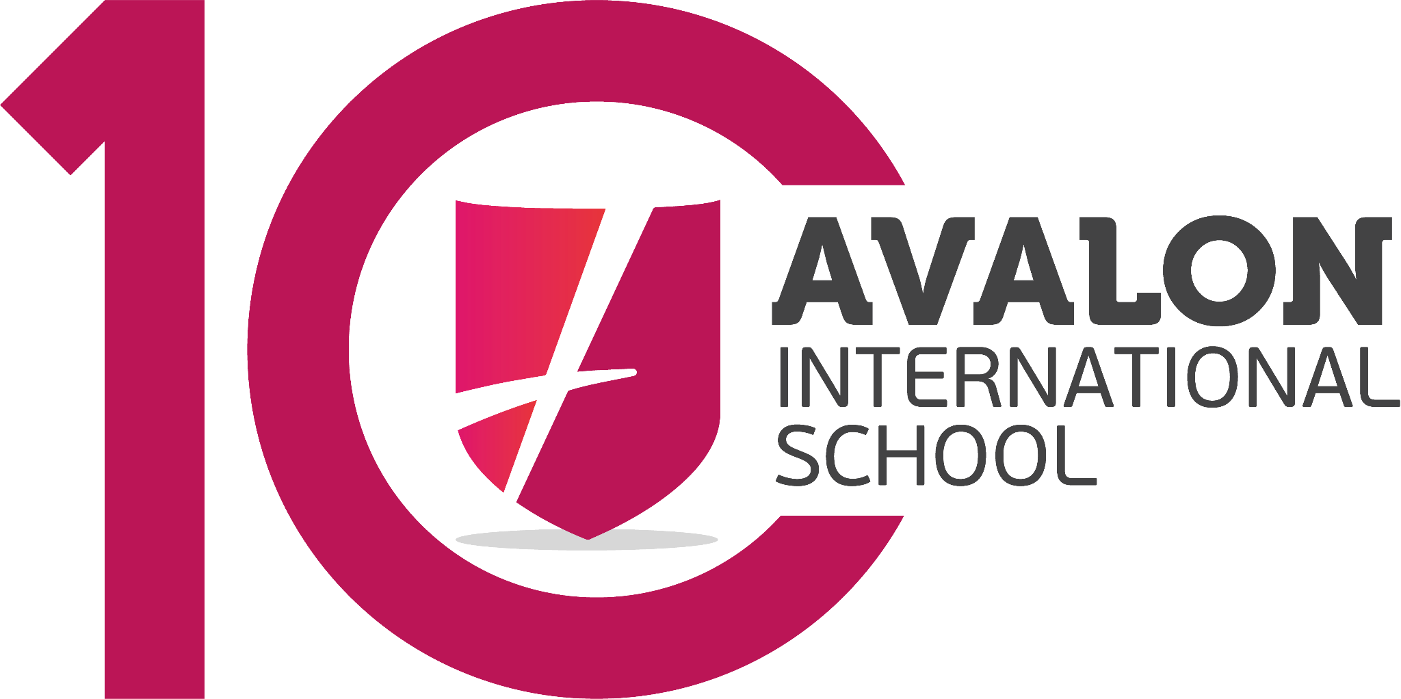
FINAL EXAM
“Bless Me, Ultima”

General Instructions: Write your name and the date in the upper right-hand corner. Read each item carefully. Be sure that you understand exactly what is being asked of you. Begin your answers on the backside of this paper. Add extra sheets of paper as needed. Be sure to write your name on any extra sheets of paper and staple all exam papers together when you are finished.
Do not look at other student’s exams. If you have a question or a request during the exam, raise your hand and the instructor will call on you.. Do not leave your desk without permission. If you finish early, raise your hand and the instructor will call on you.
This is a closed book exam.

Task 1
Provide a detailed character description for each of the following characters: Antonio, Ultima, Tenorio, and Narciso.

Task 2
Provide synopsis of the complete novel being sure to highlight main events.

Task 3
Select two (2) themes from the list of major themes below. Explain why each theme is prominent and important to the novel. Use examples to support your explanation. Be sure to clearly identify the two themes that you have chosen.
List of Major Themes: 1. Coming of Age; 2. Identity and Cultural Heritage; 3. Good vs. Evil; 4. Faith and Doubt; 5. Nature and the Supernatural; and 6. Family and Community

Task 4
Give your personal opinion of the novel. Be sure to provide evidence to support your opinion.

