Amber Parsons’ Notes on RRS2E

October/November 2014

**User’s Guide**

In the User’s Guide>>Choosing Input Parameter Values>> “Number of wild-origin spawners (one value for each year). Each value should be a whole numbers greater than zero.”

User’s Guide>>Working With Charts>> “After this, you have the option of saving to the Chart Gallery, adding more data series, or starting over with new data series. To do the latter, click the "Clear" button. **Note:** this also clears the Chart Gallery, so save any charts to your computer (i.e. using right-click and "Save As") before clearing.” ---Actually, clearing the outputs does NOT clear the chart gallery, and I like it that way. Also, clearing the chart gallery does NOT clear the chart on the main page. I like it that way, too. However, the instructions should make that clear.

Also regarding charts, consider a note under “Type” to indicate that A=Analytical and B=Bootstrap on the chart itself, so that after it has been exported (and thus taken out of context) a reader can tell more immediately what it means.

**Browser-Specific Comments**

In Chrome (Version 38.0.2125.104 m) Apart from the strange errors described below, everything runs great in Chrome.

In Firefox (33.0.2) The “Clear”, “Calculate”, and “Export” buttons are not visible or accessible. I couldn’t test the tool beyond checking to see that the alt tags show up, which they do. It cuts off the box with the number of simulations, as well, but it can be accessed.

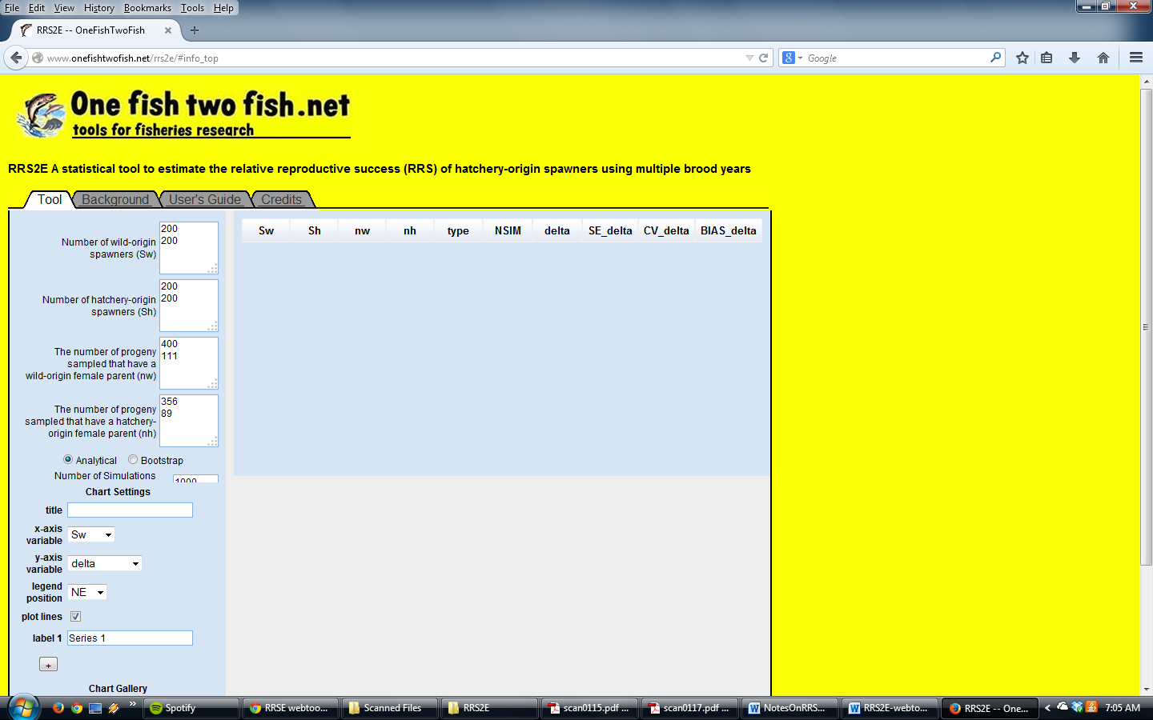

In IE (11.0.9600.17358) Everything looks pretty good except that the width of the input boxes for the input parameters (Sw, Sh, nw, and nh) are only wide enough for 3 digits. The tool still works just fine with values of 1000 and above, but they look like a new entry, since they carry over into the next line. This may be very confusing if the user is trying to match up several years’ worth of data.

**In the tool itself**

I get the proper error message if Sw is entirely empty (that the dimensions of Sw, Sh, nw, and nh must match), but no error if either Sh, nw, or nh are empty. When there are no values entered for either of these three, it just loops and loops. I have to close out of the browsers to get it to stop. For both Analytical and Bootstrap.

All the other error messages for erroneous entries (negative or decimal values, letter characters, symbols) seem to be fine.

I got a couple of strange errors when I put in drastically different numbers for the same fields (i.e. big differences between years). I got “missing value where TRUE/FALSE needed” when Sw = 2000, 200; Sh = 200, 2000; nw = 400, 1110; nh = 400, 111. And nh = defaults of 356, 89. For BOTH Analytical and Bootstrap. See screen shot.

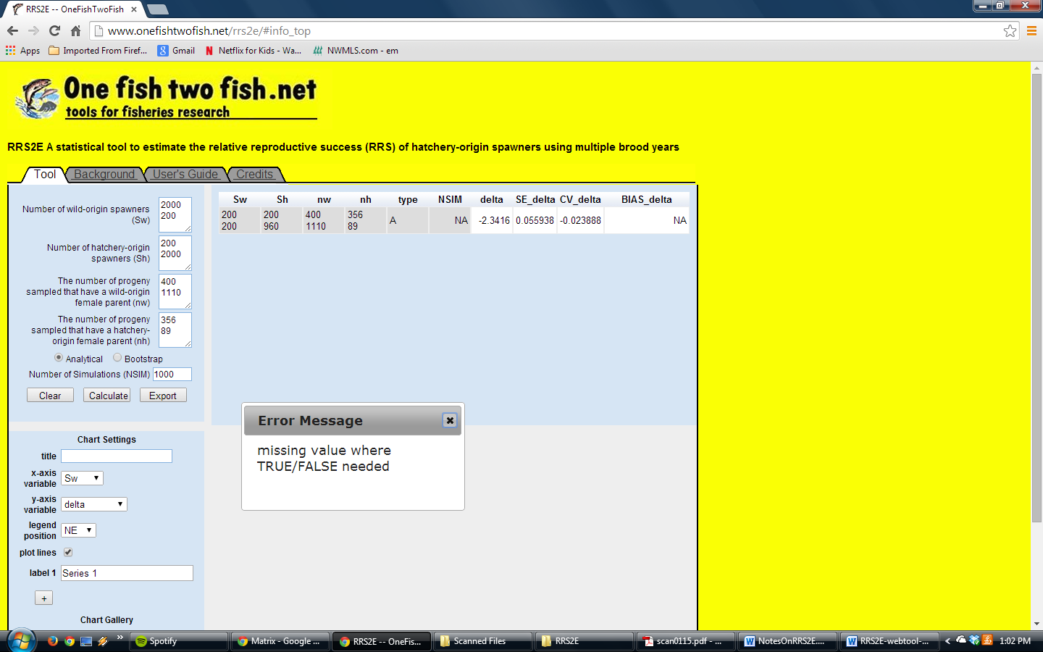

Then with Sw = 2000,200; Sh=200,200; nw=400, 1110; nh=356, 89, I got an Error Message with no text. Also with Sw = 1000,200 and the rest as previous. I tried reducing the first year of Sw by 10 and re-running. I got textless error messages until Sw = 960, 200.

Similarly, with Sw = 200, 200; Sh = 200,2000; nw=400,1110, nh = 356,89. All the way to Sh = 200, 960, I got an Error Message with no text. This is true for BOTH Analytical and Bootstrap and in both Chrome and IE. See screen shot below.

My suspicion is that the problem is in the “get.estimate” sub-function and that it runs out of (100) trials before the change in the estimate is less than the tolerance. But if that is the case, then I don’t know why isn’t it giving the error “maximum number of iterations was reached.” I recommend you try editing the code so it does 500 trials and see if it works. And investigate why the text of the error isn’t showing up. But then again, that may not be the issue at all; it’s just my best guess.

