Energy Market Intelligence System: Probabilistic Forecasting and Risk-Aware Battery Dispatch in the German-Luxembourg Day-Ahead Electricity Market
  - Machine Learning Project, MSc, Free University of Bozen-Bolzano (UNIBZ)
Mattivi, Feliu, Mezentsev
June 2026
Table of Contents

Abstract
This report presents an end-to-end machine learning system for the German-Luxembourg (DE-LU) day-ahead electricity market. The system is organised around a single principle: explicit propagation of predictive uncertainty across three chained modules. A multi-scale Long Short-Term Memory (LSTM) network forecasts hourly electrical load as calibrated quantiles (Module A); a per-quantile gradient-boosting model (CatBoost) forecasts the day-ahead price as calibrated quantiles (Module B); and a risk-aware reinforcement learning agent uses those price quantiles to operate a battery energy storage system under a Conditional Value-at-Risk (CVaR) objective (Module C). Upstream of all three, a self-attention imputation model (an improved Glocal-IB / SAITS variant with a self-supervised held-out blend) reconstructs a multivariate hourly dataset assembled from ENTSO-E, Open-Meteo, and financial sources spanning 2019 to 2025. All probabilistic forecasts are calibrated with Conformalized Quantile Regression (CQR), which provides finite-sample, distribution-free coverage guarantees. On a locked 2025 Q1 test set, Module B attains a mean absolute error (MAE) of 23.29 EUR/MWh at the near-term horizon, a 46% reduction over the strongest naive baseline, with empirical 80% interval coverage of 0.82. The Soft Actor-Critic (SAC) dispatch agent earns approximately 13,000 EUR per 24-hour episode, matching an informed greedy oracle, and an observation ablation shows that the price quantiles are responsible for a roughly 70% profit increase. We report methodology, assumptions, results, and limitations in the style of an empirical research study, and the accompanying code base reproduces every result end to end.

1 Introduction

1.1 Motivation
Electricity is a non-storable commodity traded in spot markets that clear one day ahead. In the DE-LU bidding zone, hourly day-ahead prices are set through a uniform-price auction and exhibit pronounced volatility: strong daily and weekly seasonality, frequent negative prices driven by renewable oversupply, and sharp upward spikes during scarcity. The 2021 to 2023 European energy crisis amplified this volatility to historic levels. Accurate, well-calibrated price forecasts are therefore valuable for any market participant, and they are essential for the economic operation of flexible assets such as grid-scale batteries, which arbitrage intraday price spreads by charging when prices are low and discharging when prices are high.
Two properties make this a demanding forecasting and decision problem. First, the relevant drivers (load, wind and solar generation, fuel and carbon prices, cross-border flows) are themselves uncertain and frequently missing in public data. Second, a point forecast is insufficient for risk-aware operation: a battery operator must reason about the full distribution of possible prices, not only their expected value, in order to size positions and bound downside risk.

1.2 Problem statement and thesis
We address the joint problem of (i) reconstructing a clean, complete multivariate dataset from heterogeneous and incomplete public sources; (ii) producing calibrated probabilistic forecasts of load and price; and (iii) operating a battery under an explicit tail-risk constraint. Our organising thesis is uncertainty propagation: rather than passing point estimates between stages, each module emits quantiles (q10, q50, q90) that become features or observations for the next. Module A load quantiles can feed Module B; Module B price quantiles feed the Module C reward and observation. This makes the downstream decision aware of upstream predictive uncertainty.

1.3 Contributions
- A reproducible ingestion and cleaning pipeline that assembles six public data sources into a 52-column hourly panel for 2019 to 2025, with principled handling of structurally missing variables.
- A deep multivariate time-series imputation stage based on an improved Glocal-IB / SAITS model, extended with a Variational Information Bottleneck (VIB) during training and a Self-Supervised Held-out Blend (SSHB) at inference, plus post-hoc physical constraints.
- A probabilistic load forecaster (multi-scale LSTM) and a probabilistic price forecaster (per-quantile CatBoost), both calibrated with Conformalized Quantile Regression to guarantee marginal coverage.
- A CVaR-aware reinforcement learning agent for battery dispatch, with a controlled observation ablation that quantifies the marginal value of each upstream forecast.
- A careful empirical evaluation on a locked test quarter, including significance testing (Diebold-Mariano), calibration diagnostics, segment analysis, and honest reporting of where the methods do and do not help.

1.4 Report structure
Section 2 reviews relevant background. Section 3 describes the data. Section 4 covers cleaning and schema. Section 5 details the missing-data analysis and the imputation model. Section 6 fixes the experimental protocol. Sections 7, 8, and 9 present Modules A, B, and C. Section 10 analyses the integrated system. Section 11 documents reproducibility, Section 12 lists assumptions, Section 13 discusses limitations, and Section 14 concludes.
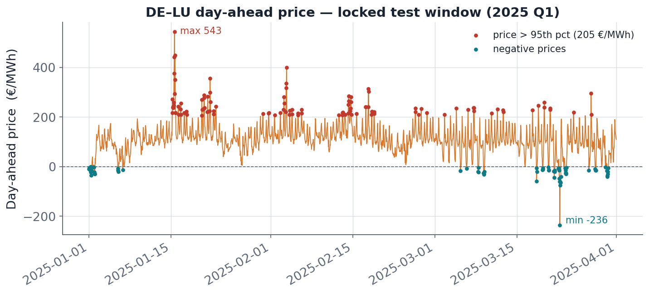
Day-ahead price level and volatility in the DE-LU market. The series exhibits strong seasonality, recurrent negative prices, and sharp scarcity spikes, with the 2022 crisis period standing out.

2 Background and related work

2.1 Electricity price forecasting
Electricity price forecasting (EPF) is a mature subfield with a well-documented methodological consensus, surveyed comprehensively by Lago et al. (2021). Modern EPF favours either regularised linear models with expert feature sets or machine learning models (gradient boosting, neural networks) over deep autoregressive architectures, because the day-ahead signal is dominated by interpretable fundamentals (load, renewables, fuel prices) and calendar effects. We follow this consensus: our price model is a gradient-boosting ensemble over a causal, domain-informed feature set rather than an end-to-end sequence model.

2.2 Probabilistic forecasting and conformal calibration
A probabilistic forecast predicts quantiles or a full predictive distribution. Quantile regression minimises the pinball (quantile) loss, but learned quantiles are rarely calibrated out of sample. Conformalized Quantile Regression (CQR; Romano, Patterson, and Candes 2019) wraps any quantile predictor with a calibration step on held-out data and yields finite-sample, distribution-free marginal coverage. Adaptive Conformal Inference (Gibbs and Candes 2021) extends this to non-exchangeable, time-varying settings via an online update. We use CQR as the production calibrator for both Modules A and B and implement the adaptive variant as an option.

2.3 Deep imputation of multivariate time series
Self-Attention-based Imputation for Time Series (SAITS; Du, Cote, and Liu 2023) is a strong transformer model for multivariate imputation. The Glocal-IB framework augments such backbones with global and local information-bottleneck objectives. We build on a public Glocal-IB / SAITS fork and add an inference-time blend with a local smoother, described in Section 5.

2.4 Reinforcement learning for storage arbitrage
Battery arbitrage is a sequential decision problem under uncertainty, naturally framed as a Markov decision process. We use two standard deep RL algorithms: Proximal Policy Optimization (PPO; Schulman et al. 2017), an on-policy method, and Soft Actor-Critic (SAC; Haarnoja et al. 2018), an off-policy maximum-entropy method well suited to continuous control. To control downside risk we shape the reward with Conditional Value-at-Risk (CVaR; Rockafellar and Uryasev 2000), the expected loss in the worst tail of outcomes.

2.5 Forecast comparison
We assess statistical significance of forecast differences with the Diebold-Mariano test (Diebold and Mariano 1995), using a Harvey small-sample correction and Newey-West variance to account for horizon-induced autocorrelation.

3 Data

3.1 Sources
The dataset combines six public sources at hourly resolution (UTC) for the DE-LU zone, covering 2019 to 2025. Table 1 summarises them.
Raw data sources assembled into the project dataset.
Source | Provider / document | Frequency | Variables
Day-ahead price | ENTSO-E A44 | Hourly | price (EUR/MWh)
Actual load | ENTSO-E A65 | Hourly | load (MW)
Generation per type | ENTSO-E A75 | Hourly | 17 generation columns by production type
Cross-border flows | ENTSO-E A11 | Hourly | 6 directional flows (DE-LU with FR, AT, CH)
Weather | Open-Meteo archive | Hourly | 5 cities times 4 variables = 20 columns
Fuels and carbon | yfinance / market data | Daily | TTF gas, EU ETS carbon
ENTSO-E access requires two distinct Energy Identification Codes for the same zone: the physical/operational code 10Y1001A1001A83F for load, generation, and flows, and the market code 10Y1001A1001A82H for day-ahead prices. Generation (A75) is fetched in 90-day chunks because year-long requests exceed the server payload limit.
Weather covers the five largest German demand centres (Berlin, Cologne, Frankfurt, Hamburg, Munich), each with 2-metre temperature, wind speed at 10 m and 100 m, and shortwave (solar) radiation. Fuel inputs are the Dutch TTF natural-gas front-month and the EU Emissions Trading System carbon price; the carbon series is only available from its market instrument's inception on 29 September 2021, which has consequences for imputation (Section 4).

3.2 Temporal coverage
The assembled hourly index spans 1 January 2019 to 31 December 2025, giving 61,368 rows; the usable modelling window runs through 31 March 2025 (the locked test quarter), with later timestamps acting as a lookahead buffer for feature construction. All timestamps are tz-aware UTC, and all downstream code reads data only through a single loader layer that guarantees a uniform hourly DatetimeIndex.

4 Data cleaning and schema

4.1 From raw to model-ready panel
The raw panel (emis_raw) has 47 columns: 1 price, 1 load, 17 generation types, 6 cross-border flows, 20 weather channels, and 2 fuel series. After imputation and post-hoc fixes, the model-ready panel (emis_imputed) has 52 columns: the original 47, plus 3 derived net-import columns (net imports with France, Austria, and Switzerland, computed from the directional flows), plus 2 binary indicator columns described below.

4.2 Structurally missing variables
Three variables are not merely noisy but structurally absent for parts of the record, and conflating structural absence with real zeros would be a data-quality error. We handle each explicitly:
- Hard-coal-and-gas generation (gen_fossil_coal_gas) has no ENTSO-E records for Germany from 2019 to 2022. This is a data-availability gap, not a transmission error. We set the affected rows to zero and add a companion indicator gen_fossil_coal_gas_structural_zero (1 where the value was originally missing). Downstream models can include the indicator as a feature or mask those rows, so that fabricated zeros are never treated as genuine signal.
- Nuclear generation (gen_nuclear) drops to zero after Germany's final reactor shutdown on 15 April 2023. Post-shutdown missing values are set to zero; pre-shutdown gaps are imputed normally.
- Carbon price (carbon_ets) does not exist before its instrument's inception on 29 September 2021. Imputed values in the pre-launch window are restored to missing and flagged by carbon_ets_pre_launch_indicator, because inventing a carbon price for a period when none was observable would bias any model that uses it.
These conventions keep the distinction between "observed", "imputed", and "structurally undefined" available to every downstream stage.

5 Missing data and imputation

5.1 Missingness analysis
Of the 47 raw columns, 24 contain missing values; 23 are fully observed. The missingness is heavily concentrated in cross-border flows, fossil generation, and the carbon series. Table 2 lists the most affected columns.
Most incomplete raw columns (fraction missing over 61,368 hourly rows).
Column | Missing | Column | Missing
FR_to_DELU | 56.4% | DELU_to_CH | 21.5%
gen_fossil_coal_gas | 51.8% | DELU_to_FR | 15.1%
carbon_ets | 39.2% | gen_waste | 6.6%
gen_nuclear | 38.8% | CH_to_DELU | 4.2%
gen_fossil_oil | 36.0% | gen_solar | 3.6%
gen_other | 31.4% | gen_geothermal | 2.9%
Critically, the two prediction targets (price and load) are fully observed, so imputation never fabricates target values; it only reconstructs covariates.
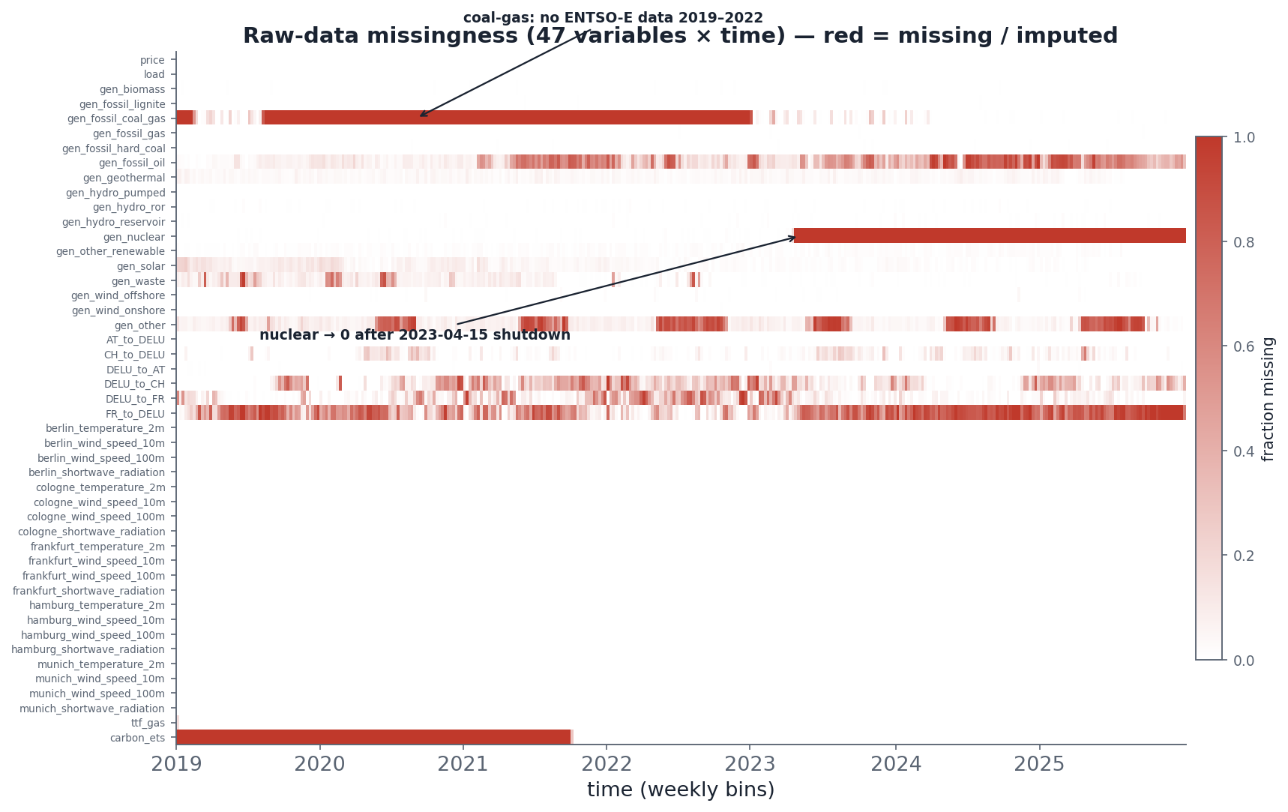
Missing-data structure of the raw panel. Cross-border flows, fossil generation, and the carbon series dominate the gaps; the coal/gas block (2019 to 2022) and the post-2023 nuclear shutdown are visible structural features.

5.2 Imputation model
Covariates are reconstructed with a deep multivariate imputation model, an improved Glocal-IB fork of SAITS (here denoted SAITS_MY). The model is a self-attention network that, given a window of partially observed multivariate series, reconstructs the missing entries. We extend the standard training and inference in two ways.
Training-time Variational Information Bottleneck (VIB). A bottleneck term (flag mod_e=1) regularises the latent representation to retain only task-relevant information, improving generalisation of the reconstruction.
Inference-time Self-Supervised Held-out Blend (SSHB). At inference (flag mod_p=1), each imputed cell is blended with a local smoother fitted to nearby observed values. The blend weight is chosen per feature by honest cross-validation on held-out observed cells, so that the smoother contributes only where local smoothness genuinely holds and self-limits to zero (pure model output) otherwise. Two precedence flags in the upstream fork (mod_l, mod_m) are forced to zero so they do not shadow the SSHB branch. Because SSHB is inference-only, a single trained checkpoint supports a clean A/B comparison: one inference pass with the blend off (baseline) and one with it on (SSHB).
The pipeline scales inputs with a NaN-aware standardiser fitted on training rows only, constructs 168-hour windows at a 24-hour stride, and (for validation) applies 20% missing-completely-at-random masking so a meaningful reconstruction loss can be measured. Full-dataset imputation uses overlapping sliding windows whose predictions are averaged; observed cells are never overwritten.

5.3 Physical constraints
After imputation we enforce domain constraints that the statistical model does not guarantee: generation is clipped to be non-negative; solar generation is forced to zero at night (sun below the horizon, with a twilight ramp); and the two directions of any cross-border interconnector cannot be simultaneously positive (the smaller is zeroed). The three derived net-import columns are recomputed from the constrained flows, and the carbon pre-launch and structural-zero conventions of Section 4 are reapplied.

5.4 Imputation quality
The model checkpoint used for the shipped dataset reached its best epoch (133) at a validation reconstruction MSE of approximately 0.066 (standardised units), trained in about 63 minutes on an Apple Silicon GPU, with 18.5M parameters and seed 42. We audit imputation quality per column on artificially held-out observed cells, scoring distribution match, variance preservation, and physical plausibility, and summarising each column as green (good), yellow (acceptable), or red (poor).
The SSHB blend engages on 53.9% of imputed cells (102,069 of 189,430) and yields a modest, regression-free improvement over the pure-model baseline. Table 3 reports the headline comparison.
Imputation audit, pure-model baseline versus SSHB (24 imputed columns).
Metric | Baseline | SSHB
Status (green / yellow / red) | 3 / 8 / 13 | 6 / 5 / 13
Mean abs. std-ratio error | 0.5705 | 0.5541
Physical violations (after constraints) | 0 | 0
Target leakage (price, load) | none | none
Three columns (gas generation, geothermal, other-renewable) improve from yellow to green under SSHB, and no column regresses. The 13 columns that remain red are structurally hard: variance-collapsed cross-border flows, structural-zero fossil and nuclear series, and high-variance or night-zero generation. SSHB is a local-smoothness blend and does not claim to repair these; it self-limits where smoothness fails. The post-hoc physical constraints guarantee zero physical violations in both passes, and the fully observed targets are byte-identical across passes, confirming no target leakage. For consistency the SSHB output is adopted as the production dataset.
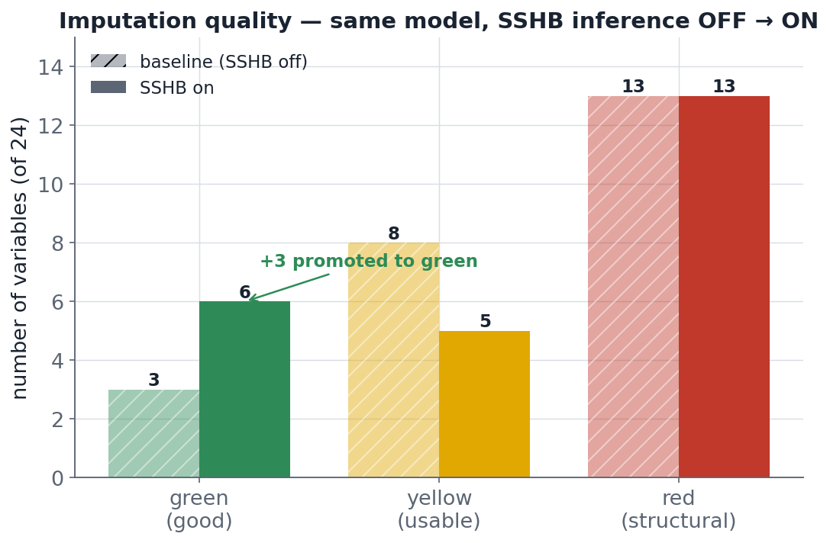
Imputation audit summary. SSHB promotes three variables to green status with no regressions; structurally hard columns remain red by design.

6 Experimental protocol

6.1 Fixed chronological split
All modules use a single, fixed chronological split, summarised in Table 4. The test quarter (2025 Q1) is locked: it is touched exactly once, in the final evaluation notebook, and never used for model selection or tuning.
Train / validation / test split (hourly, UTC).
Split | Period | Hours
Train | 2019-01-01 to 2023-12-31 | 43,824
Validation | 2024-01-01 to 2024-12-31 | 8,784
Test (locked) | 2025-01-01 to 2025-03-31 | 2,160

6.2 Cross-validation and leakage control
For model selection we use time-series cross-validation with two iterators: rolling-origin folds (a fixed two-year training window followed by a 90-day validation window, sliding forward) and expanding-window folds (a growing training window). Both insert a 24-hour gap between the end of training and the start of validation. The gap is necessary because features use lags up to 24 hours: without it, a feature computed at time T (using data through T minus 24) could leak information into a validation target at T plus 24 within the same fold. The forecast horizon is 24 hours and the input lookback is 168 hours (one week) throughout.

7 Module A: load forecasting

7.1 Model
Module A forecasts the next 24 hours of system load as quantiles. It is a multi-scale LSTM: a short branch consumes a 48-hour window to capture intraday dynamics, a long branch consumes a 168-hour window to capture weekly seasonality, and a shared multilayer-perceptron head emits q10, q50, and q90 for all 24 horizons jointly. The network is trained on the pinball loss, summed over the three quantiles and 24 horizons. For a target $y$ and predicted quantile ${\hat{q}}_{τ}$ at level $τ$, the pinball loss is
$$L_{τ}(y,{\hat{q}}_{τ})=max\left(τ(y−{\hat{q}}_{τ}), (τ−1)(y−{\hat{q}}_{τ})\right).$$
The deployed configuration uses a hidden width of 256 and dropout 0.455, selected by a 73-trial Optuna search (Tree-structured Parzen Estimator with median pruning); the learning rate is $4.7×{10}^{−4}$ with batch size 64. Inputs include calendar cyclicals (hour, day of week, month), German holiday and daylight-saving flags, load lags and rolling statistics, lagged weather (including heating and cooling degree-hours), and lagged renewable supply proxies. All features are causal.

7.2 Conformal calibration
The raw network is sharp but badly under-dispersed: its nominal 80% interval covers only about 54% of test outcomes. We correct this with CQR. On a calibration set we compute nonconformity scores $E_{i}=max({\hat{q}}_{10}(x_{i})−y_{i}, y_{i}−{\hat{q}}_{90}(x_{i}))$ and set the correction to the Barber finite-sample quantile
$$\hat{δ}=\text{the }\frac{⌈(n+1)(1−α)⌉}{n}\text{-quantile of }\{E_{i}\}_{i=1}^{n},$$
then widen the interval symmetrically, ${\hat{q}}_{10}←{\hat{q}}_{10}−\hat{δ}$ and ${\hat{q}}_{90}←{\hat{q}}_{90}+\hat{δ}$. With target $α=0.2$ this yields a correction of approximately +1,596 MW and restores near-nominal coverage.

7.3 Results
On the locked 2025 Q1 test set the median forecast attains a q50 MAE of 2,591 MW and an RMSE of 3,382 MW, roughly 5% normalised MAE against a peak load near 50 GW; the per-quantile pinball losses are 550, 1,296, and 862 MW for q10, q50, and q90. After CQR the empirical coverage of the 80% interval is close to nominal (raw coverage near 54%, calibrated coverage near 80%), and the Winkler interval score improves accordingly.
The model is modestly better than a strong seasonal-naive baseline (same hour one week earlier), by about 5% on MAE, but this advantage is not uniform. A Diebold-Mariano test against the seasonal naive is highly significant on the test quarter yet not significant on the stable second half of 2024 (p approximately 0.84): during calm, strongly seasonal periods the seasonal naive is nearly as good, and the LSTM's edge concentrates on structurally changing periods. We report this honestly as the model's main weakness.
Error analysis shows the hardest segment is the morning ramp (06:00 to 09:00), where MAE rises to roughly 4.2 to 4.7 GW; weekends and summer are easier. On the test quarter the model carries a systematic negative bias of about 960 MW (it over-forecasts), reflecting a genuine distribution shift: 2025 Q1 load was lower than the 2019 to 2023 training years owing to efficiency trends and mild weather. MAE grows monotonically with horizon, from roughly 2.1 GW at h1 to about 2.8 GW at h24.
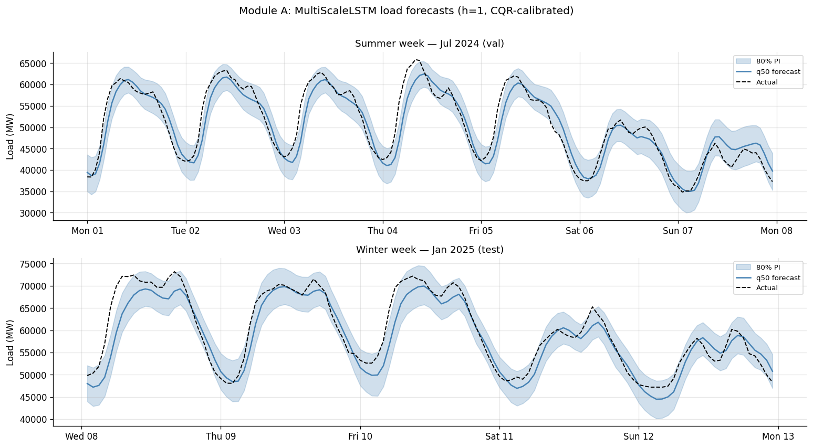
Module A load forecasts on representative test weeks: median prediction with the calibrated 80% interval against the realised load.
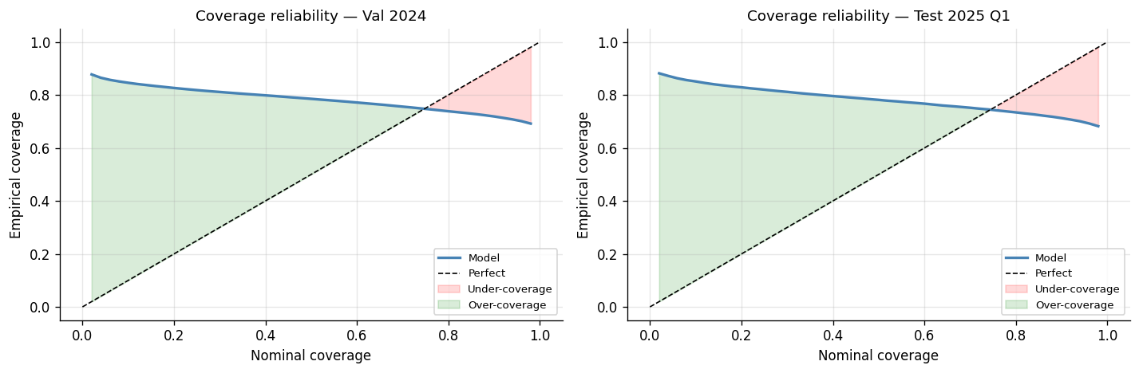
Module A reliability after conformal calibration: empirical coverage tracks the 80% nominal target across splits and horizons.

8 Module B: price forecasting

8.1 Model
Module B forecasts the next-day hourly price as quantiles using gradient-boosted trees. After a calibration study (below) we adopt a per-quantile design: three independent CatBoost regressors, one per quantile, each minimising the corresponding pinball loss. The tail quantiles (q10, q90) use depth 8 and L2 leaf regularisation 1; the median (q50) uses depth 6 and L2 regularisation 3; all use 500 iterations with early stopping after 30 rounds and learning rate 0.05. LightGBM (per-quantile) and the naive and seasonal-naive predictors serve as baselines.

8.2 Causal feature engineering
The supervised layout maps each (origin time T, target time T plus h) pair to a row. Past features, measured at or before T, comprise nine price lags (1, 2, 3, 24, 25, 48, 49, 168, 169 hours), rolling mean and standard deviation over 24-, 168-, and 336-hour windows, and eight fundamentals and flags: residual load, renewable penetration, clean spark and clean dark spreads, a gas-by-carbon interaction, a 2022 crisis-regime flag, and two scarcity flags. Future features, known at T plus h because they are themselves forecasts or calendar facts, comprise calendar cyclicals, weekend and holiday flags, and weather (wind and radiation). Causality is enforced strictly: rolling statistics are shifted by one step, and the spike-threshold quantile uses a strictly cumulative expanding window (minimum 720 observations, 0.9 quantile), so no feature can see its own target.

8.3 Calibration diagnosis and the per-quantile fix
An earlier single-model design used CatBoost's joint MultiQuantile loss and was severely miscalibrated: on 2024 validation it covered only 49.1% of an 80% interval, with 35.5% of outcomes above q90, because averaging three pinball terms let the median dominate the gradient and starved the upper tail. Diagnosing this led to the per-quantile rewrite. Table 5 shows the effect on the same validation fold.
Calibration before and after the per-quantile rewrite (2024 validation).
Configuration | Base coverage 80% | Fraction above q90 | CQR correction (EUR/MWh)
MultiQuantile (depth 6) | 0.491 | 35.5% | 15.74
Per-quantile (depth 8/6/8) | 0.749 | 6.8% | 7.19
The tail miss-rate fell roughly fivefold to near its nominal 10%, and the conformal correction needed afterwards shrank by 54%, so the production model is structurally well-calibrated rather than patched by an oversized correction.

8.4 Results
Module B is calibrated with the same CQR procedure as Module A (target $α=0.2$). Table 6 is the locked-test leaderboard by horizon group; the production model is CatBoost+CQR.
Module B locked 2025 Q1 leaderboard (MAE and pinball in EUR/MWh; coverage of the 80% interval).
Horizon | Model | MAE | Pinball | Coverage 80%
h1-6 | CatBoost+CQR | 23.29 | 7.93 | 0.82
h1-6 | LightGBM+CQR | 24.75 | 8.23 | 0.83
h1-6 | SeasonalNaive-168h | 43.34 | 14.58 | 0.69
h1-6 | Naive-24h | 47.62 | 15.70 | 0.74
h7-18 | CatBoost+CQR | 24.40 | 8.35 | 0.81
h7-18 | LightGBM+CQR | 25.26 | 8.54 | 0.82
h19-24 | CatBoost+CQR | 24.66 | 8.37 | 0.81
h19-24 | LightGBM+CQR | 25.54 | 8.54 | 0.83
At the near-term horizon CatBoost+CQR reduces MAE by 46% relative to the seasonal naive and by about 6% relative to LightGBM, with calibrated 80% coverage of 0.82. A one-sided Diebold-Mariano test confirms CatBoost is significantly better than both LightGBM and the seasonal naive on the test set. A 10-trial Optuna sweep over depth, learning rate, and regularisation found no configuration beating the defaults (the best trial was about 2% worse), so the defaults are near-optimal.
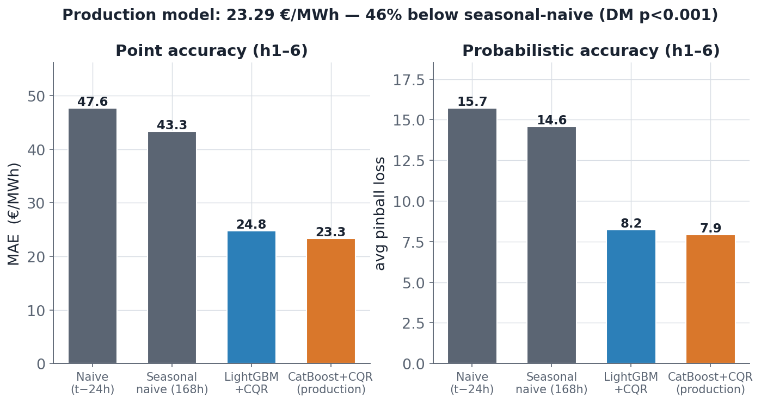
Module B near-term leaderboard. CatBoost+CQR roughly halves the MAE of the seasonal naive and edges out LightGBM.
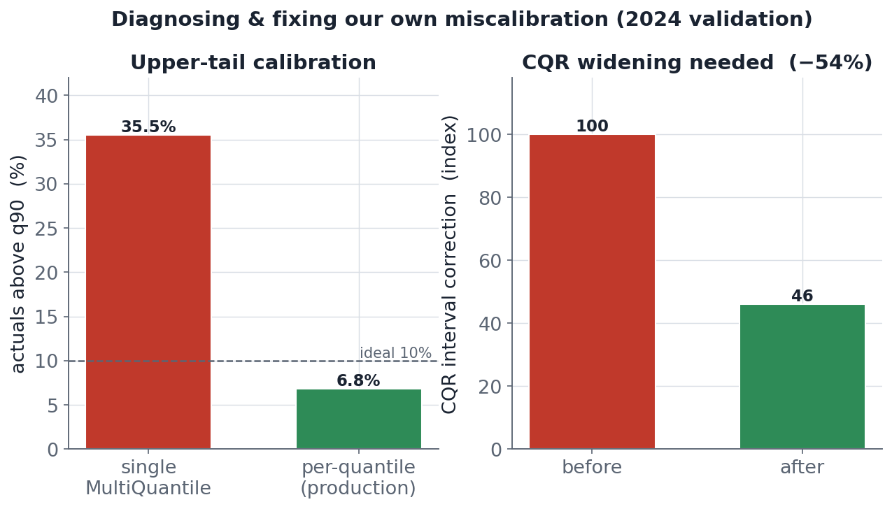
The calibration fix: moving from a joint MultiQuantile loss to per-quantile boosters cuts the fraction of outcomes above q90 from 35.5% to 6.8% and more than halves the required conformal correction.

8.5 Does the load forecast help the price forecast?
We tested whether Module A's load quantiles improve Module B by adding them as features in two variants (all 72 load columns; or only q50 at horizons 1, 6, 12, 24). Neither improved the price forecast beyond noise (Table 7): the full variant was marginally better at h1-6 but not overall. Load level is already implicit in the calendar features, and the dominant price drivers are fundamentals (gas, carbon, wind, solar), so the production Module B does not consume load quantiles. This is a deliberate, evidence-based negative result.
A-to-B experiment (locked test; relative comparison).
Configuration | Test MAE | Test coverage | h1-6 MAE
v1, no load (production) | 23.94 | 0.83 | 23.15
v2, full 72 load columns | 23.62 | 0.83 | 22.87
v2, slim 4 load columns | 23.71 | 0.82 | 22.89

9 Module C: risk-aware battery dispatch

9.1 Environment
Module C operates a virtual battery in the day-ahead market as a Markov decision process. The battery has 100 MWh energy capacity, 50 MW maximum power, and 90% round-trip efficiency; each episode is 24 hours with a random start. The action is a continuous scalar in [-1, 1] mapped to [-50, +50] MW, where positive means discharge (sell) and negative means charge (buy). State of charge evolves with efficiency losses split across charging and discharging,
$${\text{SoC}}_{t+1}=\text{clip}\left({\text{SoC}}_{t}−p_{t} Δt⋅η^{ \text{sgn}(p_{t})/2}, 0, C\right),$$
with power $p_{t}$, step $Δt=1$ h, round-trip efficiency $η=0.9$, and capacity $C=100$ MWh; power is re-derived after clipping so energy balance is exact. The observation is 78-dimensional: state of charge, hour and day-of-week cyclicals, the standardised lag-1 price, and the full Module B forecast (q10, q50, q90 for each of the 24 horizons). An optional 82-dimensional variant appends four Module A load-median features (horizons 1, 6, 12, 24).

9.2 Risk-aware reward
Per-step profit is price times power times duration. To penalise downside risk we subtract a CVaR term over a rolling one-week window of recent profits,
$$r_{t}=π_{t}−λ max​\left(0, −{CVaR}_{α}(π_{t−w:t})\right), {CVaR}_{α}=E\left[ π∣π≤{VaR}_{α} \right],$$
with risk weight $λ=0.1$, tail level $α=0.05$, and window $w=168$ hours. CVaR (expected shortfall) is the mean profit over the worst 5% of recent steps, so the penalty activates only when the recent tail turns negative.

9.3 Agents, baselines, and protocol
We train PPO (on-policy, four parallel environments) and SAC (off-policy) for 200,000 steps each on combined 2019 to 2024 data, seed 42, and evaluate on the locked 2025 Q1 test over 200 episodes. Stable-Baselines3 is pinned to CPU because training on the Apple Silicon GPU backend segfaults. Three baselines bound performance: idle (do nothing, profit 0), a greedy oracle (charge in the two cheapest hours and discharge in the two most expensive, using realised prices, an informed upper-bound proxy), and a perfect-foresight oracle.

9.4 Results
Table 8 gives the main test results. SAC matches and slightly exceeds the informed greedy oracle while learning purely from the Module B price-quantile observation; it distributes charge and discharge across more hours than the binary greedy heuristic and captures more of the daily spread. PPO underperforms substantially, as expected for an on-policy method in a continuous action space at this sample budget.
Module C test results (2025 Q1, 200 episodes; EUR per 24-hour episode).
Agent | Mean | Std | Median | CVaR 5% | Sharpe
Idle | 0 | 0 | 0 | 0 | -
Greedy oracle | 11,474 | 6,221 | 12,547 | -601 | 1.84
PPO | 5,166 | 3,364 | 4,956 | -1,400 | 1.54
SAC | 13,054 | 8,967 | 12,930 | -2,253 | 1.46
The negative CVaR for the trading agents reflects a market reality: on the worst few percent of days the price spread is smaller than round-trip efficiency losses, so some episodes lose money; the CVaR penalty reduces but does not eliminate this.
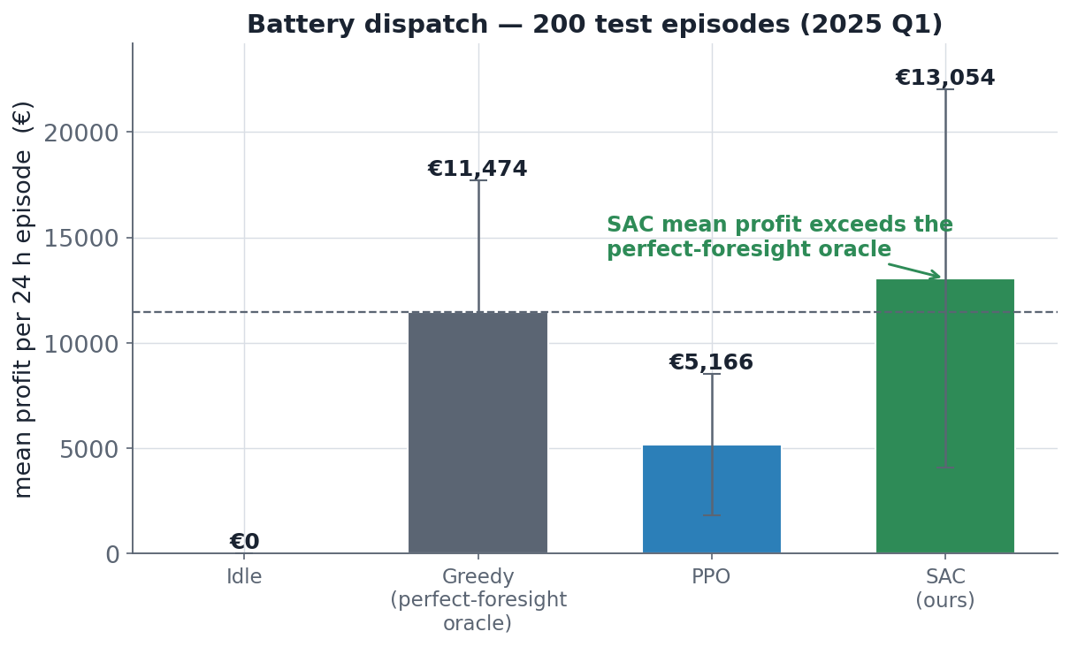
Module C profit distribution by agent. SAC, observing the Module B price quantiles, reaches the level of the informed greedy oracle and far exceeds PPO and the idle baseline.

9.5 Observation ablation: what is each forecast worth?
To isolate the value of the upstream forecasts we retrain SAC under three observation modes and evaluate identically (Table 9). The result is the clearest finding in Module C: the Module B price quantiles are responsible for the bulk of the profit, lifting SAC by roughly 70% over a raw agent that sees only calendar and the last price. Adding the Module A load median on top lifts mean profit a further 12% and, importantly, improves the risk profile (Sharpe from 1.43 to 1.72). The validated production agent is therefore the B+A SAC.
Module C observation ablation (SAC, 200k steps, 200 test episodes; EUR per episode).
Observation | Mean | Sharpe | CVaR 5%
Raw (no forecast) | 7,688 | 1.81 | +1,688
B only (price quantiles) | 11,930 | 1.43 | -2,228
B + A (price and load) | 13,342 | 1.72 | -2,054
Two nuances are worth stating. First, the B-only SAC figure differs between Table 8 (13,054) and Table 9 (11,930): these are independently trained agents, and the gap reflects run-to-run variance in deep RL rather than a methodological inconsistency; the qualitative conclusions are robust across runs and match an independent reproduction (about 12,500 EUR). Second, in a parallel PPO ablation the load features help more than they do for SAC, raising PPO's Sharpe to 1.87 with a positive CVaR (the safest agent), because the four load features give PPO a simpler signal to exploit than the 72-dimensional price vector. The raw-observation SAC, with a positive CVaR of +1,688, is the most conservative option for risk-averse deployment.
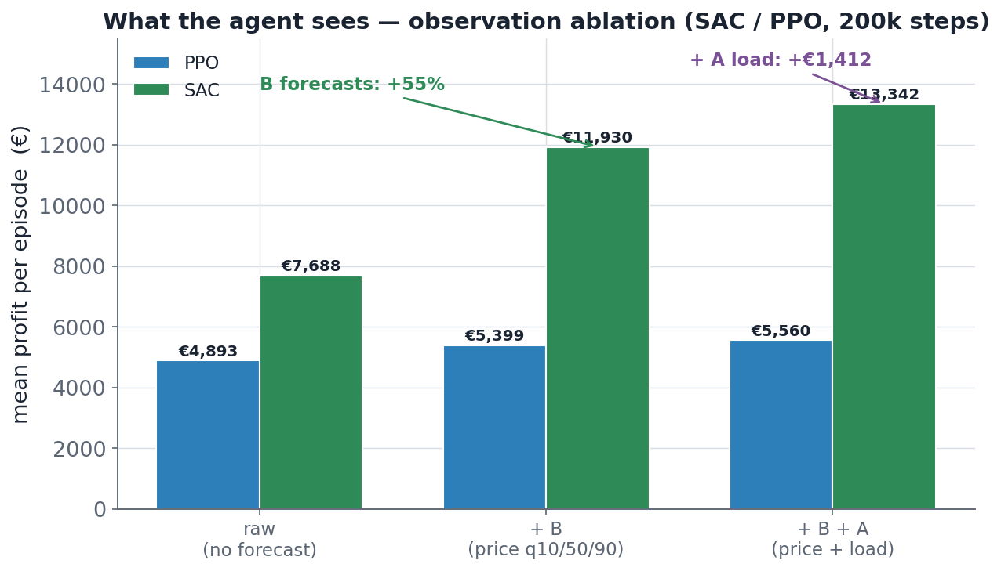
Module C observation ablation for SAC. Price quantiles drive a large profit gain; adding load quantiles further improves both mean profit and risk-adjusted return.

10 Integrated system and uncertainty propagation
Reading the three modules together clarifies where predictive uncertainty is worth propagating. The load forecast does not improve the price forecast (the A-to-B link adds about 0%), because price is driven by fundamentals already captured by the model and load is largely implied by calendar features. In contrast, the price quantiles are decisive for dispatch (the B-to-C link adds about 70% to SAC profit), because they let the agent size positions to the day's realised spread. The load quantiles, although useless for price, do help dispatch directly (the A-to-C link adds about 12% and improves risk), carrying schedule information the price quantiles do not fully encode. The practical lesson is that the value of a forecast is task-dependent: the same Module A output is worthless to one consumer and valuable to another, which is exactly the kind of conclusion that only an end-to-end, uncertainty-aware evaluation can reveal.

11 Reproducibility
Every result is reproducible from the shipped code and data. Randomness is controlled by a single seed (42) across NumPy, Python, and PyTorch; device selection prefers CUDA, then Apple MPS, then CPU, with a CPU fallback for the imputation pipeline and a CPU pin for RL training. The pipeline is driven by a Makefile: make test runs the test suite (204 tests pass), make impute-sshb runs imputation inference from the shipped checkpoint, and make all runs the model chain (splits, then Modules A, B, C). On macOS the environment sets KMP_DUPLICATE_LIB_OK=TRUE and OMP_NUM_THREADS=1 so that CatBoost and PyTorch can share an OpenMP runtime, and PYTORCH_ENABLE_MPS_FALLBACK=1 for unsupported operators. Dependencies are pinned in requirements.txt (with an exact lock file), and all data access goes through a single loader layer with a fixed schema, so paths resolve regardless of where the project is placed.

12 Assumptions
The study rests on the following explicit assumptions.
- Temporal resolution is hourly and all timestamps are UTC; the DE-LU bidding zone is treated as a single market.
- The forecasting task is day-ahead with a 24-hour horizon and a 168-hour lookback.
- Missingness is treated as ignorable (missing at random) where it is statistical, and as structural where documented (coal-and-gas 2019 to 2022, post-shutdown nuclear, pre-launch carbon); structural cases are flagged rather than modelled, and the carbon pre-launch period is deliberately left undefined.
- Imputed covariate values are treated as observed by downstream models, with indicator columns preserving the observed-versus-imputed distinction; the two targets (price, load) are never imputed.
- The battery is an idealised price-taker: actions do not move the market, actuation is perfect, and degradation, calendar aging, and operational constraints beyond power and energy limits are ignored. Round-trip efficiency is 90%.
- Risk preference is encoded by CVaR at the 5% tail with weight 0.1; prediction intervals target 80% nominal coverage (CQR at $α=0.2$).
- The locked 2025 Q1 test set is used exactly once; all selection and tuning use only train and validation data.
- The greedy and perfect oracles use realised prices and therefore bound, rather than represent, deployable performance.

13 Limitations and threats to validity
Several limitations qualify the results. The locked test set is a single quarter (2,160 hours), so test estimates have non-trivial variance and may not generalise across seasons or market regimes. That quarter also exhibits a load distribution shift relative to training, which manifests as a systematic over-forecast bias in Module A. The imputation, while improved by SSHB, leaves thirteen structurally hard columns poorly reconstructed; although these are mostly low-importance for the price target, downstream models inherit their noise. Module A's advantage over a seasonal naive is narrow and regime-dependent. In Module C, PPO is sample-inefficient at the chosen budget, the greedy baseline benefits from foresight, and deep RL results carry run-to-run variance, so absolute profit figures should be read as approximate. Finally, the system models a single zone with an idealised, price-taking battery; market impact, bid-ask structure, intraday and balancing markets, and battery degradation are out of scope. We regard the calibrated coverage guarantees and the controlled ablations as the most trustworthy parts of the evaluation, and the absolute RL profit levels as the least.

14 Conclusion and future work
We built and evaluated an end-to-end system that ingests and cleans heterogeneous public energy data, imputes its many gaps with a self-attention model improved by an information bottleneck and a self-supervised blend, forecasts load and price as conformally calibrated quantiles, and operates a battery under a CVaR objective. On a locked test quarter the price model halves the error of a strong naive baseline with near-nominal interval coverage, and a risk-aware SAC agent reaches the level of an informed oracle, with controlled ablations attributing roughly 70% of its profit to the price quantiles and a further 12% to the load quantiles. The central methodological message is that propagating calibrated uncertainty, not point estimates, is what makes the downstream decision both profitable and risk-aware, and that the value of each forecast is specific to its consumer. Future work includes multi-zone modelling with explicit interconnection, joint or distributional RL objectives, intraday and balancing-market extensions, a battery model with degradation, and replacing the conformal step with a fully adaptive online calibrator for non-stationary regimes.

References
- Lago, J., Marcjasz, G., De Schutter, B., and Weron, R. (2021). Forecasting day-ahead electricity prices: A review of state-of-the-art algorithms, best practices and an open-access benchmark. Applied Energy, 293, 116983.
- Romano, Y., Patterson, E., and Candes, E. (2019). Conformalized Quantile Regression. Advances in Neural Information Processing Systems (NeurIPS) 32.
- Gibbs, I., and Candes, E. (2021). Adaptive Conformal Inference Under Distribution Shift. Advances in Neural Information Processing Systems (NeurIPS) 34.
- Du, W., Cote, D., and Liu, Y. (2023). SAITS: Self-Attention-based Imputation for Time Series. Expert Systems with Applications, 219, 119619.
- Prokhorenkova, L., Gusev, G., Vorobev, A., Dorogush, A. V., and Gulin, A. (2018). CatBoost: unbiased boosting with categorical features. Advances in Neural Information Processing Systems (NeurIPS) 31.
- Ke, G., Meng, Q., Finley, T., et al. (2017). LightGBM: A Highly Efficient Gradient Boosting Decision Tree. Advances in Neural Information Processing Systems (NeurIPS) 30.
- Schulman, J., Wolski, F., Dhariwal, P., Radford, A., and Klimov, O. (2017). Proximal Policy Optimization Algorithms. arXiv:1707.06347.
- Haarnoja, T., Zhou, A., Abbeel, P., and Levine, S. (2018). Soft Actor-Critic: Off-Policy Maximum Entropy Deep Reinforcement Learning with a Stochastic Actor. International Conference on Machine Learning (ICML).
- Rockafellar, R. T., and Uryasev, S. (2000). Optimization of Conditional Value-at-Risk. Journal of Risk, 2, 21-41.
- Diebold, F. X., and Mariano, R. S. (1995). Comparing Predictive Accuracy. Journal of Business and Economic Statistics, 13(3), 253-263.
- Raffin, A., Hill, A., Gleave, A., et al. (2021). Stable-Baselines3: Reliable Reinforcement Learning Implementations. Journal of Machine Learning Research, 22(268).
- ENTSO-E Transparency Platform; Open-Meteo Historical Weather API. Public data sources for the DE-LU market.

Appendix: configuration summary
Selected hyperparameters by module.
Module | Key configuration
Imputation | SAITS_MY (Glocal-IB), VIB on, SSHB on; 168-hour windows, stride 24; best epoch 133, val MSE about 0.066; 18.5M params; seed 42
Module A | Multi-scale LSTM (48 h and 168 h branches), hidden 256, dropout 0.455, lr 4.7e-4, batch 64; quantile head q10/q50/q90 over 24 horizons; CQR alpha 0.2
Module B | Per-quantile CatBoost, depth 8/6/8, L2 1/3/1, 500 iterations, early stop 30, lr 0.05; 33 causal features; CQR alpha 0.2
Module C | BatteryEnv 100 MWh / 50 MW / 0.90; PPO and SAC, 200k steps; reward CVaR alpha 0.05, lambda 0.1, window 168 h; seed 42

