The Process Scheduler in Linux

Brandon E. McCarrick

Grantham University

The Process Scheduler in Linux

Part 1.

1. An interrupt enables the hardware to signal the processor. Internal interrupts, or synchronous interrupts, also occur as a direct result of the arithmetic operation or other instruction being processed. Interrupts can be generated by illegal arithmetic operations, like dividing by zero or floating-point operations generating an underflow or overflow. Interrupts can also be illegal job operations, like trying to access protected on non-existing storage locations.
2. A context switch (also sometimes referred to as a process switch or a task switch) is the switching of the CPU (central processing unit) from one process or thread to another.

Below is a screenshot of Cent OS 6 and a vmstat command in the terminal. We can see in the “in” column that there are 117 interrupts in the first 30 seconds and 613 context switches (“cs” column). I am not sure what is causing such high interrupts. It could be from the terminal or a background process.

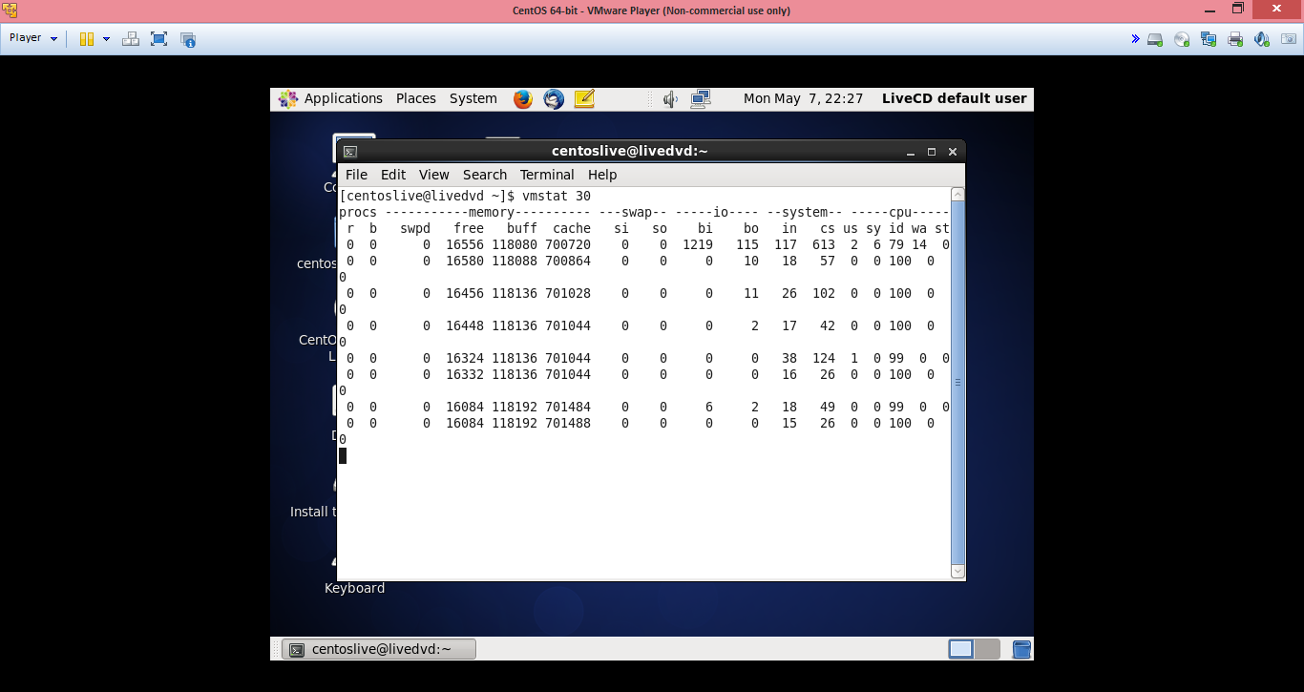

I tried the same “vmstat” command, but for 3 seconds this time, so that I could see what was happening with my memory. I opened up three terminals this time. There wer 74 interrupts and 373 context switches. Twelve seconds later there are 94 interrupts and 582 context switches!

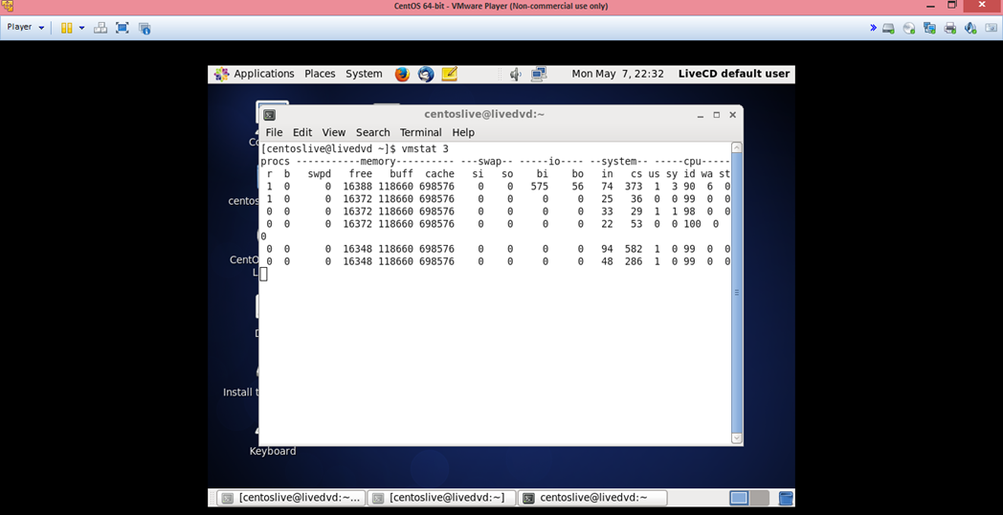

Part 2.

The screenshot below shows priorities in the “PR” column and nice values in the “NI” column. Root, nautilus, and the gnome-terminal all have different nice values, but the priorities are the same. Xorg is using the most CPU process currently.

 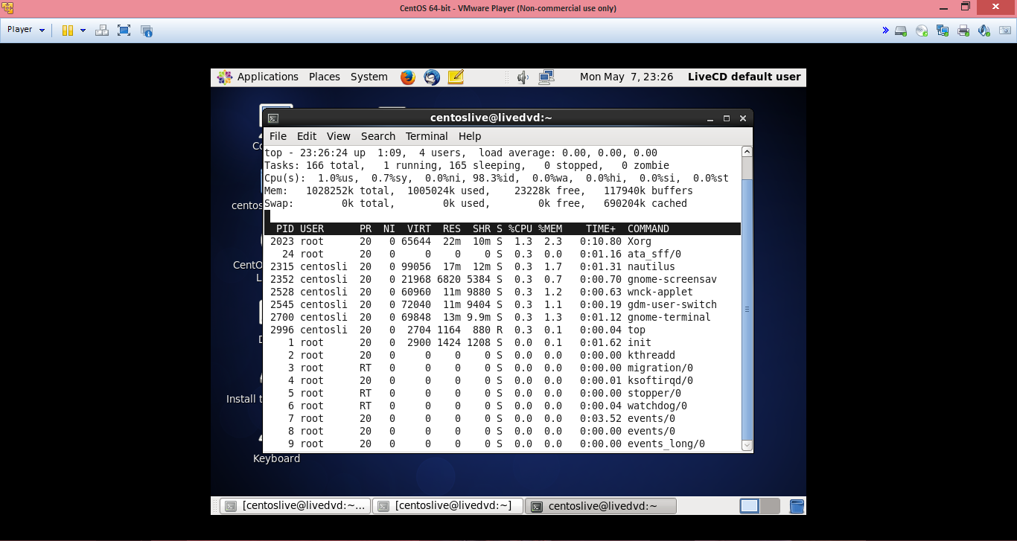

I used the chrt command to change the scheduling of firefox to round robin. You can see in the screenshot below that I had to login as root and then use the “-r” flag as round robin schedule and I knew the PID because I had “top” open in another console. I did not notice any change in performance either.

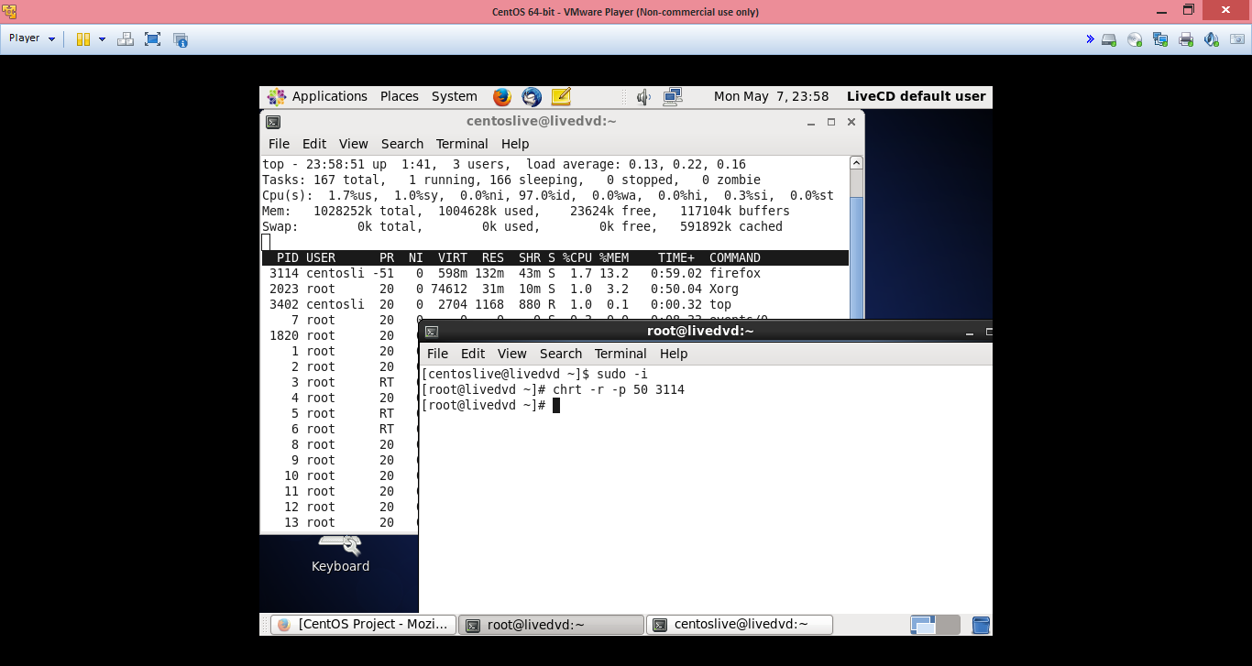

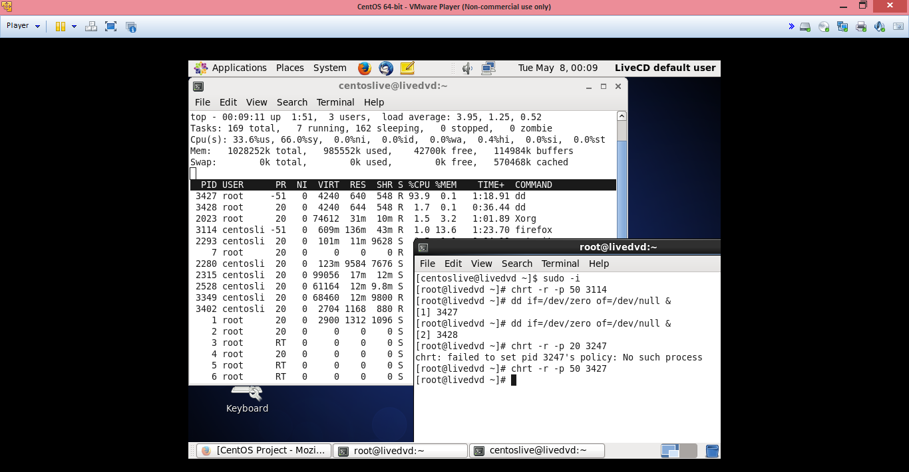

I did notice a drastic change in performance when I used this command to simulate system load: “dd if=/dev/zero of=/dev/null &”. I did this twice and I used the chrt command again, like above. It took me around five seconds just to move the console GUIs around so that I could do a screenshot. I now feel more capable using the Linux terminal and I know how to change scheduling algorithms if I need to.

References

Biswas, S. (2017). A Guide to the Linux “Top” Command. Retrieved from: <https://www.booleanworld.com/guide-linux-top-command/>.