Councillor Individual Briefing Guidelines
Version 1.0, March 2026



City of Port Phillip
99a Carlisle Street
St Kilda VIC 3182
Phone: ASSIST 03 9209 6777
Email: portphillip.vic.gov.au/contact-us
Website: portphillip.vic.gov.au

Divercity
Receive the latest news from your City and Council portphillip.vic.gov.au/divercity



National Relay Service
If you are deaf, hard of hearing or have trouble speaking, you can phone us through the National Relay Service (NRS):
TTY users, dial 133677, ask for 03 9209 6777
Voice Relay users, phone 1300 555 727,
then ask for 03 9209 6777.
accesshub.gov.au


Document Governance
Responsible division | <Enter your division>
Responsible department | <Enter your department>
Policy owner | <Name, Position title (person who is responsible for the currency of this instrument)>
Final full refresh approver | <e.g. Council / ELT / General Manager>
Date last full refresh approval | Select date  ▶ To be completed after full refresh approval. Do not change for desktop reviews.
Next full refresh date | Select date  <Default for a full refresh is four years from the date of approval. Strategies and Plans may be longer. Desktop reviews occur annually for all instruments and are not counted as a full refresh.>
Supersedes | <Enter previous instrument title or enter N/A>

Document History
Version | Date Approved | Review type | Changes made | Approved by
<1.0>  <e.g. 1.0 — full review increments the whole number (1.0 → 2.0); desktop review increments the decimal (1.0 → 1.1)> | Select date | Select... | <e.g. Full refresh OR Desktop review, legislation and related documents updated.> | <Insert final approver e.g. ELT / Council / GM/Manager / Team Leader>

Table of Contents
Document Governance 4
Review History 4
1. Process Overview 4
2. Context 6
3. When individual briefings are appropriate 6
4. What Councillors can ask for 7
5. Requests that fall outside of this purpose 7
6. Understanding the risks these guidelines manage 8
7. If boundaries are crossed 8
8. Time, capacity and appropriateness 8
9. Process to request an individual briefing 9
10. Upcoming reports - how to handle requests fairly 9
11. Privacy, confidentiality and managing conflicts of interest 9

Document Governance
Responsible Service / Department: | Communications and Governance
Adoption authorised: | Executive Leadership Group
Date of adoption: | 13 April 2026
Date effective from: | 27 April 2026
Endorsed CEO or ELT member or department manager to make and approve document editorial amendments: | Manager, Communications and Governance
Annual desktop review date: | 13 April 2028
Review date: | 13 April 2030
Completion date: | Ongoing
Version number: | 1.0
Associated Strategic Direction #: | [Insert direction]
Required by legislation (include pinpoint reference)? | Local Government Act – s 28 Role of a Councillor
Associated Council instruments: | Council Briefing Guidelines, City of Port Phillip Governance Rules, Councillor Contact Guidelines

Review History
Version | Date of approval | Changes made | ECM record
1.0 |  |  | N/A

Process Overview
The following diagram summarises the process for requesting an individual Councillor briefing. Refer to numbered sections throughout this document for detail.
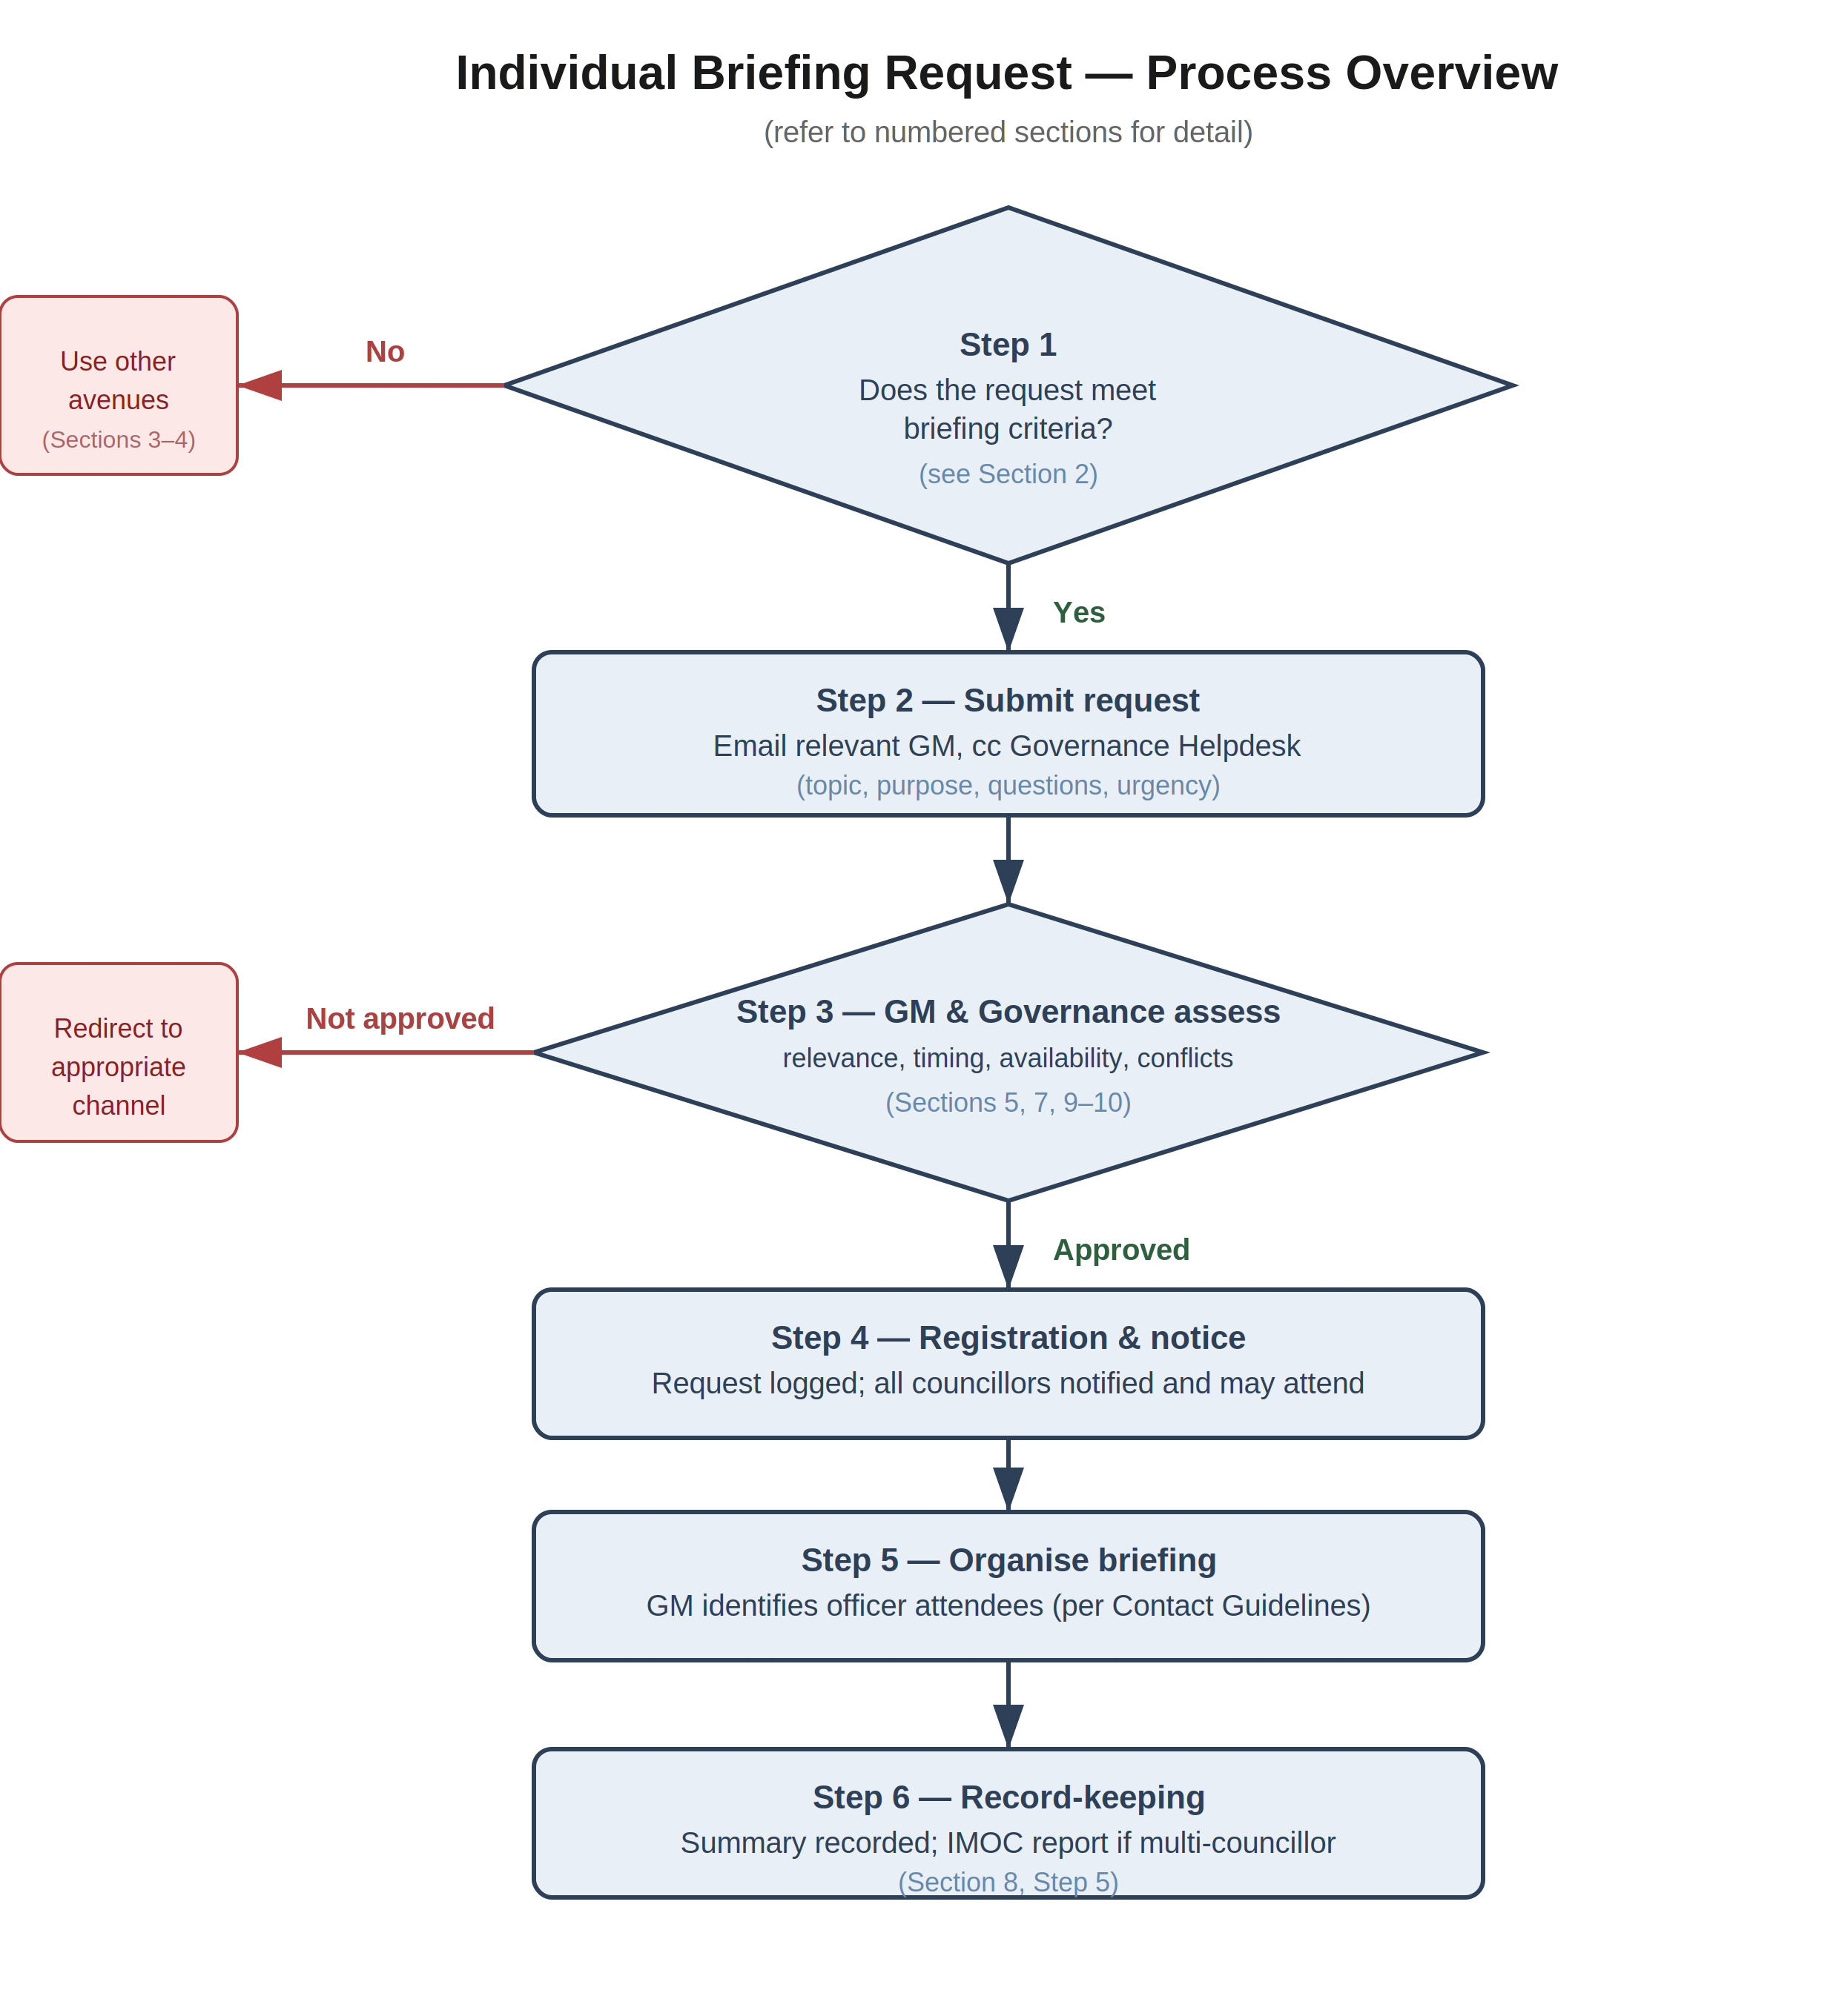

Context
Councillors play a vital role in representing community views and contributing to informed, strategic decision making. To support this role, Councilors need access to accurate, timely and relevant information about matters before Council.
Briefings - whether collective, small group or individual - are one way this information can be provided. These guidelines are intended to support Councillors and officers by clarifying when individual or small group briefings are appropriate, how they should be used, and the risks they are designed to manage.
They aim to:
- support informed participation while respecting the separation between governance and operations
- ensure fairness, transparency and confidence in Council decision making
- align with the Model Councillor Code of Conduct, particularly the obligation to diligently use Council processes to become informed
These guidelines should be read alongside Council’s broader Councillor briefing arrangements and Councillor Contact Guidelines.

When individual briefings are appropriate
In most cases, Councillor information needs can be met through existing channels, including:
- Formal Councillor request process
- Scheduled Councillor Briefings
- Proactive email updates from relevant GMs and Officers
- Councillor Notes or memos
Individual or small group briefings may be appropriate where these channels are not well suited, and where the purpose is clearly strategic.
Examples of appropriate circumstances include:
- targeted strategic clarification is genuinely required
- a matter is ward specific or location based and unlikely to be relevant to all Councillors
- an issue is complex and benefits from interactive discussion rather than written material
The intent of these briefings is to support understanding, not to replace formal briefings or decision making processes.

What Councillors can ask for
In individual or small-group briefings, Councillors can seek information that is explanatory, high-level and focused on their governance role - without disadvantaging other Councillors.
This may include:
- Strategic context and background: Information about plans, policies, strategies or issues of municipal or ward significance, consistent with Councillors’ strategic role.
- Process and timing clarification: How statutory or governance processes work, when reports or engagement are scheduled, or how decisions progress through Council.
- High-level risks, constraints and dependencies: An overview of key strategic risks or constraints (e.g. financial, legal, reputational, delivery, intergovernmental), without seeking changes to officer advice or risk assessments.
Shared understanding: Councillors contribute to Council’s strategic direction using established processes. The Chief Executive Officer and officers are responsible for operational delivery and staff management.

For ward-specific initiatives (e.g. precincts or place-based programs), officers may proactively offer briefings to relevant ward Councillors, provided these guidelines and Councillor Contact Guidelines are followed.

Practical Examples of Appropriate requests:
Requesting a briefing:
- Fishermans Bend: “Can officers provide a high-level briefing on current transport/community-infrastructure advocacy settings and how they align with Council’s adopted advocacy framework?”
Strategic context & high-level advice
- Coastal health & resilience (St Kilda/Elwood): “Could you please provide an overview of coastal adaptation priorities, key risks, indicative staging and where State partnerships are most critical?”
Process/timelines
- Local Law changes: “Can you confirm statutory steps and indicative timings for considering a Local Law amendment (public notice, submissions, decision point)?”
- Elwood Foreshore masterplan: “What are the next decision gateways (briefing → report → meeting), and when is community engagement scheduled?”
Risk, Constraints and Dependencies (High-Level)
- South Melbourne Market: “Could officers provide a high-level overview of the key strategic risks, constraints and external dependencies associated with delivering the adopted South Melbourne Market Strategy, including financial sustainability considerations, heritage and planning constraints, and any dependencies on external approvals?”

Requests that fall outside of this purpose
To protect fair decision-making and role clarity, individual or small-group briefings are not the right forum for requests that:
- direct or seek to influence how officers carry out operations
- attempt to shape, preview or alter officer advice in upcoming Council reports
- seek access to information that is not (or cannot be) made available to all Councillors
Examples include:
- asking officers to change recommendations, prioritise works, or fast-track actions
- seeking one-on-one access to draft reports or confidential material ahead of others
- requesting officers to undertake operational tasks or enforcement action
- seeking to influence technical or professional advice outside formal Council processes
Councillors are encouraged to raise perspectives, priorities and community views through formal briefings, meetings and Council debates, where all Councillors can participate.

Understanding the risks these guidelines manage
These guidelines are not about limiting engagement - they exist to manage key organisational and statutory risks, including:
- Fairness and transparency in decision-making
- Perceptions of privileged access or undue influence
- Role clarity between governance and operations
- Legal and conduct risks, including potential breaches of the Local Government Act 2020 or the Model Councillor Code of Conduct
Clear boundaries protect Councillors, officers and Council as a whole.

If boundaries are crossed
Where interactions move outside these expectations, responses are focused on resetting the process, not punitive action. Depending on the situation, this may include:
- redirecting requests through Governance or the CEO
- limiting engagement to formal, whole-of-Council channels
- voiding unapproved directions
In more serious cases, behaviour may be addressed through the Councillor conduct framework under the Model Councillor Code of Conduct, and - where relevant - the statutory provisions of the Local Government Act 2020.

Time, capacity and appropriateness
When requesting briefings, Councillors are asked to consider:
- officer time and operational impact
- whether the issue is strategic and significant
- whether the request would be more appropriately handled as training or professional development
Governance may coordinate, combine or defer requests to manage workload and ensure consistency

Process to request an individual briefing
Send request to the relevant GM cc’ing the Governance helpdesk (and the Mayor where appropriate) stating: topic, purpose, specific questions, urgency, and whether others may be interested.
- Relevant GM and Governance assesses: strategic relevance, timing, staff availability, conflicts, and whether to invite all Councillors or schedule a full Councillor briefing. A response will be provided to requesting Councillor.
- Registration & notice: the request and any briefing are logged; all Councillors are notified and may attend or receive the same material.
- The GM will work with relevant officers to organise best officer attendees. Note attendees should align with officers listed in Councillor Contact Guidelines.
- Record-keeping: officer writes a short summary of topics discussed and attendees is recorded via email to GM, and in cases that more than one Councillor attends that an IMOC report is completed and tabled at council in line with Governance Rules.

Upcoming reports - how to handle requests fairly
If clarification is needed on an upcoming report:
- requests should be made via the GM (cc Governance)
- responses should be provided to all Councilors where relevant Councillors should avoid seeking additional drafts, selective data or briefings that others do not have access to.

Privacy, confidentiality and managing conflicts of interest
Councillors are expected to handle information obtained through briefings appropriately, including:
- respecting confidentiality and privacy obligations
- not disclosing sensitive, personal, commercial-in-confidence or legally privileged information
- identifying and managing any actual, potential or perceived conflicts of interest in accordance with the Local Government Act 2020 and Council policy

