Protective Security Policy
Version 2.0



City of Port Phillip
99a Carlisle Street
St Kilda VIC 3182
Phone: ASSIST 03 9209 6777
Email: portphillip.vic.gov.au/contact-us
Website: portphillip.vic.gov.au

Divercity
Receive the latest news from your City and Council portphillip.vic.gov.au/divercity

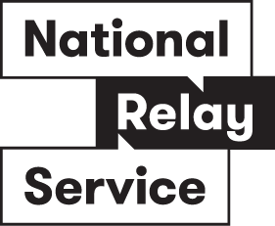

National Relay Service
If you are deaf, hard of hearing or have trouble speaking, you can phone us through the National Relay Service (NRS):
TTY users, dial 133677, ask for 03 9209 6777
Voice Relay users, phone 1300 555 727,
then ask for 03 9209 6777.
accesshub.gov.au



Document Governance
Responsible division | City Infrastructure
Responsible department | Property & Assets
Policy owner | Masi Perozi, Facilities Assurance Lead
Final full refresh approver | ELT
Date last full refresh approval | Select date
Next full refresh date | Select date
Supersedes | Protective Security Policy, version 1.0

Document History
Version | Date Approved | Review type | Changes made | Approved by
<1.0>  <e.g. 1.0 — full review increments the whole number (1.0 → 2.0); desktop review increments the decimal (1.0 → 1.1)> | Select date | Select... | <e.g. Full refresh OR Desktop review, legislation and related documents updated.> | <Insert final approver e.g. ELT / Council / GM/Manager / Team Leader>

Table of Contents
1. Purpose 4
2. Scope 4
3. Policy Context and Strategic Alignment 4
4. Governance 5
5. Operational Controls 5
6. Environmental Controls 7
7. Physical Controls 7
8. Roles and Responsibilities 7
9. Related Legislation and Standards 9
10. Attachments 10

Purpose
The purpose of this policy is to provide an overarching framework to help with the effective identification and management of security related risks in Council facilities to ensure a safe and secure operational environment for Councilors, staff, contractors, and visitors.

Scope
This policy applies to:
- All Councillors, Council Officers, visitors, contractors and their agents and other persons entrusted with access to Councils people, information, and assets.
- All contracts relevant to Council physical and environmental security.
- All buildings, sites and locations used by the Council, whether owned by it, to support the delivery of the Council Plan.
Unless otherwise stated, this policy assumes compliance with all relevant legislation, policies, and best practice guidelines. This policy does not apply to Information and IT Security or the confidentiality, integrity, and availability of information.

Policy Context and Strategic Alignment
The City of Port Phillip is committed to providing safe, secure, and resilient facilities for Councillors, employees, contractors, volunteers, visitors, and the community. Effective protective security supports the delivery of Council services by managing risks such as occupational violence, theft, vandalism, unauthorised access, security incidents, and emerging threats.
This Policy establishes a risk-based framework to protect people, facilities, and physical assets while supporting business continuity and organisational resilience. It aligns with Council's Risk Management Framework, Health and Safety obligations, Emergency Management arrangements, Child Safe commitments, and strategic objectives.
The Policy supports compliance with relevant legislation and standards, including the Occupational Health and Safety Act 2004, Privacy and Data Protection Act 2014, Child Safe Standards, ISO 31000 Risk Management Guidelines, and the Australian Government Physical Security Management Guidelines. It promotes a proactive security culture and continuous improvement approach to security risk management across all Council operations.

Council Plan Alignment
This Policy supports Strategic Direction 1 of the Plan for Port Phillip 2025 - 35: A Safe, Vibrant and Inclusive Community by promoting safe and secure environments for Council employees, Councillors, contractors, visitors, and the broader community. It also supports Strategic Direction 6: A Trusted and High-Performing Organisation by strengthening security governance, risk management, organisational resilience, and the protection of Council assets and infrastructure.

Policy Background
The Protective Security Policy provides a framework for managing security risks across Council facilities, services, and assets, ensuring the safety of Councillors, employees, contractors, volunteers, visitors, and the community. The Policy supports compliance with legislative obligations, including occupational health and safety, privacy, surveillance, and child safety requirements, as well as recognised standards such as ISO 31000 Risk Management Guidelines.
The Policy responds to risks including occupational violence and aggression, unauthorised access, theft, vandalism, security incidents, and emerging threats that may impact Council operations and service delivery. It also reflects community expectations that Council facilities and public spaces are safe, secure, and resilient.
The Policy aligns with the Plan for Port Phillip 2025-35, particularly the strategic priorities of creating a safe and inclusive community and maintaining a trusted, high-performing organisation through effective governance, risk management, and protection of Council assets and infrastructure

Governance
Council will maintain a protective security governance framework that supports the effective management of security risks and aligns with Council's strategic objectives, risk management processes, and legislative obligations.
Council will:
- Maintain appropriate security governance, oversight, and accountability arrangements.
- Implement systems and processes to identify, assess, monitor, and manage security risks and incidents.
- Ensure personnel responsible for security management have appropriate capability, resources, and access to specialist advice where required.
- Undertake security planning and risk assessments proportionate to the nature and level of risk.
- Monitor and report on security performance, risks, incidents, and control effectiveness through established governance processes.
- Maintain security-related records in accordance with Council's records management requirements.
- Regularly review this policy to ensure ongoing effectiveness, compliance, and continuous improvement.

Operational Controls

Protective Security Framework
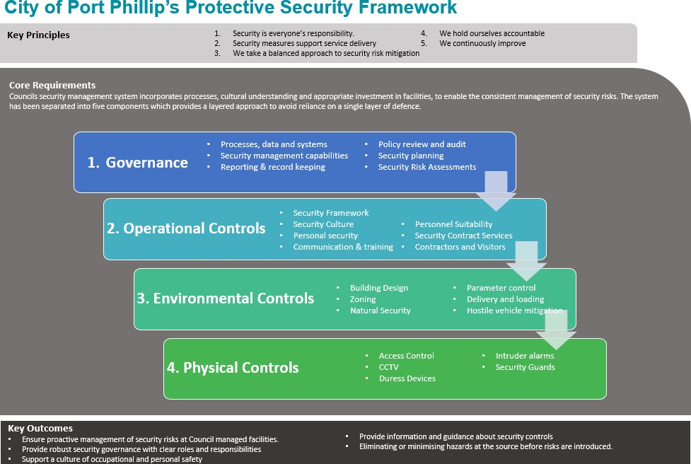
Council will implement operational controls that support the protection of people, information, and assets and contribute to a safe and secure environment across Council operations and facilities.
Council will:
- Maintain a Protective Security Framework that establishes the principles and controls required to manage security risks.
- Promote a positive security culture where all personnel understand and fulfil their security responsibilities.
- Ensure personnel take reasonable steps to support their own safety and security.
- Provide appropriate security awareness, communication, and training programs.
- Implement processes to ensure personnel and contractors entrusted with access to Council resources are appropriately authorised and suitable for their roles.
- Ensure security-related contracted services are appropriately procured, managed, and monitored.
- Require contractors, visitors, and other authorised persons to comply with applicable security requirements and procedures.

Environmental Controls
Council will implement environmental security measures to support the protection of people, information, and physical assets. Environmental controls will be based on risk and integrated into the planning, design, construction, operation, and modification of Council facilities.
Council will apply recognised security and crime prevention principles to:
- Reduce opportunities for unauthorised access, violence, vandalism, and criminal activity.
- Improve safety, visibility, and surveillance within Council facilities and public spaces.
- Support the protection of staff, contractors, visitors, and community members.
- Manage site-specific risks, including vehicle-related threats and delivery activities.
Environmental security controls must be proportionate to the identified level of risk and aligned with relevant legislation, standards, and Council requirements.

Physical Controls
Council will implement and maintain physical security controls that are proportionate to identified risks and support the protection of people, information, and assets.
Physical security controls may include access control systems, CCTV, body-worn cameras, duress systems, security personnel, intrusion detection systems, and other approved security measures.
Council will:
- Assess security risks to determine the suitability of physical controls.
- Ensure security measures are operated, maintained, and monitored appropriately.
- Implement security controls in a manner that balances security, safety, operational requirements, privacy obligations, and accessibility.
- Regularly review the effectiveness of physical security measures to ensure they continue to meet organisational needs and emerging threats.
Installation of new or upgraded physical security controls must be supported by a risk-based assessment and approved through the appropriate governance processes.

Roles and Responsibilities
Role | Responsibility
Chief Executive Officer (CEO) | - Accountable for providing and maintaining, so far as is reasonably practicable, a safe workplace that is free of risks to health.
Executive Leadership Team | - In addition to the CEO, are accountable for ensuring appropriate security risk management within the Council.  - Approve the Protective Security Policy and monitor its implementation.  - Provide executive leadership in the management of security risk and generally champion a positive security culture within Council.  - Ensure the organisation has the appropriate culture, capability, processes, and systems to deliver on this policy.  - Report expeditiously to ARCO on any security incidents or material risk mitigation failures and actions taken.  Ensure that the security management and its governance are integrated into corporate governance including financial management, reporting, and risk management.
Strategic Risk & Internal Audit Group (SRIA) | - Monitor the systems and process via the council’s risk profile.  - Consider the adequacy of actions taken to ensure that the risks have been dealt with in a timely manner to mitigate exposures to the Council.  - Identify and refer specific projects or investigations deemed necessary to assess risk management through the Audit and Risk Committee and/ CEO.
Building Safety & Security Committee | - Oversee the implementation of Protective Security Policy and Framework and review the mechanisms in place to comply with the framework.  - Provide assurance in the development  - implementation and review of the Protective Security  Policy, Framework, and other procedures within Council.  - Review security plan and procedures to ensure they reflect the strategic direction and risk appetite of Council.
General Manager Customer, Operations and Infrastructure | - Executive Sponsor for security related projects  - Quality assure security related risk management reporting to the ARCO, Council, and the ELT.  - Ensure that the financial requirements and projections for renewal, upgrade, expansion, disposals, and acquisitions are incorporated into the financial plan and the annual project portfolio through the Council budget process.
Manager, Property and Assets | - Lead the development, implementation and review of the Protective Security Policy, Framework, and supporting processes and systems.  - Monitor implementation of controls and agreed treatment actions.  - Measure security system maturity and report on the implementation of actions to achieve target maturity.  - Provide adequate resources to ensure effective mitigation of security risks.  - Responsible for letting the Strategic Risk and Internal Audit Group (SRIA) know about hazards with a high or extreme risk rating.  - Report to the SRIA at least annually on the security system security system maturity and report on the implementation of actions to achieve target maturity.  - Act as the Sponsor for security related projects
Leadership Network | - Championing security risk management within their department and appropriate risk management practice by staff, volunteers, contractors, and service providers.  - Ensure personnel and contractors are aware of their collective responsibility to foster a positive security culture and are provided with sufficient information and training to support this.
Head of Property Operations and Facilities | - Ensure the implementation and ongoing management of this Policy including maintenance of security registers and due diligence reporting
Coordinators | - Applying risk management practices in their area of work and ensuring that management are aware of risks associated with the council’s operations.  - Responsible for communicating and consulting with relevant workers, volunteers and contractors.  - Responsible for identifying and meeting the training needs of workers.
Employees, Contractors and Volunteers | - Responsible for ensuring adherence to this policy and related procedures.  - Keeping themselves informed of conditions affecting their health and safety.  - Participating in security and safety training programs as required  Take reasonable steps to ensure their own safety and security.
Facilities Assurance Lead (Security Advisor) | - Act as the Security Leader who, in cooperation with the Leadership Network, ensure that a consistent, Council-wide, well-supported and effective security program is implemented and maintained.  - Work with HSW Team, security consultants and other stakeholders to conduct security risk assessments, reviews, and audits of Council resources.  - Developing, drafting, and reviewing Security Standards and guidelines  - Contract management of security risk consultants and advisors.  - Investigate, respond, and report on security incidents and monitor effectiveness of current controls.
Building Maintenance Team | - Responsible for the operational management of contractors utilised for security related controls, including access, CCTV, and security patrols.  - Responsible for monitoring access control at council facilities including removing a person’s access from upon separation.
SMM Facilities Team | - Responsible for the operational management of contractors utilised for security related controls, including access, CCTV, and security patrols.  - Responsible for monitoring access control at council facilities including removing a person’s access from upon separation.
Learning and Development Team | - Responsible for designing, developing, and implementing training modules regarding security in conjunction with relevant business areas.
Head of safety and Wellbeing (HSW) | - Reviewing legislation, recommending policies, and monitoring compliance with health and safety statutes and regulations and Council health and safety policies and programs.  - Providing guidance on effective emergency management and business continuity programs in relation to health and safety.

Related Legislation and Standards
Council will comply with all applicable legislation, regulations, standards, codes of practice, and government guidance relating to protective security, privacy, workplace health and safety, surveillance, emergency management, and risk management.
Implementation of this policy must also support Council's obligations regarding:
- Child Safety and the Child Safe Standards.
- Human rights, privacy, and information protection requirements.
- Gender Equality and principles of inclusion and accessibility.
- Relevant Australian and international standards relating to security and risk management.
Council will maintain awareness of legislative and regulatory changes and update associated policies, procedures, and controls as required.

Attachments
Attachment 1 - Protective Security Policy Version 1.0

