# Buckhorn2 UAS-lidar data and imagery processing

## Overview

UAS-lidar data were collected by WestFork Environmental using a Surveyor 32 LiDAR System assembled by LiDAR USA (Alabama, USA) that emits up to 1.3 million points per second and collects up to two returns per pulse. Multispectral imagery was collected using an AgEagle Altum-PT sensor. Multispectral bands included blue, green, red, red-edge, and near-infrared along with thermal and panchromatic bands (*AgEagle Altum-PT Brochure*, 2022). Ground sample distance for all delivered imagery was about 3.2 cm. I think the imagery was pan-sharpened using the panchromatic band (collected at a higher resolution by the Altum-PT than other bands) but don’t know for sure.

## Point Data

Lidar point data were delivered in four tiles covering the study area. All point data were processed as a single area (no tile-by-tile processing). Overall point density is high (900 to 1400 **pulses** per square meter and 1000 to 1600 **points** per square meter), but ground point density is not. This is common with UAS-lidar when using sensors with range limited to ~100m and flying areas with dense tree cover. For this area, the ground is relatively flat and uniform (Figure 1) so trees heights should be good. Ground model resolution is a bit odd (doesn’t affect usefulness) at 0.99708m by 0.999032m.

Figure 1. Shaded relief showing the ground surface model.

Point clouds look very clean (no outliers). Individual tree detail is captured well (Figure 2). There is some noise visible in individual tree clips (scattered points slightly above branches in Figure 2). This is common with the lower-cost sensors commonly used with UAS and does not limit the usefulness of the data.

Figure 2. Point cloud for an individual tree.

## Imagery

The imagery is provided in two forms. First, as a multi-band image (7 bands) that has all spectral bands in a single file. Second, separate images (files) for each band. I tend to work with the separate bands, but you can work with the multiband image in R and GIS. I produced a set of composite images that are more human- and GIS-friendly. Various band combinations from Xie, et al. (2018) have proved useful in other analyses. Figure 3 shows the RGB image for the study area and Figure 4 shows the panchromatic (grayscale) image along with tree crown perimeters and high points. I used the imagery without normalized reflectance values as the source when producing all composite images (multiband_imagery\reflectance folder in delivered data).

There was some misalignment between the images and the lidar. This is not unusual with UAS imagery. It can be improved using more ground targets when the imagery is collected or by picking objects in the lidar point cloud that are visible and distinct in the imagery. I am pretty sure that WestFork used the latter method. I further adjusted the alignment using offsets from tree highpoints and imagery averaged for four trees in the corners of the study area. These offsets, manually measured in ArcPro, shifted imagery west 1.115m and north 0.75m. The adjusted imagery aligns better relative to the lidar data and canopy height surface. However, it is likely that this alignment could be improved with more effort. This might be worth doing if the imagery will be used for additional analyses.

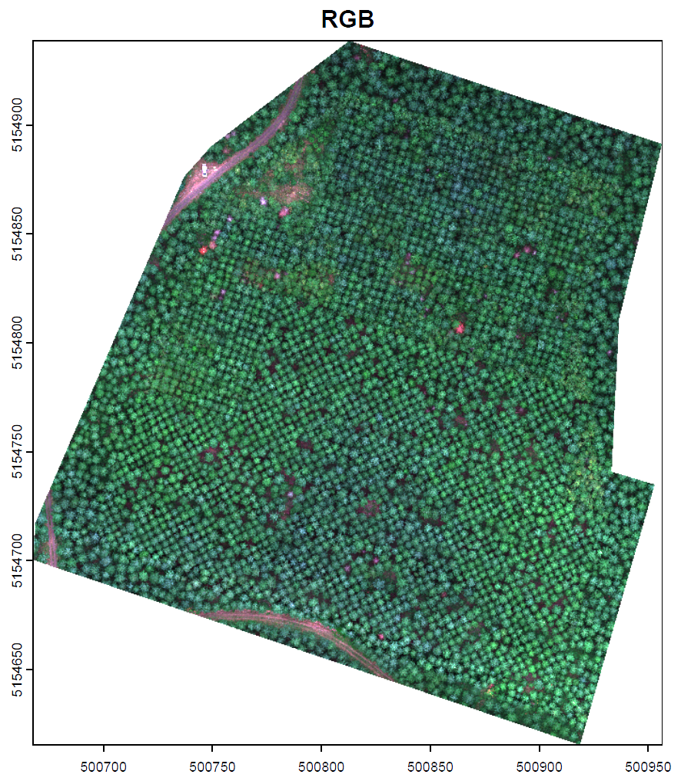

Figure 3. RGB composite image.

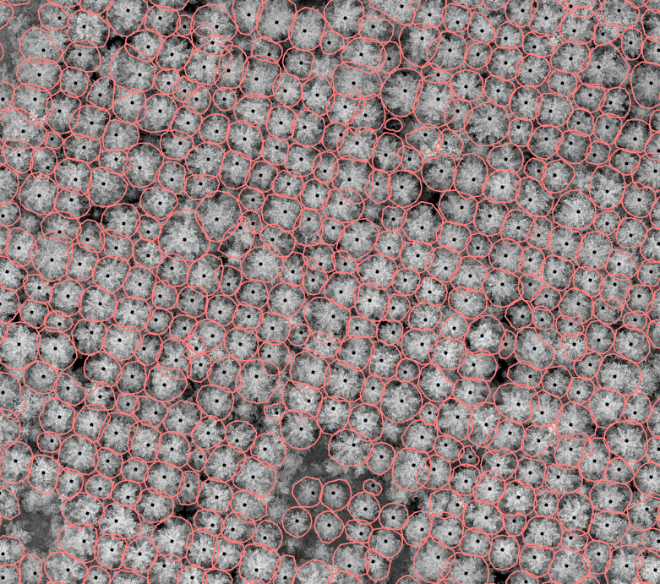

Figure 4. Tree approximate objects overlaid on adjusted panchromatic image.

## Canopy Height Model and Individual Trees

FUSION (through the fusionsrapr R package: <https://github.com/bmcgaughey1/fusionwrapr>) was used to produce canopy surface (CSM) and canopy height models (CHM). The vendor-provided ground model was used to compute heights for each lidar point when creating the CHM. The detail captured by the high-density lidar data necessitates some smoothing of the CHM to prevent oversegmentation. However, this smoothing (3 by 3 cell average) reduces the overall height of the surface resulting in underestimates of individual tree heights. FUSION’s TreeSeg program was then used with the smoothed CHM to segment the surface to produce tree approximate objects (crown polygons and high points). To overcome the height underestimation problem, I produced an unsmoothed CHM and sampled a height for each segmented tree XY location. I also clipped points for each segmented tree and captured the XY and height of the highest point in each tree. The locations and heights derived from the point cloud should be the most accurate. The tree high point and crown perimeter shapefiles include the height measured using all methods. Figure 5 shows the tree highpoints and crown perimeters overlaid on the smoothed CHM colored by height.

Figure 5. Tree approximate objects overlaid on CHM colored by height (red is high, blue is low).

## Data Products

Table 1 presents a summary of the data products developed using the lidar data. The most useful products are the tree high point and crown perimeter shapefiles. These have attributes that provide tree heights. These shapefiles can be overlaid on treatment blocks to summarize height and crown area information by block. Note that crown perimeters are developed using the smoothed CHM and logic described in the FUSION manual. This logic does not account for interlaced branches so it may underestimate the actual perimeter. Because perimeters are derived from the CHM, they represent the perimeter of the visible portion of the crown as seen from above.

Table 1. Summary of data products.

|  |  |
| --- | --- |
| **Product** | **Description** |
| Canopy height model (CHM) | 0.5m resolution surface model representing the **height** of the highest lidar point in each cell. Point heights normalized using vendor-provided ground model |
| Canopy Surface Model (CSM) | 0.5m resolution surface model representing the **elevation** of the highest lidar point in each cell. |
| Smoothed CHM | 0.5m resolution surface model representing the **height** of the highest lidar point in each cell. Point heights normalized using vendor-provided ground model. Surface was smoothed by applying a 3 by 3 cell averaging filter (center cell value is the average of the 9 values in the 3 by 3 window). The smoothed CHM was the input for the individual tree segmentation. |
| Tree high points | ESRI point shapefile with output from the tree segmentation process representing the highest point in each tree. Height attributes are derived from the smooth CHM, the unsmoothed CHM and the individual tree point clips using the crown perimeters from the segmentation process. |
| Tree crown perimeters | ESRI polygon shapefile with output from the tree segmentation process representing the perimeter of object derived using the smoothed CHM. Height attributes are derived from the smooth CHM, the unsmoothed CHM and the individual tree point clips using the crown perimeters from the segmentation process. |

The attributes in the ESRI highpoint and crown perimeter shapefiles are described in Table 2.

Table 2. Attributes in crown perimeter shapefile.

|  |  |
| --- | --- |
| Column name | Description |
| BasinID | Identifying number. Sequential starting at 2. |
| GridHighX | Grid cell location (UTM zone 10 X) for the highest cell in the tree object. |
| GridHighY | Grid cell location (UTM zone 10 Y) for the highest cell in the tree object. |
| GridCells | Number of grid cells in the raster basin (~tree). |
| GridMaxHt | Maximum height in the tree object from the **smoothed** CHM. |
| Row | Grid cell location (row) for the highest point in the tree object. |
| Col | Grid cell location (column) for the highest point in the tree object. |
| UnsmthHt | Maximum height in the tree object from the **unsmoothed** CHM. |
| HighPtX | Location (UTM zone 10 X) of the highest point in the tree point clip. |
| HighPtY | Location (UTM zone 10 Y) of the highest point in the tree point clip. |
| HighPtHt | Height of the highest point in the tree point clip. This should be the most accurate value for tree heights. |

## References

AgEagle Altum-PT Brochure. (2022). AgEagle. <https://ageagle.com/wp-content/uploads/2022/07/AgEagle-Altum-PT-Brochure-EN.pdf>

FUSION download: <http://forsys.cfr.washington.edu/fusion/fusionlatest.html>.

FUSION manual: <http://forsys.cfr.washington.edu/software/fusion/FUSION_manual.pdf>.

Xie, Qiaoyun & Dash, Jadu & Huang, Wenjiang & Peng, Dailiang & Qin, Qiming & Mortimer, Hugh & Casa, Raffaele & Pignatti, Stefano & Laneve, Giovanni & Pascucci, Simone & Dong, Yingying & Ye, Huichun. (2018). Vegetation Indices Combining the Red and Red-Edge Spectral Information for Leaf Area Index Retrieval. IEEE Journal of Selected Topics in Applied Earth Observations and Remote Sensing. 11. 10.1109/JSTARS.2018.2813281.