Lab: Mapping Corridors, Pinchpoints, and Restoration Opportunities
using Linkage Mapper and Circuitscape
Brad McRae
Updated August 30, 2015
Please send suggestions for improvements to me at bmcrae@tnc.org

For this lab, you will be using the Linkage Mapper Toolkit to map corridors connecting core areas (large patches of semi-natural vegetation) in eastern Washington, USA. This lab uses three Linkage Mapper modules: Linkage Mapper (to map corridors), Pinchpoint Mapper (to map constrictions or ‘bottlenecks’ in corridors by calling Circuitscape), and Barrier Mapper (to map important barriers and restoration opportunities). User guides for these tools are included in the Linkage Mapper download.

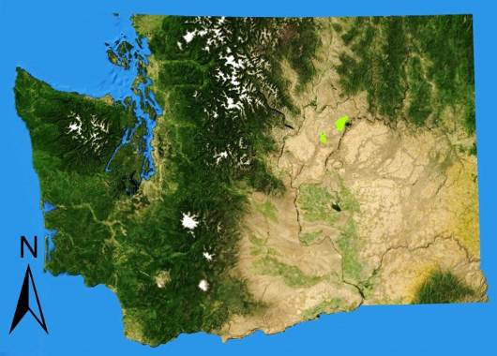
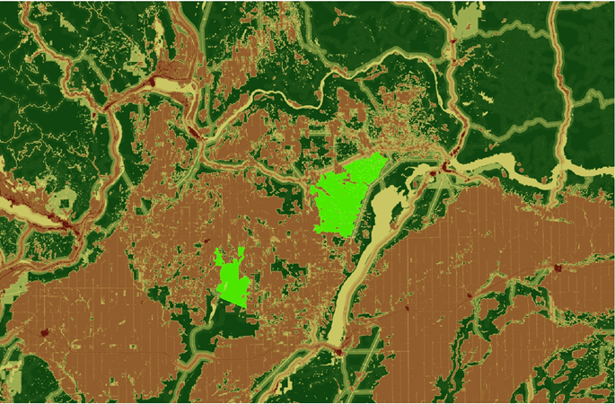
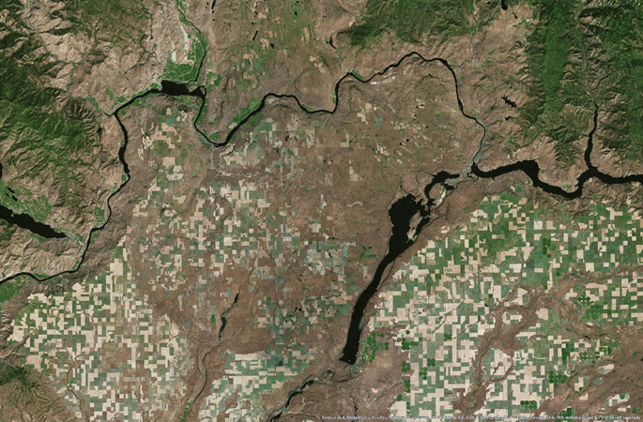
Here’s the study area:
Area Enlarged
Banks
Lake
Moses
Coulee
Lake
Chelan
Columbia River
A

D

Top panels: 80 km by 120 km study area in eastern Washington, USA. Bottom panel: Resistance map used to model corridors across the Columbia Plateau Ecoregion by the Washington Wildlife Habitat Connectivity Working Group. Resistance values range from 1 (dark green) to 1000 (red). Low resistance areas include native grassland and shrub-steppe. High resistance areas include roads, developed areas, and agriculture. Core areas to be connected are shown in bright green.

The bright green core areas were identified by the Washington Wildlife Habitat Connectivity Working Group as having high ‘landscape integrity.’ They represent contiguous areas with low levels of human modification like roads, agriculture, and power lines. They are home to several species of conservation concern, like Greater Sage-Grouse, and connecting them is a conservation priority for state and federal agencies.

1) View the study area and base data
First, you will need to download and unzip the lab data if you haven’t already. Download the lab data from http://www.circuitscape.org/linkagemapper. Unzip it and place it in a shallow directory with no spaces or special characters (the tool dialogs below use C:\LM_LAB). If Circuitscape isn’t installed on your computer, you will need to download and install it from http://www.circuitscape.org/downloads.

Open LM_Lab_2Cores.mxd in ArcMap. In ArcMap, make sure the Linkage Mapper Toolkit is installed. Click Geoprocessing >> ArcToolbox. If Linkage Mapper isn’t in the list, right-click on ArcToolbox and click ‘Add Toolbox.’ Browse to LM_Lab\LinkageMapper1_0_9\toolbox and add ‘Linkage Mapper Arc10.tbx.’

Take some time to look at the aerial imagery, core areas, and resistance surface. The resistance surface was created by combining features from many base layers such as roads, utilities, and land cover, and assigning appropriate resistances to each feature. The core areas were created using a similar procedure, as well as a set of rules to delineate contiguous polygons. Tools in the Gnarly Landscape Utilities toolkit can facilitate resistance and core area layer creation.

Based on the resistances (lower is better), where do you think the most important areas for movement between the two core areas might be?

2) Map the least-cost corridor between the two core areas
Use Linkage Mapper to map the least-cost corridor. To do this, open the Linkage Mapper Toolkit and navigate to ‘Build Network and Map Linkages’ as shown below:

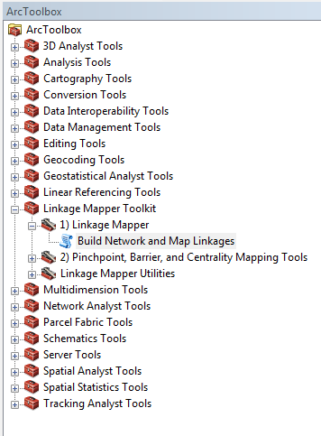

Use the settings below. ‘Results\Project_2Cores’ will be your project directory, which is where outputs will be written.

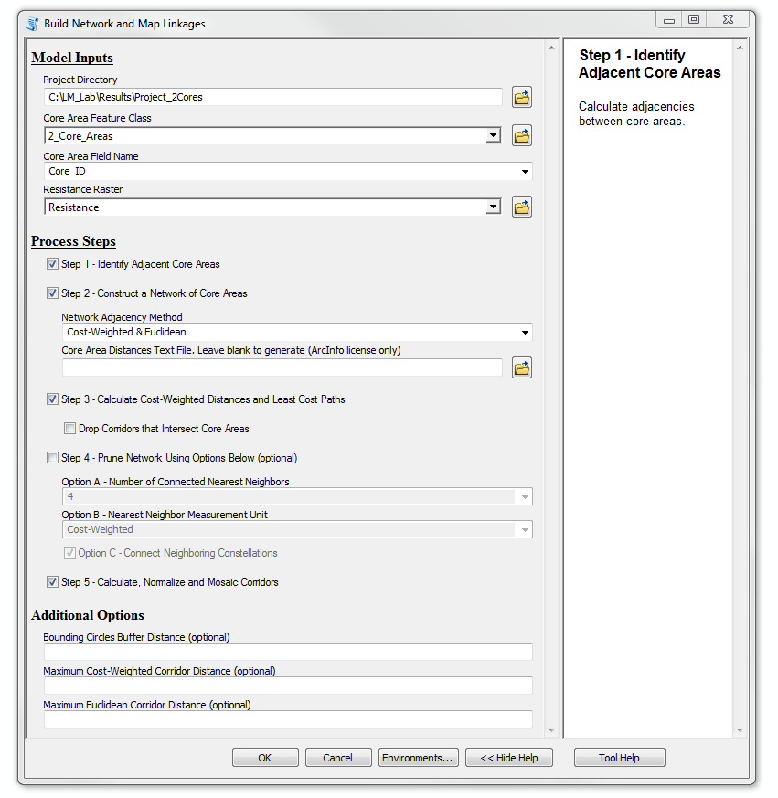

Note: with any of these tools, if you get errors and you are sure you have the settings right, save your work, restart ArcMap, and try again.

Linkage Mapper will create two corridor files (both located in the project directory under Results\Project_2Cores\output\corridors.gdb) plus a map of cost-weighted distances to the nearest core area (in cwd.gdb) and least-cost path lines (in link_maps.gdb). I’ve put layer files (*.lyr) for some of these in your project directory to make things easier. These are already symbolized.

Add the following corridor layer file to ArcMap:
Results\Project_2Cores\Project_2Cores_corridors.lyr

Note that the corridor raster fills the entire study area. It shows the cost-weighted distance of the best route passing through each cell on the landscape. The map has lower values for routes close to the least-cost path, higher values for routes that are more costly.

Results check 1: what is the range of values in the corridor raster? (Answers at end of this document.)

Now add a corridor raster that has been automatically truncated (clipped) to a width of 200 cost-weighted km to show just the best part of the corridor. Also add the layer showing the least-cost path (LCP):

Results\Project_2Cores\Project_2Cores_corridors_truncated_at_200k.lyr
Results\Project_2Cores\Project_2Cores_LCPs.lyr

Use the information button to click on the LCP layer (Project_2Cores_LCPs). This will give you statistics on the corridor including:
-CW_Dist: total cost-weighted distance (in weighted meters) incurred moving along the least-cost path.
-LCP_Length: total (un-weighted) length of the least-cost path.

It will also provide ratios of these quantities to give you an idea of resistance encountered per unit distance (again, lower is better).

Results check 2: What is the CW_Dist value?
Results check 3: What is the LCP_Length value?

3) Run Circuitscape between the core areas
We could use the Circuitscape stand-alone program (which doesn’t require ArcGIS) or the Circuitscape for ArcGIS toolbox to do this, but for convenience we will just use the Pinchpoint Mapper tool in Linkage Mapper here.

In the Linkage Mapper Toolbox, click on ‘Pinchpoint, Barrier, and Centrality Mapping Tools.’ Run Circuitscape using Pinchpoint Mapper with the following settings (most importantly use 100 million as your CWD cutoff distance):
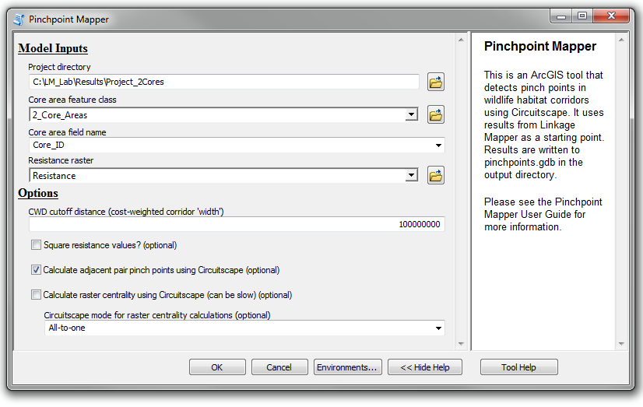

This tool will run Circuitscape, injecting electrical current into one core area and letting it flow across the landscape to the other core area. Because the CWD cutoff distance of 100 million is higher than the highest cost-weighted distance in the corridor map, Circuitscape will be run across the entire resistance surface (in other words it will not constrain current flow to the least-cost corridor). Current will concentrate in pinch points and potential stepping-stone habitats.

Add Project_2Cores_current_adjacentPairs_100m.lyr from your project directory to ArcMap (the actual current raster will be in Results\Project_2Cores\output\pinchpoints.gdb).

This current map shows the probability that a random walker leaving one patch and moving until it hits the other patch would pass through each cell. (A random walker has no memory- it wanders through the landscape, preferring to enter cells with low resistance, until it reaches its destination.) Running Circuitscape across the landscape like this shows areas outside of corridors that might add redundancy (alternative routes and stepping stones).
Results check 4: What is the highest value in the current map?
Discussion question: Do any of the highlighted areas seem like they’d be important for conservation? Does this add useful information to the least-cost corridor maps?

4) Run a hybrid least-cost corridor and Circuitscape analysis
Pinchpoint Mapper was designed to run Circuitscape within least-cost corridors to map pinch points. This produces current flow maps that identify and map pinch points (places where corridors are constricted, also called bottlenecks or choke points).
Map pinch points within the corridor using Pinchpoint Mapper with the following settings:
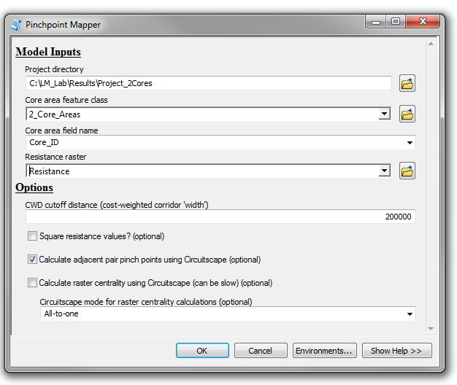

This tool will run Circuitscape, injecting current into one core area and letting it flow through the corridor to the other core area. The CWD cutoff distance of 200,000 tells the tool to limit current to a cost-weighted corridor ‘width’ of 200 cost-weighted km (the same as the truncated corridor you mapped earlier). Current will concentrate in areas where corridors get narrow.

Add Project_2Cores_current_adjacentPairs_200k.lyr from your project directory

Examine the pinch point map. The higher the value, the more the corridor is constricted (and movement is funneled) at the pinch point.

Results check 5: What is the highest value in this current map?
Discussion question: Does the pinch point map give you any extra information or insight into important areas for connectivity in this landscape?

5) Map important barriers
Here we will use Barrier Mapper tool to map important barriers (some of which might represent restoration opportunities). Run Barrier Mapper using a barrier detection radius of 1000 m (detecting effects of barriers up to 2km across):

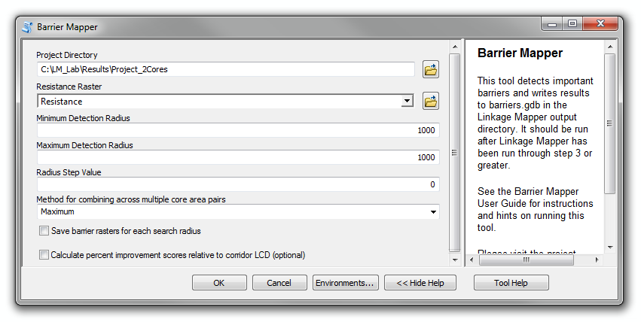

Add the result from the run to ArcMap:
Results\Project_2Cores\Project_2Cores_BarrrierCircles_Rad1000.lyr
(The actual raster will be in Results\Project_2Cores\output\barriers.gdb.)

Higher numbers indicate barriers that have the strongest effect on cost-weighted distances between the core areas. Restoring these would most improve connectivity. Any area that shows up outside of the least-cost path would re-route the path if restored.

Results check 6: What is the highest barrier value?
Discussion question: Have a look at the barriers and at the resistance surface under them. Do all of the areas identified as barriers make sense to you?

6) Restore a barrier
Next, we will simulate a restoration in one of the areas identified by Barrier Mapper. Instead of focusing on a barrier in the least-cost corridor, we will restore one entirely outside the corridor. It’s not a particularly strong barrier, but because it doesn’t fall on the least-cost path, we know that its restoration would completely re-route the least-cost corridor.

Add the Restoration Area polygon and corresponding new resistance raster:
Input_Data\Restoration_Area.lyr
Input_Data\Resistance_Post_Restoration.lyr

The polygon is a 1km² (500 m x 2 km) strip of agricultural land indicated as an important barrier in the analysis above. The resistance layer we will use for the next model run will simulate restoring this area to natural vegetation by lowering its resistance. This would result in not just an easier least-cost path, but would also add redundancy because in addition to the original corridor, there would be a new, entirely independent least-cost corridor.

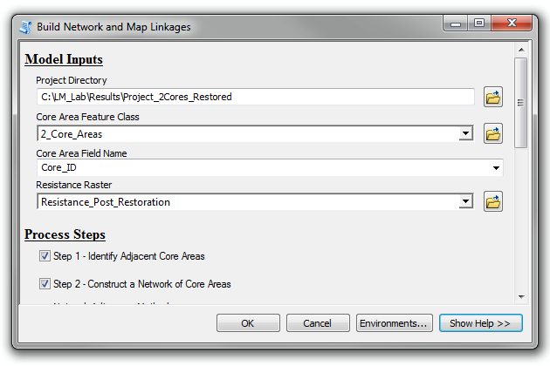
Repeat steps 2-3 using ‘Results\Project_2Cores_Restored’ as your project directory and ‘Resistance_Post_Restoration’ as the resistance raster in Linkage Mapper. This raster has the simulated restored area. The resistance in the restoration polygon has been reduced to 1, the same as natural vegetation. Keep all other settings in the tools the same as before.

Now do the same with Pinchpoint Mapper (with a CWD cutoff distance of 200,000):

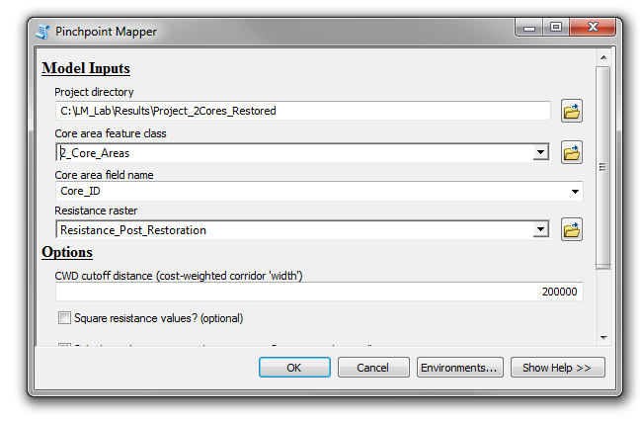
Add in the corridor, pinch point and LCP layer files from these new runs to your ArcMap project. Layer files will be in the Results\Project_2cores_Restored directory. Compare the corridors and pinchpoints. Click on the post-restoration LCP polyline to see new corridor statistics.

How do the corridor statistics compare to the old corridor statistics? Visually, how do the corridors compare?

Results check 7: What is the CW_Dist value for the new corridor?
Results check 8: What is the LCP_Length value for the new corridor?

Discussion question: How much did the corridor map and statistics change following restoration? What does the strong effect of restoring a 1km² strip of land say about the sensitivity of corridor maps to errors in base data or resistance estimates?

PART II: Connectivity among Multiple Core Areas
For this part, we will repeat the above steps but with multiple sets of core areas to connect. We will use Linkage Mapper to connect adjacent (neighboring) core area pairs only, but it can also be run to map corridors among all pairs of core areas.

7) Model corridors, pinch points, and barriers among 5 core areas
First, open LM_Lab_5Cores.mxd. This has the restored resistance raster and five core areas to be connected.
Repeat steps 2-5 above using these settings:
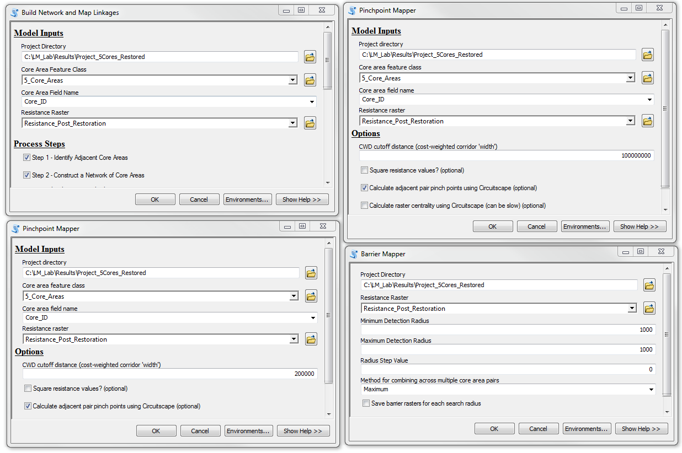

Add in all of the layer files from the Results\Project_5Cores_Restored directory. An additional layer (Project_5Cores_Restored_Sticks.lyr) is included to show which core areas were connected based on the settings (recall that only core areas that are adjacent to one another were connected).

Discussion question: If you were a conservation planner, which maps do you think would be most useful to you?

Discussion question: Looking at the aerial imagery, are there barriers that don’t look restorable?

Discussion question: If you could only protect or restore some of the corridors, how would you prioritize among them? What factors would you consider?

8) Optional data exploration
Optional: Display the raw cost-weighted distance map found in the output/cwd.gdb directory within any of your project directories. These maps show the cost-weighted distance to the nearest core area. Take some time to look at these and how they relate to the resistance map (you will probably want to try different color ramps and classification schemes to really get a good feel for them). Think about how resistance accumulates as you move outward from a core area. Can you tell from the maps where the least-cost corridor would be? Or where barriers might be? Does examining these maps give you a better feel for connectivity in the area or not?

Optional: Try the Centrality Mapper tool with the 5-core area data. This provides a very simple measure of which core areas and corridors might be most important for keeping the network connected. It assumes that all core areas have equal importance and is sensitive to decisions made earlier in the process, such as whether to only map corridors between adjacent core areas. It updates the LCP layer with a Current Flow Centrality attribute, and also creates a new core area layer with centrality scores in output\core_centrality.gdb.

Optional: Experiment with different settings with the 5-core area dataset. Choose whether or not to drop intermediate core areas or whether to connect adjacent or all core areas. Use a new project directory for each new run of the ‘Build Network and Map Linkages’ tool. Try displaying corridors with different width cutoffs (you can take a corridor map and truncate it to any value you wish in Linkage Mapper Toolkit > Utilities > Clip Corridors to Cutoff Width). Try running Pinchpoint Mapper with different cutoffs as well.

Optional: Try restoring different areas by editing either of the resistance rasters, and observe the effect on corridor location and quality. Use a new project directory for each new run of the ‘Build Network and Map Linkages’ tool.

Results check answers. These are provided to help you make sure analyses have been run correctly.

Results check 1: what is the range of values in the corridor raster? Cost-weighted distance values for the corridor range from -2 to 12,641,021. (The real minimum value should be zero, but there is some rounding error in the ArcGIS calculations).

Results check 2: What is the CW_Dist value? 1,488,982.75 (1,488 cost-weighted km)

Results check 3: What is the LCP_Length value? 50,285 (50 km)

Results check 4 What is the highest value in the current map? 0.178 Amps

Results check 5: What is the highest value in this current map? 0.84 Amps

Results check 6: What is the highest barrier value? 343

Results check 7: What is the CW_Dist value for the new corridor? 1,348,383 (1,348 cost-weighted km)

Results check 8: What is the LCP_Length value for the new corridor? 28,245 (28 km)

