

Budapest University of Technology and Economics (BME)

Faculty of Electrical Engineering and Informatics (VIK)

Department of Measurement and Information Systems

Tamás Borbás  
Péter Lunk  
Dávid Zilahi

DFN Modeler User Guide

BUDAPEST, 2014

Contents

1 Environment 3

2 How To 4

2.1 Run configuration 4

2.2 Plugin usage 4

2.2.1 Modeller 4

2.2.2 Generators 5

2.3 Generated graphs usage 6

2.4 Generated code usage 6

# Environment

Java Development Kit: 1.7.0_45

Eclipse: Kepler (4.3)

Plugins for Eclipse:

* EMF-IncQuery SDK: 0.8.0
* Zest: 1.5.1
* E(fx)clipse: 0.9.0
* m2e: 1.4.0

MQTT broker: <http://mosquitto.org/>

Paho library: <http://www.eclipse.org/paho/>

# How To

## Run configuration

Main page

* Run a product: org.eclipse.platform.ide

Arguments page

* Program arguments: -os ${target.os} -ws ${target.ws} -arch ${target.arch} -nl ${target.nl} –consoleLog
* VM arguments: -Dosgi.requiredJavaVersion=1.6 -Xms40m -Xmx512m

## Plugin usage

Import projects to Eclipse and start the previously described run configuration.

### Modeller

First of all you need a simple project. In this project you can create new DFN model. If you open the dfn with the DFN Model Editor you get a tree editor. The root element should be a Data Flow Network but in this you have a lot of option what you want to create. Before you start working we suggest to initializing our model validator system (1. figure).

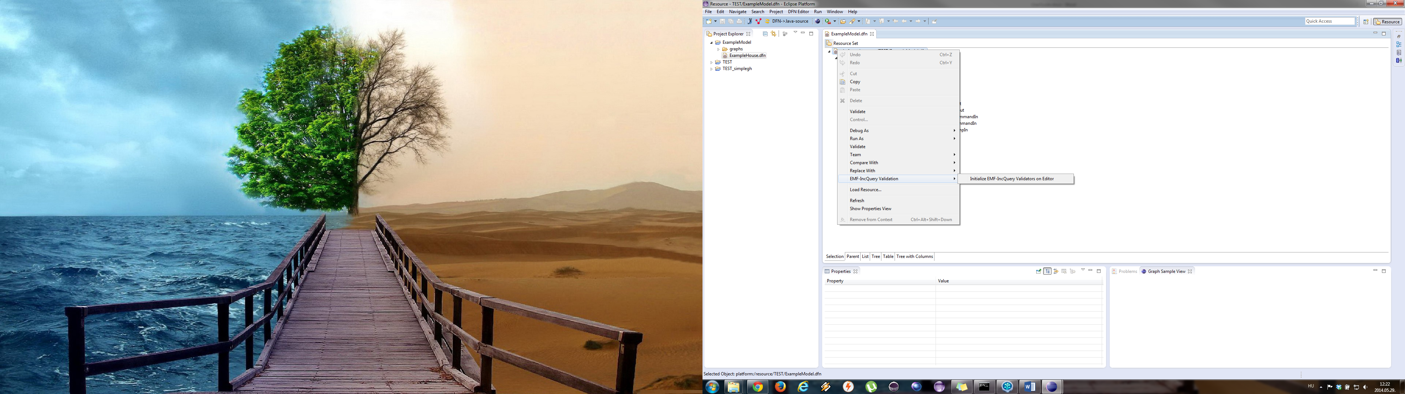

1. figure – Initializing the model validator

You can separate your models generated code in different projects. You only have to create Application in the model and you must assign your nodes to one Application. You can specify the communication channel between the Applications (JMS, MQTT or local) at the Data Flow Network. Data Flow Networks and Nodes can communicate over Channels and this Cannels need to assign to one In Port and one Out Port. You also have to specify the Token what you want to send over the Channel. In your Data Flow Network can be other DFNs or Nodes.

Nodes build from States and Transactions between the States. You can define condition for Transaction as String Equation or Inequality. This states and transactions will specify how your system will work.

There is an example project with a dfn file in our repository’s example folder. You can import this project to an Eclipse where our plugins have been installed (or a run-time Eclipse with the specified settings).

### Generators

We have a toolbar with four button (2. figure) for generating from the model or visualize it. The first and second button generates graphml files in the project’s graphs folder (if the folder does not exist the plugin will create it). The difference between generated files is that the first button generates a yEd specific graph with labels, colors, content based sizes and the second button generates a standard graphml which can be used any other tools not just yEd. The third button refresh our run-time visualizer but the layout algorithm does not work well so the result will not be nice. If you does not open our Graph Sample View you need to push this button twice.



2. figure - Toolbar

The last button will generate code.

**TODO…**

## Generated graphs usage

Both graph what you generated (yEd specific and standard) can be opened with yEd. You will need a layout if you want to see the graphs because the generator not layout them. We suggest the Classic Orthogonal layout if you use yEd because the others can hide some edges. After layouting you need to get something like on 3. figure.

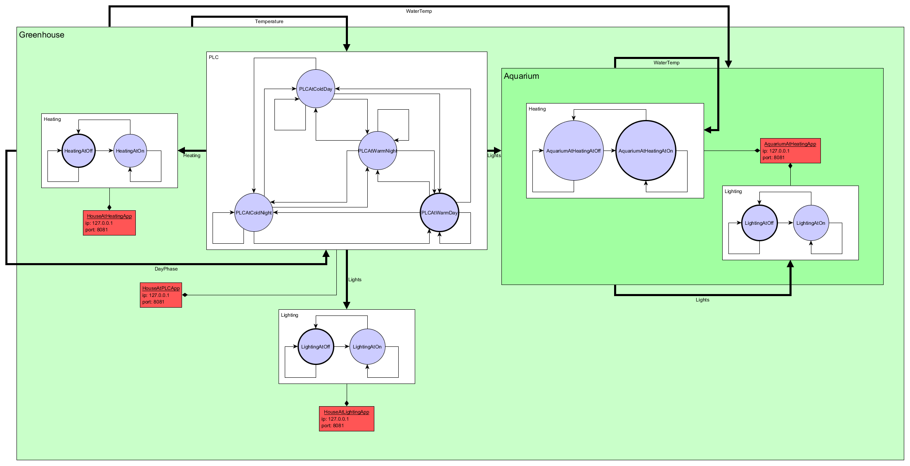

3. figure – Layouted graph

## Generated code usage

**TODO…**