Unit 10: Putting it all Together

Lesson 10.03: The Qualities of Effective Schools | What Makes an Effective School?

Lesson at Glance
Warm-Up (4 mins)  - Bellringer | Instruction (6 mins)  - Instruction: Texas Effective Schools Framework Notes | Application (35 mins)  - Practice: ESF Essential Actions Stations (25 min)  - Debrief (5 min)  - Exit Ticket (5 min)

TEKS | 3 | The student explores the teaching and training profession. The student is expected to:  (C) identify qualities of effective schools;
Objectives | - Identify the components of an effective school.  - Apply the Effective Schools Framework to determine areas of strength and weakness in a given school.
Rationale/  Summary | While teachers are the most important indicator in student’s academic success, they operate within schools. In this lesson, students will investigate the Texas Effective Schools Framework to determine what are the characteristics of an effective school and how can school leaders can work to ensure their schools meet these characteristics.
Formative Assessment and Exemplar Response | - Name the five levers of an effective school.  - Examine teacher and student responses on this year’s Effective Schools Framework Survey. School leaders use this survey to identify areas of growth on the framework. Based on the responses to the survey, which levers should the principal prioritize in the next school year? How do you know?  See Exit Ticket Answer Key for exemplar responses.
Vocabulary | Texas Effective Schools Framework (ESF) |  | A research-based tool that schools and districts can use to ensure they are leveraging best practices to guarantee an excellent education for all Texas students.

Est Time | Instructional Activities (including formative assessments) | Materials
 | At the conclusion of this lesson, remind students to hang on to the student guide, as it will be an important resource for Lesson 10.04.
4 mins | Bellringer:  - Schools provide the environment in which teachers and students operate, and each school has certain characteristics that can help us determine if they are effective in helping students and teachers find success. For example, effective schools provide teachers and students with high-quality instructional materials.  Use the chart below to brainstorm qualities of effective schools based on the categories provided.
6 mins | Instruction: Effective Schools Framework  T: While this course has focused largely on the components of effective instruction, teachers sit within schools, and no matter how effective they are independently, there are several school-level factors that can impact teacher and student success. What are some of the ideas you listed in your bellringer that are qualities of effective and ineffective schools?  S: (Responses will vary)  T: Decades of research have taught us the components of an effective school. In Texas, we have a tool to help evaluate a school’s effectiveness. Please locate the vocabulary section on your student guide where we will discuss the term Texas Effective Schools Framework or ESF.  S: (Locates vocab in student guide and copies the term.)  T: The Texas Effective Schools Framework, or ESF, is a research-based tool that schools and districts can use to ensure they are leveraging best practices to guarantee an excellent education for all Texas students. This framework includes five “levers”, or characteristics, of effective schools. Within each framework, there are essential actions, or best practices, that a school can employ that will ensure that they are working effectively. Today, we will examine these levers and apply them to specific school-based scenarios to identify where schools are highly effective, and where they have areas of growth. It is important to note that just because a school does not fully implement all five these levers does not mean it is a “bad” school. This is simply a tool to help school leaders implement best practices that we know create positive outcomes for students.  T: Before we jump into the specific levers, take 2 minutes to turn and talk with a neighbor to discuss some potential actions that schools (and their leaders) could implement that would ensure they’re effective.  T: Please locate the table entitled “Levers of Effective Schools” in your student guide. These levers match the characteristics we discussed as part of our bellringer. As we review each, please capture the description in your student guide. The ESF includes five levers of effective schools:  - Strong School Leadership and Planning  - Strategic Staffing  - Positive School Culture  - High-Quality Instructional Materials and Assessments  - Effective Instruction  T: (Using the PowerPoint, review the descriptions of each of the five levers of effective schools. Students may need additional context regarding school improvement plans.)  S: (Complete the table with descriptors for each lever.)
25 min | Practice: ESF Essential Actions Stations  T: In addition to the five levers, the framework provides schools and school leaders with specific strategies they can employ to ensure effective operations. In your student guide locate the section titled ESF Essential Actions Stations.  S: (Location station table in the student guide.)  T: There are five stations, one for each lever, that include these actions and a scenario describing how a school is implementing these actions. For example, under the Strong School Leadership and Planning lever, the first major action is having a schoolwide school improvement plan in place to address root causes of low performance. Effective schools have a clear plan in place to identify and resolve gaps in student achievement.  T: You will have five minutes at each station to complete the chart in your student guide, filling in the different essential actions that correspond with levers of effectiveness and then reading the scenario and answering the two questions that go with each. The questions are the same for each scenario:  - What are the strengths of this school, based on this lever of the Effective Schools Framework?  - What might the school leader want to improve to ensure that their school is highly effective?  T: What questions do you have?  S: (Ask clarifying questions. Then complete the stations activity.)
5 mins | Debrief  T: Let’s discuss the different responses for each scenario. For Scenario 1, what are the strengths of this school?  S: Ms. O has an instructional leadership team that meets regularly to analyze student data. They also have data systems in place to monitor student progress in academics, attendance, and behavior.  T: What might the school leader want to improve to ensure that their school is highly-effective?  S: Even though Ms. O has an experienced staff, they still need ongoing professional development to learn new and effective strategies. Her school also does not have an improvement plan in place, which is important even though student data is promising.  T: How about Scenario 2? What are the strengths in this scenario?  S: Ms. T’s school has some retention strategies in place, like a retention bonus. Her school also places teachers based on student need, as shown by her shift from 6th to 8th grade science.  T: What might the school leader want to improve to ensure that their school is highly effective?  S: Ms. T’s school has a pipeline from the local college into the district, but it is clear that won’t be enough to meet their needs. They should identify other sources of talent. Additionally, the retention bonus is likely not enough to provide a personalized retention strategy. She also needs more support through PD for the new curriculum she is using.  T: What about Scenario 3?  S: Mr. E’s school has a clear mission, but it isn’t clear if it is the right one. They also have a school climate survey and a reward/consequence system in place. On the other hand, the school does not do an effective job living out its mission since kids aren’t really being prepared for a career and they don’t have access to the mental health supports. They should increase the focus on student supports and re-commit to their mission.  T: Scenario 4?  S: Mr. F’s school provides high-quality TEKS aligned curriculum, but Mr. F. should have been advised to build in more time to reteach in his scope and sequence. His principal should be providing helpful feedback on how he can adjust his pacing and lessons based on his needs instead of putting it off until the next year.  T: And finally, what are the strengths and weaknesses of the school in scenario 5?  S: Instructional leaders observe teachers and provide feedback. Teachers also meet regularly to discuss student data. However, the teachers aren’t receiving timely feedback from their observations, and they aren’t implementing their interventions in a timely way.
5 mins | S: (Complete the exit ticket.) | Exit Ticket

Lever 1: Strong School Leadership and Planning

Effective school instructional leaders with clear roles and responsibilities develop and implement improvement plans that address the causes of low performance.

Essential Actions
- Schoolwide school improvement plan to address root causes of low performance
- Instructional leaders meet weekly to discuss student data.
- Data systems track student academic, attendance, and discipline data
- Ongoing professional development for Instructional Leaders

Scenario 1: Ms. O. is the principal at a medium-sized rural elementary school. This is her second year in the school, and she hopes to implement a new school improvement plan by the beginning of the next year but has not had much time to focus on writing one. Her instructional leadership team regularly meets to review student academic and behavioral data, and overall things are going well for most students. Her district recently adopted a new data system to help track student discipline which as been helpful in resolving some challenging student behaviors. She feels lucky to have an experienced staff and leadership team that does not need much professional development to be effective.


Lever 2: Strategic Staffing
Campus leadership ensured that all students have access to high-quality educators by retaining effective, well-supported teachers through strategic hiring, placement, training, and onboarding.

Essential Actions
- Proactive Recruitment strategies targeting high-quality candidates from multiple sources.
- Targeted and personalized support and retention strategies, especially for high-performing staff
- Strategic teacher placements based on student need and teacher strengths.

Scenario 2: Ms. T. is a teacher at a large urban middle school. She, like most teachers in her district, graduated from a college nearby and was immediately hired by the district. Her school struggles to retain effective teachers, however, and will soon need more teachers than the local college can produce. For the past two years she taught sixth grade science, but her principal recently moved her to eighth grade (which is a tested subject) because she is considered a high-performing teacher. Ms. T. really enjoyed sixth graders, but her school offers a retention bonus for teachers in high-need positions like 8th grade science. She also wishes she had more professional development to better use the new curriculum and the complex labs she will be required to execute.

Lever 3: Positive School Culture

Positive school culture requires aligned vision, mission, goals and values, explicit behavioral expectations and management systems, proactive and responsive student support services, and involved families and community.

Essential Actions
- A clear, community created mission, vision, and values
- Regular campus climate surveys for staff and students
- Clear system of schoolwide rewards and consequences
- Mental Health and Wellness Skills are taught
- Available Student Support Services, including counseling, mentoring, and external service referrals.
- Frequent family Communication

Scenario 3: Mr. E is a teacher at a medium sized suburban high school. Part of his school’s mission is to “provide student-centered programs that put students on the path to the career or college of their choice,” but he doesn’t see this live out through the school’s daily operations. The focus for the school seems to only be on college-prep—his students have shared that they rarely have organized opportunities to engage in career experiences through their school. While behavior is not a challenge at his school (far more students engage in the monthly rewards than receive consequences), Mr. E. also feels that his school does not offer the mental health supports necessary to be considered “student centered.” His principal recently implemented a student and staff climate survey, so he is hopeful these things will be resolved in the next few years.

Lever 4: High-Quality Instructional Materials and Assessments
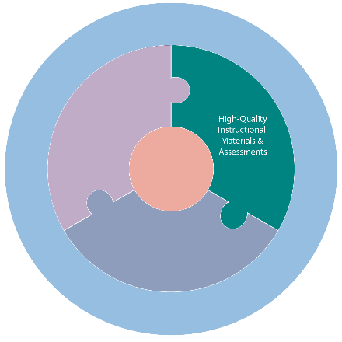
All students engage daily with TEKS-aligned, high-quality instructional materials, and assessments that support learning at appropriate levels of rigor.

Essential Actions

- High-quality, TEKS aligned instructional materials and assessments that support all learners are consistently used across classrooms
- Time for reteach is built into the scope and sequence.
- Campus instructional leaders frequently review how teachers internalize, modify, and use lesson plans and provide feedback and lesson planning support, as needed.

Scenario 4: Mr. F is a first-year teacher in a small rural school district. He is teaching three different classes, but fortunately has high-quality, TEKS aligned curriculum provided to him for each course. Unfortunately, he continues to fall behind with all his classes because he does not want to move on to a new topic when his students haven’t mastered the current content. Mr. F. did not effectively plan out his units, so he did not add in flex time to reteach difficult concepts. Behavior management has not been a problem in his class, so his principal has not considered him a high priority to regularly observe and provide feedback on how he can improve his pacing. The principal simply told him that this happens to all first-year teachers and that he will know what to do differently next year.

Lever 5: Effective Instruction
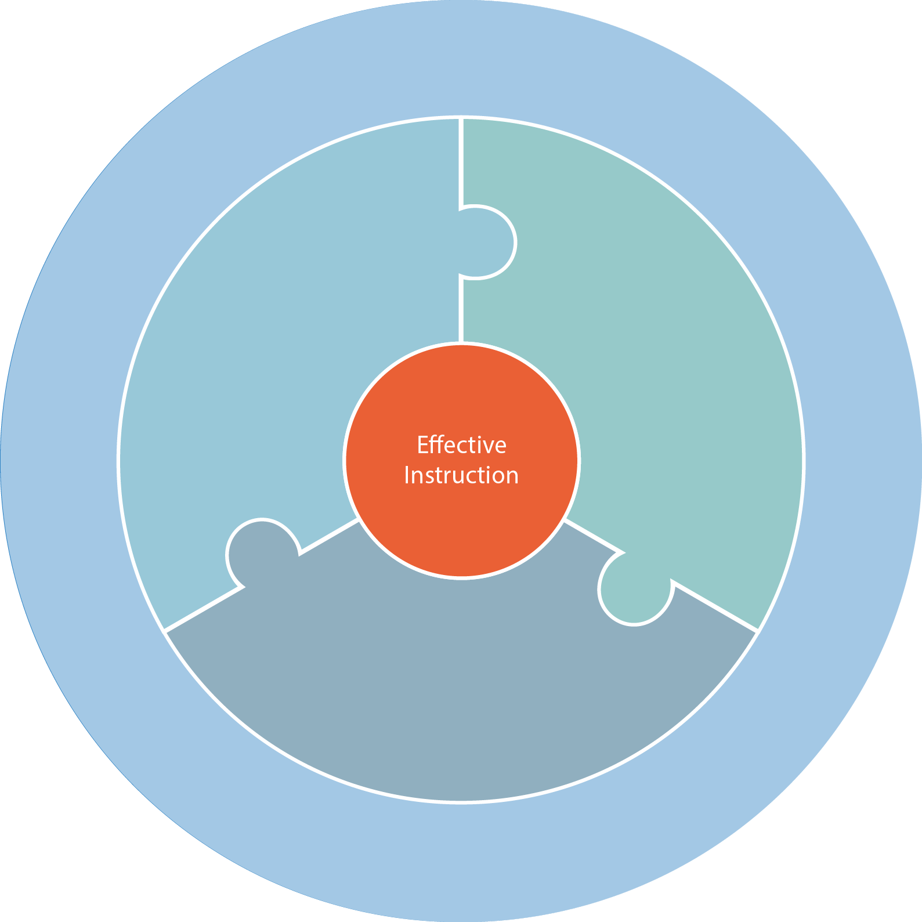
Campus leaders provide teachers with job-embedded professional development and access to time and data needed to reflect, adjust, and deliver instruction that meets the needs of all students.

Essential Actions

- Training and ongoing support aid teachers in implementing best practices around research-based teaching practices.
- Teachers benefit from regular normed observations.
- Observation feedback is timely and provides clear, actionable next steps.
- Teachers have protected time in their day to meet with their peers to discuss student data and possible adjustments to instructional delivery.
- Students who have significant learning gaps are proactively identified and provided with timely interventions.

Scenario 5: Ms. V. is a teacher at a medium-sized urban school. She wants to be the best teacher she can be and finds great value in her regular classroom observations, but sometimes it takes more than a week for her administrator to provide feedback. In her weekly grade level team meeting, she has heard that this is true for others on her team as well. During this meeting they also discuss additional interventions for students, but the team decides to wait to implement these interventions until the end of the unit.

