Student Guide – Answer Key

Lesson 10.08: Reflective, Collegial Practices | Developing Habits of Continuous Improvement
Name:
Date:
Bellringer:
Of the quotes listed below, select one of them that speaks most to you. Why does this quote stand out? Do you agree or disagree with it? How do you think the quote you selected applies to teaching and learning?
Quote A: “When you’re in a growth mindset, what that means is that you choose to see struggle and challenge as an opportunity for growth and for learning and development.” -Chris Bertram

Quote B: “It is only after you’ve stepped outside your comfort zone that you begin to change, grow, and transform.” -Roy T. Bennett

Quote C: “Practice the philosophy of continuous improvement. Get a little better every single day.” -Author Unknown

Introduction to the Continuous Improvement Cycle
Continuous Improvement Cycle

Plan-Do-Study-Act
An example of a continuous improvement cycle where, when used in education, teachers ______________, ________________, and ___________ the process of a _______________. (Adapted from Plan-Do-Study-Act (PDSA) Directions and Examples. Content last reviewed September 2020. Agency for Healthcare Research and Quality, Rockville, MD. https://www.ahrq.gov/health-literacy/improve/precautions/tool2b.html)

Step | Implementation of the Step
Plan
Do
Study
Act
Class Example:
Ms. K has noticed that her third-grade students are struggling with finding the missing value in a number sentence. She gives the problem _____ + 7 = 19. She notices that many of her students are putting 26 as their answer. To approach this type of problem differently, she decides to implement a Plan-Do-Study-Act cycle. Using the table below, describe how Ms. K might approach each step of the cycle.
Step
Plan
Do
Study
Act

Texas Lesson Study Deep Dive
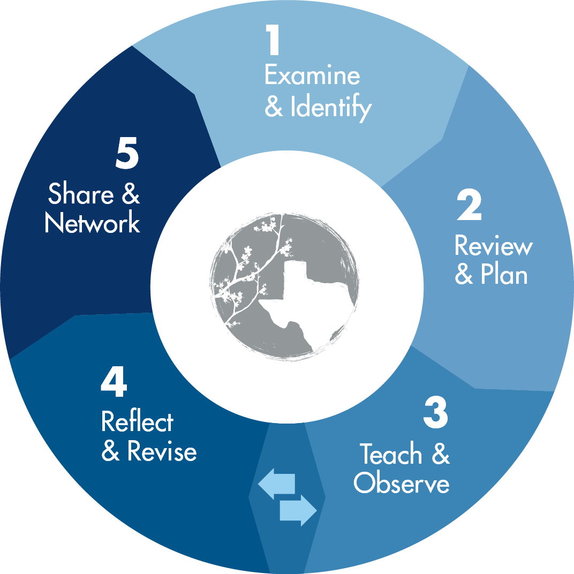
Texas Lesson Study Phases:

Group Members:
Assigned Phase(s):
What are the teachers doing during this phase? | Where does this phase fit in the PSDA Cycle? | How does this phase benefit teaching/learning?

