Student Guide – Answer Key

Lesson 10.08: Reflective, Collegial Practices | Developing Habits of Continuous Improvement
Name:
Date:
Bellringer:
Of the quotes listed below, select one of them that speaks most to you. Why does this quote stand out? Do you agree or disagree with it? How do you think the quote you selected applies to teaching and learning?
Quote A: “When you’re in a growth mindset, what that means is that you choose to see struggle and challenge as an opportunity for growth and for learning and development.” -Chris Bertram

Quote B: “It is only after you’ve stepped outside your comfort zone that you begin to change, grow, and transform.” -Roy T. Bennett

Quote C: “Practice the philosophy of continuous improvement. Get a little better every single day.” -Author Unknown

Answers will vary.

Introduction to the Continuous Improvement Cycle
Continuous Improvement Cycle | An intentional approach to improving one’s practice through planning, action, and reflection.

Plan-Do-Study-Act
An example of a continuous improvement cycle where, when used in education, teachers plan for, implement, and observe the process of a desired change. (Adapted from Plan-Do-Study-Act (PDSA) Directions and Examples. Content last reviewed September 2020. Agency for Healthcare Research and Quality, Rockville, MD. https://www.ahrq.gov/health-literacy/improve/precautions/tool2b.html)

Step | Implementation of the Step
Plan | - Identify the problem  - List possible steps to approach the problem  - List desired outcomes
Do | - Apply the steps listed in the plan  - Take notes/make observations during this time
Study | - Study the results after applying the plan. Did you see the outcome you expected? What were the actual results when compared to the desired ones?
Act | - Consider your next steps.  - Has the solution addressed the problem? Do you need to return to any of the previous step?

Class Example:
Ms. K has noticed that her third-grade students are struggling with finding the missing value in a number sentence. She gives the problem _____ + 7 = 19. She notices that many of her students are putting 26 as their answer. To approach this type of problem differently, she decides to implement a Plan-Do-Study-Act cycle. Using the table below, describe how Ms. K might approach each step of the cycle.
Step
Plan | Problem: Students are adding the numbers they see, not looking for the missing number.  Possible Solution: Using a picture in place of the blank line. Using manipulatives and single digit problems to explain the steps, before trying number sentences with two-digit numbers.  Desired Outcome: For students to understand that they are looking for a missing value.
Do | Re-teach the concept using scaffolding as listed above, as well as hands-on manipulatives to help students connect to the material.  Observe the students when practicing with the manipulatives to check for understanding.
Study | Review samples of student work and observational data to determine students’ level of understanding compared to the goal.
Act | Determine if the students understand the concept or if there is a need to approach the topic differently and reteach (repeat PDSA cycle).

Texas Lesson Study Deep Dive
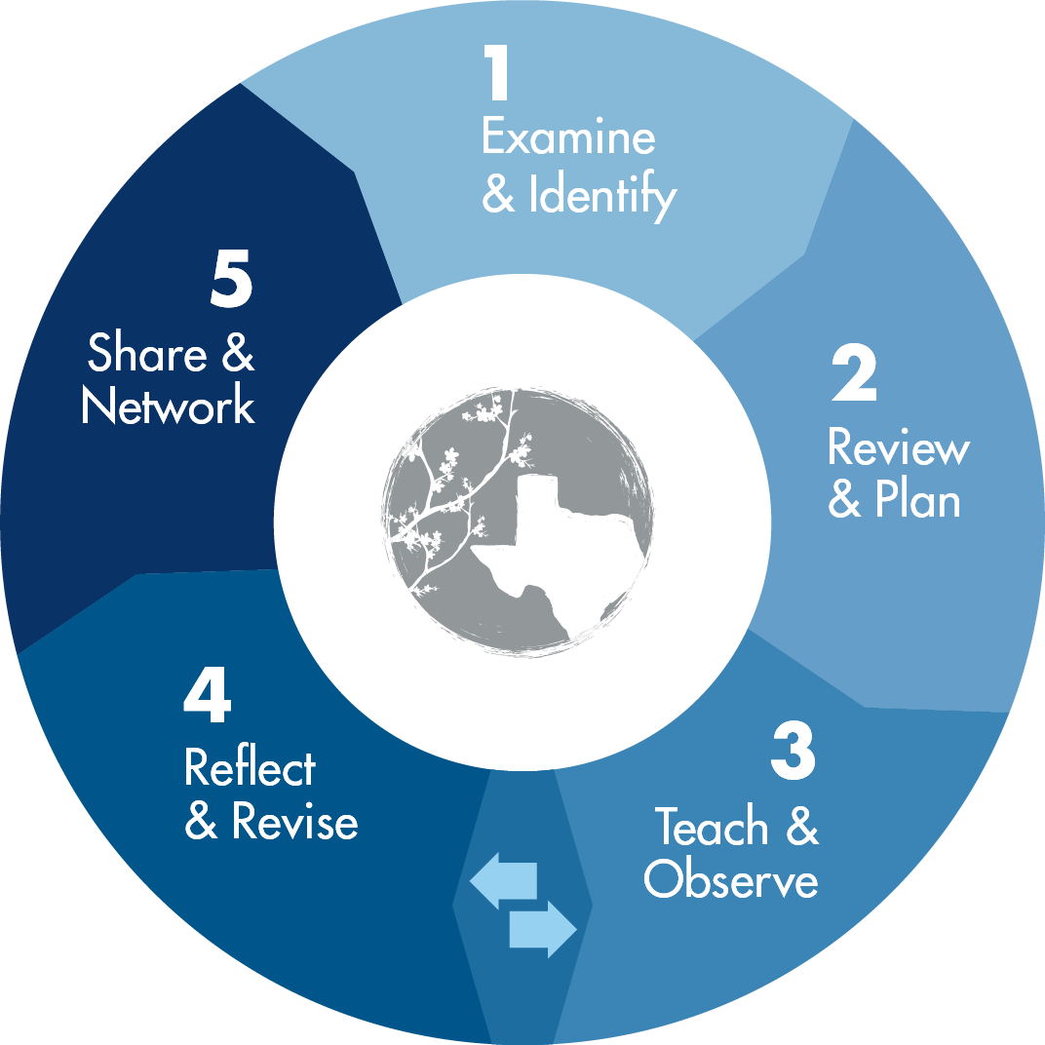
Group Members:
Assigned Phase(s):
What are the teachers doing during this phase? | Where does this phase fit in the PSDA Cycle? | How does this phase benefit teaching/learning?
Phase 0- Prepare: Forming teams, scheduling meetings, establishing norms, roles, and procedures. | Plan | Answers will vary but may include: This planning phase sets the expectations for the lesson study, establishes a safe environment for collaboration, and allows the teachers to feel well prepared to initiate the changes they intend to make.
Phase 1- Examine and Identify: Examining student data and identifying a research theme and student expectations from the TEKS. | Plan | Answers will vary but may include: This planning phase gives the teachers an opportunity to see where students currently have understanding or potential misconceptions, as well as what they would like students to learn based on state standards.
Phase 2- Review and Plan: Reviewing instructional materials, researching best practices, and planning an effective lesson. | Plan | Answers will vary but may include: This planning phase allows teachers to collaborate with one another on tools and resources that could be valuable in providing effective instruction for all of their students.
Phase 3- Teach and Observe: Teaching the lesson, collecting observation data on students’ learning process and engagement. | Do | Answers will vary but may include: This phase provides students with thoughtful instruction, where the teacher is paying close attention to the learning that is taking place as well as how engaged students are with the material. Both teachers and students benefit from this instructional time because of the informal data collection and well-planned instruction.
Phase 4- Reflect and Revise: Reflecting on the lesson and data collected, and refining lesson accordingly (may reteach). | Study | Answers will vary but may include: This phase provides teachers with an opportunity to review how their implementation impacted student learning. This impacts teacher understanding of how students retained the information they were learning, but also creates opportunity for a teacher to re-teach if the students did not show evidence of high levels of understanding.
Phase 5- Share and Network: Share the research-based lesson and findings, and network with other Lesson Study groups. | Act | Answers will vary but may include: This phase provides teachers with a space for collaboration and feedback. Here they could potentially get new ideas for ways to approach the content, as well as ask questions around problems of practice they may have noticed during instruction.

