Unit 1: Building an Effective Classroom – Classroom Culture

Lesson 1.12: Rolling Out Systems and Routines

Lesson at Glance
Warm-Up (5 mins)  - Bellringer | Instruction (5 mins)  - Instructions for Double-Planning Activity | Application (35 mins)  - Small Group Discussion and Work Time: Double-Planning Activity (15 mins)  - Small Group Practice: Double-Planning Activity and Reflection (15 mins)  - Exit Ticket (5 mins)

TEKS | 7 | The student creates an effective learning environment. The student is expected to:  - describe and implement a safe and an effective learning environment that incorporates the principles of universal design;  - demonstrate teacher and trainer characteristics that promote an effective learning environment;  - identify classroom-management techniques that promote an effective learning environment
Objectives | - Identify possible pitfalls of a routine  - Use a double plan and possible pitfalls to plan for deliberate practice of a routine
Rationale/  Summary | Designing effective systems and routines is only a start to developing an efficient, focused, and safe classroom. This lesson is the fourth in a series of six focused on the introduction of systems and routines. For systems and routines to work, teachers must get student buy-in. One way to increase student buy-in is to help students own the systems and routines. Careful attention to the roll-out of a routine or system can increase student ownership. In this lesson, students identify possible pitfalls of the routine they designed in small groups earlier in the course and apply the keys to effective practice to double-plan for student practice.
Formative Assessment and Exemplar Response | Review the sample double-plan for the practice of a routine below. Complete the “Potential Pitfalls” and “How to Practice” columns of the table below.  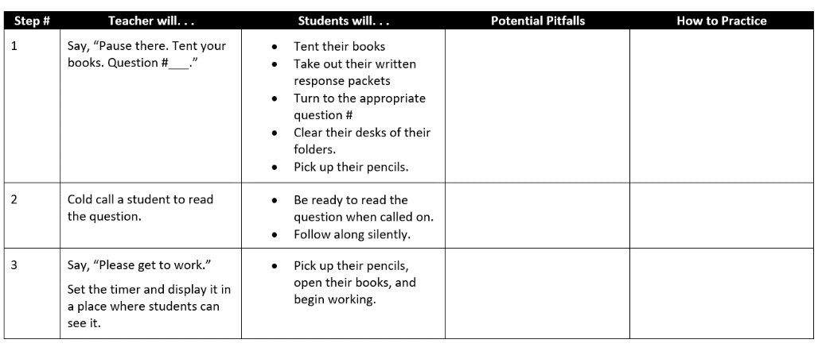  See Exit Ticket Answer Key for exemplar responses.
Vocabulary

Est Time | Instructional Activities (including formative assessments) | Materials
 | In Lessons 1.08 and 1.10, students worked in five groups to design classroom routines. In this lesson, students will need to return to those groups to double-plan for student practice of the routines.
5 mins | Bellringer:  Consider the routine you designed with your small group earlier in this unit. What are some of the potential pitfalls of this routine? What might students need to practice to ensure that this routine is enacted successfully? | Student Guide
5 mins | Instructions for Double-Planning Activity  T: Please set aside your bellringer. You’ll discuss your responses with your group after I explain the plan for today.  S: (Set aside bellringer responses.)  T: Today, you’re going to work in your routine design groups again. You’ve already worked with this group to plan a routine, as well as design a roll-out for it. Today, your goal is to work together to identify the possible pitfalls of that routine and plan for student practice that will avoid those pitfalls.  T: You will be working through a template for Deliberate Practice Planning Template found in your Student Guide. Please locate this section and follow along as I explain the steps.  S: (Locate Deliberate Practice Planning Template and follow along.)  T: First, use your earlier work with the routine to complete the first two columns of the template in your Student Guide. This shouldn’t take you very long as you’ve already designed the routine and planned a roll-out speech to introduce it.  T: Second, take some time in your group to share your bellringer responses. Use your responses, and those from your group members, to record potential pitfalls in your routine.  T: Next, work together to design student practice that will help avoid those pitfalls.  T: If you need an example, feel free to return to the plan we reviewed yesterday: Ms. Bowen’s double-plan for practicing the reading routine with her students. You will have 15 minutes to complete the template in your groups.  T: Are there any questions?  S: (Ask clarifying questions.) | Student Guide
15 mins | Small Group Discussion and Work Time: Double-Planning Activity  T: (Set timer for fifteen minutes.)  T: Move into your groups and begin.  S: (Move into groups and complete Deliberate Practice Planning Template in Student Guide.)  T: (Circulate to answer questions and provide support as needed.) | Student Guide
15 mins | Small Group Practice: Double-Planning Activity  T: Let me have your attention for a few minutes to explain the next part of the activity. Now that you have completed the template, you will have time to practice. There is a chart in your Student Guide to help with this part of the lesson.  T: Begin by assigning each member of your group one step in your routine. If you have more students than steps, it’s okay for more than one student to be assigned the same step of the routine. You will practice being the teacher for your assigned step. For the other steps, you will be a student.  T: Next, beginning with the first step, the assigned student will lead the practice activity, just like they are the teacher. Other members of the group should listen to the teacher and follow their directions. You’re the students!  T: After your group practices a step, pause, and answer the reflection questions in the last two columns of the Deliberate Practice Planning Template. Then, move on the next step.  T: You have 12 minutes for practice. When you begin, think about the number of steps in your routine and determine how many minutes you can spend on each step. For example, a group with four steps in their routine can spend about three minutes on each step.  T: Are there any questions?  S: (Ask clarifying questions.)  T: Begin.  T: (Circulate to answer questions and provide support as needed.) | Student Guide
5 mins | S: (Complete the Exit Ticket.) | Exit Ticket

