Student Guide

Lesson 2.01: Classroom Management Defined
Name:
Date:
Bellringer:
Respond to the following prompts:

- Reflect on what we’ve learned about classroom culture and an effective learning environment.

- What do you think of when you hear the term Classroom Management?

Intro to Classroom Management

Practice 1: Defining Classroom Management
Annotate the graphic organizer below.
  - Add notes related to key ideas.
  - Circle any terms with which you are not familiar.
  - Place a star by any terms for which you can explain and identify an instructional strategy.

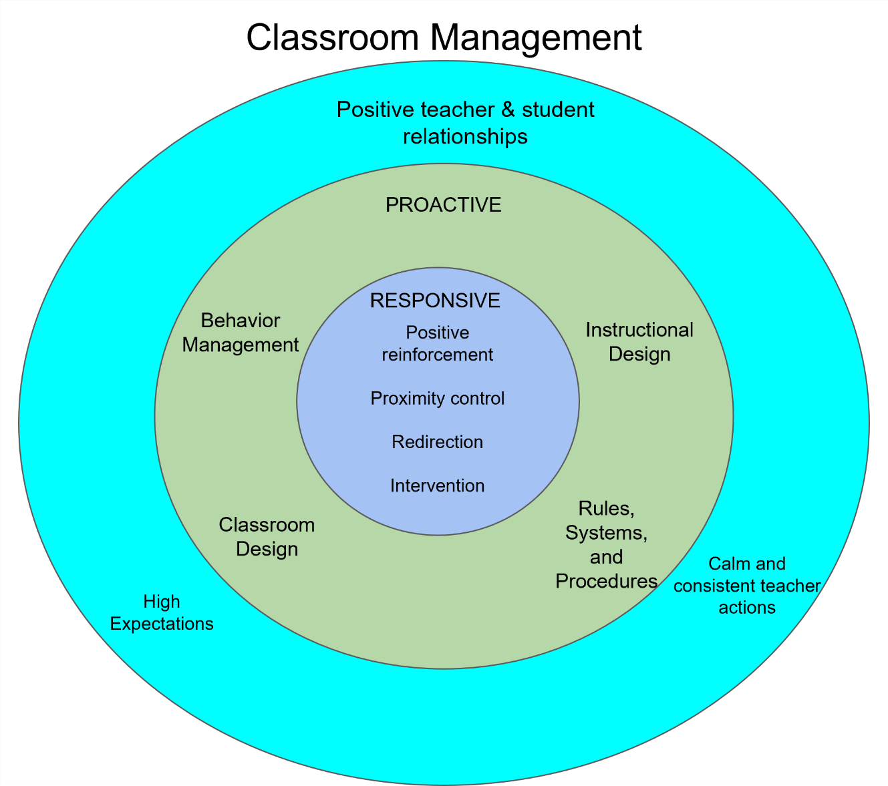

Practice 2: Definitions and Strategies

Classroom Management
 |  | Definition | Strategies
Positive Teacher & Student Relationships | High Expectations
Positive Teacher & Student Relationships | Calm & Consistent Teacher Actions
Proactive | Behavior Management
Proactive | Rules, Systems, & Procedures
Proactive | Instructional Design
Proactive | Classroom Design
Responsive | Positive Reinforcement
Responsive | Proximity Control
Responsive | Redirection
Responsive | Intervention

Basketball Questioning

In Basketball Questioning, the teacher moves questions and discussion responses around the room. The teacher poses a question that is answered initially by one student. Teacher then asks additional students to evaluate and/or add to the initial answer. In this way, ideas and responses are moved around the class and students build on one other another’s ideas and comments.

What are some examples of when should you use Basketball Questioning?

