Student Guide – Answer Key

Lesson 2.01: Classroom Management Defined
Name:
Date:
Bellringer:
Respond to the following prompts:

- Reflect on what we’ve learned about classroom culture and an effective learning environment.

Answers will vary.

- What do you think of when you hear the term Classroom Management?

Answers will vary.

Intro to Classroom Management

Practice 1: Defining Classroom Management
Annotate the graphic organizer below.
  - Add notes related to key ideas.
  - Circle any terms with which you are not familiar.
  - Place a star by any terms for which you can explain and identify an instructional strategy.

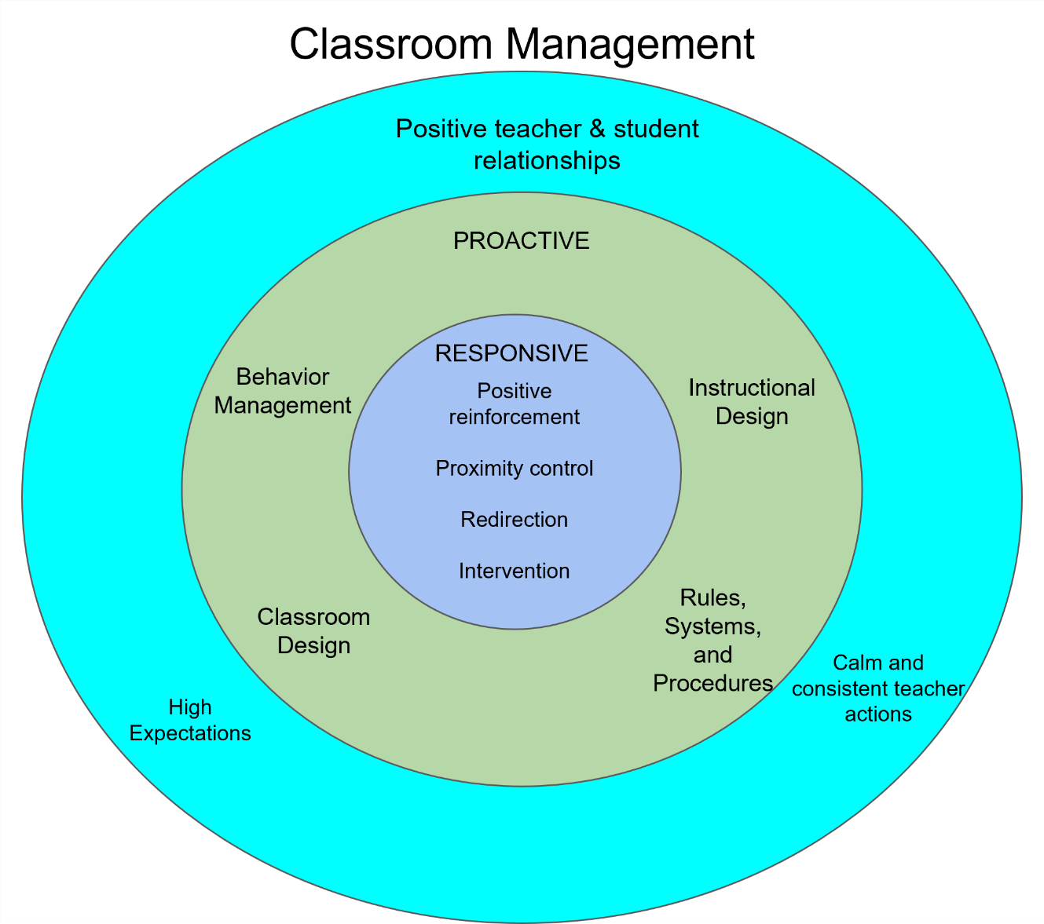

Practice 2: Definitions and Strategies

Classroom Management |  | The skills and techniques that teachers use to create a safe, organized, and positive learning environment.
 |  | Definition | Strategies
Positive Teacher & Student Relationships | High Expectations | Actions based on the belief that all students can achieve at high levels for academics and behavior. | Call on all students, ask higher-order questions, demand effort and engagement, encourage productive struggle
Positive Teacher & Student Relationships | Calm & Consistent Teacher Actions | Actions that ensure a safe learning environment and are implemented with regularity and fairness for all students. | Explicit and enforced rules and procedures, calm tone, procedures and routines
Proactive | Behavior Management | The processes or procedures that encourage students to engage in positive behavior that is essential for successful teaching and learning. | Radar, Be Seen, Do Not Talk Over
Proactive | Rules, Systems, & Procedures | The structures that set expectations for how a class operates and interacts. | How to enter and exit the classroom, how to access materials, Bellringer routines, reinforced and consistent classroom rules
Proactive | Instructional Design | The intentional development of engaging learning tasks that are relevant, interesting, and appropriately challenging to students | Connecting lessons to student interest, engaging and high-interest materials
Proactive | Classroom Design | The purposeful arrangement and physical layout of a classroom to achieve desired teaching and learning outcomes. | Space between desks for safe movement, teacher access to all students
Responsive | Positive Reinforcement | A response following a desired behavior that is intended to make the behavior more likely to occur in the future. | Noticing appropriate behavior
Responsive | Proximity Control | A strategy in which a teacher moves towards and stands near a student who may be off task as a reminder of expected behavior. | Moving closer to students who are talking, moving closer to students who are off task
Responsive | Redirection | The act of helping a student to focus on whatever your class is being asked to do at a given point in time. | Private correction, least intrusive strategies
Responsive | Intervention | A specific program or set of steps to address an academic or behavioral need. | Private correction, contracts

Basketball Questioning

In Basketball Questioning, the teacher moves questions and discussion responses around the room. The teacher poses a question that is answered initially by one student. Teacher then asks additional students to evaluate and/or add to the initial answer. In this way, ideas and responses are moved around the class and students build on one other another’s ideas and comments.

What are some examples of when should you use Basketball Questioning?

- There is more than one appropriate response to a question
- When you want to build on and connect ideas between students

