Student Guide – Answer Key

Lesson 2.08: Positive Framing | Motivate Effort and Excellence
Name:
Date:
Bellringer:
Think of a time when someone motivated you to do something you thought would be challenging. How did that motivation impact your efforts?
Answers will vary.

Intro to Challenge!
Concept Map (Answers will vary, some exemplar responses below)
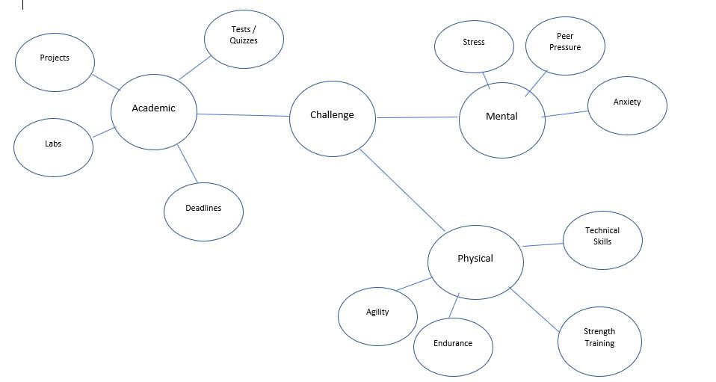

What does it mean to challenge someone?

Responses may include: to take part in a context or competition, to object or question the truth of something, etc.

How might a teacher challenge their students?

Responses may reference that a teacher might challenge students by extending a competition to inspire them or motivate them to do their best, etc.

Challenge Scenario
Read the scenario below, then answer the questions that follow.

Ms. Wood is reviewing a math problem with her class. A student, Kayla, answers.

Ms. Wood: What is the area of a rectangle with a long side measuring 12 inches and a short side measuring 10 inches?

Kayla: 120.

Ms. Wood: Yes, Kayla. Excellent. But 120 what? How would a mathematician say it?

Kayla: 120 inches squared.

Ms. Wood: Great job! Now you sound like a mathematician.

- How does Ms. Wood encourage Kayla to revise her initial solution, and what message do those words send?

Ms. Wood asks Kayla to revise her solution to give add the units by saying, “How would a mathematician say it?” When Kayla improves her response using more academic and rigorous language, Ms. Wood says, “now you sound like a mathematician.”

- What impact might do you think this interaction could have for Kayla?

Answers will vary but could include: Kayla will remember to add the units to her answers in the future, Kayla will feel inspired to do more math problems because she sounds like a mathematician, etc.

Notes on Challenge!
List the elements of an effective Challenge

- Inspires students: Exhort students to prove what they can do by building competition into the day.
- Maintains Economy of Language: Using fewer words helps students to focus on what they need to do to meet expectations and brings everyone back to the lesson as quickly as possible.
- Maintains Emotional Constancy: Again, it’s wise to use a neutral tone when delivering redirections of any kind.

Four Ways to Bring Challenge to Students
List the four ways to bring Challenge to students and provide a description.

Challenge Type | Description | Example
Self | Communicate that you believe in a student by challenging them to compete against themselves | “This sentence is good, but I think you can make it even better.”
Others | Inspire friendly competition by challenging your students to compete against each other | “The Blue Group is killing it. Hope everyone else brought their A game!”
Goals & Standards | Reference an external goal or standard to which students might strive | “When writing, we always strive for precision. Go back and see if you can be even more precise.”
The Clock | Encourage students to use every moment effectively | “Three minutes left. See how many verbs you can improve before the bell.”

Practice 1: Study the example and upgrade the nonexample
Read the different examples of Challenge provided by the teacher and record the examples in the chart above. Discuss as a class how this list aligns with the success criteria.

Responses may include reference to pushing students to prove what they can do by building competition, using economy of language, etc.

Upgrade the nonexample
Look at statements below that do not meet the success criteria. Work with a partner to identify how the statements do not meet the success criteria and adjust the statements to improve them.

Statement | Revision | Rationale
“You still haven’t used the technical terminology.” | Possible response: You’ve got the idea but let me hear you use the word “mitosis” in your answer. Can you do it?! | Response will vary based on revised statement, but responses should reference a change to more positive framing and challenging students to prove what they can do.
“Ms. Austin’s class is doing a much better job learning their math tables. This class needs to be more like them.” | Possible response: Ms. Austin said she didn’t think you guys could knock out your math tables faster than her class. Let’s show ‘em what we’ve got! | Response will vary based on revises statement, but responses should reference a change to more positive framing and challenging students to prove what they can do.

Practice 2: Creating Effective Challenge Statements
Plan a Challenge statement using the following scenarios. As you plan, ensure your statement:
- Inspires students
- Maintains Economy of Language
- Maintains Emotional Constancy

Scenario #1: Mr. Richardson’s sixth graders are doing a project on a scientist of their choice, which they will present to the class. He notices that Daria’s project includes basic information but lack details that would meet all of the assignment criteria and also make her project and presentation engaging. He wants to encourage and motivate his Daria.
Answers will vary.

Scenario #2: It is almost the end of the class period, and Mr. Richardson’s students still have many of their project materials out. The classroom needs to be cleaned up quickly as he prepares for his next class. How can Mr. Richardson motivate his students to best use their remaining time?
Answers will vary.

Practice 3: Delivering Your Challenge Statements
With a partner, take turns delivering your Challenge statements for the two scenarios above. As your partner delivers their Challenge statement, use the feedback rubric below to provide specific feedback to your partner on their alignment to the success criteria.

Feedback Rubric

 |  | Still Working On It. Provide Suggestions for Improvement. | You got it! Provide Evidence.
Inspires students: Exhort students to prove what they can do by building competition into the day. | Scenario 1: | Answers will vary. | Answers will vary.
 | Scenario 2: | Answers will vary. | Answers will vary.
Economy of Language: Use as few words as possible to focus students on what they need to do to meet expectations and bring everyone back to the lesson as quickly as possible. | Scenario 1: | Answers will vary. | Answers will vary.
 | Scenario 2: | Answers will vary. | Answers will vary.
Maintains Emotional Constancy: Use a neutral tone and facial expression when delivering redirections of any kind | Scenario 1: | Answers will vary. | Answers will vary.
 | Scenario 2: | Answers will vary. | Answers will vary.

