Student Guide – Answer Key

Lesson 2.12: A Well-Designed Classroom
Name:
Date:
Bellringer:
Choose either a classroom in which you find it easy to learn OR a classroom in which you find it difficult to learn. Describe the classroom in detail. Consider the following questions:
  - When you are at your desk, what can you see in this classroom?
  - How is the classroom arranged? How does the arrangement contribute to your (in)ability to learn?
  - What is the cultural environment of the classroom and what about the classroom contributes to this culture?

Answers will vary.

Introduction to a Well-Designed Classroom

Directions: Take notes on key ideas about classroom design as you watch the video.

Design Category | Key Ideas from the Video | Additional Ideas from Class Discussion
Furniture | Position furniture to allow the teacher to move easily and monitor all students; too much clutter makes movement and monitoring difficult; out of sight areas can promote behavior problems; access to each student helps provide independent support, reinforcement, feedback | Responses will vary
Materials | Access to materials supports positive behavior and engagement; sets up students for success; keep teacher materials out of reach  Balance signs, posters, miscellaneous objects; too little decoration can make a classroom feel cold, too much can be overstimulating | Responses will vary
Activities | Create settings for group and individual work, a place for students to settle if they are having a hard time, etc. | Responses will vary

Components of Effective Classroom Design
4 essential components of classroom design:
- Allows for smooth transitions
- Provides access to materials
- Limits noise and distractions
- Meets individual needs of students, such as:
  - Students who need to be close to the board
  - Students who need to be away from distractions
  - Students who need space for more frequent breaks
  - Students who need to be close to the teacher or sit with a buddy
  - Students who may have personal classroom aides
  - Students who need extra space for wheelchairs or other mobility supports

Analyze an Example

Directions: Review the classroom layout below and respond to the analysis questions.

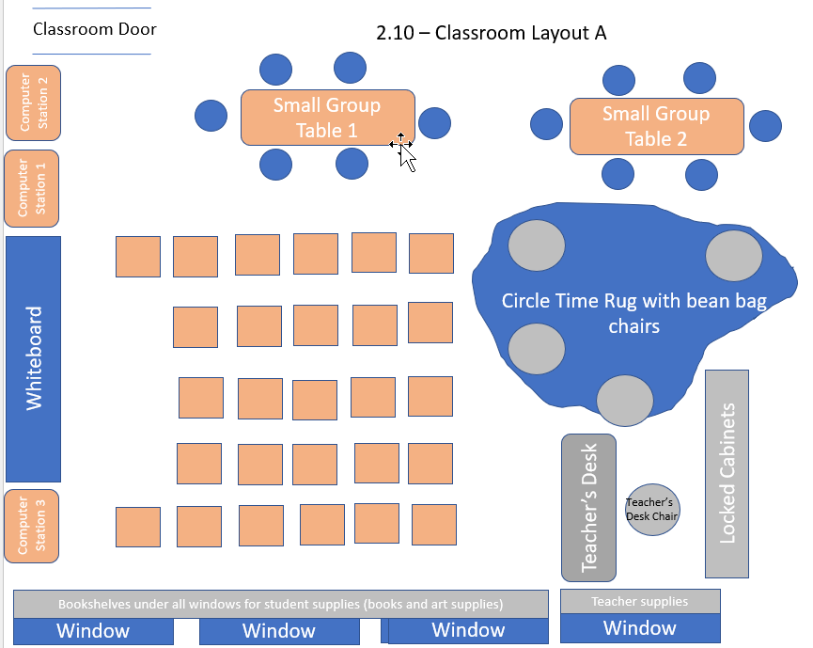

- How does the furniture arrangement encourage smooth transitions?
Desks are arranged so that they can easily be grouped and re-grouped, aisles are provided between desks and between desks and other work spaced, desks are arranged so that all students can see the teacher’s presentation space easily, areas are provided for small group work.

- How does the furniture arrangement provide easy access to materials?
There is a clear path from each desk to materials, materials are clearly organized into types with space for each type.

- How does the furniture arrangement limit noise and distractions?
Furniture is arranged so that students aren’t looking at each other during whole group activities, small group stations are placed away from individual workspaces, computer stations are against walls.

- How does material arrangement allow for smooth transitions?
Materials are in easily accessible and centralized locations, materials are arranged by type so students can quickly find what they need, teacher can easily transition from whiteboard space to other spaces, supply area under windows is spread out so students can access material.

- How does the layout contribute to a safe and orderly classroom?
There are clear paths between desks, to material storage, and to alternative workspaces.

Analyze a Non-Example

Directions: Review the classroom layout below circle problem areas. Explain each of the problems areas by writing a sentence near the circle that explains the problem.

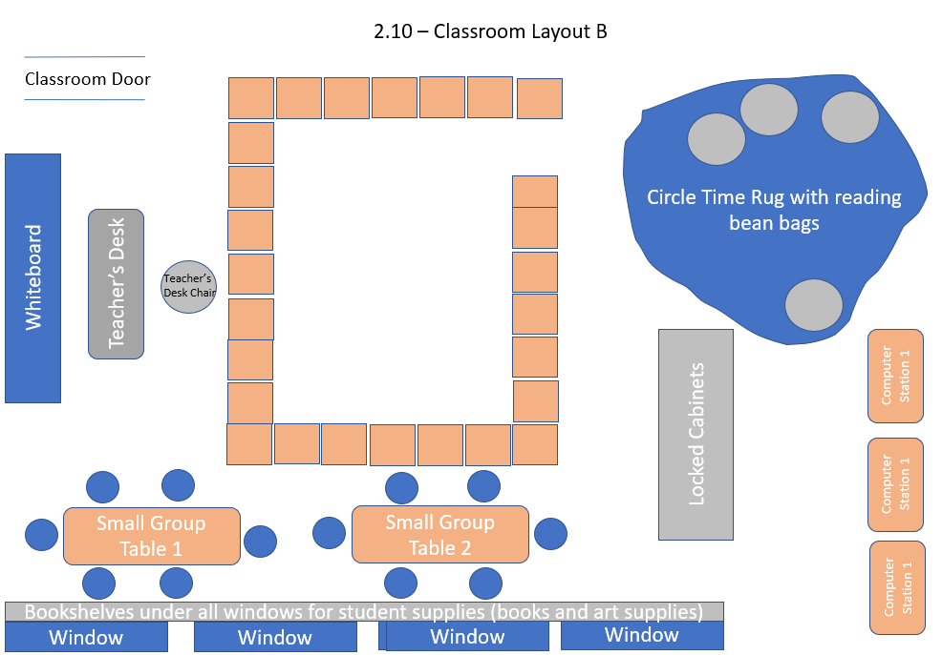

- Teacher’s Desk blocks the white board
- Teacher’s chair faces the white board instead of students so teacher can’t see students
- Teacher access to students is difficult since desks are so close together; only opening is on the far side from the teacher
- Student supplies are blocked by small group tables
- Computer stations are blocked by the locked cabinets so teacher can’t see what is happening
- Small group tables are too close to student desks – no aisles for teachers or students

