Student Guide

Lesson 2.13: A Well-Designed Classroom, Part II
Name:
Date:
Bellringer:
Review the classroom layout below. Identify and explain 2 strengths of the design and 2 opportunities for improvement by responding to the questions provided.

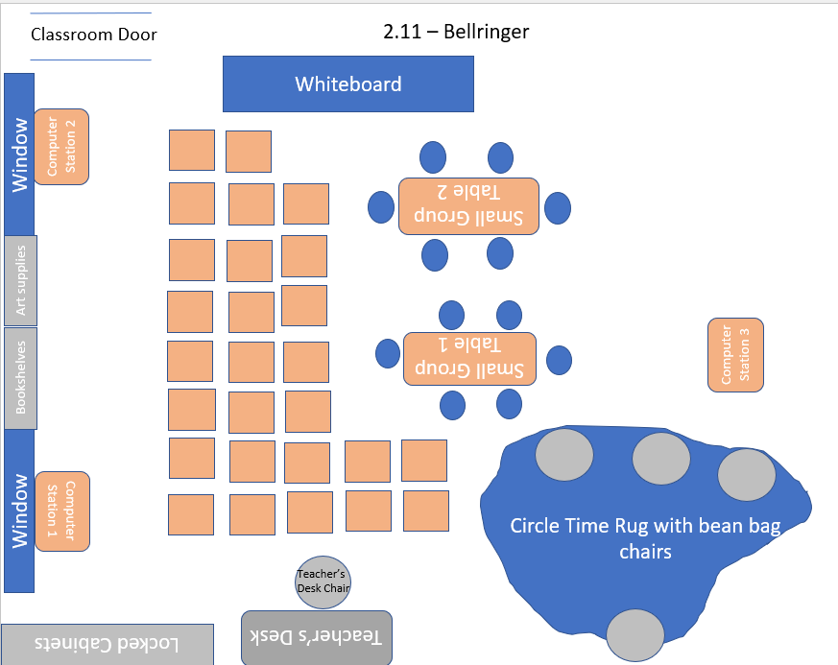

Strengths
- What is the strength?

Why is this a strength?

- What is the strength?

Why is this a strength?

Opportunities for Improvement
- What is the opportunity for improvement?

Why is this an opportunity for improvement?

What can the teacher do to improve this element?

- What is the opportunity for improvement?

Why is this an opportunity for improvement?

What can the teacher do to improve this element?

The Science of Classroom Design: Group Discussion Questions
- Review the classroom layouts. How does each align to best practices for classroom arrangement? Which classroom design are you likely to choose and why?

- Based on the positives and negatives for each color choice, what color(s) are you likely to include in your classroom design and why? What colors would you like to avoid and why?

- What additional factors will you consider as you design your classroom?

