Student Guide—Answer Key

Lesson 2.27: Classroom Management Plans
Name:
Date:
Bellringer:
- What is a classroom management plan?
A classroom management plan is a written plan that encompasses all aspects of classroom management including strategies for the development of positive relationships, proactive and responsive techniques for behavior management and intervention, physical classroom design, and classroom rules, systems, and procedures.

- Why do teachers need a classroom management plan?
A successful classroom management plan permits the cultivation and sustention of an effective learning environment.
Classroom Management Plan Template
Use this template to develop your Classroom Management Plan.

I. Classroom Rules (emphasizing simplicity, clarity, positive framing, and student ownership):
1. Follow directions quickly
2. Treat others with kindness
3. Talk at appropriate times and use appropriate voices.
4. Ensure that your work is just that, your work
Write the script that you will use to introduce the classroom rules to your students.
Today, we are going to talk about our classroom rules. Our first rule is “follow directions quickly.” This rule means that as soon as I give you an instruction and the signal to go, you must immediately follow those directions. It is important to follow rules quickly to minimize disruption to instruction and learning as well as maintain safety. Let’s practice! Class, when I say go, please quietly stand up, push in your chairs, and stand behind your desk. Go!

Rule 2 is “treat others with kindness.” This rule means that we should be respectful and kind to others by being friendly, considerate, and generous. When we are kind to others, we consider their feelings and consider the way we speak and act toward the person. It is important to treat others with kindness because it allows us to connect with other people and build meaningful and positive relationships. Let’s practice! You heard a student say something mean to the person beside you. How can you show kindness?

Rule 3 is “talk at appropriate times and use appropriate voices.” This rule means that you must raise your hand for permission to speak during instruction or wait for when the teacher gives you the okay to talk. It also means that when speaking inside, you need to use quiet voices. It is important to talk at appropriate times and use appropriate voices because this ensures everyone remains focused on instruction and learning. Let’s practice! You just thought of something related to the lesson that you want to share with your teacher and the class. What do you do?

Rule 4 is “ensure that your work is just that, your work.” This rule means that all the work you complete must come from you. We must ensure that we allow ourselves and our classmates the opportunity to practice and complete their own work. It is important to complete our own work because it allows the teacher to see what we know and what we may need more help with. If we get answers from a friend, the teacher can’t accurately tell what we truly know or don’t know. Let’s practice! I just gave you a math problem to complete. You start working, but you aren’t sure if you are completing the problems correctly, what do you do?

II. Classroom Procedures:
In the space below, describe your plan for managing classroom procedures.
Class Attention Signals | Teacher | Student
Class Attention Signals | 1, 2, 3, eyes on me! | Students immediately stop what they are doing and look at the teacher
Class Attention Signals | Class, Class | Students immediately stop what they are doing, look at the teacher, and say “yes, yes?”
Beginning of Class Routines
 | Teacher | Students
Entering the Room | Greet students at the door as they arrive | Students will immediately go to their assigned seats, hang their books bags on the back of the chair, and begin working on the morning work.
Starting Work | Explicitly explain the assignment and success criteria | Students will SLANT while the teacher is providing directions for the assignment and immediately begin working when instructed by the teacher.
Arriving Tardy | Greet the student as they arrive and provide necessary instructions | The student will place their tardy slip in the “notes for teacher basket” and immediately go to their assigned seat to put their materials away. The student will wait for further instructions from the teacher.
Accessing Materials | Label areas where extra materials are in the room. The teacher will inform students when they are allowed to access those materials. | Students must ask the teacher for permission to get materials. Once granted permission, students may access the designed basket.
Other
Managing Work
 | Teacher | Students
Receiving & Submitting Assignments | Place a “completed work basket” on their desk and instruct students when it is time to submit their work. | Students will place completed work in the “completed work basket” when instructed by the teacher.
Managing Independent Work | Develop independent work agreements with students to increase buy-in. Agreements should be around focusing and thinking about the task at hand, hands up for questions, completing your own work, using appropriate voices, etc. | Students will think about the type of environment in which they work best. They will use this to help develop independent work agreements.
Managing Group Work | Develop group work agreements with students to increase buy-in. Agreements should be around focusing and thinking about the task at hand, listening and valuing each other’s opinions, using appropriate voices, etc. | Students will individually write two things that need to be in place for them to feel safe or to feel that they can work or learn  while in groups. They will use this to help develop group work agreements.
Requesting Assistance | Frequently scan the room to look for students who have their hand up for assistance | Students will raise their hand to ask for help.
Transitions | Secure students’ attention, explain the procedure, prepare students for the signal to start, initiate the transition, and observe. | Students will focus on the teacher while the teacher explains the procedure, watch for the signal to start, transition quickly and quietly when asked.
Other
End of Class Routines
 | Teacher | Students
Ending Instruction | Secure student’s attention, explain the procedure for cleaning up materials, prepare students for the signal to start, initiate the ending routine, and observe. | Students will focus on the teacher while the teacher explains the procedure, watch for the signal to start, clean up quickly and quietly.
Returning Materials | Explicitly teach where materials are located and how to return materials. Select designated students at each table group to be material managers. | Designated students for each table group will return materials to the correct location when given the signal.
Giving Feedback | Circulate the room while students are working to provide timely, specific, and actionable feedback. Feedback will also be provided on assignments and during one-on-one conferences with students. | Students will focus on the teacher when the teacher is giving feedback, ask questions to clarify, and use feedback to make revisions, improve performance, etc.
Dismissal | Secure student’s attention, explain the procedure for packing up for the day, prepare students for the signal to start, initiate the dismissal routine, and observe. | Students will focus on the teacher while the teacher explains the dismissal procedure, watch for the signal to start, pack up quickly and quietly.
Other

III. Classroom Layout:
In the space below, draw your classroom layout. Then, explain how your layout accounts for smooth transitions, whole group discussion, small group work, and ease of access to materials.
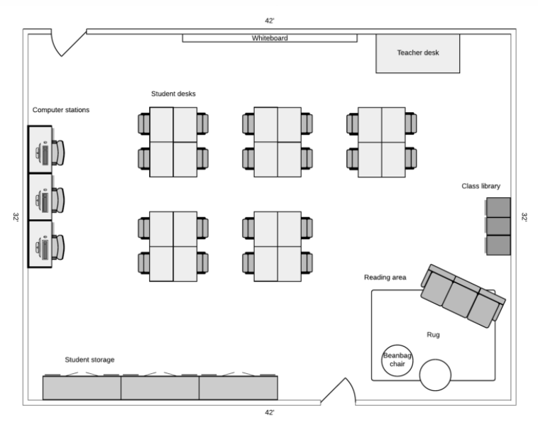
This layout offers plenty of space for students to move around to different parts of the room (e.g., class library, computer stations, student storage). Small group work is facilitated by students sitting in groups and the teacher can easily move around the classroom to each group. For whole group discussion, the desks can be moved without too much work to make a circle shape, or students can have the ability to simply move their chairs to make a class discussion more engaging. Finally, students have easy access to materials like books, computers, their personal items, and the teacher’s desk and whiteboard in the event that they need any additional supports.

Application of Classroom Management: Behavior Management, Intervention, & Positive Relationships
Answer the following questions as you apply your knowledge of implementing effective classroom management. Keep in mind your grade level and content context as you respond.
- How does your classroom layout support strategies like Radar and Pastore’s Perch?
I will be able to give clear, observable directions and visually scan the room from various places throughout the classroom; I will also be able to position myself to be easily seen by students throughout the room. The placement of my desk in the corner of the classroom reinforces the use of Pastore’s Perch since I can see all students from the corner of the room.

- How will your rules support consistency and high expectations for your students?
I will use my rules to support consistency and high expectations for students by:
- Establishing classroom routines and procedures
- Maintaining and equitably enforcing classroom rules for all
- Displaying visuals that remind students of classroom expectations

- Provide an example of a situation in which you would use each register.
I will use a formal register when giving directions and getting students’ attention. I will use a casual register teaching content like normal. I will use the urgent register during emergencies.

- Describe how you will build relationships with students in the first week of school. Include at least two ideas.
To build relationships with students, I will:
- Learn and call students by their preferred name, ensuring to pronounce it correctly.
- Learn about students’ interests, hobbies, and aspirations by having students write me a letter on the first day of school.
- Accept and celebrate students’ uniqueness and listen without judgment.

- A student in your class continues to district his peers, even after you have given him non-verbal cues and redirected his behavior early when possible. How will you manage this student’s behavior and support him in correcting the behavior? What strategies might you use and how will you use them?
To manage student privacy, I will offer additional private correction to the student. I will describe what he is supposed to do (as opposed to what not to do) in order to meet expectations, use a warm or neutral tone, and start and end the interaction with a pair of observable directions. I will continue to build rapport with the student so that we establish mutual trust and respect. With the student, we may come up with a special non-verbal cue or hand signal that only he and I understand so that he knows to adjust his behavior in a private way.

Classroom Management Plan Feedback Rubric
 | 1  Grows  Still Working On It  Suggestions for Improvement | 2  Success Criteria  You Got It!  Meeting Expectations | 3  Glows  Exceeding Success Criteria  Provide Evidence
Classroom Rules |  | - Rules are few in number
Classroom Rules |  | - Rules are written expectations for classroom behavior
Classroom Rules |  | - Rules are easily understandable
Classroom Rules |  | - Rules are stated positively
Classroom Rules |  | - Rules are manageable, are easily monitored, and do not require excessive time to hold students accountable
Classroom Procedures |  | - Classroom procedures teach students the simplest right way to do something using consistent cues so that it is easy for the teacher to recall and for students to replicate it with regularity
Classroom Procedures |  | - Classroom procedures are double planned, accounting for what the teacher and students will do at every step as well as which materials will be used and by whom
Classroom Procedures |  | - Classroom procedures minimize teacher narration to keep students focused on the most important points or steps of a procedure so their trains of thought can stay relatively uninterrupted
Classroom Procedures |  | - Classroom procedures account for beginning and end of class routines as well as work management
Classroom Layout |  | - Classroom layout encourages smooth transitions
Classroom Layout |  | - Classroom layout provides easy access to materials
Classroom Layout |  | - Classroom layout limits noise and distractions
Classroom Layout |  | - Classroom layout contributes to a safe and orderly classroom
Behavior Management, Intervention, & Positive Relationships |  | - Behavior management and interventions are proactive and allow the teacher to see the classroom well and provide positive reinforcement
Behavior Management, Intervention, & Positive Relationships |  | - Behavior management is responsive and least invasive, employing both verbal and non-verbal interventions
Behavior Management, Intervention, & Positive Relationships |  | - Behavior management, interventions, and positive relationships are developed and implemented with emotional constancy, using a warm or neutral tone, with brevity, and privately to allow the teacher to keep teaching and students to keep learning
Behavior Management, Intervention, & Positive Relationships |  | - Behavior management, interventions, and positive relationships are targeted and positive, build students’ intrinsic and extrinsic motivations, and employ a reward system while maintaining high expectations
Behavior Management, Intervention, & Positive Relationships |  | - Positive relationships are developed by building trust and rapport

