Student Guide – Answer Key

Lesson 3.11: Learning about Students Using Quantitative and Qualitative Data
Name:
Date:
Bellringer:
Read the scenario below and respond to the question.
A new student (Tom) has enrolled in Ms. G’s seventh grade class. He used to attend a different school in the same school district. He has been quiet since he joined the class.
What are some strategies that Ms. G can use to find out more about Tom? Think back to our lesson on building relationships with students to develop your list.

Introduction to Learning about Students Using Qualitative and Quantitative Data
Type of Data | Definition | Questions Answered | Examples
Quantitative Data
Qualitative Data
Why should teachers collect both types of data?

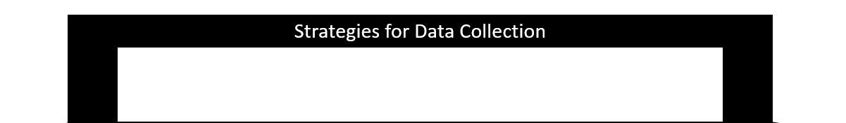
Collecting Quantitative and Qualitative Data about Students
Strategy | Type of Data Collected

Learner Profile

Practice: Collecting Quantitative and Qualitative Data about Students
Student Name: __________________
Teacher Name: __________________
Learner Profile – Template 2
Favorite Subject in School:

Least Favorite Subject in School:

Something that Makes This Student Proud (Academic or Non-Academic):

Student Learning Preferences:
☐ Likes to learn by working alone
☐ Likes to learn by working with others
☐ Learns best in silence
☐ Learns best with some background noise
☐ Likes to stay in one place while learning
☐ Likes to move around while learning
☐ Likes to ask peers for help
☐ Likes to ask the teacher for help
When this student is given an assignment, they

When this student needs help, they

This student’s major outside-of-school commitments are:

