Student Guide – Answer Key

Lesson 3.11: Learning about Students Using Quantitative and Qualitative Data
Name:
Date:
Bellringer:
Read the scenario below and respond to the question.
A new student (Tom) has enrolled in Ms. G’s seventh grade class. He used to attend a different school in the same school district. He has been quiet since he joined the class.
What are some strategies that Ms. G can use to find out more about Tom? Think back to our lesson on building relationships with students to develop your list.
- Review assignments to learn more about the student.
- Talk to the student!
- Access his grades and other academic data!
- Talk to the student’s previous teachers, coaches, club sponsors, etc.
- Do classroom ice-breaker activities!

Introduction to Learning about Students Using Qualitative and Quantitative Data
Type of Data | Definition | Questions Answered | Examples
Quantitative Data | Data that can be counted and expressed in numbers | How many?  How often? | Test scores and grades  Number of times student has switched schools
Qualitative Data | Data that are expressed in words | Why?  How? | Name of a student’s favorite book  Student’s preferred learning activities
Why should teachers collect both types of data?
Because they each tell us something different. With both types of data, we’re more likely to see the whole picture about a student.

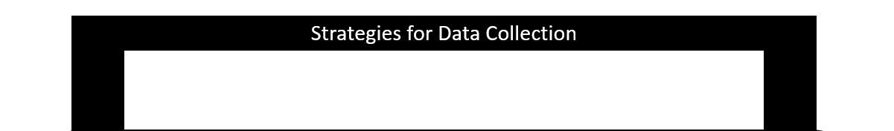
Collecting Quantitative and Qualitative Data about Students
Strategy | Type of Data Collected
Talk to students’ previous or current teachers | Quantitative and Qualitative
Review student records | Quantitative and Qualitative
Give assignments that ask students to share more about themselves | Qualitative
Send home a survey for students’ families to complete | Quantitative and Qualitative
Have informal conversations and ask questions | Qualitative
Incorporate icebreakers into your instruction when possible | Quantitative and Qualitative
Administer a student perception survey | Qualitative

Learner Profile | A complete picture of a student’s learning preferences, strengths, and challenges

Practice: Collecting Quantitative and Qualitative Data about Students
Student Name: Gina
Teacher Name: Mr. Our-Class
Learner Profile – Template 2
Favorite Subject in School: Science (Gina seems to like Spanish too.)
Least Favorite Subject in School: Social studies (Gina’s social studies grades have gotten worse over time.)
Something that Makes This Student Proud (Academic or Non-Academic):
Gina used to struggle in science in middle school. She’s been improving her performance over time, and science is her favorite subject. It’s also an important one for her because she wants to be a doctor and knows that science will be important for that pursuit.
Student Learning Preferences:
X Likes to learn by working alone.
X Like to learn by working with others.
☐ Learns best in silence.
☐ Learns best with some background noise.
☐ Likes to stay in one place while learning.
☐ Likes to move around while learning.
X Likes to ask peers for help.
☐ Likes to ask the teacher for help.
When this student is given an assignment, they ___________________________________________
_________________________________________________________________________________________________________________________________________________________________________________________________________________________________________________________
When this student needs help, they want to get the help as soon as possible so that they don’t get further confused. Gina doesn’t like to ask for help in a public setting, so she prefers asking a fellow student quietly. Gina doesn’t always ask for help when she needs it.
This student’s major outside-of-school commitments are taking care of her younger brothers while her mom works.

