Unit 4: The Science of Learning

Lesson 4.01: The Simple Memory Model

Lesson at Glance
Warm-Up (7 mins)  - Bellringer | Instruction (20 mins)  - Introduction to the simple memory model | Application (18 mins)  - Small Group Practice: Scenarios and Discussion (13 min)  - Exit Ticket (5 min)

TEKS | 4 | The student understands the learner and the learning process. The student is expected to:  - relate and implement principles and theories of human development to teaching and training situations;  - relate and implement principles and theories about the learning process to teaching and training situations;
TEKS | 6 | The student plans and develops effective instruction. The student is expected to:  - describe principles and theories that impact instructional planning;
Objectives | - Understand the simple memory model and its role in learning.  - Apply the simple memory model to identify why learning is or is not happening in real-life and classroom situations.
Rationale/  Summary | Dan Willingham’s simple memory model depicts the cognitive process for how humans learn – specifically how new content becomes part of a long-term memory. An understanding of the model and related practices can support effective instruction.
Formative Assessment and Exemplar Response | Use the blank template of the simple memory model of learning to annotate the process for new ideas becoming part of part of long-term memory.  See Exit Ticket Answer Key for Exemplar Response.
Vocabulary | Environment |  | Your surroundings that can be experienced through your senses which includes things happening around you that you can hear, see, read, touch, smell, taste
Vocabulary | Attention |  | The process of selectively concentrating on discreet information in the environment while ignoring the other information in the environment.
Vocabulary | Working Memory |  | Temporary memory that must be constantly activated to maintain
Vocabulary | Learning |  | A relatively permanent change in knowledge or behavior as a result of experience
Vocabulary | Long-term Memory |  | Stored information that can be retrieved even after long periods of inactivity
Vocabulary | Remembering |  | The process of retrieving a memory (something you learned) and bringing it back into your working memory
Vocabulary | Forgetting |  | Unsuccessfully storing a memory or idea

Est Time | Instructional Activities (including formative assessments) | Materials
5 mins | Bellringer: Think about how you tie your shoelaces. You likely learned to tie your shoes long ago and probably do it often without giving it a second thought. But how did you learn it? Based on what you anticipate about how learning works, use the chart in your student guide to create a list of some of the steps that you would take to help a child to learn to tie their shoelaces.  S: (Students draft potential steps in the student guide) | Student Guide  PPT
2 mins | T: Let’s review your bellringer. What are some of the steps that you would take to help a child learn to tie their shoelaces?  S: Answers will vary.  T: (As students offer steps that they would take, look for ideas that anticipate principles of learning discussed in the course – e.g., goal setting, using sequenced examples, thinking aloud, modeling, practice with feedback, encouraging effort, repeated independent practice, etc.) | Student Guide  PPT
20 mins | Introduction to the simple memory model  T: Today we are going to learn how we learn. In the bellringer, we imagined how we would teach a child to tie their shoelaces. In that example, we talked about the things we would say and do and the things the child would say and do to learn.  T: In that scenario, the child’s brain had to be fully engaged, paying attention to what you did, how you correct their mistakes, adjusting based on that feedback, and practicing until they got it right.  T: All learning happens right up here (point to your head). Learning is a cognitive process – meaning that it happens in the brain.  T: We are going to look at a simple memory model for how we learn. This model is also in your student guide.  T: To teach this content, I am going to use an annotated diagram which means I’ll walk through each of the components of the simple memory model step-by-step and you will follow along, annotating on your diagram and taking notes in the notes table in your student guide.  Note: The ppt is laid out to show a visual representation of the big ideas in the memory model. This demonstration might best be done with a drawing or displayed version of the model on a white board or on a smartboard that can be annotated as you sequentially explain the model.  Environment – Key Ideas  T: Please turn to the diagram for annotating and notes page in your student guide and following along as I walk through the model, recording the annotation and notes.  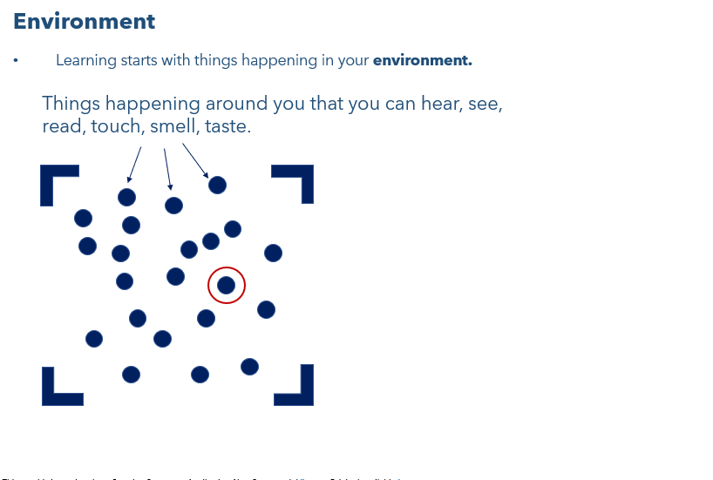  T: Learning starts with things happening in your environment  T: Each little dot in the graphic represents something in your environment - things happening or existing around you. (Provide examples in your current environment – walls, chairs, desks, students, lights, computers, etc.).  S: (Draw on diagram and record notes in the student guide.)  T: Why aren’t you learning from what is happening in Ms. _____ class down the hall?  S: We aren’t in her class. We can’t experience what is happening in that environment so there is no way we could be learning from her.  T: You can’t learn anything from what is happening in the class down the hall. You are not in that environment - you learn by sensing things in this classroom, in this environment ….for instance the words on poster on the wall and or what I am saying right now.  Attention – Key Ideas  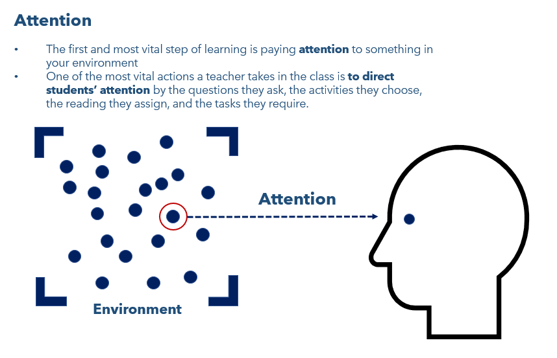  T: The first and most vital step of learning is paying attention to something in your environment.  S: (Draw on diagram and record notes in the student guide.)  T: Stop and pay attention. What can you hear in this current environment (take answers via raised hands)?  S: Examples: Computer fan, walking in the hallway, wind outside, etc.  T: Now turn your attention to what you can see. (Ask students to do a quick - 15 seconds - turn and talk with their partner and share things they see in their environment).  T: What are some things that you see in your environment?  S: Other students, white board, desk, pencils, doors, etc.  T: Now turn your attention to _____ (Here you want to highlight a specific bit of text on the wall - perhaps your classroom rules. Pick something specific that focuses student attention on the words on the wall).  T: Tell me what you notice about this (solicit answers via raised hands).  S: Answers here will vary but the students should be able read the actual text on the wall you referenced.  T: Notice when I drew your attention to _____, you all were likely able to quickly read that text because of the direction I gave to you to focus your attention on this.  T: One of the most important actions a teacher takes in the class is to direct student’s attention to important content by the questions they ask, the activities they choose, the readings they assign, and the tasks they require.  T: The learner must pay attention to the important content to be learned and ignore other information in the environment. You are learning new content in this lesson. What tools am I using to draw your attention to the most important content?  S: A diagram, a note-taking guide, an ordered explanation, routines, and rules so that the classroom is calm, and we can focus on what we are learning.  T: What would happen to in your brain if suddenly you heard the fire alarm go off?  S: We would be distracted – our attention would shift to the fire alarm, and we wouldn’t be learning or thinking the simple memory model.  Working Memory - Key Ideas  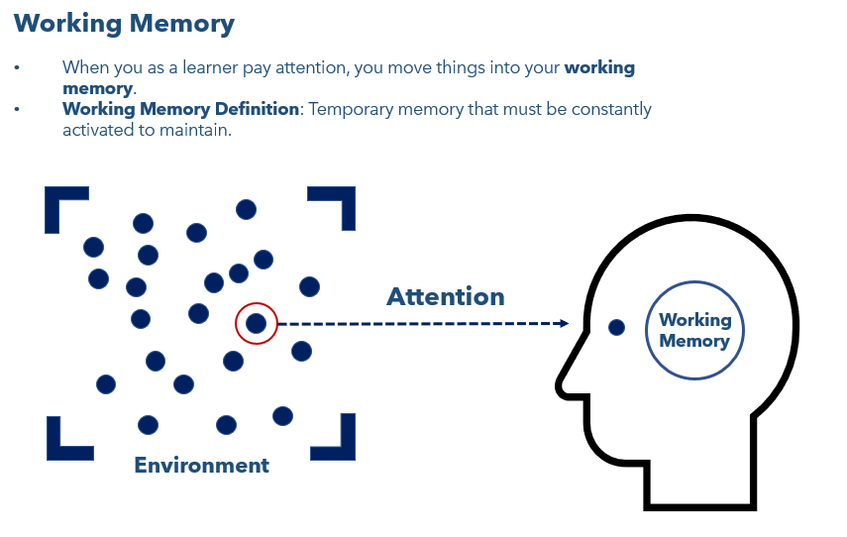  T: When you as a learner pay attention, you move things into your working memory.  T: Working Memory is temporary memory that must be constantly activated to maintain.  S: (Draw on diagram and record notes in the student guide.)  T: The working memory is where you wrestle with ideas and consciously make sense of them. I use the term wrestle, because it often takes effort to think about things in your working memory and part of teaching is getting students’ working memory really engaged by assigning meaningful tasks, asking good questions, exploring examples, and structuring practice.  T: The more a learner spends time attending to the content and thinking about it in the working memory, the more likely they will learn the content.  Learning - Key Ideas  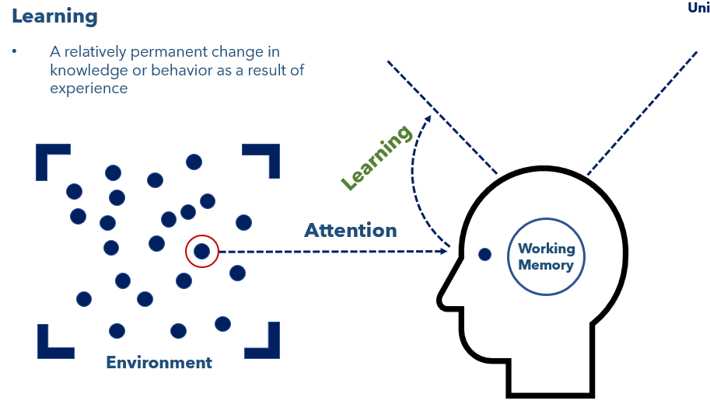  T: This is the simplest way to answer the main question of how humans learn: By paying attention to something in your environment and thinking about it in your working memory. You use your working memory when you see examples and non-examples, discuss ideas, ask questions, practice skills, correct your mistakes, and update your understanding. Right now, you are taking notes to help learn this new material.  T: Through this process, you can eventually learn the idea or content.  T: Learning is a relatively permanent change in knowledge or behavior as a result of experience.  S: (Draw on diagram and record notes in the student guide.)  T: Think back to the bell ringer about teaching a child to tie their shoelaces. How are the child’s attention and working memory helping them learn?  S: The child must pay attention to what you show them. They must think about it and practice the steps of tying your shoelaces.  T: Will they learn to tie their shoes immediately?  S: No – it’ll take practice and more teaching, probably over several days.  T: When you learn something, you move something you’ve thought about and practiced a lot in your working memory into your long-term memory.  T: Let’s think about what is happening right now in your brains. Your attention is on the most important content. We are using discussion and notetaking to help you think about and process this information.  How much of this do you think you’ll remember tomorrow? In one week? In one year?  S: We will remember some of what we are learning, but maybe not all of it.  T: How else can we make this information stick?  S: Practicing it, applying it a lot. Using it.  T: Learning something requires you to recall the information often and experience it multiple times to move it into long-term memory.  Long-Term Memory - Key Ideas  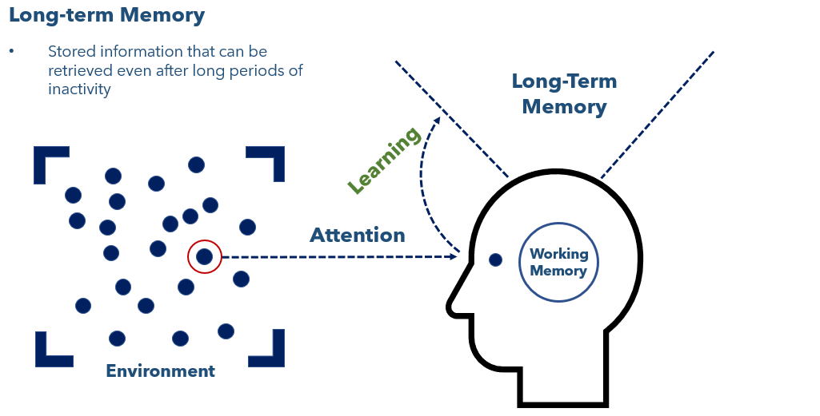  T: Long-term memory is stored information that can be retrieved even after long periods of inactivity.  T: The goal of teaching is to make permanent changes to students’ long-term memory.  T: Let’s test our long-term memory. What is 5 x 4?  S: 20  T: Right. You pulled that simple fact from your long-term memory. That retrieval is called remembering. Why do multiplication facts live in your long-term memory?  Remembering - Key Ideas  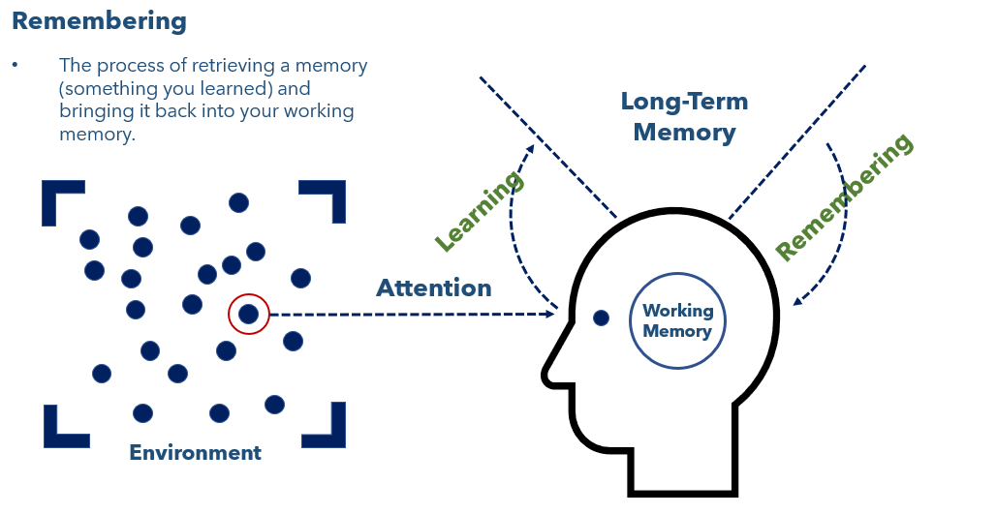  T: Remembering is the process of bringing ideas from your long-term memory into your working memory.  S: (Draw on diagram and record notes in the student guide.)  T: So how does information move into long term memory? When students practice a skill often and over time, explore examples and non-examples, answer challenging questions, write about a subject, recall information, and test their understanding, ideas have a much better chance of moving into long term memory.  T: This is why multiple opportunities to practice with feedback over time is so important to learning. You need to spend a lot of time thinking about the content to deeply understand it and fix it permanently in your long-term memory.  Forgetting  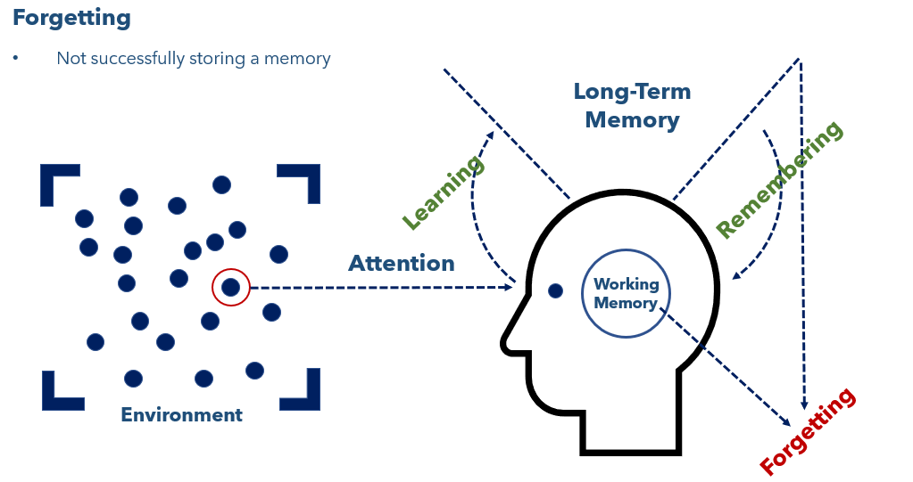  T: Finally, what is forgetting?  S: Not successfully storing a memory, concept, or idea (or an inability to retrieve it when needed).  T: Ideas that are not thought about or practiced enough in the working memory never make it to long-term memory. Additionally, memories can be hard or impossible to retrieve from long-term memory if they have not been regularly accessed after you first learned them.  T: Now let’s turn and talk to describe how the learning process works. You can use your diagram.  S: (Students turn and talk)  T: (Call on individual students to describe the process, asking students to build on to each other’s explanations.) | Student Guide  PPT
13 mins | Small Group Practice: Scenarios and Discussion  T: (Move students into groups of three or four.)  T: Let’s explore some examples and nonexamples of learning using the simple memory model.  T: On your student guide, you will see 4 scenarios. For the first 4 minutes, read each scenario individually and record why learning is or is not happening. After 4 minutes, I will ask you to discuss each scenario as a group, come to a consensus, and then we will share our answers with the whole class.  S: (Move into groups. Read and write in student guide).  T: (After 4 minutes, direct students to discuss their thinking for 3 minutes coming to consensus on the answer for each scenario.)  T: (Go through each example calling on different groups to share their reasoning. Use answer key to guide students to the correct answer). | Student Guide  PPT
5 mins | Exit Ticket  S: (Complete exit ticket.) | Exit Ticket

