Student Guide – Answer Key

Lesson 4.01: The Simple Memory Model
Name:
Date:
Bellringer:
Think about how you tie your shoelaces. You likely learned to tie your shoes long ago and probably do it often without giving it a second thought. But how did you learn it? Based on what you anticipate about how learning works, use the chart in below to create a list of some of the steps that you would take to help a child to learn to tie their shoelaces.
Step to teach a child to tie their shoelaces | Who takes the step  (either you or the child or both together)
Show the child exactly what they are going to learn by tying your shoelaces once as a model. | You (the teacher)
Have the student sit side-by-side with you with, both with your shoes untied. | Both
Demonstrate each step tying your shoelaces slowly, one at a time. | You (the teacher)
Have the child do just what you are doing along each step. | Child
If the child struggles with a step, show them how to do it on their own shoe. Then have them try again. | Both
Praise the child for their effort to learn. Tell them that it is okay if takes some time learn. | You (the teacher)
After the child has gone through the process, have them start over intervening to support them as needed. | You (the teacher)
Have the child practice with your help over the next several days and weeks, removing your support as they get better at completing the task. | Both

The Simple Learning Model – Diagram for Annotation


Completed Version:
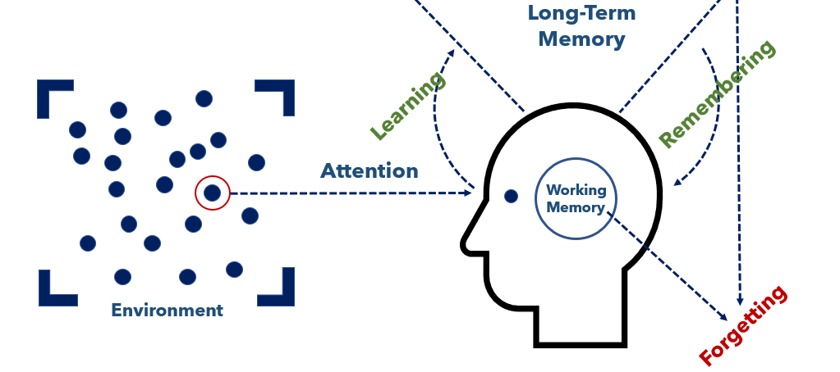
The Simple Learning Model – Student Notes Chart
Simple Memory Model Component | Notes
Environment
Attention
Working Memory
Learning
Remembering
Forgetting

Small Group Practice: Scenarios and Discussion
Scenario #1 | Use the simple memory model to indicate why learning is or is not happening in the scenario.
John is trying to read in a room with the TV on very loud. He keeps reading and re-reading the paragraph he is on without understanding it. | Learning is not happening because John can’t understand the book because the TV is distracting his attention. He is unable to focus on the words and their meaning in his working memory.

Scenario #2 | Use the simple memory model to indicate why learning is or is not happening in the scenario.
Marisol sits at the back of the class. She can’t see the math problem on the white board that the teacher is demonstrating because she needs glasses. | Learning is not happening because Marisol cannot experience fully her environment because she can’t see the white board.

Scenario #3 | Use the simple memory model to indicate why learning is or is not happening in the scenario.
Clyde wants to learn how to make a paper airplane. His friend does it quickly while Clyde watches. When Clyde tries it, he is unable to make the paper airplane. | Learning is not happening because Clyde didn’t spend enough time thinking about and practicing the steps to making a paper airplane in his working-memory. The process did not get stored in his long-term memory.

Scenario #4 | Use the simple memory model to indicate why learning is or is not happening in the scenario.
Sheila is trying to learn the lyrics to her favorite song that she is going to sing in a choir concert. While her friend drives on a road trip, she listens to it a dozen times and writes the lyrics out in her notebook as she listens. She sings along using her notebook. By the end of the trip, she is singing along with all the lyrics without her notes. | Learning is happening because Sheila had the lyrics to the song in her working memory many times – with multiple chances to hear the song, write the lyrics down, sing along, and commit them to memory.

