Unit 4: The Science of Learning

Lesson 4.02: Science of Learning Principles

Lesson at Glance
Warm-Up (5 mins)  - Bellringer | Instruction (35 mins)  - Science of Learning Principles Introduction (5 min)  - Jigsaw “Expert” Group (10 min)  - Jigsaw “Learning” Group (12 min)  - Jigsaw Debrief (8 min) | Application (5 mins)  - Exit Ticket

TEKS | 4 | The student understands the learner and the learning process. The student is expected to:  - relate and implement principles and theories of human development to teaching and training situations;  - relate and implement principles and theories about the learning process to teaching and training situations
TEKS | 6 | The student plans and develops effective instruction. The student is expected to:  - describe principles and theories that impact instructional planning
Objectives | - Identify five science of learning principles to guide teaching and learning and explain how they are connected to the simple memory model
Rationale/  Summary | A knowledge of the science of learning principles will provide a framework – based on cognitive science – to guide teaching and instructional decision-making.  - Principle 1: Learning requires attending to the most important content.  - Principle 2: Learning builds on prior knowledge.  - Principle 3: Too much information at once can interfere with learning.  - Principle 4: Learning requires cognitive engagement and should be effortful.  - Principle 5: Practice and feedback are essential to move ideas permanently into long-term memory.
Formative Assessment and Exemplar Response | Synopsize the 5 science of learning principles for teaching and learning by filling in the blanks.  - Teachers must help students _____________ to the most important content, meaning they must focus not on simple surface level information, but the how and why of the content – the deeper meaning.  - _________ can occur when too much information comes at students too fast, and the working memory can’t hold all of it at once.  - __________ is information or context a learner already has about a topic before they learn new information.  - _________________ engagement means that students use their brains during the entire lesson to engage in effortful thinking focused on making meaning.  - After students are taught a concept, idea, or skill they need to __________ that concept, idea, skill and receive feedback to help them strengthen their understanding.  - Attend  - Overload  - Prior knowledge  - Cognitive  - Practice
Vocabulary | Attending |  | Focusing on a specific aspect of the environment. In a lesson, focusing on the important content to be learned.
Vocabulary | Prior knowledge |  | Information or context a learner already has about a topic before they learn new information
Vocabulary | Cognitive overload |  | Failure to learn because too much information comes at students too fast, and the working memory can’t hold all of it at once.
Vocabulary | Cognitive engagement |  | When students use their brains in the classroom – bringing important ideas into their working memory by being asked questions and completing tasks that make them think hard about a topic and make meaning.
Vocabulary | Practice with feedback |  | Practice: Trying a skill or task, especially one you haven’t yet mastered, in order to improve your performance.  Feedback: Giving students information about their performance during practice with the purpose of improving student performance.

Est Time | Instructional Activities (including formative assessments) | Materials
5 mins | Bellringer:  Quick Write: Think of something you have learned that you now know really well. It could be a non-academic skill (like a game, activity, musical instrument, or sport) or an academic skill (like operating with fractions or citing evidence in your writing).  What steps did you take to move from a novice (not knowing it well) to an expert (knowing it inside and out)?  T: (Solicit a few responses from the class drawing connections to five principles when appropriate). | Student Guide  PPT
5 mins | Science of Learning Principles - Introduction  T: Yesterday we discussed the simple memory model that describes how we learn. (Display model on the overhead)  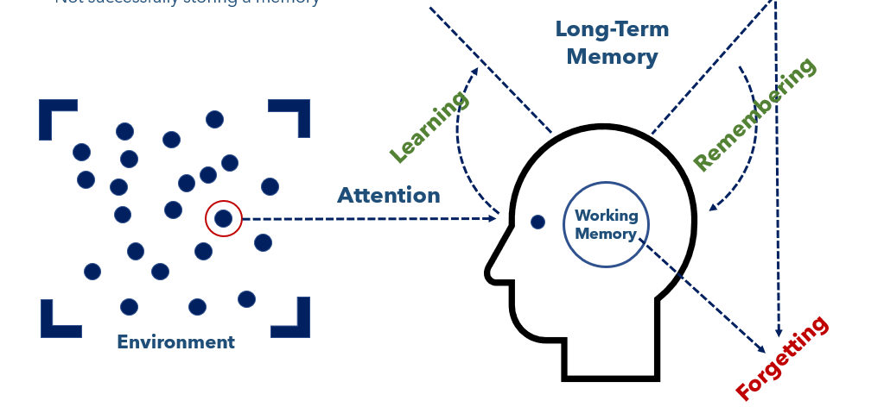  T: Today we are going to discuss five principles for learning that are related to the simple memory model of how we learn.  T: These principles, when used effectively, help students learn and can help us understand how to best teach so students can learn most effectively.  T: Yesterday’s activity used an annotated diagram, where I wrote and explained the model step-by-step while you took notes and drew the diagram with me.  T: To learn this new material today, we are going to engage in Jigsaw. You will start in groups where you will learn to be an “expert” around a topic – in this case one of the five science of learning principles.  T: After you work with your “expert” group, I will send you to a “learning” group with members from each of the five expert groups. There you will teach each other what you learned.  T: Finally, we will share out with the whole group about what we learned to check for understanding.  T: First we will establish our “learning” groups.  T: (Direct students to create groups of 5 or 6 with students sitting close to them.) | Student Guide  PPT
10 mins | Science of Learning Principles Jigsaw - Expert Groups  T: Within your learning group, count off by fives. If you have a group of 6, the last person can choose any number between 1 and 5.  S: (Students count off by fives within learning groups.)  T: (Direct students into five expert groups around the room, one for each of the 5 principles, ones going with principle 1, twos with principle 2, etc.)  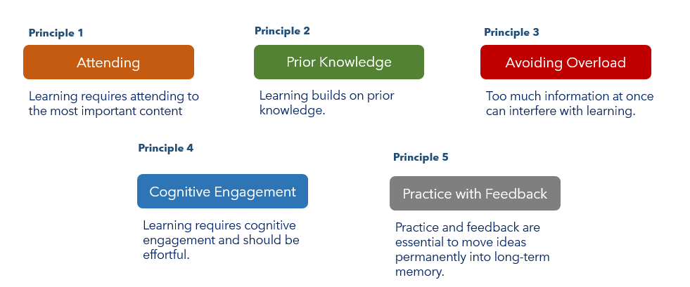  S: (Students move to their “expert” groups with their student guides.)  T: Turn to your student guide and read the descriptions and examples of your principle.  S: (Students read the materials in the student guide for their principle – this will likely take 3 or 4 minutes.)  T: Now use the graphic organizer to discuss the principle and prepare to teach your “learning” group. You want to become an expert. Use the three questions in your student guide to guide your discussion and preparation and use the chart to write down what you will share with your “learning” group.  - What are the most important ideas to understand about this principle?  - Why is it important for teaching and learning?  - How does it relate to the simple memory model?  S: (Students discuss the principle and prepare to teach their learning group by discussing the three questions and filling out the table in their student guide).  T: (Circulate to “expert” groups to support their discussion and preparation.) | Student Guide  PPT
10 mins | Science of Learning Principles Jigsaw – Learning Groups  T: Now that each of you have prepared, we are going to return to our “learning” groups and teach each other what we’ve learned. Please return quickly to your learning group.  S: (Return to their original learning groups.)  T: Starting with Principle 1, experts will share what they learned. Learners should listen and take notes on each principle in their student guide.  T: Each “expert” presenter will have 2 minutes to share what they learned. If there are two experts on the same topic, share the duties of teaching your fellow “learning” team members.  T: (Display a two-minute timer for the Principle 1 expert, then two minutes for Principle 2 expert, and so on).  S: (Experts teach and learners listen and take notes.) | Student Guide  PPT
8 mins | Science of Learning Principles Jigsaw – Debrief  T: Let’s collectively review what we learned.  T: (Going principle by principle, have students explain what they understand about each principle, correcting and reinforcing the big ideas.)  T: (Display the principles framework slides as students explain the principles to the whole class).  S: (Students share their learning about each principle.)  T: These six principles will frame this whole unit. They are all built on an understanding of the Simple Memory Model. | Student Guide  PPT
5 mins | Exit Ticket  S: (Complete exit ticket.) | Exit Ticket

