Unit 4: The Science of Learning

Lesson 4.03: Attending to the Most Important Content

Lesson at Glance
Warm-Up (6 mins)  - Bellringer (5 mins) | Instruction (34 mins)  - Introduction (7 min)  - Think Aloud and Think-Pair-Share (12 min)  - Practice #1 - Card Sort (15 min) | Application (5 mins)  - Exit Ticket (5 min)

TEKS | 4 | The student understands the learner and the learning process. The student is expected to:  - relate and implement principles and theories of human development to teaching and training situations;  - relate and implement principles and theories about the learning process to teaching and training situations
TEKS | 6 | The student plans and develops effective instruction. The student is expected to:  - describe principles and theories that impact instructional planning
Objectives | - Describe why focusing attention on the most important content is necessary for effective instruction.  - Analyze examples of learning activities to determine how they focus student attention on the most important content
Rationale/  Summary | Where a student focuses his or her attention in class will determine the level of engagement of their working memory and the likelihood of ensuring lasting student learning. Attention is both important at the basic level of “paying attention” – in the behavioral sense – but also at the level of ensuring that the teacher draws students’ attention to the most important ideas, and not tangential facts or frivolous tasks. Teachers make instructional decisions that can focus or distract from the most important content.
Formative Assessment and Exemplar Response | Exit Ticket:  - Describe why directing student’s attention is vital to helping students learn. Use components of the simple memory model to explain.  - Choose which activity best focuses student’s attention on the most important content.
Vocabulary | Attending |  | Focusing on a specific aspect of the environment. In a lesson, focusing on the important content to be learned.
Vocabulary | Anticipatory set |  | A short, introductory activity at the beginning of a lesson about the topic of the day that anticipates the learning to come and gets students thinking about the content they will learn.
Vocabulary | Misaligned activities |  | Activities that don’t require students to attend to what is important to learn.
Vocabulary | Working memory |  | Temporary memory that must be constantly activated to maintain.
Vocabulary | Prior knowledge |  | Information or context a learner already has about a topic before they learn new information.
Vocabulary | Think-aloud |  | An activity in which a teacher describes aloud what they are thinking as they solve a problem, analyze a situation, read a text, or apply a skill

Est Time | Instructional Activities (including formative assessments) | Materials
 | Prior to this lesson, print copies of the Card Sort activity (located in the Student Guide). You will need copies for groups of three students. A copy of the card sort cards is in the Student Guide for students to reference if they need after the lesson.
4 mins | Bellringer: A social studies teacher’s students need to understand the effects of volcanoes in shaping the landscape. Which learning activity would best do this?  - Students create a paper mâché volcano, paint it, and make it erupt using baking soda and vinegar.  - Students read a short article about volcanoes, answer five multiple-choice questions, and draw a picture of a volcano.  - Students choose a region whose geography is affected by volcanoes. They collect research from three different approved sources and give a short presentation about their findings.  Use the following table to analyze the three options by answering the following questions: Where will the students’ attention be focused during the learning activity? Do you anticipate students will understand the effects of volcanoes in shaping the landscape after this activity? Why? | Student Guide
2 mins | T: This bellringer is intended to get you thinking about today’s lesson and what you already might know – sometimes this is called an anticipatory set and can help you as student access and recognize you have prior knowledge about a topic.  T: Which of these three options would focuses students’ attention on how volcanoes affect the landscape?  S: If the students need to understand the effects of volcanos in shaping the landscape, neither answer A nor B allow students the opportunity to demonstrate that knowledge. Only answer C includes learning that aligns to understanding the effects that volcanoes have on the landscape.  T: Why might a teacher be tempted to plan activity #1?  S: Because it seems fun.  T: It does. But it doesn’t require students to focus their attention on learning how volcanoes affect the landscape. Today we will learn that where you focus student attention is vital to successful teaching. We will also learn how to examine where an activity focuses students’ attention. | PPT  Student Guide
7 mins | Introduction - Attending to the most important content.  T: (Revisit the 5 Principles slide from yesterday's lesson).  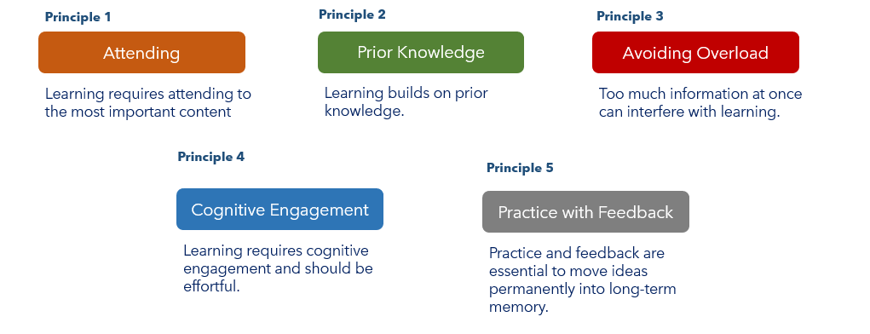  T: Yesterday we were introduced to five principles for teaching informed by the science of learning. Today we are going to learn more about attending and helping students focus on the most important content in class.  T: Let’s do a quick turn and talk. (Display the following question from the ppt.)  T: What is this math teacher trying to do when she makes this statement? Turn and Talk.  S: (Students Turn-and-Talk)  T: Who can share your thinking?  S: The teacher is trying to get the students to pay attention to putting units on the word problem.  T: What else?  S: …and why that is important.  T: Right. The teacher is directing students to attend to why units are important. That kind of question – why something is important – engages the working memory. So why is your math teacher always telling you to put units on your answers?  S: It is the accurate way to respond (2 seconds is a lot different than 2 hours!), and because it reminds students that math is something that is useful and models situations in the real world. (Answers will vary.)  T: A key part of teaching is determining what the most important content you want students to remember is; what do you want students’ working memory to be engaged in thinking about during the lesson so that the most important ideas move into long-term memory.  T: It’s harder than you’d think to make sure activities focus on the most meaningful content. | PPT  Student Guide  Cards for Card Sort Activity  (copied & cut out in advance)
  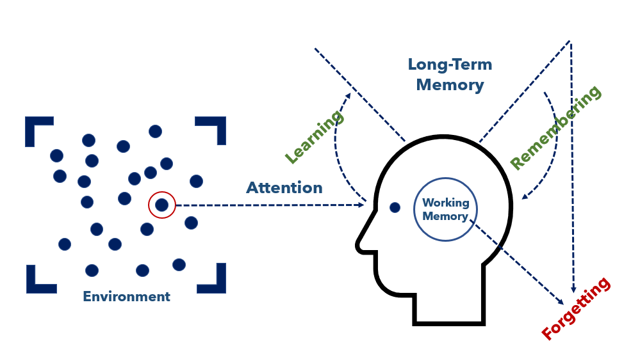 | Thinking about the simple memory model, what is a math teacher trying to do when she says to her students,  “I always tell you to make sure you put units on your answers to word problems – 4.3 seconds, 900 kilograms, 12 candy bars – why do you think I am such a stickler for that?”
12 mins | Think Aloud and Think-Pair-Share  T: Let’s look at some examples and non-examples of guiding student’s attention to the most important content. Turn to the Learning Goals, Activity and Attention Table in your student guide.  S: (Students take out Learning Goals, Activity and Attention Table for analysis in their student guide).  T: I am going to model how I think about this topic – we sometimes call this a think-aloud. Please follow along with me, recording on your chart in the student guide in the same way I am recording in mine, and we can discuss.  T: (Conducts think-aloud with Learning Goals #1 and #2 in the first two examples in Learning Goals, Activity and Attention Table using the answer key as a guide,)  S: (Record rationale in the student guide.)  T: Now, let’s have you try two of your own and give you a chance to get some feedback from a partner using a Think-Pair-Share.  T: First, take 3 minutes to read and record your thinking on Learning Goals #3 and #4.  S: (Students work independently.)  T: Now pair with your partner and share your thinking.  S: (Share with a partner.)  T: (Conduct whole group debrief checking for understanding and students’ explanation of rationale using answer key as a guide). | PPT  Student Guide
15 min | Practice #1 – Card Sort  T: Now we are going to do a sorting activity to determine what activities focus students’ attention on the most important content relative to the learning goal and which do not. We will discuss your answers at the end.  T: Please get in groups of three.  S: (Move into small groups of three.)  T: (Hand each group a copy of the card sort) Cards will need to be printed and cut from 4.3 Student Guide – Answer Key prior to the lesson.  T: Sort the cards into 2 piles, ones that appear to require students to attend to the import content and ones that we will call misaligned. By misaligned, we mean that the activities don’t line up with what is most important about the learning goal.  S: (Groups engage in card sort.)  T: (Teacher calls on students in groups to explain why they grouped each card as they did, using the answer key as a guide. Teacher may also show each card on a doc reader/overhead and conduct the sort as the class provides their answers and thinking). | Card Sort
5 mins | Exit Ticket  S: (Complete the Exit Ticket.) | Exit Ticket

