Unit 4: Science of Learning

Lesson 4.05: New Learning is Built on Previous Learning

Lesson at Glance
Warm-Up (5 mins)  - Bellringer (5) | Instruction (17 mins)  - Return to the Memory Model (5)  - Think-Aloud Analysis (7)  - Prior Knowledge Activities (5) | Application (18 mins)  - Practice 1 (12)  - Debrief (3)  - Exit Ticket (3)

TEKS | 4 | The student understands the learner and the learning process. The student is expected to:  - relate and implement principles and theories of human development to teaching and training situations;  - relate and implement principles and theories about the learning process to teaching and training situations
Objectives | - Define and describe the role of prior knowledge in learning.
Rationale/ Summary | In this lesson, students will consider the importance of prior knowledge for new learning. Additionally, they will learn the success criteria for an effective prior knowledge activity. Analyzing prior knowledge needs and assessing prior knowledge and misconceptions is an essential component of lesson planning.
Formative Assessment and Exemplar Response | Why is it important for a teacher to consider the prior knowledge of their students?  See Exit Ticket Answers for exemplar responses.
Vocabulary | Working Memory |  | Temporary memory that must be constantly activated to maintain
Vocabulary | Long-Term Memory |  | Stored information that can be retrieved even after long periods of inactivity
Vocabulary | Prior Knowledge |  | Information or context a learner already has about a topic before they learn new information. Prior knowledge can help students:  - Make connections to new information.  - Better understand new information.  - Store and retrieve new information.
Vocabulary | Misconception |  | An incorrect understanding that students bring to new learning
Vocabulary | Prior Knowledge Activities |  | Activities that draw upon students' prior knowledge, giving teachers a way to identify misconceptions and understand what students already know about a given topic
Vocabulary | KWL Chart |  | A strategy for assessing prior knowledge that asks students what they already know and what they want to know; it can be used throughout a unit as students complete the final column about what they have learned

Est Time | Instructional Activities (including formative assessments) | Materials
4 mins | Bellringer: Read the following excerpts and respond to the questions that follow.  - Choosing to bat, Vanuatu struggled to build partnerships. They were reduced from 26/1 to 26/4 in the space of five balls, and no batsman was able to make more than 12 runs. Pavandeep Singh and Nazril Rahman took four wickets each to bowl Vanuatu out in 25.1 overs.  - Dylan Cease, the right-handed pitcher, allowed seven runs on four hits with four strikeouts and two walks in 3⅓ innings. Michael Brantley hit a three-run home run in the first — the first of three homers for the Astros.  What is each excerpt about? Is one easier to understand? Why do you think that is? | Student Guide  PPT
1 min | T: Which excerpt was easier to understand?  S: (Share responses. Answers should include that the second excerpt was easier to understand since it is about baseball.)  T: The first excerpt was probably harder to understand because it is about a sport called cricket, which is not widely familiar in the United States. The second excerpt—about baseball—is about a sport with which many people in the United States are familiar. It’s easier to understand because we all likely have more prior knowledge about baseball than cricket. What do you think would make the first paragraph easier to understand?  S: (Share responses. Answers might include how knowing vocabulary like batsman or wicket would be beneficial or how known words were used in context—ultimately having any background information about cricket would be helpful.)
5 mins | Return to the Principles and the Memory Model  T: (Revisit the 5 Principles slide.) Today we are going to learn about the role of prior knowledge in learning. Remember that Prior Knowledge is one of the principles informed by the science of learning.  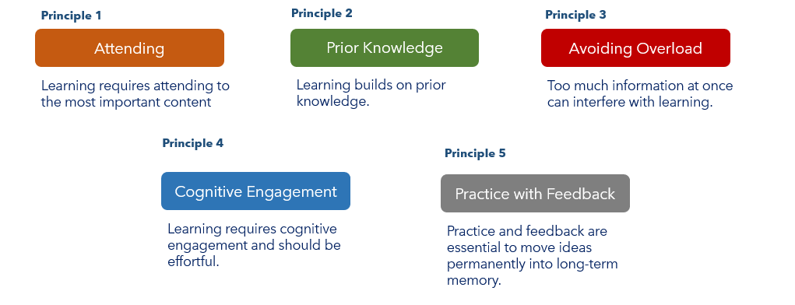  T: For the working memory to engage fully, students need to have the necessary prior knowledge to make new meaning.  T: (Display the head with working memory on PowerPoint.) Please follow along with my annotations in your student guide. Prior knowledge is information and context a learner already has about a topic before they learn new information.  S: (Annotate diagram in Student Guide.)  T: Prior knowledge can help students make connections and better understand, store, and retrieve new information.  T: Prior knowledge can also help the teacher address students’ misconceptions—incorrect understandings students have about new learning—and know what students already understand about a given topic.  S: (Annotate diagram in Student Guide.)  T: (Show Memory Model to students.) Prior knowledge about a topic needs to live in the long-term memory and be accessed to make new meaning in the working memory. That means that prior knowledge is knowledge that is already learned and stored.  S: (Annotate diagram in Student Guide.)  T: In the baseball bellringer, most of you were able to access the important vocabulary about baseball—pitcher, runs, hits, strikeouts—to understand the text.  T: (Reference Memory Model.) Notice in the model how the vocabulary words are brought from long-term memory into working memory as you read the baseball example. If you do not have necessary prior knowledge in your long-term memory, it will hinder your ability to learn new content efficiently and effectively. Think about how not understanding vocabulary in the cricket example impacted your understanding. | Student Guide  PPT
7 mins | Think Aloud Analysis  T: Now we are going to look at some content-based examples to illustrate how prior knowledge is necessary to understanding new ideas. First, we will look at a text.  T: (Point students to the text-based example in their Student Guides. Display the text-based example on the board from the PowerPoint.) What important prior knowledge do you think students will need to have to understand this text?  S: (Share responses. See Student Guide Answer Key for sample responses.)  T: (Note key vocabulary and/or concepts that students need to know while viewing the PowerPoint to make sense of the text using students’ ideas as they share. Guide students towards pre-identified concepts when necessary.)  T: (Return to the Memory Model.) Part of why prior knowledge is so important is that if you have already learned some information—like the meaning of specific vocabulary words—you free up working memory to think about the deeper meaning of a text or other content.  T: (Point students to the math example in their Student Guides. Display the math example on the board from the PowerPoint.) Now, we will look at a math example. What important prior knowledge do you think students will need to solve this problem?  S: (Share responses. See Student Guide Answer Key for sample responses.)  T: (Note any key vocabulary and/or concepts that students need to know while viewing the PowerPoint to make sense of the text using students’ ideas as they share. Guide students towards pre-identified concepts when necessary.) | Student Guide  PPT
5 mins | Prior Knowledge Activities  T: There are three steps in using prior knowledge in your teaching:  - Determine what prior knowledge is necessary for students to access.  - Determine if students have the prior knowledge they need for the lesson.  - Plan for how to support students if they do not have that prior knowledge.  T: Teachers use prior knowledge activities—activities that draw upon students’ prior knowledge—to identify misconceptions and understand what students already know about a given topic. How many of you ever completed something called a KWL Chart?  S: (Raise hands to show whether they have completed a KWL Chart.)  T: A KWL Chart is one strategy for assessing prior knowledge that asks students what they already know and what they want to know. It can be used throughout a unit as students complete the final column about what they have learned.  T: Who can explain what a KWL Chart is and how it is completed? (Call on a student with raised hand to explain.)  S: (Volunteer to respond.)  T: KWL Charts are just one example of a prior knowledge activity. What other strategies have you experienced in other classes to activate or assess your prior knowledge?  S: (Share responses. Responses might include concept maps, pre-assessments, journal responses, etc.)  T: Activities that successfully assess prior knowledge should be:  - Targeted and focused on the important parts of the lesson.  - Non-threatening—low- or no-stakes.  - Relatively short.  T: We will explore a host of strategies to assess prior knowledge in our next lesson. Now, let’s practice a little of what we have learned. | Student Guide
15 mins | Practice (12 mins)  T: Find the “Practice” section in your students guides. Independently, review the learning goals and the prior knowledge needed. Explain why the prior knowledge is necessary for successful learning.  S: (Independently identify why the prior knowledge is necessary for the learning goal in their Student Guide.)  T: Take a moment now to turn to a partner near you to share your responses.  S: (Share responses with a partner. Sample responses found in Student Guide Answer Key.)  T: How might a teacher use a KWL Chart with these learning goals to help them plan for understanding students’ prior knowledge?  S: (Share out responses. Sample responses include:  - The “Know” [K] column will allow the student to identify what they already know. This column may also surface some misconceptions that students have about the topic.  - The “Want to Know” [W] column might help the teacher identify things that students do not understand, which is why they want to know those things.  - If students struggle to fill out the [K] or [W] columns, it might tell the teacher that the student does not have the prior knowledge needed to move on with the content. Then, the teacher will have to plan how to support that student accordingly.) | Student Guide
Debrief (3 mins)
T: It is also important for us to think about how the KWL Chart meets the success criteria for prior knowledge activities. How are KWL Charts targeted, non-threatening, and short?

S: (Share responses.) Sample responses include:
- Targeted: KWL Charts can be focused on a specific topic within a unit; these charts specifically ask what students already know, what they want to know, and what they have learned.
- Non-threatening: KWL Charts are not graded and can be kept in a student journal; these are assessments of what students already know, not assessments of what students have learned/been taught.
Short: KWL Charts are quick activities that can be done in a short period of time; can spend as little as 5 minutes and as much as up to 15 minutes working on filling out a chart.)
3 mins | Exit Ticket  S: (Complete the Exit Ticket.) | Exit Ticket

