Student Guide

Lesson 4.05: New Learning is Built on Previous Learning
Name:
Date:

Bellringer: Read the following excerpts and respond to the questions that follow.
- Choosing to bat, Vanuatu struggled to build partnerships. They were reduced from 26/1 to 26/4 in the space of five balls, and no batsman was able to make more than 12 runs. Pavandeep Singh and Nazril Rahman took four wickets each to bowl Vanuatu out in 25.1 overs.
- Dylan Cease, the right-handed pitcher, allowed seven runs on four hits with four strikeouts and two walks in 3⅓ innings. Michael Brantley hit a three-run home run in the first — the first of three homers for the Astros.

What is each excerpt about?

Is one easier to understand? Why do you think that is?

Return to the Memory Model
Label the missing components of the Memory Model diagram. 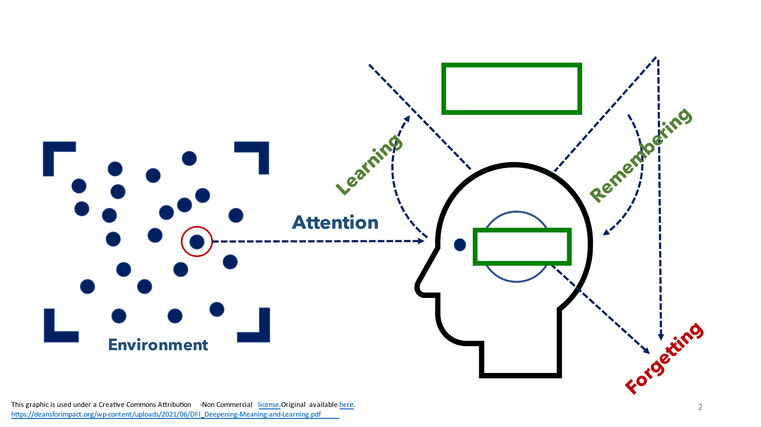

Key Vocabulary
Define each key term below.
Term | Definition
Working Memory
Long-Term Memory
Prior Knowledge
Misconception
Prior Knowledge Activities
KWL Chart

Think Aloud Analysis
For each example, explain how prior knowledge is necessary to learn new ideas.
 | Content-Based Example | Explanation
Text | Mesoamerica, or Middle America, was home to the Maya and the Aztec civilizations. This region lies north of the Equator in an area called the tropics. It includes a portion of present-day Mexico in North America and parts of Central America. It occupies much of the isthmus that joins the continents of North and South America. Mesoamerica has very diverse landscapes, including dry coastal deserts and wet inland forests.
Math | Solve the following equation:  (3 + 12) / 7 = ?

Prior Knowledge Activities
What are the steps of using prior knowledge in your teaching?

What is a prior knowledge activity?

What makes for a successful prior knowledge activity?

What is a KWL Chart?

Practice
For the following third grade learning goals, independently identify how and why the listed prior knowledge is necessary to meet the given learning goals.
Learning Goals | Prior Knowledge | Explanation
Students will be able to:  - Define three human body systems (skeletal, muscular, nervous)  - Understand how the skeletal, muscular, and nervous systems work together | - Other systems in the human body (e.g., circulatory, digestive)  - Understanding of how the body moves  - Exposure to language around human body systems

