Student Guide – Answer Key

Lesson 4.05: New Learning is Built on Previous Learning
Name:
Date:
Bellringer: Read the following excerpts and respond to the questions that follow.
- Choosing to bat, Vanuatu struggled to build partnerships. They were reduced from 26/1 to 26/4 in the space of five balls, and no batsman was able to make more than 12 runs. Pavandeep Singh and Nazril Rahman took four wickets each to bowl Vanuatu out in 25.1 overs.
- Dylan Cease, the right-handed pitcher, allowed seven runs on four hits with four strikeouts and two walks in 3⅓ innings. Michael Brantley hit a three-run home run in the first — the first of three homers for the Astros.

What is each excerpt about?
The first excerpt is about cricket and the second excerpt is about baseball.

Is one easier to understand? Why do you think that is?
The second excerpt is easier to understand because I am familiar with the language used in that excerpt. For example, I know what a pitcher is and what strikeouts are—the vocabulary used in the excerpt is about baseball.

Return to the Memory Model
Label the missing components of the Memory Model diagram.
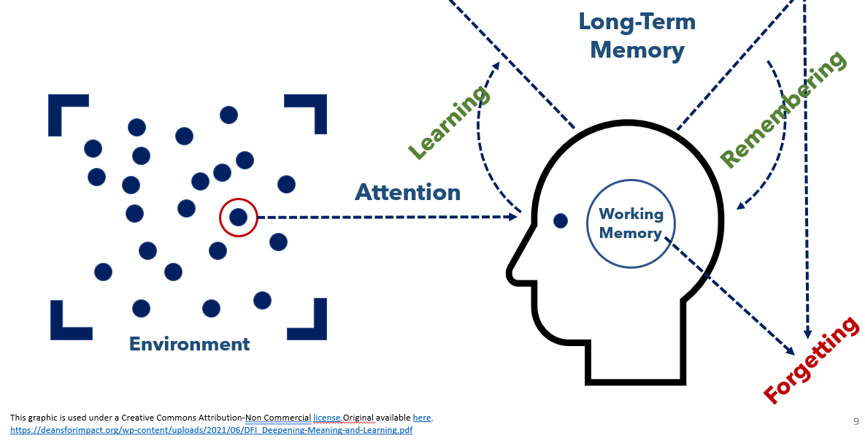

Key Vocabulary
Define each key term below.
Term | Definition
Working Memory | Temporary memory that must be constantly activated to maintain.
Long-Term Memory | Stored information that can be retrieved even after long periods of inactivity.
Prior Knowledge | Information or context a learner already has about a topic before they learn new information. Prior knowledge can help students:  - Make connections to new information  - Better understand new information  - Store and retrieve new information
Misconception | An incorrect understanding that students bring to new learning.
Prior Knowledge Activities | Activities that draw upon students' prior knowledge, giving teachers a way to identify misconceptions and understand what students already know about a given topic.
KWL Chart | A strategy for assessing prior knowledge that asks students what they already know and what they want to know. It can be used throughout a unit as students complete the final column about what they have learned.

Think Aloud Analysis
For each example, explain how prior knowledge is necessary to learn new ideas.
 | Content-Based Example | Explanation
Text | Mesoamerica, or Middle America, was home to the Maya and the Aztec civilizations. This region lies north of the Equator in an area called the tropics. It includes a portion of present-day Mexico in North America and parts of Central America. It occupies much of the isthmus that joins the continents of North and South America. Mesoamerica has very diverse landscapes, including dry coastal deserts and wet inland forests. | To understand this excerpt, a student must have some prior knowledge about geography to know the location that the author is referencing. Vocabulary that would be helpful to know are Equator, tropics, isthmus, diverse landscapes, coastal deserts, and wet inland forests.
Math | Solve the following equation:  (3 + 12) / 7 = ? | To solve the equation, a student must have prior knowledge of order of operations, addition, and division. To understand division, a student must also understand repeated subtraction.

Prior Knowledge Activities
What are the steps of using prior knowledge in your teaching?
- Determine what prior knowledge is necessary for students to access.
- Determine if students have the prior knowledge they need for the lesson.
- Plan for how to support students if they do not have that prior knowledge.

What is a prior knowledge activity?
Prior knowledge activities are activities that draw upon students’ prior knowledge, giving teachers a way to identify misconceptions and understand what students already know about a given topic.
What makes for a successful prior knowledge activity?
Prior knowledge activities should be targeted on the most important parts of a lesson, non-threatening/low-stakes, and relatively short.
What is a KWL Chart?
A KWL Chart is a strategy for assessing prior knowledge that asks students what they already know and what they want to know. It can be used throughout a unit as students complete the final column about what they have learned.

Practice
For the following third grade learning goals, independently identify how and why the listed prior knowledge is necessary to meet the given learning goals.
Learning Goals | Prior Knowledge | Explanation
Students will be able to:  - Define three human body systems (skeletal, muscular, nervous)  - Understand how the skeletal, muscular, and nervous systems work together | - Other systems in the human body (e.g., circulatory, digestive)  - Understanding of how the body moves  - Exposure to language around human body systems | The listed prior knowledge is needed for a student to meet the learning goals because knowing about other systems in the body can relate to the three systems in the learning goals (skeletal, muscular, nervous). If students understand how their body moves, they can make connections to how the three systems work together to move the body.

