Student Guide – Answer Key

Lesson 4.06: Prior Knowledge | Practice
Name: Text
Date: Text
Bellringer: How are KWL Charts good assessments of prior knowledge?
KWL Charts are good assessments of prior knowledge because they are targeted and allow students to share what they already know about a specific topic. KWL Charts are also low stakes as they are not graded assignments, and they are short and do not take much time to complete. Finally, KWL Charts provide important information for teachers about the information students already know about a topic and what, if any, misconceptions they may have so that the teacher can plan to address those during instruction. The teacher can also use KWL Charts to plan for how to support students who do not have any prior knowledge about the given topic.

Key Vocabulary
Define each key term below. Include an image or example for each term.
Term | Definition | Image/Example
Concept Map | A visual organization and representation of knowledge. Concept maps show how topics and ideas relate to one another. | 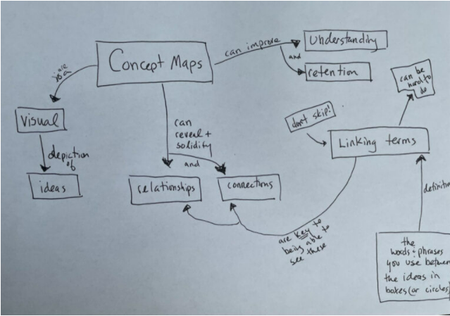  Photo credit: https://lsc.cornell.edu/how-to-study/studying-for-and-taking-exams/concept-maps/
Anticipation Guide | A set of statements about a topic that students react to (can be true/false statements, agree/disagree statements, etc.). | 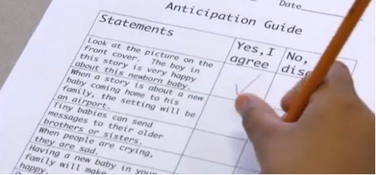  Photo credit: https://www.readingrockets.org/strategies/anticipation_guide
Self-Assessment | Assessments that students complete about their individual knowledge of a topic. Self-assessments are not graded but used as a way for students to individually reflect on what they know about a given concept. | Examples may include:  - Student self-reflection questions about their performance or learning  - Rubrics  - Colored cards (e.g., red, yellow, green) noting how students are feeling about a given topic

Strategy Highlight: Stations
Station teaching can allow you to differentiate and/or personalize learning for students while also giving students opportunities to experience content in various meaningful ways. To implement stations, teachers must first consider how each station activity correlates to class learning objectives and standards. Teachers must think about whether station activities will be independent, discussion-based, completed with a partner, teacher-led, etc. Then, teachers must prepare materials for each station, including directions for each station. It is important to be as organized as possible when implementing stations so that students can work independently without the teacher having to field questions about how to manage each station’s activity so (s)he can monitor student progress across stations and answer content-related questions. Pre-grouping students and using a timer that is visible to the entire class can help ensure smooth station transitions.

Practicing Prior Knowledge Activities: Strategy Stations
Fill out the table below as you rotate to each station. At the conclusion of your station rotation, reflect on your experience and answer the questions below the table.
 | In your own words, what is this prior knowledge activity? | How does this strategy or activity help students activate or assess their prior knowledge? | When might be a good time to use this strategy or activity?
Station 1: Concept Maps | A way for students to make connections to new content based on what they already know. | Students can use concept maps to start with topics they know and find relationships to new content. Using prior knowledge, they can make connections across different topics. | Answers may vary but may include:  - Reviewing previously taught content to connect to new content  - To organize new learning and information
Station 2: Anticipation Guides | Giving students a chance to be exposed to new content before learning it. | This activity helps students activate prior knowledge by giving them a chance to see content before it is taught and to consider what they already know and connect it to future learning. | Answers may vary but may include:  - At the start of a new unit or lesson  - With English learner students who would benefit from seeing content before it is formally taught
Station 3: Self-Assessments | A way for students to assess themselves and what they know about a topic. | This activity allows students to assess their own prior knowledge of a topic by letting students reflect on what they have previously learned or already know. | Answers may vary but may include:  - To enhance students’ understanding of how they learn and what they learn

How did each activity align to the success criteria for prior knowledge activities?
Success Criteria for Prior Knowledge Activities
- Targeted
- Non-threatening
- Relatively short

Answers will vary.

What did you learn through the activities?
Answers will vary.

