Unit 4: Science of Learning

Lesson 4.07: Avoiding Overload | Too Much Information Can Interfere with Learning

Lesson at Glance
Warm-Up (3 mins)  - Bellringer (3) | Instruction (19 mins)  - Return to the Memory Model (4)  - Avoiding Overload: Sequencing & Scaffolding (15) | Application (23 mins)  - Practice: Identifying Sequencing & Scaffolding (15)  - Debrief (5)  - Exit Ticket (3)

TEKS | 4 | The student understands the learner and the learning process. The student is expected to:  - relate and implement principles and theories of human development to teaching and training situations;  - relate and implement principles and theories about the learning process to teaching and training situations
Objectives | - Analyze how learning can be sequenced and scaffolded to build toward mastery of content and avoid overload
Rationale/ Summary | In this lesson, students will learn about sequencing and scaffolding to ensure that students are not overloaded with information. Using sequencing and scaffolding strategies while teaching supports learners to become more independent with their content knowledge and skills.
Formative Assessment and Exemplar Response | Determine whether each scenario demonstrates an example of sequencing or scaffolding. Explain how the activity helps students avoid overload.  See Exit Ticket Answers for exemplar responses.
Vocabulary | Prior knowledge |  | Information or context a learner already has about a topic before they learn new information. Prior knowledge can help students:  - Make connections to new information.  - Better understand new information.  - Store and retrieve new information.
Vocabulary | Overload |  | The situation in which the demands placed on a person by mental work (cognitive load) are greater than the person’s mental abilities can cope with
Vocabulary | Sequencing |  | The effective ordering of academic content to support students' understanding of a topic.  Sequencing also relies on building on prior knowledge to ensure that there are not gaps in student learning.
Vocabulary | Scaffolding |  | Structured supports offered to students by the teacher to help students attain a strong command of a new skill and/or concept
Vocabulary | Cognitive load |  | The relative demand imposed by a particular task in terms of mental resources required (also called “mental load” or “mental workload”)
Vocabulary | Worked examples |  | Step-by-step demonstrations of how to perform a task or solve a problem

Est Time | Instructional Activities (including formative assessments) | Materials
3 mins | Bellringer: How can teachers use prior knowledge to aid them in planning for instruction?  S: (Complete Bellringer in Student Guide.)  T: What are some ideas you have in response to the bellringer?  S: Answers will vary but may include:  - Prior knowledge lets teachers know what information students already know.  - Prior knowledge gives teachers insight as to what, if any, misconceptions students have about a topic/content area.  - If teachers know that students do NOT have the prior knowledge necessary to move on to the next topic, they can adjust their plans accordingly to give students the support they need to acquire that knowledge.  T: Today, we are going to return to the Memory Model diagram and think about how sequencing and scaffolding—two instructional strategies—help a teacher avoid overloading students. | Student Guide
4 mins | Return to the Principles and the Memory Model  T: (Revisit the 5 Principles slide.) Today we are going to learn about overload and how to avoid it during instruction. Remember that Avoiding Overload is one of the principles informed by the science of learning.  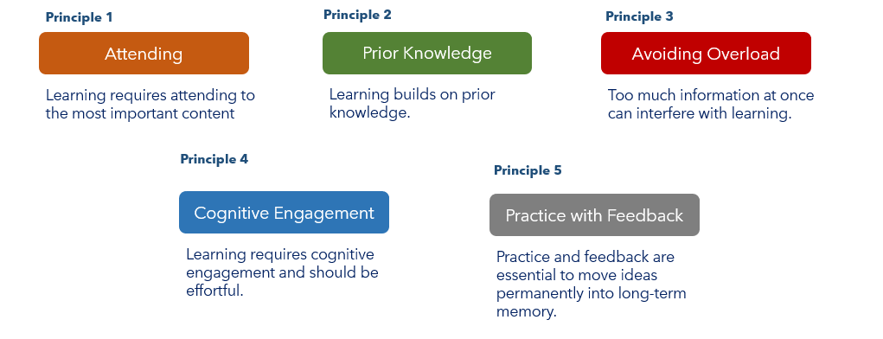  T: (Share the Memory Model diagram in the PowerPoint.)  T: In the Memory Model diagram, the dots represent individual things happening in a students’ environment. No one can pay attention to everything in their environment. Teachers must ensure that they are intentional about what information they are drawing students’ attention to, so students don’t get overloaded with too much information. This is called “avoiding overload.”  T: Overload, also called cognitive overload, is the situation in which the demands placed on a person by mental work are greater than the person’s mental abilities can cope with. Overload occurs when the brain becomes weighed down with so much information or data that it exceeds an individual’s capacity to process incoming or new information or data.  S: (Capture definition of overload in Student Guide.) | PPT  Student Guide
15 mins | Avoiding Overload: Sequencing & Scaffolding  T: One way teachers can avoid overloading students is through sequencing. Sequencing is the effective ordering of academic content to support students' understanding of a topic while building on students’ prior knowledge.  S: (Capture definition of sequencing in Student Guide.)  T: Introducing ideas with an intentional sequence or order helps students understand content. Can you think of a topic that you had to learn in a specific order?  S: (Answers will vary, but may include things like learning addition before multiplication, learning letter sounds before learning to read, learning scientific processes like the water or rock cycle, etc.)  T: Let’s look at an example together (display the photo below on the PowerPoint)  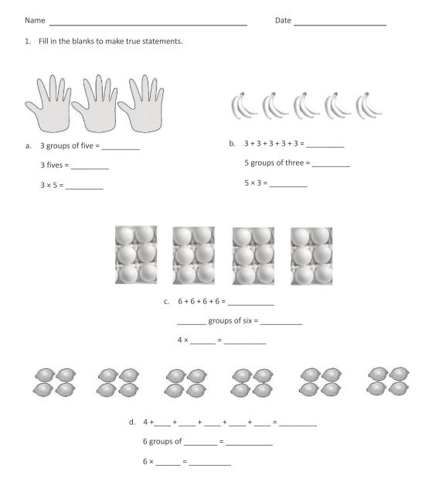  T: This example is from a problem set in a multiplication lesson designed for third grade math. The objective of the lesson is to understand “equal groups of” as multiplication.  T: This is an example of how teachers would use students’ prior knowledge of repeated addition to help them learn the concept of multiplication. By seeing the problem first with a visual aid, then by determining values of equal groups, the students can make a connection to what task they are being asked to do when they see a multiplication number sentence.  T: How does sequencing help students avoid overload? Write your response in your student guide.  S: (Record responses in the student guide.)  T: (Elicit volunteers to share their response.)  S: (Share their responses.)  T: Another strategy to avoid overloading students with information is through scaffolding. Scaffolding includes the structured supports offered to students by the teacher to help students gain a strong command of a new skill and/or concept. This strategy of breaking down content into manageable “chunks” of information can help students better process information and ultimately avoid overload.  S: (Capture definition of scaffolding in Student Guide.)  T: For example, one way that teachers can scaffold for students is by using worked examples to reduce cognitive load or the mental demand it will take a student to complete a given task. Worked examples are step-by-step demonstrations of how to perform a task or solve a problem.  S: (Capture definitions of cognitive load and worked examples in Student Guide.)  T: Scaffolding with worked examples can be gradually removed in subsequent problems so that students can complete these tasks more independently. This gradual release can be thought of in an “I Do/We Do/You Do” framework. Here’s an example:  - The teacher works out a problem while students watch.  - The teacher asks the class to help her solve a problem.  - Students work on a similar problem individually.  S: (Complete the “I Do/We Do/You Do” table in Student Guide.)  T: Let’s practice. I am going to work through a math word problem, and I want you to watch what I do. (Display the word problem from the PowerPoint slides: “Brianna buys 3 packs of balloons for a party. Each pack has 60 balloons. How many balloons does Brianna have?”)  T: (Actively complete the word problem showing your work and talking out loud.) First, I will underline key words. (Underline key words like “each” or circle the numbers to note important pieces of information.)  T: Now, what operation might I use to solve the problem—addition? Subtraction? Multiplication? Division? How do I know which operation to use? I’m looking for the total number represented by multiple packs. So, I will multiply.  T: I am going to represent the problem visually. (Draw a picture of three rectangles to represent balloon packs and write “60” in each rectangle.) 60 times three equals 180. (Write the algorithm to solve the problem.)  S: (Take notes in “I Do/We Do/You Do” table in Student Guide.)  T: Now, let’s try a problem together. (Display the word problem from the PowerPoint slides: “Jordan has twenty times as many baseball cards as his brother. His brother has 9 cards. How many cards does Jordan have?”)  T: What do you think we should do first?  S: Underline key words.  T: Great! Let’s underline some words that can help us solve this problem. What do you think we should underline?  S: “Twenty times more.”  T: (Underline “twenty times more” in word problem.) Alright, that’s helpful—that lets us know that maybe we should add or multiply since the answer will be more than the number of cards Jordan’s brother has. Do you think we should add or multiply here?  S: Multiply.  T: Right! We should multiply—the problem even says that Jordan has twenty TIMES more cards than his brother, and we are looking for how many cards Jordan has.  T: I wonder how we might try to represent this problem visually. What kind of picture might we draw?  S: We should somehow draw 20 groups of 9. We could draw 20 circles and put 9 tally marks in each circle, then we could count all the tally marks. Note: Answers may also vary, so long as the visual represents 20 groups of 9 in some way.  T: That’s a good idea. Let’s draw it out and then write the algorithm beside our picture. (Draw a picture of 20 circles and place 9 tally marks in each circle.) 20 times 9 equals 180. (Write the algorithm to solve the problem.)  T: Great! See how in the first example, I completed a problem on my own and you all observed, and in the second example, we completed a similar problem together where you helped me out along the way. Now, you will have a minute to complete a problem independently in your Student Guide.  S: (Complete the practice problem in Student Guide.)  T: Does someone want to share how they thought through their answer? (Call on a student to share response.)  T: Great. Before we move on, let’s quickly review what we just completed. Who can explain the difference between sequencing and scaffolding?  S: Sequencing is the order in which a new concept is taught, with consideration to students’ prior knowledge. Scaffolding is when the teacher breaks down the content into meaningful “chunks” so that the student can better process new information.  T: Who can explain how sequencing and scaffolding support learning?  S: Sequencing and scaffolding support learning because they help students avoid overload. Overload is when the mental task put on a learner is greater than the mental ability of the learner. | PPT  Student Guide  Questions in this section used/adapted from HQIM - 4th Grade Eureka Math TEKS Module 3 - Learn (pp. 28-29)
20 mins | Practice: How Sequencing and Scaffolding Help Students to Avoid Overload (15 mins)  T: Next, we’re going to look at some examples from a first grade resource on the human body. Each example demonstrates either sequencing or scaffolding to reduce the risk of overload for students. You are going to read each example and determine how the activity helps students to avoid overload.  T: (direct students to read the first example)  T: This lesson component demonstrates sequencing because it shows an intentional progression of vocabulary for students to learn lesson after lesson. For example, a student might have a hard time understanding “vaccines” without understanding terms like muscles, systems, blood, brain, etc. This lesson component shows that the terms were thoughtfully placed so that students could build on their learning from previous lessons.  T: Now let’s look together at the second example, “Everybody has a Body.”  T: (direct students to read the second example)  T: Example 2 is an example of scaffolding.  T: How do you know?  S: (exemplar answer) The highlighted parts of the read aloud text seem to imply that it is something the teacher would say to the class while reading aloud. This support allows for students to understand the word “human.” Additionally, the teacher asks the students a question about who is sharing information about the human body, which lets the teacher check for reading comprehension understanding so the teacher can address confusion in the moment.  T: Great. Lastly, spend three minutes independently reviewing the final example and determining how overload is avoided using this strategy. After three minutes, you will turn and talk to a partner about your answer.  S: (answer the question in Student Guide.)  T: (Keep track of time using a timer visible to all students. Monitor students working. After three minutes, ask students to turn and talk with a partner).  T: (after three minutes) Turn to your partner and compare your answers.  T: (after one minute) In what ways did you and your partner decide the third example demonstrated a strategy for avoiding overload?  S: (exemplar answer) There are specified supports listed in the right-hand column of this section of the lesson plan, including ways to support English learners and additional opportunities to support students in creating their KWL charts. The “Inferential” part of the comprehension questions also gives the teacher a way to support students in thinking about organs and systems in the body and how they have different functions. A “Check for Understanding” can be a scaffold or form of student support to keep them on track with the lesson.  Debrief (5 mins)  T: How can sequencing and scaffolding help make sure that students do not experience overload?  S: (Share examples. Answers will vary but may include:  - Sequencing allows for students to understand content in an intentionally ordered way so that they may be able to build on prior knowledge to learn new content.  - Scaffolding avoids overload by breaking down content into manageable pieces for students to understand.) | Student Guide  Lesson components pulled from HQIM – Amplify Grade 1, Knowledge 2: The Human Body Teacher Guide (Lesson 1)
3 mins | Exit Ticket  S: (Complete the Exit Ticket.) | Exit Ticket

