Student Guide

Lesson 4.07: Avoiding Overload | Too Much Information Can Interfere with Learning
Name:
Date:

Bellringer: How can teachers use prior knowledge to aid them in planning for instruction?

Key Vocabulary
Define each key term below.
Term | Definition
Overload
Sequencing
Scaffolding
Cognitive Load
Worked Examples

Avoiding Overload: Sequencing & Scaffolding
How does sequencing help students avoid overload?

Fill out the table below explaining the steps of the “I Do/We Do/You Do” scaffolding model. Then, observe the teacher’s actions during your practice time with this strategy and note what (s)he did at each stage.
 | I Do | We Do | You Do
Explanation

What happens during each stage of this scaffolding?
Practice

What did you notice the teacher doing during each stage of this scaffolding?

“I Do/We Do/You Do” Practice Problem
The aquarium has 30 times as many fish in one tank as Jacob has. Jacob has 3 fish. How many fish does the aquarium have?

Practice: Identifying Sequencing & Scaffolding
The lesson components below are from the Amplify Grade 1, Knowledge 2: The Human Body Teacher Guide (Lesson 1). Each component is an example of either sequencing or scaffolding, which is noted below. How does each example support learning and decrease cognitive load?
Example 1: Sequencing
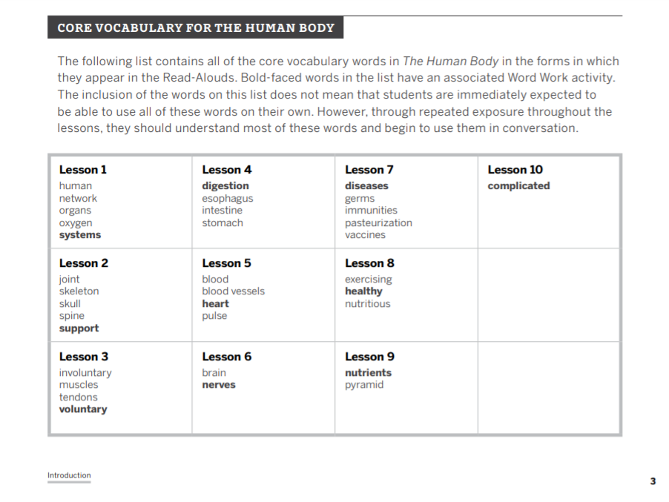
How does this example support learning and decrease cognitive load?

Example 2: Scaffolding
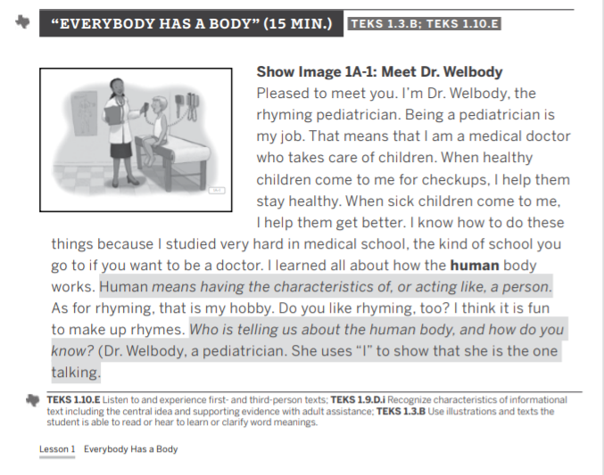
How does this example support learning and decrease cognitive load?

Example 3: Scaffolding
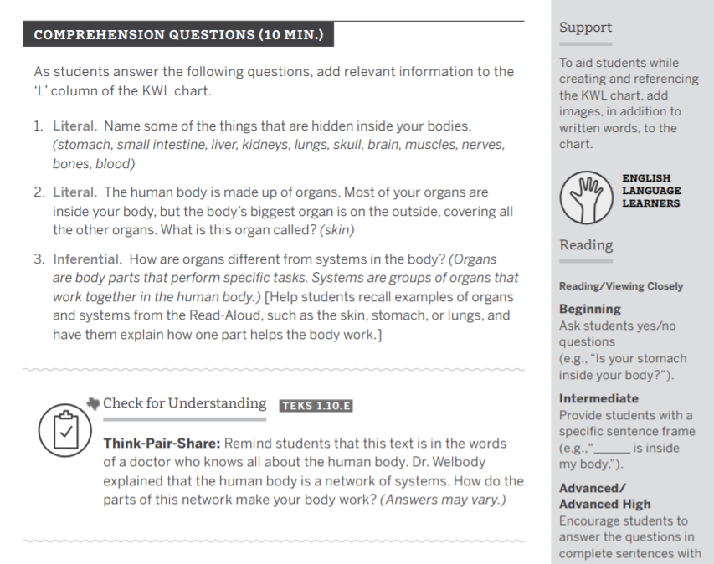
How does this example support learning and decrease cognitive load?

