Student Guide – Answer Key

Lesson 4.07: Avoiding Overload | Too Much Information Can Interfere with Learning
Name:
Date:

Bellringer: How can teachers use prior knowledge to aid them in planning for instruction?
Answers will vary but may include:
- Prior knowledge lets teachers know what information students already know
- Prior knowledge gives teachers insight as to what, if any, misconceptions students have about a topic/content area
- If teachers know that students do NOT have the prior knowledge necessary to move onto the next topic, they can adjust their plans accordingly to give students the support they need to acquire that knowledge

Key Vocabulary
Define each key term below.
Term | Definition
Overload | The situation in which the demands placed on a person by mental work (cognitive load) are greater than the person's mental abilities can cope with
Sequencing | The effective ordering of academic content to support students' understanding of a topic; sequencing also relies on building on prior knowledge to ensure that there are not gaps in student learning
Scaffolding | Structured supports offered to students by the teacher to help students attain a strong command of a new skill and/or concept
Cognitive Load | The relative demand imposed by a particular task in terms of mental resources required (also called “mental load” or “mental workload”)
Worked Examples | Step-by-step demonstrations of how to perform a task or solve a problem

Avoiding Overload: Sequencing & Scaffolding
How does sequencing help students avoid overload?
Sequencing can help students avoid overload by giving students a little bit to learn at a time—it is like taking pieces of a larger process and breaking them down for students. For example, if students are learning about the water cycle, they cannot learn about evaporation without first learning about condensation. Sequencing is the intentional ordering of content so that students can better understand and process information. By ordering content in a specific way, teachers build on prior knowledge to ensure students master academic content.

Fill out the table below explaining the steps of the “I Do/We Do/You Do” scaffolding model. Then, observe the teacher’s actions during your practice time with this strategy and note what (s)he did at each stage.
 | I Do | We Do | You Do
Explanation  What happens during each stage of this scaffolding? | The teacher demonstrates to the students as a whole group how to work out a given problem or task. | The teacher works out a problem with the help of students by asking students questions about how to complete each step of the problem or task. | Students work independently on a similar problem or task.
Practice  What is an example of scaffolding? How does it help to avoid overload? | Answers will vary. | Answers will vary. | Answers will vary.

“I Do/We Do/You Do” Practice Problem
The aquarium has 30 times as many fish in one tank as Jacob has. Jacob has 3 fish. How many fish does the aquarium have?

Practice: Identifying Sequencing & Scaffolding
The lesson components below are from the Amplify Grade 1, Knowledge 2: The Human Body Teacher Guide (Lesson 1). Each component is an example of either sequencing or scaffolding, which is noted below. How does each example support learning and decrease cognitive load?

Example 1: Sequencing
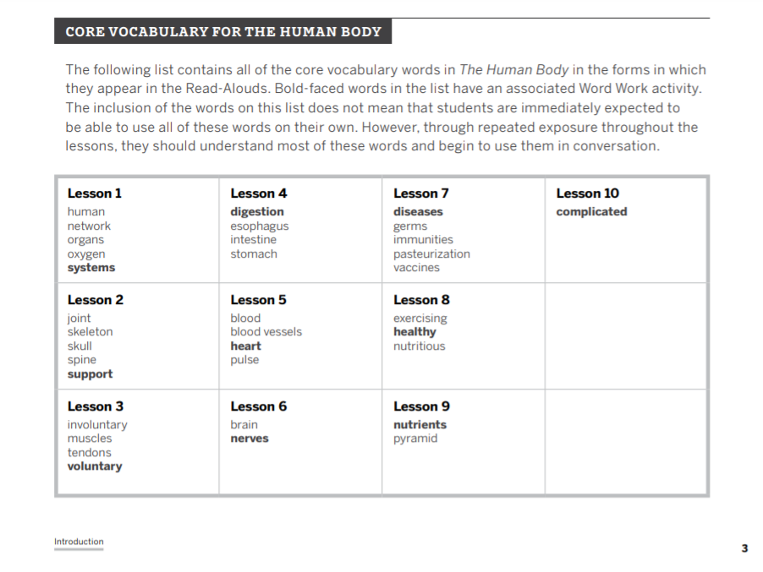
How does this example support learning and decrease cognitive load?
A student might have a hard time understanding the vocabulary terms if they are not taught in an intentional progression. For example, a student might not understand “vaccines” without understanding terms like muscles, systems, blood, brain, etc. This lesson component shows that the terms were thoughtfully placed so that students could build on their learning from previous lessons.

Example 2: Scaffolding
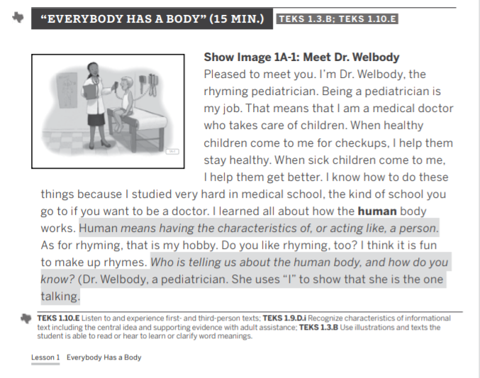
How does this example support learning and decrease cognitive load?
The highlighted parts of the read aloud text seem to imply that it is something the teacher would say to the class while reading aloud. This support allows for students to understand the word “human”. Additionally, the teacher asks the students a question about who is sharing information about the human body, which lets the teacher check for reading comprehension understanding so the teacher can address confusion in the moment.

Example 3: Scaffolding
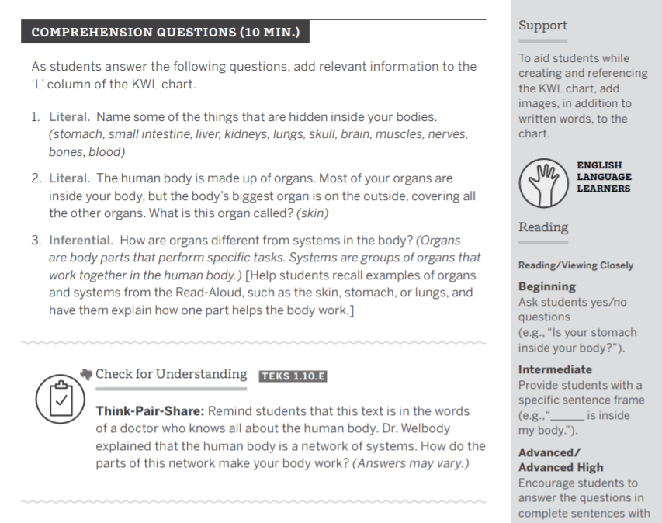
How does this example support learning and decrease cognitive load?
Specified supports listed in the right-hand column of this section of the lesson plan, including ways to support English learners and additional opportunities to support students in creating their KWL charts. The “Inferential” part of the comprehension questions also gives the teacher a way to support students in thinking about organs and systems in the body and how they have different functions. A “Check for Understanding” can be a scaffold or form of student support to keep them on track with the lesson.

