Unit 4: The Science of Learning

Lesson 4.08: Cognitive Engagement

Lesson at Glance
Warm-Up (5 mins)  - Bellringer | Instruction (15 mins)  - Intro to Cognitive Engagement  - Guidelines for Cognitive Engagement | Application (25 mins)  - Practice #1  - Practice #2  - Debrief  - Exit Ticket

TEKS | 4 | The student understands the learner and the learning process. The student is expected to:  - relate and implement principles and theories of human development to teaching and training situations;  - relate and implement principles and theories about the learning process to teaching and training situations
TEKS | 6 | The student plans and develops effective instruction. The student is expected to:  - describe principles and theories that impact instructional planning
Objectives | - Define cognitive engagement.  - Identify examples and non-examples of cognitive engagement in a lesson plan.  - Evaluate the impact of cognitive engagement on learning.
Rationale/  Summary | In this lesson, students will learn the meaning of cognitive engagement and learn ways to cognitively engage students with the content being taught. Students will identify examples and nonexamples of cognitive engagement in a lesson plan and evaluate the impact of cognitive engagement on learning.
Formative Assessment and Exemplar Response | Students will examine Lesson plan 3.1 from 3rd Grade Eureka Math – Understand equal groups of as multiplication (Teacher Guide Pages 23-33). Students will identify how the lesson requires cognitive engagement and record evidence.  See Exit Ticket for exemplar response.
Vocabulary | Cognitive Engagement |  | The amount of effort and mental energy a student devotes to make sense of what they are learning.
Vocabulary | Effortful Thinking |  | The right amount of challenge that builds understanding of new concepts and transfers them to long-term memory

Est Time | Instructional Activities (including formative assessments) | Materials
 | Prior to this lesson, print copies of the lesson plan form Eureka Math: Understand Equal Groups Of as Multiplication. The students will need to access these copies during the Exit Ticket. You may also choose to share the lesson plan as a digital document.
5 mins | Bellringer: Read the following two scenarios. Your task is to determine which would lead to better learning and explain why.  Scenario #1: Mrs. James is teaching students about the changing shape of land. During her lesson, Mrs. James presents images of various landforms and has students consider what caused the formation through a series of open-ended questions. Students explore water and land interactions by using a model to investigate what happens to land when it interacts with waves along a shoreline. Students analyze and compare solutions to problems caused by water changing the shape of the land. Students apply what they have learned using the engineering design process to develop a shoreline protection system that could slow changes to the shore of Port Aransas to prevent the Aransas Pass Lighthouse from falling into the ocean.  Scenario #2: Mrs. Emery is also teaching students about the changing shape of land. She presents a PowerPoint on the role water plays in shaping land and creating landforms. Mrs. Emery shows students images of landforms and reads various texts about how different landforms were formed by water. At the end of the lesson, students take an assessment on water and land interactions.  T: (Solicit a few responses from the class) | PPT  Student Guide
5 mins | Intro to Cognitive Engagement  T: (Revisit the 5 Principles slide.) Today we are going to discuss cognitive engagement. Cognitive engagement is one of the 5 principles for teaching informed by the science of learning.  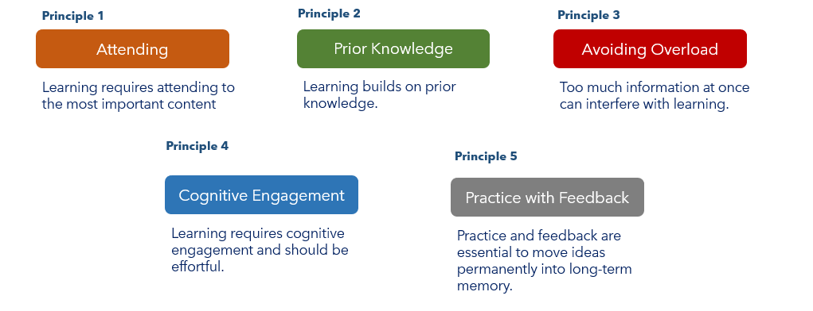  T: (Use the PPT to define cognitive engagement.) If you remember from lesson 4.2, cognitive engagement is the amount of effort and mental energy a student devotes to make sense of what they are learning.  Cognitive engagement means that students use their brains during the entire lesson and are asked questions and complete tasks that make them think hard about a topic, not just repeat a surface level understanding of the facts. Students must think about how or why something is the way it is. Cognitive engagement does not mean students are getting all the right answers right away. Instead, it means that they are making an effort to understand what something new means.  In this course, we will refer to this as teaching that requires effortful thinking or the right amount of challenge that builds understanding of new concepts and transfers them to long-term memory.  S: (Students will record definitions and notes in the student guide.)  T: One of the challenges of teaching is presenting students with challenging content that engages their brains without overloading them.  T: (Return to the memory model and focus student attention on Working Memory -> Learning -> Long-term Memory section: slides 5-7). If you think about the memory model, students focus their attention on something and bring it into their working memory. When you teach lessons that engage cognitively, the student’s working memory is busy making meaning, seeking to understand and make connections about why content is important.  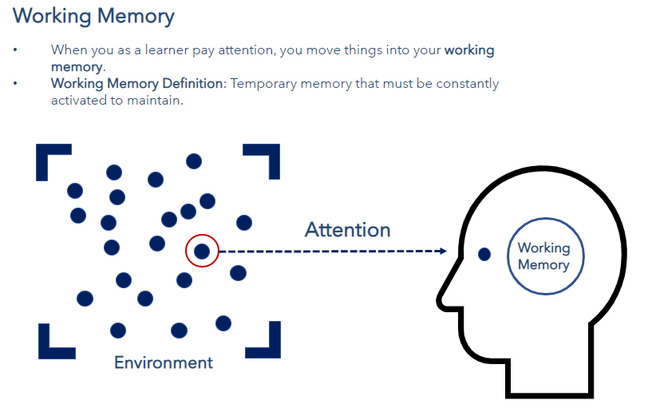  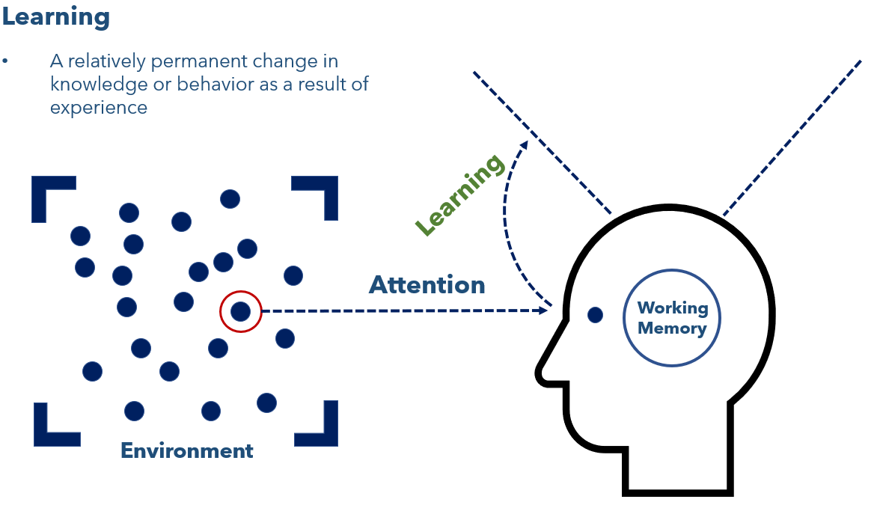  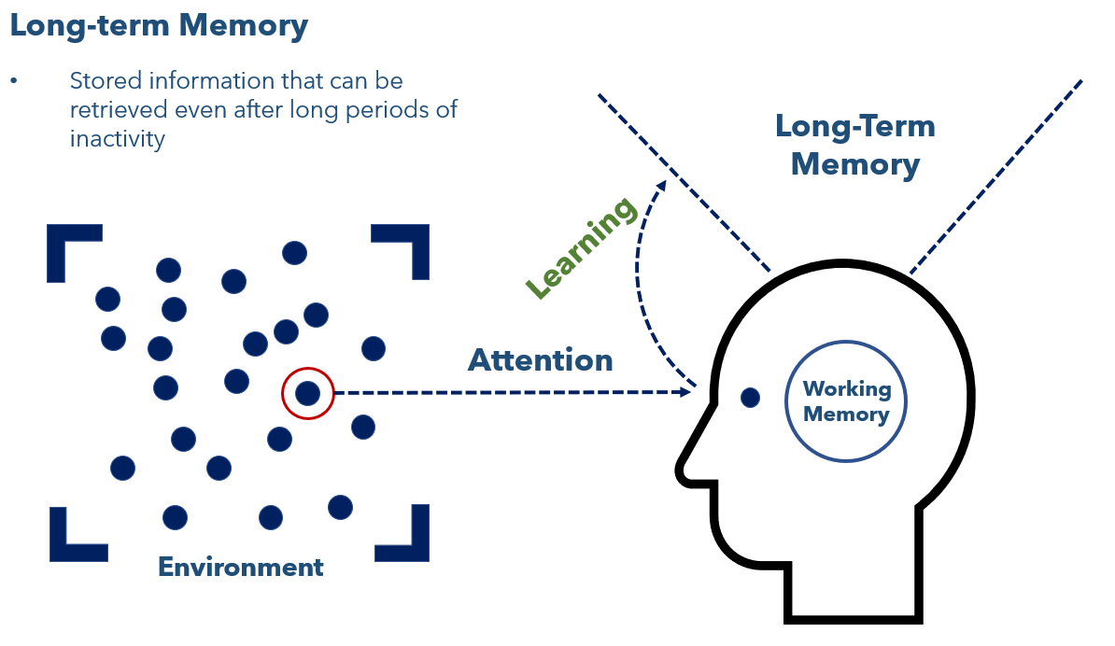  T: A teacher can ensure students are drawing attention to the most important content. During planning, a teacher thinks strategically about the different ways they can ensure students brains are active. | SoL Graphic: Long-term Memory (Slides 5-7)  PPT  Student Guide
10 mins | Guidelines for Cognitive Engagement  T: A teacher needs to answer the question: How do I get my students to cognitively engage with the content I teach?  T: (Share via PPT and allow time for students to write the description and examples in the student guide.) In many cases, cognitively engaging lessons will go beyond simply what happens and get to why and how it happens. Cognitively engaging instruction will often:  - Require students to organize a body of knowledge and understand how it works together.  - Examples:  - Question: What are the organs of the body, their purpose, and how do they work together?  - Task: Create a visual model to show the purpose of each organ of the body and how the organs work together.  - Nonexample:  - Question: What are the organs of the body?  - Task: Using the image of the body, draw and label the organs.  T: Why do the examples require more cognitive engagement?  S: The question goes beyond simple yes/no or call and requires students to think deeply and provide a more in-depth response. The task requires students to create visual model to demonstrate their understanding of the purpose of the organs and how they work together.  T: Yes – the examples require students to make meaning, understand the content, and make connections about why the content is important.  - Require students to think about why something happens.  - Examples:  - Question: Why does the author use this adjective in the opening sentence?  - Task: Draft an opening sentence using descriptive language. Highlight the adjectives used in your sentence and explain why you chose to use that adjective in your sentence.  - Nonexample:  - Question: What adjective does the author use in the opening sentence?  - Task: Make a list of the different adjectives you see used in the paragraph.  T: Why do the examples require more cognitive engagement?  S: The question requires students to think about why an author uses this adjective in a particular place, not just identify what adjective the author used. The task requires students to apply their knowledge of adjectives to develop their own opening sentence and justify their reasoning for using a particular adjective.  T: Yes – the nonexamples are simple recall to determine if a student knows what an adjective is. The nonexamples do not require students to make sense of the content or make connections about why you use adjectives.  - Require students to think about how something happens.  - Examples:  - Question: How does water shape land?  - Task: Build a model to test ways to slow down erosion  - Nonexample:  - Question: Can water shape the land?  - Task: Write a paragraph to explain erosion.  T: Why do the examples require more cognitive engagement?  S: The example question asks students to think about how water shapes land, not just if water can shape land. The task requires students to use their prior knowledge and learning on how water shapes land to develop a way to slow down erosion.  T: Yes - Students have to apply their understanding of how water changes the land to develop the model. To do this, students have to make meaning, understand the content, and make connections about why the content is important.  - Require students to compare and contrast ideas.  - Examples:  - Question: What similar themes are conveyed in these two short stories? How do they convey these themes using different literary devices?  - Task: Write your own short story. With a partner, read each other’s short stories. Create a Venn Diagram to analyze how the themes and the literary devices used to convey those themes compare between your two short stories.  - Nonexample:  - Question: Are the two stories similar or different?  - Task: Write a short paragraph to tell what is similar about the two stories  T: Why do the examples require more cognitive engagement?  S: The example question requires students to move beyond simply looking at how two stories compare by having students consider the similar themes conveyed in the two stories using different literary devices. The task requires students to write a short story and compare their story to a peer’s short story. Students use a Venn Diagram to compare the themes and literary devices used to convey the themes.  T: Yes – students must identify the theme of both stories, explain how each story uses literary devices to convey that meaning, then analyze how those compare between the two short stories. In the nonexamples, students just have to compare two stories. The nonexamples are not specific to the skill of theme and literary devices.  T: By engaging students in questions and tasks that require them to make meaning, understand the content, and make connections about why the content is important, students are engaging the working memory. This leads toward a relatively permanent change in the brain and helps the brain store information in the long-term memory for later retrieval.
10 mins | Practice #1:  T: We are going to look at a short text. As we read the text, we are going to examine text-based questions. We will use the guidelines discussed earlier to identify which questions require effortful thinking and which are surface level questions.  T: An important point to note is that surface level questions are not bad; they just shouldn’t take up a lot of space. Surface level questions should be used to scaffold toward higher-level questions.  T: As you complete the activity, consider whether the questions progress from simple to high-level as understanding is built.  S: (Student groups complete the activity in the student guide.)   | Text Source: Sick by Shel Silverstein
10 mins | Practice #2  T: Now, we will examine a lesson from HQIM to find evidence of cognitively engaging practices.  T: (Provide students with a copy of Lesson 8 (pages 94-101) from the teacher edition of Earth Changes – 3rd grade science lesson. Place students in groups of three to examine the lesson).  T: You are going to work with a small group to examine lesson 8 from a 3rd grade science unit entitled Earth Changes. With your group, analyze the lesson plan to find evidence of challenging work that cognitively engages students through effortful thinking. This can take the form of questions, tasks, etc. You must also identify how the components of the lesson draw on the most important content and helps students think deeply about it. You will record all your evidence in the student guide.  T: Let’s look at the first one together.    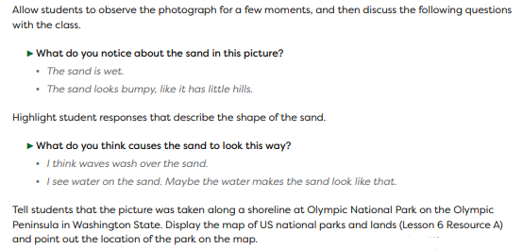  T: The first activity I see students engaging with is where they look at an image of a shoreline at Olympic National Park and consider the following questions:  - What do you notice about the sand in this picture?  - What do you think cause the sand to look this way?  T: (Record on chart as a model while students record in the student guide)  T: How does this activity cognitively engage students?  S: Students analyze the image and make observations. Students must think about what caused something to happen, which means they must draw on their prior knowledge. (Record on chart)  T: Now you will work with your group to analyze the remainder of the lesson plan to find evidence of challenging work that cognitively engages students through effortful thinking.  S: (Student groups complete the lesson analysis in the student guide.)
  Activity/Task | Evidence of Cognitive Engagement
  Students look at an image of a shoreline at Olympic National Park and consider the following questions:  - What do you notice about the sand in this picture?  - What do you think cause the sand to look this way? | Students analyze an image and make observations. Students also must think about why something happens, which forces them to draw on their prior knowledge.
2 mins | Debrief  T: How does a student’s cognitive engagement in the learning process affect their performance and understanding of the content?  S: When a student cognitively engages in the learning process, they are using their Working Memory to make meaning, understand the content, and make connections about why the content is important. This creates a relatively permanent change in the brain and helps the brain store information in the long-term memory for later retrieval.  T: Over the next few lessons, we will talk about cognitively engaging students by: Assigning Rigorous Tasks, Examples & Nonexamples, and Asking Meaningful Questions.
5 mins | Exit Ticket  S: (Complete the exit ticket.) | Exit Ticket

