Student Guide

Lesson 4.08: Cognitive Engagement
Name:
Date:
Bellringer: Read the two scenarios. Determine which would lead to better learning and explain why.
Scenario #1: Mrs. James is teaching students about the changing shape of land. During her lesson, Mrs. James presents images of various landforms and has students consider what caused the formation through a series of open-ended questions. Students explore water and land interactions by using a model to investigate what happens to land when it interacts with waves along a shoreline. Students analyze and compare solutions to problems caused by water changing the shape of the land. Students apply what they have learned using the engineering design process to develop a shoreline protection system that could slow changes to the shore of Montauk Point to prevent the Montauk Point Lighthouse from falling into the ocean.
Scenario #2: Mrs. Emery is also teaching students about the changing shape of land. She presents a PowerPoint on the role water plays in shaping land and creating landforms. Mrs. Emery shows students images of landforms and reads various texts about how different landforms were formed by water. At the end of the lesson, students take an assessment on water and land interactions.

Intro to Cognitive Engagement

Key Vocabulary
Define each key term below.
Cognitive Engagement

Effortful Thinking

Guidelines for Cognitive Engagement
Record the guidelines for cognitive engagement below:
Guideline | Examples | Nonexample
Requires students to organize a body of knowledge and understand how it works together

Requires students to think about why something happens
Requires students to think about how something happens

Requires students to compare and contrast ideas

Practice #1
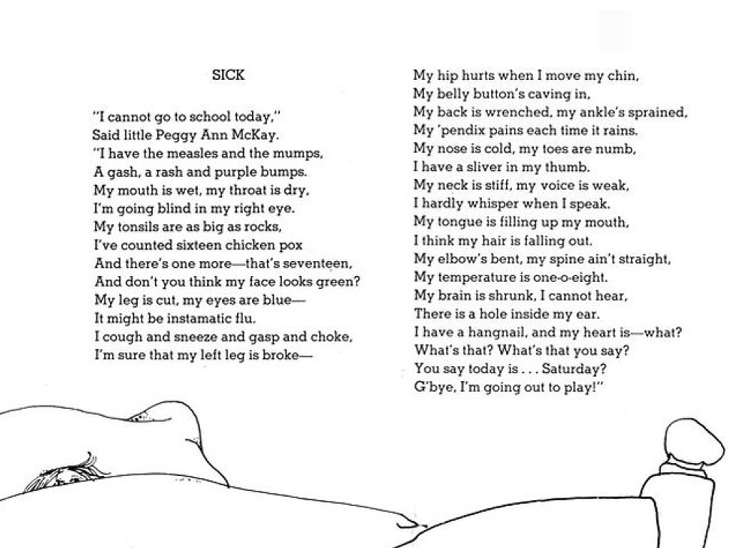

Examine the questions below. Use the Guidelines for Cognitive Engagement to identify which questions require effortful thinking and which are surface level. For each question, provide evidence for why you think the question does or does not cognitively engage students.
Question | Effortful Thinking or Surface Level? | Evidence
How many chickenpox did Peggy have?

Why was Peggy feeling sick?

What can you conclude about the main character?

Is the poem fiction or nonfiction?

How might this text have been different if Peggy would have realized it was Saturday?

Practice #2
Work with your small group to examine Lesson 8 from the 3rd grade science Unit - Earth Changes. With your group, you will analyze the lesson plan to find evidence of challenging work that cognitively engages students through effortful thinking. This can take the form of questions, tasks, etc. You will then identify how the components of the lesson draws on the most important content and helps students think deeply about it. You will record all your evidence in the student guide.
Activity/Task | Evidence of Cognitive Engagement

