Student Guide – Answer Key

Lesson 4.08: Cognitive Engagement
Name:
Date:
Bellringer: Read the two scenarios. Determine which would lead to better learning and explain why.
Scenario #1: Mrs. James is teaching students about the changing shape of land. During her lesson, Mrs. James presents images of various landforms and has students consider what caused the formation through a series of open-ended questions. Students explore water and land interactions by using a model to investigate what happens to land when it interacts with waves along a shoreline. Students analyze and compare solutions to problems caused by water changing the shape of the land. Students apply what they have learned using the engineering design process to develop a shoreline protection system that could slow changes to the shore of Montauk Point to prevent the Montauk Point Lighthouse from falling into the ocean.
Scenario #2: Mrs. Emery is also teaching students about the changing shape of land. She presents a PowerPoint on the role water plays in shaping land and creating landforms. Mrs. Emery shows students images of landforms and reads various texts about how different landforms were formed by water. At the end of the lesson, students take an assessment on water and land interactions.
Scenario #1 would lead to better learning because the students are doing the thinking. The teacher provides just enough content and asks open-ended questions to get students thinking about why and how land changes. Students also use a model to investigate what happens to the land when it interacts with waves along a shoreline which provides a real-world example Students must analyze and compare solutions and apply what they have learned through creating their own shoreline protection system.

Intro to Cognitive Engagement

Key Vocabulary
Define each key term below.
Cognitive Engagement | The amount of effort and mental energy a student devotes to make sense of what they are learning.  Students are using their brains to complete learning activities and make sense of content.
Effortful Thinking | The right amount of challenge that builds understanding of new concepts and transfers them to long-term memory.

Guidelines for Cognitive Engagement
Record the guidelines for cognitive engagement below:
Guideline | Examples | Nonexample
Requires students to organize a body of knowledge and understand how it works together | Question: What are the organs of the body, their purpose, and how do they work together?  Task: Create a visual model to show the purpose of each organ of the body and how the organs work together. | Question: What are the organs of the body?  Task: Using the image of the body, draw and label the organs.
Requires students to think about why something happens | Question: Why does the author use this adjective in the opening sentence?  Task: Draft an opening sentence using descriptive language. Highlight the adjectives used in your sentence and explain why you chose to use that adjective in your sentence. | Question: What adjective does the author use in the opening sentence?  Task: Make a list of the different adjectives you see used in the paragraph.
Requires students to think about how something happens | Question: How does water shape land?  Task: Build a model to test ways to slow down erosion | Question: Can water shape the land?  Task: Write a paragraph to explain erosion.
Requires students to compare and contrast ideas | Question: What similar themes are conveyed in these two short stories? How do they convey these themes using different literary devices?  Task: Write your own short story. With a partner, read each other’s short stories. Create a Venn Diagram to analyze how the themes and the literary devices used to convey those themes compare between your two short stories. | Question: Are the two stories similar or different?  Task: Write a short paragraph to tell what is similar about the two stories

Practice #1
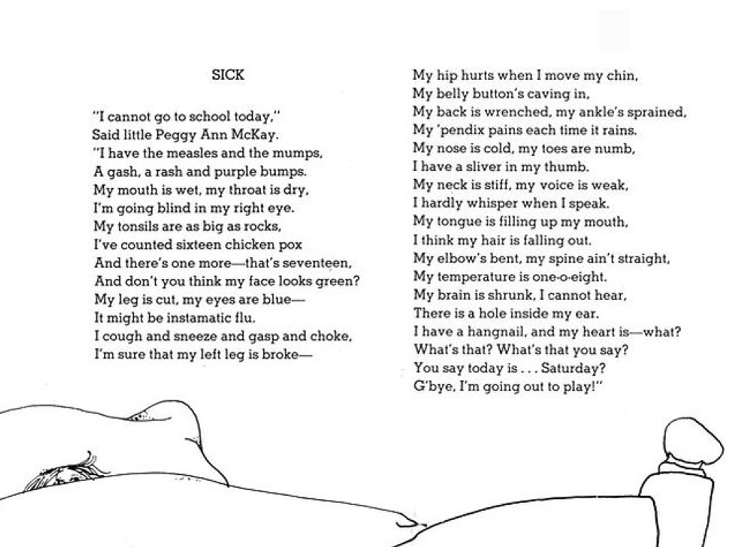

Examine the questions below. Use the Guidelines for Cognitive Engagement to identify which questions require effortful thinking and which are surface level. For each question, provide evidence for why you think the question does or does not cognitively engage students.
Question | Effortful Thinking or Surface Level? | Evidence
How many chickenpox did Peggy have? | Surface level | The answer to the question is surface level and can be found directly in the text.
Why was Peggy feeling sick? | Effortful thinking | This question requires students to infer and think more deeply about why Peggy was feeling this way.
What can you conclude about the main character? | Effortful thinking | This question requires students to make inferences from the text to conduct a character analysis about the main character.
Is the poem fiction or nonfiction? | Surface level | The answer to the question is surface level and recall question.
How might this text have been different if Peggy would have realized it was Saturday? | Effortful thinking | This question asks students to consider a different plot for the story in order to determine what they think might happen.

Practice #2
Work with your small group to examine Lesson 8 from the 3rd grade science Unit - Earth Changes. With your group, you will analyze the lesson plan to find evidence of challenging work that cognitively engages students through effortful thinking. This can take the form of questions, tasks, etc. You will then identify how the components of the lesson draws on the most important content and helps students think deeply about it. You will record all your evidence in the student guide.
Activity/Task | Evidence of Cognitive Engagement
Students look at an image of a shoreline at Olympic National Park and consider the following questions:  - What do you notice about the sand in this picture?  - What do you think cause the sand to look this way? | Students analyze an image and make observations. Students also must think about why something happens, which means they must use their prior knowledge.
Students see a video that shows a shoreline at the park and respond to the following:  - What did you see in the video that might explain what is happening to the sand in the picture?  - How can water affect land? | Students have to organize the knowledge they’ve gained and understand how it works together. Students have to think about how something happens.
Investigate water and land interactions. Students see the wave model and respond to the following:  - What evidence can we look for in the model to help us describe how water can affect land?  - What do you think the waves will do to the land?  - In what other ways or places have you observed water changing land?  Students conduct experiments, make observations, and record data | Students have to find evidence, which requires them to first organize information to understand what is happening and draw on prior knowledge.  Students have to organize and process what they’ve learned to infer what they think might happen.  Students have to compare what they are observing to previous experiences or prior knowledge.
Analyze data – students consider the data they collected from their investigations to consider the following:  - How are the wave, rain, and river models similar? How are they different?  - What evidence do you now have that water can affect land? | Students must compare and contrast ideas.  Students have to organize their new knowledge and explain how why/how something happens.

