Student Guide

Lesson 4.09 Engaging Students in Rigorous and Authentic Tasks
Name:
Date:

Bellringer: Read the passage below. Examine the five questions that correspond to the passage and identify if the question is or is not cognitively engaging. Defend your answers with evidence.
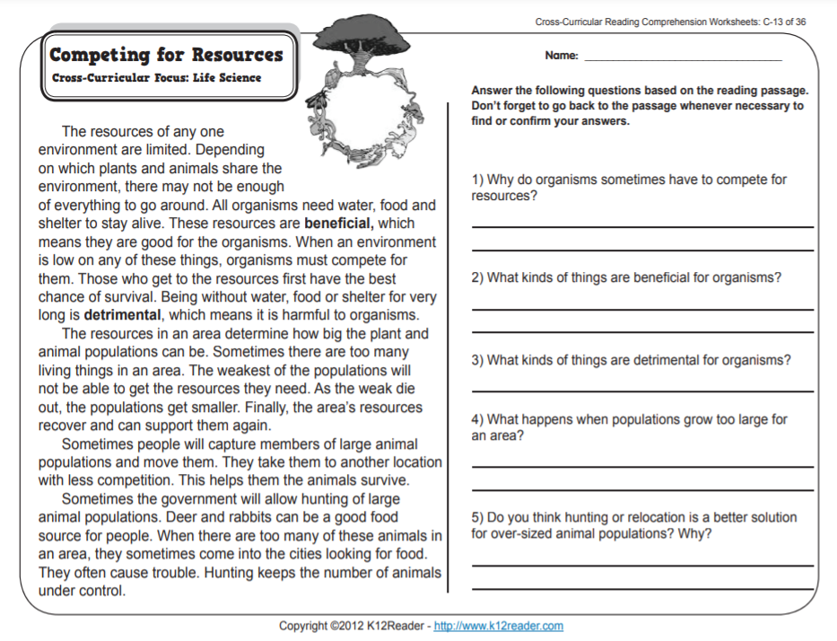

Question | Cognitively Engaging? (Yes or No) | Reasoning
1
2
3
4
5

Intro to Rigorous and Authentic Tasks
Write the definition and notes for each key term below:
Tasks

Rigorous

Guidelines for Rigorous Tasks
Use the space below to record the 5 guidelines for rigorous tasks:

Practice #1
Notes during teacher model:
What are students physically doing? | How does this align to the guidelines for rigorous tasks to help students think deeply about the content?

Read the rest of the launch from Earth Changes Lesson 18 – Teacher Guide Page 190-191. Use the graphic organizer to record what students are physically doing during the task, and how the task aligns to the guidelines for rigorous tasks.
What are students physically doing during the task? | How does this task align to the guidelines for rigorous tasks to help students think deeply about the content?

Practice #2
Analyze the remainder of Lesson 18 to determine the various tasks the teacher uses to engage students in comparing Earth events that change land and the time span over which the events occur. You will use the following questions to help you think about the tasks and record evidence of rigorous and authentic tasks that foster cognitive engagement.
Task | What are students physically doing during the task? | How does this task align to the guidelines for rigorous tasks to help students think deeply about the content?

