Student Guide – Answer Key

Lesson 4.09 Engaging Students in Rigorous and Authentic Tasks
Name:
Date:

Bellringer: Read the passage below. Examine the five questions that correspond to the passage and identify if the question is or is not cognitively engaging. Defend your answers with evidence.
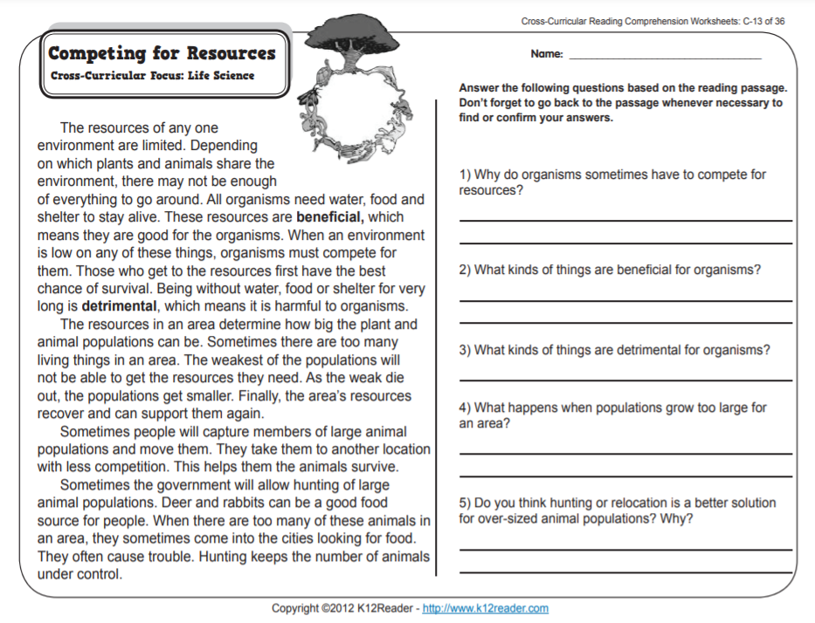

Question | Cognitively Engaging? (Yes or No) | Reasoning
1 | Yes | This question requires that students think about why something happens
2 | No | This question is surface level and can be found in the text
3 | No | This question is surface level and can be found in the text
4 | No | This question is surface level and can be found in the text
5 | Yes | Students must organize their knowledge about the content and understand how it works together

Intro to Rigorous and Authentic Tasks

Key Vocabulary
Define each key term below.
Tasks | Tasks are things that a student must do in class to learn
Rigorous | Task that requires students to engage in effortful thinking to deepen their understanding of the content

Guidelines for Rigorous Tasks
Use the space below to record the 5 guidelines for rigorous tasks:
- Build on and extend prior knowledge
- Involve effortful thought
- Deepen conceptual understanding of material
- Require learners to communicate their understanding to others
- Involve multiple interpretations or paths to a solution

Practice #1
Notes during teacher model:
What are students physically doing? | How does this align to the guidelines for rigorous tasks to help students think deeply about the content?
Students must think about how a sharpened pencil has changed over time | - Builds on and extend prior knowledge  - Involves effortful thought
Students compare their ideas with a partner | - Requires learners to communicate their understanding to others
Students examine an unsharpened pencil and record additional changes they observe in the sharpened pencil now that they have compared the two pencils. | - Build on and extend prior knowledge  - Involve effortful thought
Students consider how other objects, such as the pencil, can change. | - Build on and extend prior knowledge  - Involve effortful thought  - Involve multiple interpretations or paths to a solution

Read the rest of the launch from Earth Changes Lesson 18 – Teacher Guide Page 190-191. Use the graphic organizer to record what students are physically doing during the task, and how the task aligns to the guidelines for rigorous tasks.
What are students physically doing during the task? | How does this task align to the guidelines for rigorous tasks to help students think deeply about the content?
Students respond to open-ended questions and communicate their understanding to others by comparing ideas with the whole group | - Build on and extend prior knowledge  - Involve effortful thought  - Deepen conceptual understanding of material  - Require learners to communicate their understanding to others  - Involve multiple interpretations or paths to a solution
Students participate in a scavenger hunt to find additional classroom objects that show evidence of change | - Deepen conceptual understanding of material  - Involve multiple interpretations or paths to a solution
Students share their findings with the class and explain the evidence they used to determine whether the object had changed. | - Build on and extend prior knowledge  - Involve effortful thought  - Deepen conceptual understanding of material  - Require learners to communicate their understanding to others  - Involve multiple interpretations or paths to a solution

Practice #2
Analyze the remainder of Lesson 18 to determine the various tasks the teacher uses to engage students in comparing Earth events that change land and the time span over which the events occur. You will use the following questions to help you think about the tasks and record evidence of rigorous and authentic tasks that foster cognitive engagement.
Task | What are students physically doing during the task? | How does this task align to the guidelines for rigorous tasks to help students think deeply about the content?
Picture Comparison | Students look at two photographs of Mount St. Helens – one before and one after natural changes happened to it. Students work with a partner to brainstorm ideas on a sticky note about what can cause Earth’s land to change naturally. The teacher then used those sticky notes to create a whole class list of the causes of changes to Earth’s land. | - Build on and extend prior knowledge  - Involve effortful thought  - Deepen conceptual understanding of material  - Require learners to communicate their understanding to others  - Involve multiple interpretations or paths to a solution
Sort Earth Event Cards | Students work in groups to analyze a set of Earth event cards. Groups had to look at the picture cards and create categories to sort the cards into. Groups then had to label their categories with sticky notes. Students used a “Whip Around” routine to share the category names and their reason for putting specific events in each category. | - Build on and extend prior knowledge  - Involve effortful thought  - Deepen conceptual understanding of material  - Require learners to communicate their understanding to others  - Involve multiple interpretations or paths to a solution
Higher-Order Thinking Questions | Higher-order thinking questions were used –  - What evidence do we have that the land on each Earth event card changed?  - How long do you think it took for these changes to happen? Why?  - How did you decide on the order of the Earth events?  - What new questions do you have about how long it takes for Earth events to happen? | - Build on and extend prior knowledge  - Involve effortful thought  - Deepen conceptual understanding of material  - Require learners to communicate their understanding to others  - Involve multiple interpretations or paths to a solution
Order Event Cards | Students worked in groups to place the Earth event cards in order according to how long they think each event took to happen. | - Build on and extend prior knowledge  - Involve effortful thought  - Involve multiple interpretations or paths to a solution

