Unit 4: The Science of Learning

Lesson 4.10: Deepening Student Understanding with Examples and Nonexamples

Lesson at Glance
Warm-Up (5 mins)  - Bellringer | Instruction (20 mins)  - Instruction on Examples and Nonexamples | Application (20 mins)  - Practice 1  - Debrief  - Exit Ticket

TEKS | 4 | The student understands the learner and the learning process. The student is expected to:  - relate and implement principles and theories of human development to teaching and training situations;  - relate and implement principles and theories about the learning process to teaching and training situations
TEKS | 6 | The student plans and develops effective instruction. The student is expected to:  (D) describe principles and theories that impact instructional planning
Objectives | - Identify and analyze the use of examples and nonexamples in a lesson.  - Evaluate the impact of using examples and nonexamples on learning
Rationale/  Summary | In this lesson, students will learn how to use examples and nonexamples in a lesson to help students recognize the concept or idea in a variety of context and develop an accurate mental picture of what a concept is and is not. Students will also learn how to articulate key connections and distinctions to foster cognitive engagement and learning. Students analyze a scenario to identify how the use of examples and nonexamples impacted student learning.
Formative Assessment and Exemplar Response | Students will read the “Slice It Up!” Lesson Plan .  This lesson uses only examples to teach the concept of partitioning a whole into fractions. Students will:  - Identify two examples used in the plan.  - Suggest a specific nonexample the teacher could use to build understanding.  - Describe how the teacher could help students understand the connections and differences between the examples and nonexamples.  See Exit Ticket Answer Key for exemplar response.
Vocabulary | Example |  | Something that shows what is expected or what something is
Vocabulary | Nonexample |  | Something that shows what is not expected or what something is not
Vocabulary | Frayer Model |  | a graphic organizer that helps students clarify the meaning of vocabulary words or concepts

Est Time | Instructional Activities (including formative assessments) | Materials
5 mins | Bellringer: You are going to look at two tasks to determine which task is more rigorous based on the guidelines for rigorous tasks. Use the guidelines for rigorous tasks to support your answer.  Task 1: What is 1/3 of ½?  Task 2: Ms. Green makes a full pan of brownies to bring to school. She’s going to bring half of the pan to share with her students. She knows many of her students like icing, so she needs to figure out how much icing to make. If she ices one third of the part that she’s taking to school, how much of the whole pan would that be? Write an equation to represent this, and then use a fraction bar or number line to explain your answer.  T: Which task is more rigorous based on the guidelines rigorous tasks? Use evidence from the tasks to support your response.  T: (Provide time for students to complete the bell ringer.)  T: Which task is more rigorous and why?  S: Task 2 because students build on and extend their prior knowledge of fractions and use effortful thinking by analyzing a scenario, drawing a visual representation, and creating an equation to explain their visual. Students communicate their understanding to others by explaining their answer with the class or partner. By allowing students to represent their thinking using either a fraction bar or number line, students have multiple paths to a solution. Lastly, task two requires a conceptual understanding of the material.  T: Yes – task 2 requires a conceptual understanding of the math. Students must explain the mathematical reasoning behind it, not just use a procedure to find the right answer. Tasks that require cognitive engagement allow students space to communicate an understanding of the concept, not just a right answer. | PPT  Student Guide
20 mins | Instruction on Examples and Nonexamples  T: Today, we are going to talk about an important way instruction can cognitively engage students – using examples and nonexamples.  T: (Share via PPT while students take notes in the student guide). There are three criteria that can help deepen meaning and learning for students (Deans for Impact):  Success Criteria: Deans for Impact  - Lessons should include varied examples that will help students recognize the concept or idea in a variety of contexts.  - Lessons should include contrasting non-examples that will help students develop an accurate mental picture of what a concept is and is not.  - Lessons should prompt students to elaborate about the connections and differences among the examples and non-examples.  T: Let’s explore the meaning of each of these guidelines.  T: (Share via PPT while students take notes in the student guide.) Let’s look at the first guideline.  - Lessons should include varied examples that will help students recognize the concept or idea in a variety of context.  T: An example is something that shows what is expected or what something is.  T: Here is an example. (Via PPT, display the word solid and the definition). Who can read me the definition of the word solid?  S: A type of matter that keeps its shape.  T: Here’s are some examples of what a solid might look like. (Show via PPT)  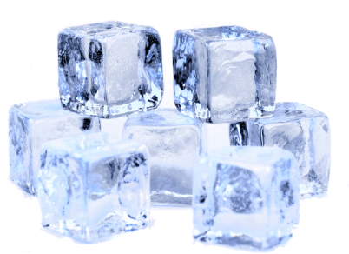  T: Showing varied examples helps students recognize the concept or idea in a variety of contexts which helps develop a more complex understanding of the word.  T: Now, let’s look at guideline 2.  - Lessons should include contrasting non-examples that will help students develop an accurate mental picture of what a concept is and is not.  T: A nonexample is something that shows what is not expected or what something is not.  T: I’m going to show you a few other pictures. The first picture shows an example of a solid. (Show via PPT)  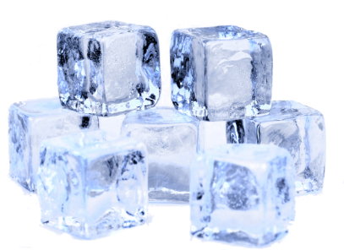  T: The second picture shows water.    T: Why is water a nonexample of a solid?  S: It does not keep its shape.  T: Here are a few more nonexamples.  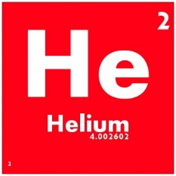  T: Why are these nonexamples?  S: They do not keep their shape. The soda only keeps its shape because it is in the cup which is a solid. The air and the helium only keep their shape if they are contained within something, like a helium tank.  T: It is important for teachers to use both examples and nonexamples to help students better understand a concept.  T: Let’s look at guideline 3.  - Lessons should prompt students to elaborate about the connections and distinctions among the examples and non-examples.  T: It is important that students are able to articulate the connections and differences between the examples and nonexamples.  T: Take a look at the examples of solids (Show via PPT). The examples look quite different, but they all are examples of solids.”  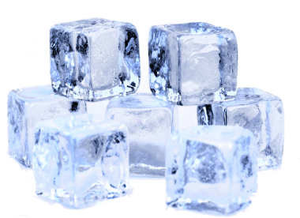  T: You might also examine the distinctions between the examples and nonexamples. The picture on the left shows ice. The picture on the right shows ice that has melted or water.  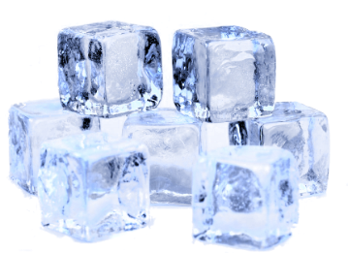  T: Let’s reread the definition of solid. (Show definition via PPT)  T: Why isn’t the picture on the right aligned to the definition? Why would we say the picture on the left is an example?  S: According to the definition, a solid is a type of matter than keeps its shape. Ice can hold its shape, but water cannot.  T: Yes -they are both states of matter, but only the ice is considered a solid.  T: When teachers use prompts to help students think about and articulate key connections and distinctions, it makes it more likely that the new information gets stored in long-term memory.  T: We will do an example together. Suppose you were teaching students about similes. After defining similes (a phrase that uses the words like or as to describe someone or something by comparing it with someone or something else that is similar), you need to provide them with examples. What are examples of similes?  S: (Provide examples of similes and add them to their notes)  T: These are all examples of similes. They all use “like” or “as” to compare two things. What are some nonexamples of similes?  S: (Answers will vary but should include examples of metaphor or other figurative language. Students add nonexamples to notes).  T: What connections between the examples and nonexamples would you help students make?  S: All are examples of figurative language.  T: What differences between the examples and nonexamples would you help students make?  S: Similes make comparisons using “like” or “as.”  T: Try the next example on your own. Think of how you could prompt students to make connections and identify differences between the examples and nonexamples.  S: (Work independently on the third example)  T: (Call on several students to share their responses). We’re next going to work in pairs to evaluate two approaches to introducing a concept. Remember that people develop a better understanding of content when they are provided with examples, nonexamples, and are required to think about the connections and differences between them. | Example adapted from Deans for Impact  PPT  Student Guide
15 mins | Practice #1  T: With a partner, you are going to look at two scenarios. (Share via PPT)  In his first period math class, Mr. B has his students write the definition and some examples of integers.  A Frayer model is a graphic organizer that helps students clarify the meaning of vocabulary words or concepts.  In his second period class, he and his students complete a Frayer model to introduce the concept of integers.  Read and compare the two approaches:  First Period:  Integers: An integer is a number with no decimal or fractional part, from the set of negative and positive numbers, including zero.  Examples: -5, 0, -1, 5, 8, -97, and 3,043  Second Period:  T: Work together to determine what is similar and different between the First Period and Second Period activities. Consider how the use of the Frayer model in the Second Period activity could lead to a better understanding of the concept of integers. Then explain how in Mr. B’s Second Period, he could prompt his students to make connections and identify differences between the examples and nonexamples.  S: (Students complete activity in student guide). | PPT  Student Guide
  Definition  An integer is a number with no decimal or fractional part, from the set of negative and positive numbers, including zero. | Characteristics  Are rational numbers.  No fractions  No decimals  Can be positive, negative, or zero  Integer
  Example  -5, 0, -1, 5, 8, -97, and 3,043 | Nonexample  1/2 , -3.02, 5 ¾ , $\sqrt{2}$
2 mins | Debrief  T: Why is it important to use examples and nonexamples during instruction? What impact do they have on learning?  S: Examples and nonexamples help students make sense of the content. It helps students think about and articulate key connections and distinctions, which makes it more likely that the new information gets stored in long-term memory.
5 mins | Exit Ticket  S: (Complete the exit ticket.) | Exit Ticket

Berlin, R. (2021, April 9). Putting learning science in practice: Using examples and non-examples. Deans for Impact. Retrieved from https://deansforimpact.org/lbsd-examples-non-examples/

