Unit 4: Science of Learning

Lesson 4.13: Practice with Feedback | Deliberate Practice

Lesson at Glance
Warm-Up (5 mins)  - Bellringer | Instruction (20 mins)  - Simple Memory Model & Vocabulary (10 mins)  - Intro to Deliberate Practice  - Deliberate Practice: Think-Aloud | Application (20 mins)  - Practice 1 (12 mins)  - Debrief (3 mins)  - Exit Ticket (5 mins)

TEKS | 4 | The student understands the learner and the learning process. The student is expected to:  - relate and implement principles and theories of human development to teaching and training situations.  - relate and implement principles and theories about the learning process to teaching and training situations.
Objectives | - Understand why practice is vital to learning.  - Evaluate the qualities of deliberate practice.
Rationale/  Summary | In this lesson, students will explore the qualities of deliberate practice and how it relates to the simple memory model. They will learn that practice with feedback is an essential part of engaging the working memory and moving ideas and content to long-term memory.
Formative Assessment and Exemplar Response | - A kindergarten teacher plans to teach the following math lesson on the attributes of two related objects. Examine the lesson goal and the corresponding practice. Does this practice activity reflect the qualities of deliberate practice? Explain why or why not.  Instructional Goal: Students will analyze to find two objects that are the same or not the same.  Planned practice: Students will be given pairs of socks in a variety of patterns, colors, sizes, and lengths in a laundry bag. The teacher will hold up two socks and students will utilize the sentence stems “these are exactly the same because….” Or “these are NOT exactly the same because…” Then students will be given a set of pictures that they will sort individually into piles of “exactly the same” or “not exactly the same”. After they are finished sorting, they will share their thinking with a partner.  - Why is deliberate practice important to the learning process?  See Exit Ticket – Answer key for exemplar response.
Vocabulary | Guided Practice |  | Practice where students are engaged in working on problems or practicing skills with support provided by the teacher
Vocabulary | Independent Practice |  | Practice where students engage in working on problems or practicing skills on their own
Vocabulary | Deliberate Practice |  | Practice that performs the learning goal (authentic), is spaced over time, is low-stakes and is paired with timely feedback for improvement
Vocabulary | Feedback |  | Practice of giving students information about their performance against a standard with the purpose of improving student performance

Est Time | Instructional Activities (including formative assessments) | Materials
4 mins | Bellringer: Have you ever heard someone use the phrase “practice makes perfect?” Why do you think practicing helps to learn new concepts or ideas? How does this relate to what you already know about the simple memory model? | Student Guide
1 min | T: Based on the simple memory model, how does practice help people learn?  S: Practicing involves focus and repetition, which allows for the learner to help to move ideas from the working memory to long term memory.
10 mins | Return to the Simple Memory Model & Vocabulary  T: (Revisit the 5 Principles slide.) In earlier lessons we talked about avoiding cognitive overload through prior knowledge, sequencing, and scaffolding. We also discussed the value of cognitive engagement.  T: Now, we are going to explore Practice with feedback, another one of the principles of teaching based on the science of learning.  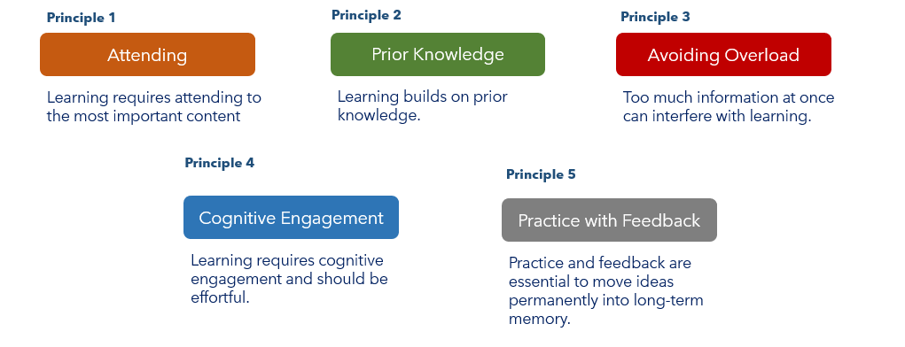  T: Today, we will learn why practice with feedback is an essential part of engaging the working memory and moving ideas into long-term memory. (Display the lesson ppt.) Look at the picture of the simple memory model on your student guide.  S: (Take out 4.13 Student guide.)  T: Please record notes on your student guide.  T: Practice happens after you introduce students to new content. What are some ways that your teachers ask you to practice new learning?  S: In math class, we work math problems for homework. In PE we play the game to practice a skill, we use flash cards for vocabulary, etc.  T: When students practice, for example, by doing a set of math problems or writing an argumentative essay, you deeply engage their working memory in sense-making and learning. Practice helps you move from a novice, meaning knowing a little about the content, to expert, meaning understanding the content and how it works.  T: Not all practice is the same and we can use different types of practice to support student learning. Lessons often include guided practice, where students solve problems or apply a skill with some scaffolding to make sure they don’t lose their way. Then we may move to independent practice, where students solve problems or apply a skill by themselves.  S: (Record the definitions for guided practice and independent practice in their student guides.)  T: Often, during practice, students get things wrong. This is part of the learning process. Feedback should be given to the student throughout practice. Feedback helps the student to improve and better learn the content.  T: In this lesson we will focus on a type of practice called deliberate practice. Deliberate practice is practice that performs the learning goal (authentic), is spaced over time, is low-stakes and is paired with timely feedback for improvement. Let’s look at some characteristics of deliberate practice now.  S: (Write down the definition of deliberate practice on their student guides) | PPT  Student Guide
5 mins | Intro to Deliberate Practice  T: As we discuss the characteristics of deliberate practice, take notes on your student guide.  S: (Take notes on student guide during PPT.)  T: While most learning requires practice, deliberate practice supports the most effective learning. For practice to be deliberate it should be:  - Authentic. The practice should require the student to perform the actual learning goal.  - If you are learning to write thesis statements for an essay in English class, you might want students to practice writing thesis statements before writing the whole essay.  - A non-example of authentic practice would be if students were asked to read through essays and identify the thesis statements.  T: Why is reading through the essays to identify the thesis statements NOT an example of deliberate practice?  S: While still working in the same context, for the practice to be deliberate students need to be authentically practicing the skill, which in this case is writing thesis statements.  T: Another characteristic of deliberate practice is that it is spaced over time. Knowledge or skills are made more lasting and permanent in your long-term memory when you practice them regularly over time.  - An example of practice that is spaced over would be when you are introduced to new vocabulary word in Spanish class. You are initially introduced to the words, then you practice using the words in speaking and writing each day throughout the entire unit.  - A non-example of practice that is spaced over time would be if you were introduced to some new vocabulary words in Spanish class today, used them in your work but never reviewed or applied them again. Likely you would not remember these words because you did not have the opportunity to revisit and refine your learning through practice spaced over time.  T: Why does practicing the words repeatedly throughout the unit important as deliberate practice?  S: By regularly practicing, students pull ideas from their long term-memory into working memory and refresh and strengthen their understanding of that content.  T: Deliberate practice is also low Stakes. The point of practice is to check your understanding before the stakes are high. High stakes can refer to many situations, but generally it refers to when students do not feel psychologically safe enough to practice for fear of judgement, either by grading or other people.  - If you wanted to practice a big speech you were going to give, you’d want to practice at home to get better at the delivery, not stumble on the words and work to make your thoughts clearer. Then you may deliver that speech to a trusted friend to get their opinion before the actual day of the speech.  - A non-example of low stakes would be being forced to practice your speech in front of a large group of people you didn’t know.  T: Why is being forced to practice the speech in front of a large group of people you didn’t know a non-example of low stakes?  S: It is not low stakes because you might feel self -conscious or uncomfortable practicing in front of you don’t know or feel like they are judging you.  T: The final characteristic of deliberate practice we will discuss is practice that is paired with timely feedback. Throughout the practice it is important to receive timely feedback to ensure that the skills and content you are practicing are correct.  T: An example of practice with timely feedback is if a teacher circulates around the room during independent practice and identifies one strength and one areas of growth for each student.  T: A non-example of would be if a teacher collected student work, graded it for completion and returns it one week later. Why is this a non-example?  S: The teacher didn’t provide feedback to students as to their correctness if it was only graded on completion. Also, by the time it was returned a week later, students would have already moved on from that concept and not had a chance to revise and improve their learning from the feedback. | PPT  Student Guide
5 mins | Deliberate Practice: Think-Aloud  T: Now we will look at an example of how deliberate practice can be implemented within a lesson. In your student guide you have been provided an example of a lesson objective and some suggested practice. Please locate the example in your student guide under instructional activity 1. Please read through the learning goal and the suggested practice.  S: (Locate & read through Instructional Activity 1 on their student guide.)  T: We just learned that deliberate practice is authentic, spaced over time, low stakes and timely feedback is provided on the practice. In this example, you will notice that the learning goal is to identify the steps of the scientific method and examples of each step.  T: Why is this an example of authentic practice?  S: Because the students are matching the step with its definition and an example of each step.  T: Why is this activity low stakes?  S: Students are not being provided a grade for this activity. matching activity allows students to match examples before creating their own.  T: How do students receive feedback on their practice?  S:When they check their answers with a peer.  T: The only characteristic that might not be observed here is spacing the practice over time. Does anyone have an idea of how a teacher might space this practice over time for students?  S: The teacher might review these steps the next day or they could have the students identify the steps each time they conduct an experiment. | Student Guide
5 mins | Non-Example of Deliberate Practice: Think-Aloud  T: Now let’s look at a non-example of deliberate practice. This is where the practice does not meet the characteristics of deliberate practice.  T: Please locate and read through the example of a lesson and suggested practice provided under Instructional Activity 2 on your student guide.  S: (Locate and read instructional activity 2 on student guide.)  T: What is the lesson goal?  S: To solve word problems using fractions.  T: What are students doing in the learning task?  S: Students are practicing the skills representing their thinking with fractions, but they are not using these skills within word problems.  T: This is a nonexample because the practice does not align with the learning goal. It is not authentic.  T: Why is this practice high stakes?  S: Students are asked to turn the worksheet in for a grade at the end of class.  T: So, this task is not authentic, and it is high stakes. What else makes it a nonexample?  S: Students were not given the opportunity to receive feedback or check their work during the practice.  T: What might the teacher do to adjust the practice to make it align better with the characteristics of deliberate practice?  S: The teacher could make sure that the problems assigned were word problems utilizing the fraction skills. Also, the teacher could provide an opportunity for the students to check their answers with each other or check their own work. It would also be important to allow students the practice before assigning the grade to ensure that the practice is low stakes. | Student Guide
12 mins | Practice 1: 2nd Grade ELA lesson on Adjectives  T: (Arrange students into groups of 2.)  T: You will now get a chance to examine another lesson example to look for the characteristics of deliberate practice. Please locate the student practice on your student guide.  T: In groups of 2, you will read through the lesson provided and identity the student opportunities for practice in the lesson. As you consider each practice, determine if you have evidence that supports if the practice aligns to the characteristics of deliberate practice. You will have 7 minutes to complete this work. You will share your thinking with another group after everyone has time to examine the lesson.  S: (Work in their groups to evaluate the lesson.)  T: (After 7 minutes, instruct the students to share their thinking with another group for 3 minutes.) | Student Guide
3 mins | Debrief  T: In our lesson today, we discussed that practice is an essential part of the learning process. Why is practice so important?  S: Practice allows you to move information from the short term to long term memory. By returning to previous learning with practice you can retrieve information from the long-term memory, refine and strengthen understanding through practice.  T: We also discussed that while most learning requires practice, not all practice is the same. Deliberate practice is important for learning. Can anyone recall the four characteristics of deliberate practice that we discussed?  S: Authentic, spaced out over time, low stakes, and practice with feedback  T: Why is it important for our practice to be deliberate?  S: We need to make sure that our practice is aligned to the task (authentic), that it is spaced out over time to strengthen and refine the learning in long term memory, that students have an opportunity to practice without the pressure of grades to build confidence and that we receive feedback to ensure that our practice is on the right track.
5 mins | Exit Ticket  S: (Complete the Exit Ticket.) | Exit Ticket

