Student Guide

Lesson 4.13: Practice with Feedback | Deliberate Practice
Name:
Date:

Bellringer:
Have you ever heard someone use the phrase “practice makes perfect?” Why do you think practicing helps to learn new concepts or ideas? How does this relate to what you already know about the simple memory model?

Simple Memory Model
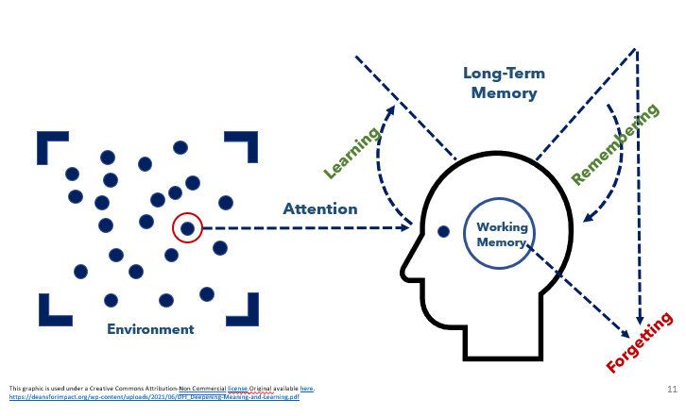

Key Vocabulary
Define each key term below.
Guided Practice
Independent Practice
Deliberate Practice
Feedback

Notes: Deliberate Practice
Characteristics of Deliberate Practice
Characteristic | Description | Example | Non-Example
 |  |  | Students were asked to read through essays and identify the thesis statements. They are not practicing the skill of writing the thesis statements which makes the practice authentic.
 |  | If you are introduced to new vocabulary words in Spanish class. You are initially introduced to the words, then you practice using the words in speaking and writing each day throughout the entire unit.
 |  |  | A non-example of low stakes would be standing up in front of a large group of people you don’t know to practice the speech. This is high stakes because you might feel self -conscious or uncomfortable practicing in front of you don’t know or feel like they are judging you.
 |  | A teacher circulates around the room during independent practice and identifies one strength and one areas of growth for each student.

Instructional Activity 1: Example of Deliberate Practice

Learning Goals | Suggested Practice | Characteristics of Deliberate Practice
Students will be able to identify the steps of the scientific method and examples of each step | After reviewing the steps of the scientific method as a class, students are given cards that contain the description of each step and examples of each step of the scientific method. Students will match the definition and examples to the appropriate step. After completing the matching exercise, students will check their answers with a partner.

How might this example be extended to include spaced over time

Instructional Activity 2: Non-Example of Deliberate Practice
Learning Goals | Suggested Practice | Characteristics of Deliberate Practice
Students will solve word problem using fractions | A teacher provides instruction on how to solve a word problem using fractions. Students are provided a worksheet where they are directed to draw a picture to represent their thinking and then solve each problem. Students are asked to turn in the worksheet at the end of class to be graded.

Student Practice: 2nd Grade ELA Scenario: Lesson 4 Adjectives
(Adapted from Amplify Texas Grade 2 Skills 5)
Lesson goal: Students will recognize the suffix -ous indicates a word is an adjective and will pair adjectives with nouns.
Lesson:
- As a whole group, the class will read from a story called “The Beginning” from Sir Gus.
- As they read, students will play a game called “Adjective Hunt” where they will find as many adjectives as they can in the story. The teacher will record the words on the board as they are identified by the class.
- The teacher will introduce a type of adjective that ends in -ous, providing the example of “famous.”
- Students will sound out the word and then use the root to determine the meaning.
- Students will create a list individually of all the words they know that end in -ous. The teacher will ask for examples and record them on the board.
- After creating the list, the students will think of nouns that they could pair with the adjectives. This will be done individually.
- Students will then share the pairings they created with a partner.
- For homework, students are given another passage to read and identify any -ous adjectives and their respective nouns.
- At the end of class, the teacher mentions they will review this idea again at the beginning of class the next day.
Where do you find evidence of deliberate practice in the lesson plan shared above?
Characteristics of Deliberate Practice | Evidence of the Characteristic

