Student Guide – Answer Key

Lesson 4.13: Practice with Feedback | Deliberate Practice
Name:
Date:

Bellringer:
Have you ever heard someone use the phrase “practice makes perfect?” Why do you think practicing helps to learn new concepts or ideas? How does this relate to what you already know about the simple memory model?
Answers will vary. Students may say that practice requires focus and repetition, which is important for moving information from the working memory to long term memory.

Simple Memory Model
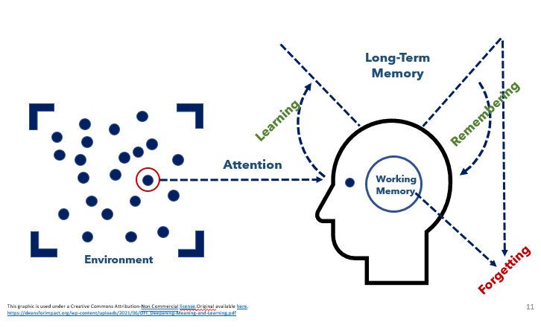

Key Vocabulary
Define each key term below.
Guided Practice | Practice where students are engaged in working on problems or practicing skills with support provided by the teacher
Independent Practice | Practice where students engage in working on problems or practicing skills on their own
Deliberate Practice | Practice that performs the learning goal (authentic), is spaced over time, is low-stakes and is paired with feedback for improvement.
Feedback | Practice of giving students information about their performance against a standard with the purpose of improving student performance.

Notes: Deliberate Practice
Characteristics of Deliberate Practice
Characteristic | Description | Example | Non-Example
Authentic | Practice should require the student to perform the actual learning goal. | If the goal is to write a thesis statement for an essay, students should practice writing thesis statements before moving to writing the entire essay. | students were asked to read through essays and identify the thesis statements. They are not practicing the skill of writing the thesis statements which makes the practice authentic.
Spaced Over Time | Practice should happen regularly over time. | If you are introduced to new vocabulary words in Spanish class. You are initially introduced to the words, then you practice using the words in speaking and writing each day throughout the entire unit. | If you learned new vocabulary in Spanish class, practiced it in that class but never returned or used that vocabulary again, that is not an example of practice spaced over time.
Low Stakes | Practice should happen before assigning major grades or placing high value. | If students must give a big speech, they may practice at home first, then give to a friend before delivering speech in class. | A non-example of low stakes would be standing up in front of a large group of people you don’t know to practice the speech. This is high stakes because you might feel self -conscious or uncomfortable practicing in front of you don’t know or feel like they are judging you.
Paired with Timely Feedback | Practice provides opportunities to check to make sure that the skills and content practiced are correct. | A teacher circulates around the room during independent practice and identifies one strength and one areas of growth for each student. | A teacher collects student homework, grades it for completion and returns it a week later.

Instructional Activity 1: Example of Deliberate Practice

Learning Goals | Suggested Practice | Characteristics of Deliberate Practice
Students will be able to identify the steps of the scientific method and examples of each step | After reviewing the steps of the scientific method as a class, students are given cards that contain the description of each step and examples of each step of the scientific method. Students will match the definition and examples to the appropriate step. After completing the matching exercise, students will check their answers with a partner. | Authentic (task matches the learning goal)  Low Stakes (not for a grade, students provided the definitions & examples and asked to match rather than recall from memory)  Practice with timely feedback: Students check answers with partner

How might this example be extended to include spaced over time?
The teacher could review the steps again the next class and students could identify the steps in actual experiments they are conducting before taking the test at the end of the unit.

Instructional Activity 2: Non-Example of Deliberate Practice

Learning Goals | Suggested Practice | Characteristics of Deliberate Practice
Students will solve word problem using fractions | A teacher provides instruction on how to solve a word problem using fractions. Students are provided a worksheet where they are directed to draw a picture to represent their thinking and then solve each problem. Students are asked to turn in the worksheet at the end of class to be graded. | Not authentic – students are not practicing word problems; they are practicing only representing fractions. This doesn’t help them to develop the skills to use those facts in a word problem.  Not low stakes – students are not given the opportunity to practice refining their learning and understanding before a grade is awarded  No opportunity for timely feedback – students did not receive any feedback from the teacher or have opportunities to check their work.

Student Practice: 2nd Grade ELA Scenario: Lesson 4 Adjectives
(Adapted from Amplify Texas Grade 2 Skills 5)
Lesson goal: Students will recognize the suffix -ous indicates a word is an adjective and will pair adjectives with nouns.
Lesson:
- As a whole group, the class will read from a story called “The Beginning” from Sir Gus.
- As they read, students will play a game called “Adjective Hunt” where they will find as many adjectives as they can in the story. The teacher will record the words on the board as they are identified by the class.
- The teacher will introduce a type of adjective that ends in -ous, providing the example of “famous.”
- Students will sound out the word and then use the root to determine the meaning.
- Students will create a list individually of all the words they know that end in -ous. The teacher will ask for examples and record them on the board.
- After creating the list, the students will think of nouns that they could pair with the adjectives. This will be done individually.
- Students will then share the pairings they created with a partner.
- For homework, students are given another passage to read and identify any -ous adjectives and their respective nouns.
- At the end of class, the teacher mentions they will review this idea again at the beginning of class the next day.
Where do you find evidence of deliberate practice in the lesson plan shared above?
Characteristics of Deliberate Practice | Evidence of the Characteristic
Authentic | Students identify adjectives as a whole group first, brainstorm -ous adjectives and then pair them with nouns. Students are given another passage for homework where they read and identify the -ous adjectives and the respective nouns.
Spaced Over Time | The teacher provides time for students to practice in class, practice independently with homework and then will review the ideas at the beginning of the next class as well.
Low stakes | Students are provided opportunities to practice with guided practice (whole class), independent practice (individually) and as homework. The students are not assessed on their work for a grade.
Practice with timely feedback | Students have an opportunity for guided practice at the beginning of the lesson where feedback could be provided by the teacher. Students also share their thinking with a partner after they are pairing the -ous adjectives with nouns.

