Student Guide

Lesson 4.14: Practice with Feedback | Quality Feedback
Name:
Date:
Bellringer: You have asked two friends to review the poem that you have just written for your English class. Below is the feedback that you received from each:
- Friend 1: The imagery in your work is very strong. I was able to see the environment that you described and felt like I was there, and it pulled me in as a reader.
- Friend 2: I really liked your poem. Great job!
After considering the feedback, which of the two do you feel is most helpful? What makes the feedback more helpful than the other?

Return to the Memory Model
Label the missing components of the Memory Model diagram.


Key Vocabulary
Define the key term below.
Term | Definition
Feedback

Quality Feedback Criteria Notes
Criteria | Description
Specific and Clear
Focused on task rather than the student
Identifies strengths & areas of improvement

Practice 1: Summary Paragraphs
A 3rd grade ELA teacher asked her students to write a summary paragraph for the text that they just read about octopi. Below are the success criteria for the paragraph:
Criteria | Description of Success
Paragraph Structure | The paragraph must have 5 or more complete sentences, using capitalization and punctuation
Supporting Details | The paragraph must have 3 or more supporting details from the text.
Main Idea | The main idea of the text must be included in the summary

Student Work Examples | Questions
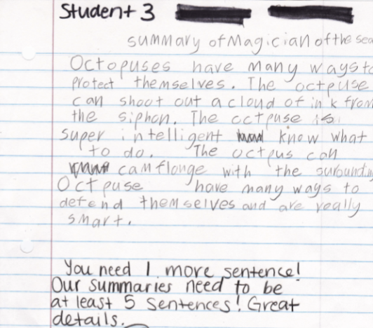 | Is the feedback provided an example of quality feedback? Justify using the criteria for quality feedback.
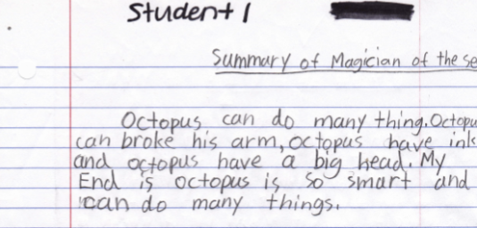 | Based on the work, how would you provide quality feedback to student 1?

Practice 2: Non-Example of Quality Feedback
A social studies teacher asked students to write a summary about the Boston Tea Party and include a picture that illustrated what happened during the Boston Tea Party. Below was her success criteria for the assignment:
Criteria | Description of Success
Summary of Boston Tea Party | Summary should include when the Boston Tea Party happened, who was involved, what happened and why it happened.
Representative Picture | Picture accurately shows some aspect of the Boston Tea Party and enhances the understanding for the reader.
Writing Conventions | Appropriate capitalization, punctuation and spelling are used throughout.

Student Work Example | Questions
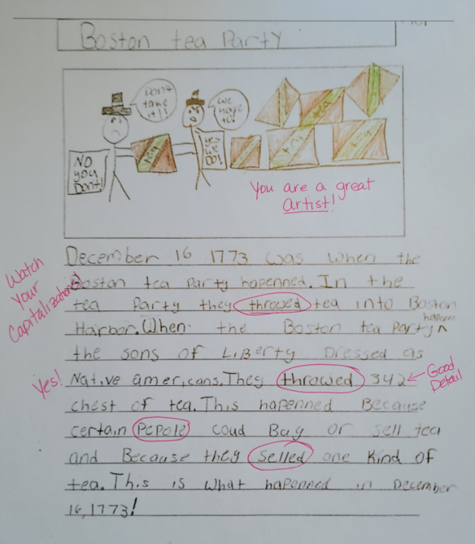 | Why is the feedback provided NOT an example of quality feedback? Justify using the criteria for quality feedback.  What changes would you make to the feedback to make it better align to the characteristics of quality feedback?

Practice 3: Cookie Dough Math
Below is an example of student work on cookie dough math. Consider the following success criteria provided to the students when completing their work:
Criteria | Description of Success
Represent mathematical thinking | Students should show the calculations and thinking used to determine the answer to each problem
Utilize appropriate mathematical strategies | Students should identify an appropriate mathematical strategy and utilize it to calculate the answer to each problem.
Explain mathematical reasoning | Students should explain their mathematical reasoning in words when prompted by the question.
Calculate the appropriate answer | Students should utilize the strategies to determine the correct answer to each question.

Examine the student work below. What quality feedback could you provide to the student to improve their work based on the success criteria outlined above? (Assume all the calculations are correct).

Record the feedback that your group members provided.

What feedback would you provided as a group to this student? Explain how it meets the characteristics of specific and clear, focused on the task and not the student and identifies strengths and areas of improvement.

