Student Guide – Answer Key

Lesson 4.14: Practice with Feedback | Quality Feedback
Name:
Date:
Bellringer: You have asked two friends to review the poem that you have just written for your English class. Below is the feedback that you received from each:
- Friend 1: The imagery in your work is very strong. I was able to see the environment that you described and felt like I was there, and it pulled me in as a reader.
- Friend 2: I really liked your poem. Great job!
After considering the feedback, which of the two do you feel is most helpful? What makes the feedback more helpful than the other?
The feedback from friend number 1 was most helpful because it was specific. It discussed the strong points of my poem and how it affected the reader. The feedback from friend number 2 was nice to hear but did not contain any specific information about what made the poem great.

Return to the Memory Model
Label the missing components of the Memory Model diagram.
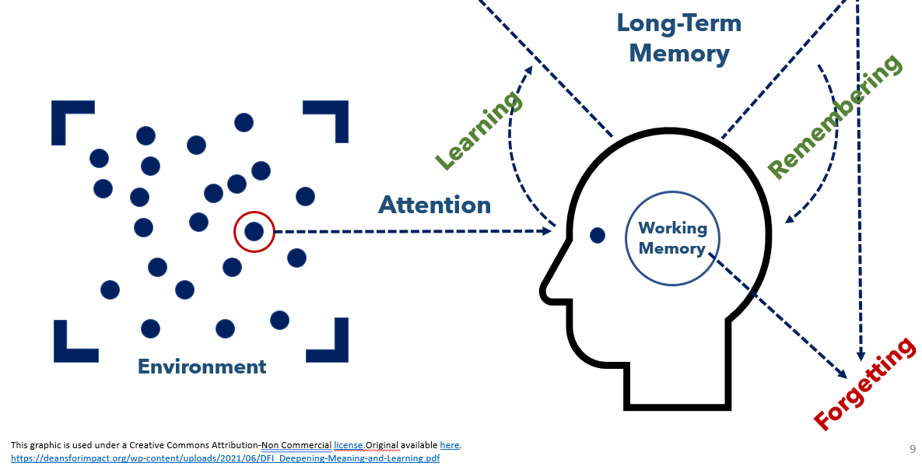

Key Vocabulary
Define the key term below.
Term | Definition
Feedback | Practice of giving students information about their performance against a standard with the purpose of improving student performance.

Quality Feedback Criteria Notes
Criteria | Description
Specific and Clear | The feedback provides specific information about the strengths and areas where the work can be improved. You will remember that the feedback from friend 1 in the bellringer example clearly identified the strength of the poem to be the imagery and described how the imagery impacted the reader.
Focused on task rather than the student | A key piece of quality feedback is that is references standards versus referencing the student. Feedback such as “I noticed you only had 3 supporting details. The assignment asks for 5 supporting details” provides key information to the student about how they can strengthen their work.
Identifies strengths & areas of improvement | While it is important to know the areas growth and improvement, it is also important to recognize what is done well so that can be replicated in future work.

Practice 1: Summary Paragraphs
A 3rd grade ELA teacher asked her students to write a summary paragraph for the text that they just read about octopi. Below are the success criteria for the paragraph:
Criteria | Description of Success
Paragraph Structure | The paragraph must have 5 or more complete sentences, using capitalization and punctuation
Supporting Details | The paragraph must have 3 or more supporting details from the text.
Main Idea | The main idea of the text must be included in the summary

Student Work Examples | Questions
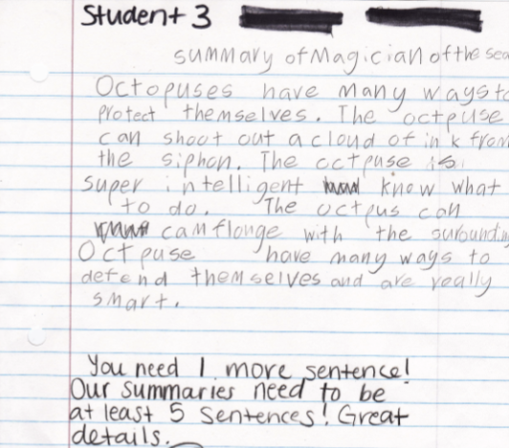 | Is the feedback provided an example of quality feedback? Justify using the criteria for quality feedback.  The feedback could be considered quality because it is specific and clear identifying how the student can improve the work. It also focuses on the task by referencing the pre-established success criteria. It also identifies areas of strength (great details) as well as areas of improvement (need 1 more sentence).
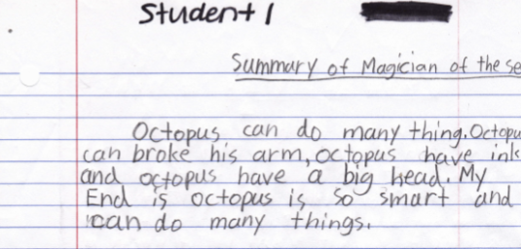 | Based on the work, how would you provide quality feedback to student 1?  I only see three sentences here and our summaries need to have at least 5. Great main ideas and details!

Practice 2: Non-Example of Quality Feedback
A social studies teacher asked students to write a summary about the Boston Tea Party and include a picture that illustrated what happened during the Boston Tea Party. Below was her success criteria for the assignment:
Criteria | Description of Success
Summary of Boston Tea Party | Summary should include when the Boston Tea Party happened, who was involved, what happened and why it happened.
Representative Picture | Picture accurately shows some aspect of the Boston Tea Party and enhances the understanding for the reader.
Writing Conventions | Appropriate capitalization, punctuation and spelling are used throughout.

Student Work Example | Questions
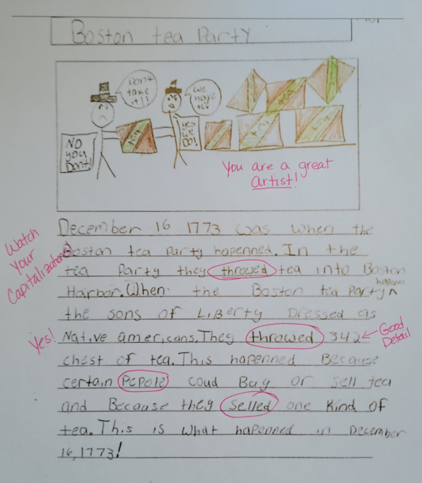 | Why is the feedback provided NOT an example of quality feedback? Justify using the criteria for quality feedback.  The feedback is not specific. It mentions “Watch your Capitalizations” but doesn’t identify where that is a problem. Also, there are random words circled and it is unclear to the student why they were circled. There is some positive feedback like “Yes” or “Good Detail” but the student doesn’t know why the yes was put there or what made that a good detail to include. Also, saying “You are a great artist” refers more to the student than the task.  What changes would you make to the feedback to make it better align to the characteristics of quality feedback?  Clarify why the words are circled with a specific comment about how to change them (Throwed to threw, selled to sold). More clarity around the “Yes” comment, such as “Great job identifying the participants” and “good detail” could be enhanced by “This detail is specific and tells what happened”. The comment “You are a great artist” could be changed to say “Your picture is great. It helps to explain the summary better.

Practice 3: Cookie Dough Math
Below is an example of student work on cookie dough math. Consider the following success criteria provided to the students when completing their work:
Criteria | Description of Success
Represent mathematical thinking | Students should show the calculations and thinking used to determine the answer to each problem
Utilize appropriate mathematical strategies | Students should identify an appropriate mathematical strategy and utilize it to calculate the answer to each problem.
Explain mathematical reasoning | Students should explain their mathematical reasoning in words when prompted by the question.
Calculate the appropriate answer | Students should utilize the strategies to determine the correct answer to each question.

Examine the student work below. What quality feedback could you provide to the student to improve their work based on the success criteria outlined above? (Assume all the calculations are correct).

Answers will vary but students may include comments such as:
- Excellent job explaining your thinking (question 4). Is there a strategy that you could name that describes your thinking?
- Way to show two different ways to represent your thinking (question 3)
- You did a great job representing your mathematical thinking in the equations you wrote and the details you included.
Record the feedback that your group members provided.

Answers will vary.

What feedback would you provided as a group to this student? Explain how it meets the characteristics of specific and clear, focused on the task and not the student and identifies strengths and areas of improvement.

Answers will vary.

