Student Guide – Answer Key

Lesson 4.02: Science of Learning Principles
Name:
Date:
Bellringer:
Quick Write: Think of something you have learned that you now know really well. It could be a non-academic skill (like a game, activity, musical instrument, or sport) or an academic skill (like operating with fractions or citing evidence in your writing).
What steps did you take to move from a novice (not knowing it well) to an expert (knowing it inside and out)?
Answer will vary. When discussing, highlight those ideas that are reflected in the five principles.
- Principle 1: Learning requires attending to the most important content.
- Principle 2: Learning builds on prior knowledge.
- Principle 3: Too much information at once can interfere with learning.
- Principle 4: Learning requires cognitive engagement and should be effortful.
- Principle 5: Practice and feedback are essential to move ideas permanently into long-term memory.

Science of Learning Principles Overview – Readings for the Jigsaw
Principle 1: Attending
Learning requires attending to the most important content
- One of the most vital actions a teacher takes in the class is to direct students’ attention to important content by the questions they ask, the activities they choose, the reading they assign, and the tasks they require.
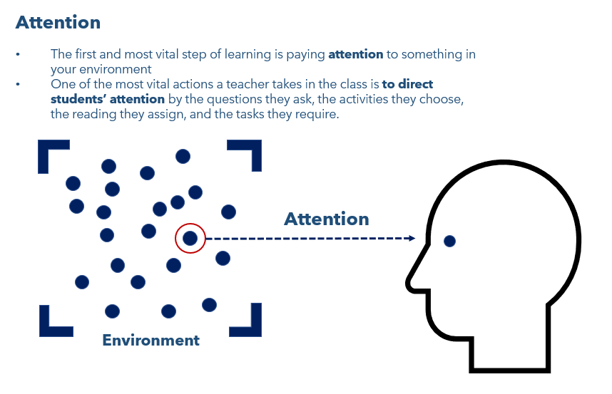
- In the simple memory model, we said that learning could not take place if a student did not pay attention to their environment.
- A teacher must direct student’s attention specifically to what they want students to learn. For instance, in the example of teaching a child to tie their shoes, it isn’t enough to simply tie your shoes in front of them and let them try to pick it up on their own. Instead, it helps their learning to direct the child’s attention to each step along the way and model each step.

A classroom example
- Imagine you are a teacher, and you want your students to learn the word “swagger.” It isn’t enough for you to just read a book that uses the word “swagger” in it. Instead, you need think about what is important to know about the word and draw students’ attention to that. For instance, they could look at an example and non-example:
  - Example: Melvin was so proud of his performance in the basketball game Friday night and his team-high 20 points. He was full of himself as a he swaggered into school on Monday morning.
  - Non-example: Jackson tossed and turned all night, barely sleeping as he worried over his lost dog. He was very tired when he swaggered out of bed in the morning.
- A “swagger” is more than a type of walking. When you “swagger”, you have an attitude and a self-confidence. The non-example seems odd because some one who was worrying all night and not sleeping would likely not “swagger” out of bed.
- To teach the important shades of meaning in the word “swagger”, you need to draw student’s attention to the idea of walking or behaving in a very confident and typically arrogant way.
Principle 2: Prior Knowledge
Learning builds on prior knowledge.
- Prior Knowledge is information or context a learner already has about a topic before they learn new information. Prior knowledge can help students:
  - Make connections to new information
  - Better understand new information
  - Store and retrieve new information
- Without prior knowledge, the working memory cannot engage. For example:
  - If someone asks you to read a passage in a language that you don’t read or understand, you’d have no way to meaningfully engage your working memory to understand the text.
  - In order to compute ½ x ¼, you need have some fundamental mathematical prior knowledge.
    - At least two pieces of prior knowledge are
      - 1 x 1 = 1 and
      - 2 x 4 = 8
      - Those two pieces of prior knowledge are needed to calculate the answer, 1/8.

(People} come to formal education with a range of prior knowledge, skills, beliefs, and concepts that significantly influence what they notice about the environment and how they organize and interpret it. This, in turn, affects their abilities to remember, reason, solve problems, and acquire new knowledge.
In the most general sense, the contemporary view of learning is that people construct new knowledge and understandings based on what they already know and believe (e.g., Cobb, 1994; Piaget,1952, 1973a,b, 1977, 1978; Vygotsky, 1962, 1978).
A logical extension of the view that new knowledge must be constructed from existing knowledge is that teachers need to pay attention to the incomplete understandings, the false beliefs, and the naive renditions of concepts that learners bring with them to a given subject. Teachers then need to build on these ideas in ways that help each student achieve a more mature understanding. If students’ initial ideas and beliefs are ignored, the understandings that they develop can be very different from what the teacher intends.
Speculation to Science in National Research Council. 2000. How People Learn: Brain, Mind, Experience, and School: Expanded Edition. Washington, DC: The National Academies Press.

Principle 3: Avoiding Overload
Too much information at once can interfere with learning.
- Overload occurs when the brain becomes weighed down with so much information or data that it exceeds an individual’s capacity to process incoming or new information or data.
- In the simple memory model, all the individual things happening in an environment are represented by the little dots. No one can possibly pay attention to everything in the environment. A teacher needs to ensure that too much information doesn’t come at students all at once.
- By spacing out content sequentially, making sure students have all the prior knowledge and vocabulary they need, teachers can keep students from experiencing cognitive overload.

If there is too much cognitive load, a student might be unable to do the task; maybe they even have that feeling that they are trying to hold too much in their head at once and bits keep spilling out. Or they may be able to do the task in the moment but, because they did not have the cognitive capacity to write it into their long-term memory, they were unable to do it later for homework, or the next day in class. It wasn’t learned. I had an epiphany when I learned about this. Cognitive load is often a barrier to learning, and one I can do something about.”
Kelleher, Ian. 2021, July 29. Cognitive load theory on my mind. The Center for Transformative Teaching and Learning. https://www.thecttl.org/2021/07/29/cognitive-load-theory/
Principle 4: Cognitive Engagement
Learning requires cognitive engagement and should be effortful.
- Cognitive engagement means that students use their brains during the entire lesson and are asked questions and complete tasks that make them think hard about a topic, not just repeat a surface level understanding of facts. They think about how or why something is the way it is when they are cognitively engaged.
- Sometimes teachers will say that tasks need to be “brains on.” By this, they mean that students need to be thinking and making sense through the whole class – engaging their working memory.

- If you think about the memory model, students focus their attention on something and bring it into their working memory. When you teach lessons that engage cognitively, the student’s working memory is busy making meaning, seeking to understand and make connections about why content is important.
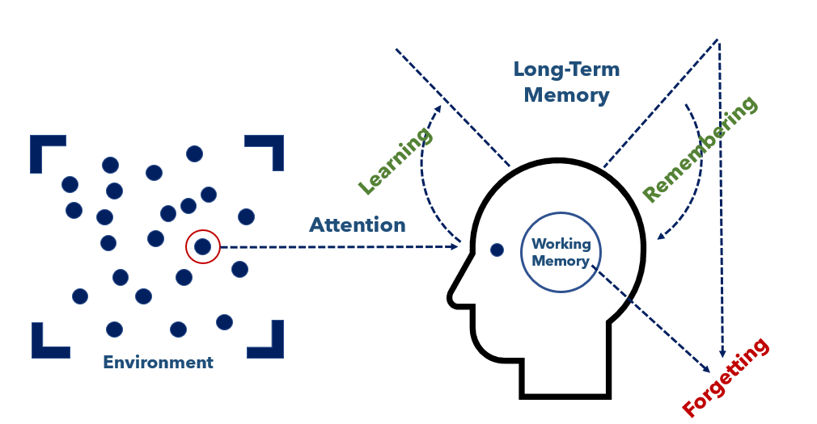
- Cognitively engaging lessons require effortful thinking – they have the right amount of challenge to build understanding of new concepts and transfer them to long-term memory.
“How we make sense of the world depends on our vantage point. Consider snorkeling versus scuba diving: both allow you to observe the ocean, but the latter gives you greater range to explore underwater depths.
Effortful-thinking questions are like scuba-diving gear for learners. They provide the means by which to “dive deep” on a new concept or idea. Such questions make students think hard about new ideas, making it more likely that they will remember what they’ve thought about. They include questions such as: Why might ___ be true? Why would this be true of X and not Y? How might this be different if…? How did you figure that out, and why did you take those steps?”
Bradbury, Staci. 2021, August 31. Diving deep into new concepts with effortful thinking. Deans for Impact. https://deansforimpact.org/diving-deep-effortful-thinking

Principle 5: Practice with Feedback
Practice and feedback are essential to move ideas permanently into long-term memory.
- Practice: Trying a skill or task, especially one you haven’t yet mastered, in order to improve your performance.
- Feedback: Giving students information about their performance during practice with the purpose of improving student performance.
  - One of the mistakes many new teachers make is thinking that teaching is all about explaining and “telling” students things about the world.
  - While that is an important part of teaching, it is just as important to give students lots of chances to practice applying knowledge or skills.
  - Practice involves making mistakes and using feedback to adjust your understanding until you fully understand the content or skill.
- Remember Clyde from an earlier lesson:
Clyde wants to learn how to make a paper airplane. His friend does it quickly while Clyde watches. When Clyde tries it, he is unable to make the paper airplane.
- Ideally, to learn that skill, Clyde’s friend would have demonstrated how to make the airplane step-by-step while Clyde followed along, and then Clyde would have practiced making a plane a few times with his friend watching to correct mistakes along the way. Finally, Clyde would practice - making more paper airplanes by himself until he had it mastered.
- This process of practicing and incorporating feedback makes the working memory work very hard and can help a student fully understand content and store ideas in their long-term memory.

- One of the simplest and most effective ways to practice and get feedback is to test yourself or be tested.
“Perhaps most importantly, researchers have found that having students take a test is almost always a more potent learning device than having students spend additional time studying the target material. This is especially true when the test requires students to actively recall information (e.g., providing answers to fill-in-the-blank or short-answer/essay type items). That is, the act of recalling information from memory helps to cement the information to memory and thereby reduces forgetting. By answering the questions on the quiz, the student is practicing the act of recalling specific information from memory.”

Jigsaw – “Expert” Questions
Your Principle _______________________
- What are the most important ideas to understand about this principle?

Answers will vary depending on principle.

- Why is it important for teaching and learning?
Answers will vary depending on principle.

- How does it relate to the simple memory model?
Answers will vary depending on principle.

“Learning” Group Notes on the five principles

Principle | Notes
Attending | One of the most vital actions a teacher takes in the class is to direct students’ attention to important content by the questions they ask, the activities they choose, the reading they assign, and the tasks they require.
Prior Knowledge | Prior Knowledge is information or context a learner already has about a topic before they learn new information.  Without prior knowledge, the working memory cannot engage.
Avoiding Overload | Overload occurs when the brain becomes weighed down with so much information or data that it exceeds an individual’s capacity to process incoming or new information or data.  By spacing out content sequentially, making sure students have all the prior knowledge and vocabulary they need, teachers can keep students from experiencing cognitive overload.
Cognitive Engagement | Cognitive engagement means that students use their brains during the entire lesson and are asked questions and complete tasks that make them think hard about a topic, not just repeat a surface level understanding of facts.  When you teach lessons that engage cognitively, the student’s working memory is busy making meaning, seeking to understand and make connections about why content is important.
Practice with Feedback | Practice: Trying a skill or task, especially one you haven’t yet mastered, in order to improve your performance.  Feedback: Giving students information about their performance during practice with the purpose of improving student performance.  Practice involves making mistakes and using feedback to adjust your understanding until you fully understand the content or skill.  This process of practicing and incorporating feedback makes the working memory work very hard and can help a student fully understand content and store ideas in their long-term memory.

