Student Guide

Lesson 5.01: Defining Assessment | Formative and Summative
Name:
Date:

Bellringer
Mark each statement true or false. Explain your thinking for each.
- The purpose of all assessment is to evaluate students and give students grades.
Explanation:

- All assessments are graded.
Explanation:

- Assessments are given every day.
Explanation:

- Assessment is part of the learning process.
Explanation:

- Journals and graphic organizers can be forms of assessment.
Explanation:

Defining Assessments: Formative and Summative
Key Vocabulary | Definition and Notes | Examples
Assessment
Formative Assessment
Summative Assessment

Practice 1: Comparing Formative and Summative Assessments

Key Vocabulary | Definition | Examples
Low-stakes
No-stakes
High-stakes

Practice 2: Sorting Activity (1-3-6 Consensus)
Assessment #1:
Students are engaged in a lesson about text structures using stations. By the end of the lesson, they are expected to explain how different text structures can help a reader understand the meaning of a text. At each station, they are asked to read a text and complete a graphic organizer that represents the structure of the text. The teacher reviews their graphic organizers to identify what students understand. Here is one example of a station activity:

Station 1
Directions: Read the text below about how to grow a plant. As you read, complete the graphic organizer to show the sequence of events in the text. The first step has been completed for you. Add steps as necessary.

Get a pot.

Adapted from https://reading.amplify.com/educator/resources/pdf/v1/mCLASS/G2_Text_Structure.pdf
What type of assessment is the graphic organizer?

Assessment #2:
At the end of a lesson on text structure, the teacher asks student to complete 5 matching questions. She tells students to do their best to match the descriptions of each text to the corresponding text structure. She plans to use student responses to plan her lesson for the next day. Depending on which structures the students struggle with the most, she will determine what she needs to reteach and whether she needs to group students to reteach specific structures to specific students.
What type of assessment are the matching questions?

Assessment #3:
Over the course of a unit on text structure, students have been working on writing an essay. Each student chose a text structure most appropriate to a topic of their choice. As a part of the assignment, they completed a text structure graphic organizer to brainstorm their topic, built an outline of their essay, and wrote multiple drafts with feedback from peers and teacher. Now, it is time to submit their final essay for a grade.
What type of assessment is the essay?

Assessment #4
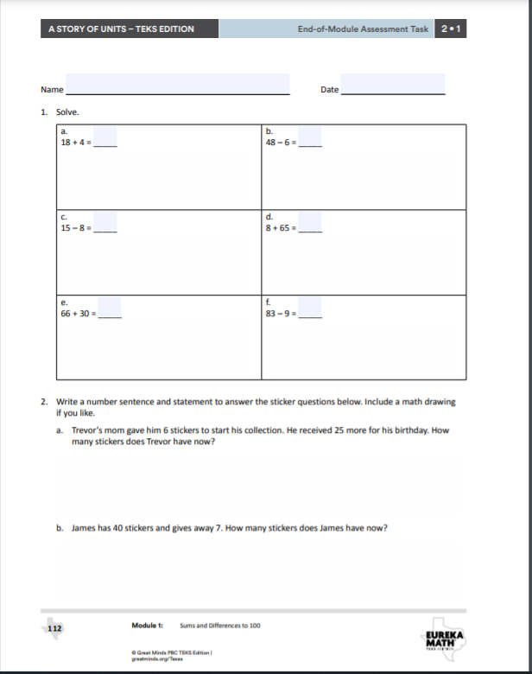
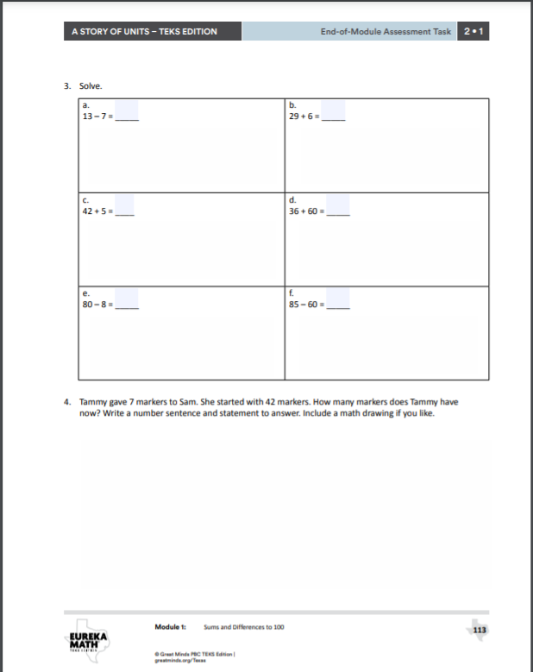
What type of assessment is this?
https://digital.greatminds.org/assessments/student/resources/emtx.g2.m1/file/5f4d3b087e0777004234b357
Assessment #5
During a unit on solving subtraction problems, students are given practice problems with the instruction to use the “take from ten strategy.” The teacher provides a word problem and then asks students to talk with a partner to create a number sentence to solve the problem. After working with their partner to create the numbers sentence, students individually solve the problem. The teacher monitors students as they discuss with partners to identify potential areas of confusion and collects the individual student work at the end of the period.

What type of assessment is this?

Assessment #6
During a science lab in which students investigate different types of rocks, students are asked to record notes in their science journal. The teacher meets with students to discuss their answers and clarify any misconceptions. See below:

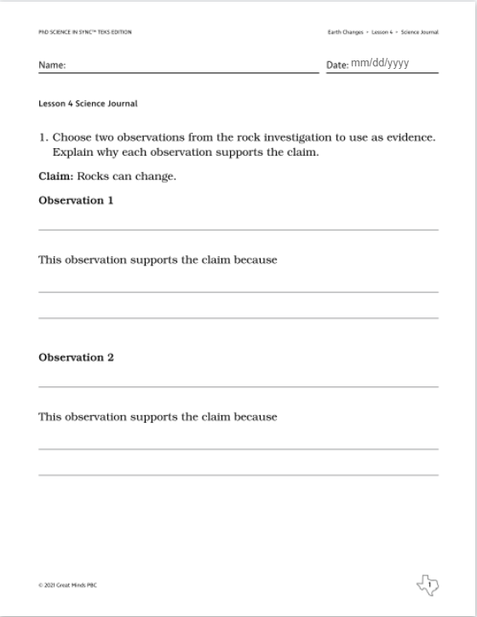

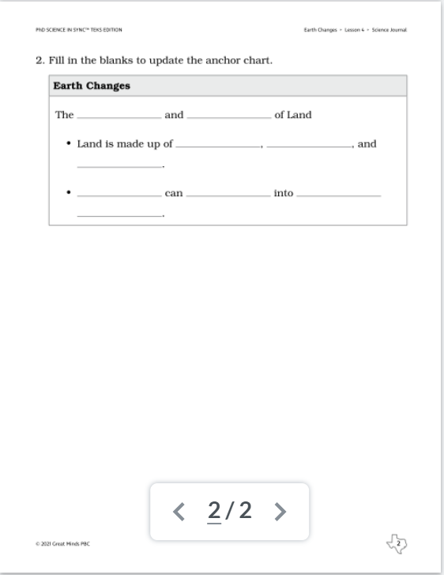
https://digital.greatminds.org/assessments/student/resources/phdteks.g3.m1.c1.l4/file/60d400e0073f0a00428e1477
What type of assessment is this?

1-3-6 Consensus

This consensus building activity provides an opportunity for students to learn with and from their peers. To begin, students work on their own to answer questions, respond to prompts, and/or develop ideas. Next, individuals are joined in groups of 3 to share their thinking and come to consensus. Finally, small groups of 3 are combined with another group for an additional opportunity to share their thinking and come to consensus. 1-3-6 Consensus is an effective tool to use when you want to give students the opportunity to share their reasoning with others and to work together to problem-solve and reach agreement.

