Student Guide – Answer Key

Lesson 5.01: Defining Assessment | Formative and Summative
Name:
Date:

Bellringer
Mark each statement true or false. Explain your thinking for each.
- The purpose of all assessment is to evaluate students and give students grades. F
Explanation: Answers will vary.

- All assessments are graded. F
Explanation: Answers will vary.

- Assessments are given every day. T
Explanation: Answers will vary.

- Assessment is part of the learning process. T
Explanation: Answers will vary.

- Journals and graphic organizers can be forms of assessment. T
Explanation: Answers will vary.

Defining Assessments: Formative and Summative
Key Vocabulary | Definition and Notes | Examples
Assessment | A tool used to  - collect data about student understanding.  - help a teacher make instructional decisions.  - communicate progress with students. | Tests, quizzes, projects, essays, exit tickets, journals, class discussions, polls, self-assessments, graphic organizers
Formative Assessment | - Low or no-stakes.  - Allow the teacher to collect data through the learning process.  - Usually measures 1–2 objectives.  - Help students move information from short-term to long-term memory. | Classroom discussions, journals, graphic organizers, anticipation guides, exit tickets, polls, quick writes, summaries, low- or no-stakes quizzes
Summative Assessment | - High stakes (graded).  - Used at the end of a learning sequence.  - Evaluate student achievement of learning targets.  - Usually measures multiple learning targets. | Tests, high-stakes quizzes, projects, essays

Practice 1: Comparing Formative and Summative Assessments

- Takes place throughout a learning sequence (beginning, middle, or end)
- Low- or no-stakes
- Used to inform next steps and followed by opportunities for reteaching, relearning, and/or extension; to improve learning
- Provide multiple opportunities for students to access information in short term memory
- Followed by a return to learning
- Takes place at the end of a learning sequence; final evaluation
- High-stakes
- Followed by a grade

- Aligned with learning targets/lesson objectives.
- Provide data about student learning.

Key Vocabulary | Definition | Examples
Low-stakes | An assessment that represents a small percentage of a student’s grade | Quizzes, homework (if graded)
No-stakes | An assessment that does not count towards a student’s grade | Homework (if not graded), exit tickets, journals, self-assessments
High-stakes | An assessment that represents a large percentage of a student’s grade | Tests, essays, projects

Practice 2: Sorting Activity (1-3-6 Consensus)
Assessment #1:
Students are engaged in a lesson about text structures using stations. By the end of the lesson, they are expected to explain how different text structures can help a reader understand the meaning of a text. At each station, they are asked to read a text and complete a graphic organizer that represents the structure of the text. The teacher reviews their graphic organizers to identify what students understand. Here is one example of a station activity:

Station 1
Directions: Read the text below about how to grow a plant. As you read, complete the graphic organizer to show the sequence of events in the text. The first step has been completed for you. Add steps as necessary.

Get a pot.

Adapted from https://reading.amplify.com/educator/resources/pdf/v1/mCLASS/G2_Text_Structure.pdf
What type of assessment is the graphic organizer? Formative

Assessment #2:
At the end of a lesson on text structure, the teacher asks student to complete 5 matching questions. She tells students to do their best to match the descriptions of each text to the corresponding text structure. She plans to use student responses to plan her lesson for the next day. Depending on which structures the students struggle with the most, she will determine what she needs to reteach and whether she needs to group students to reteach specific structures to specific students.
What type of assessment are the matching questions? Formative Note: Because these are matching questions – and therefore potentially look like test or quiz questions – students may decide this is a summative assessment. Teacher should guide students in a discussion that points back to the purpose of assessment. Because this assessment is used to inform the teacher’s next steps, it is a formative assessment even if the question types are common to summative assessments.

Assessment #3:
Over the course of a unit on text structure, students have been working on writing an essay. Each student chose a text structure most appropriate to a topic of their choice. As a part of the assignment, they completed a text structure graphic organizer to brainstorm their topic, built an outline of their essay, and wrote multiple drafts with feedback from peers and teacher. Now, it is time to submit their final essay for a grade
What type of assessment is the essay? Summative

Assessment #4
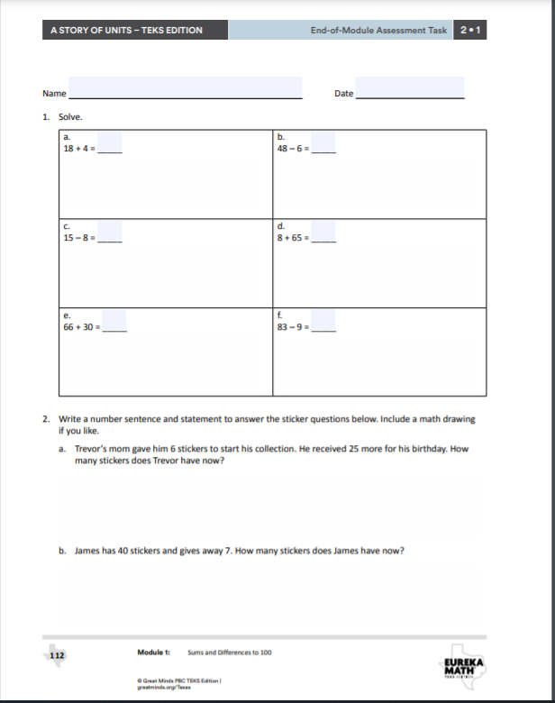
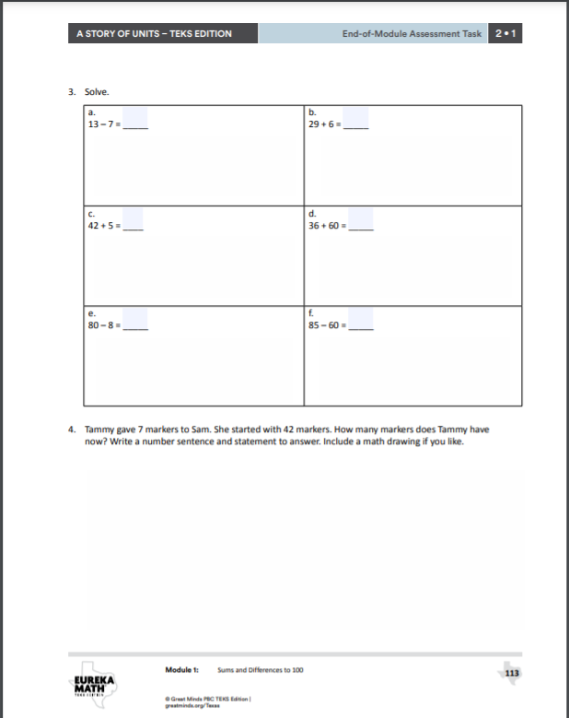

What type of assessment is this? Summative
https://digital.greatminds.org/assessments/student/resources/emtx.g2.m1/file/5f4d3b087e0777004234b357

Assessment #5
During a unit on solving subtraction problems, students are given practice problems with the instruction to use the “take from ten strategy.” The teacher provides a word problem and then asks students to talk with a partner to create a number sentence to solve the problem. After working with their partner to create the numbers sentence, students individually solve the problem. The teacher monitors students as they discuss with partners to identify potential areas of confusion and collects the individual student work at the end of the period.
What type of assessment is this? Formative

Assessment #6
During a science lab in which students investigate different types of rocks, students are asked to record notes in their science journal. The teacher meets with students to discuss their answers and clarify any misconceptions. See below:

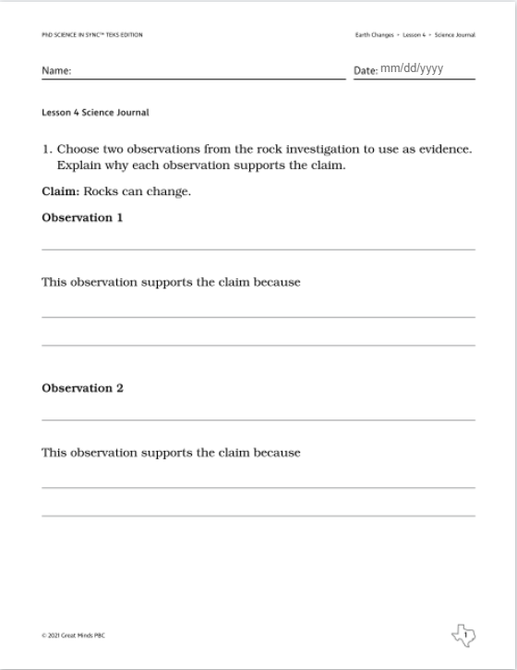

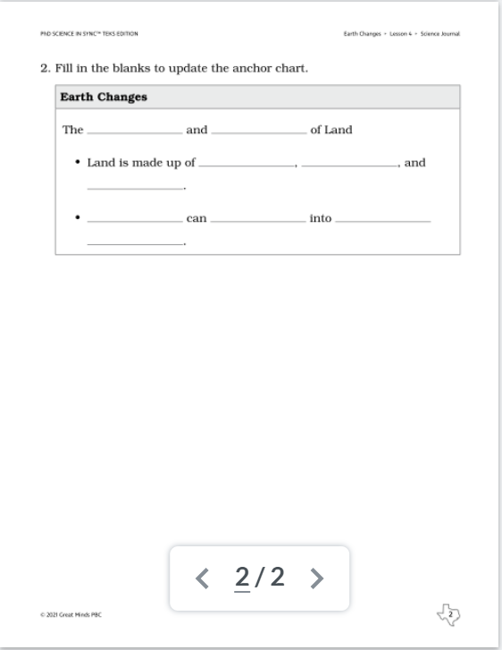
https://digital.greatminds.org/assessments/student/resources/phdteks.g3.m1.c1.l4/file/60d400e0073f0a00428e1477
What type of assessment is this? Formative

1-3-6 Consensus

This consensus building activity provides an opportunity for students to learn with and from their peers. To begin, students work on their own to answer questions, respond to prompts, and/or develop ideas. Next, individuals are joined in groups of 3 to share their thinking and come to consensus. Finally, small groups of 3 are combined with another group for an additional opportunity to share their thinking and come to consensus. 1-3-6 Consensus is an effective tool to use when you want to give students the opportunity to share their reasoning with others and to work together to problem-solve and reach agreement.

