Student Guide –Answer Key

Lesson 5.02: Characteristics of Effective Assessments
Name:
Date:
Bellringer: Review each scenario below and determine whether the teacher should use a formative or summative assessment:
Scenario 1: Mr. N. has been teaching students about fractions. As he used the idea of pizza and pie slices to explain fractions, students nodded along and answered his questions accurately. Things were going so well that he moved right along to fractions as numbers on a number line. Students stayed with him. They were able correctly shade fractions using fraction strips but then things started to change. Mr. N. saw some students transferring their understanding easily to number lines while other students looked at him with blank stares. Based on his lesson plans, he was planning to move into comparing fractions the next day, but now he’s not so sure. Some of his students seem ready but others don’t.

What type of assessment should Mr. N. use?

Why?

Scenario 2: Ms. G.’s class will be presenting the science projects they have been working on for the last two weeks to local scientists. The presentation is next week, and Ms. G. wants to give students an opportunity to practice and identify next steps for improvement.

What type of assessment should Ms. G. use?

Why?

Scenario 3: Mr. M. has been teaching his students about narrative writing. At the beginning of the unit, he told students that they would be writing their own short stories. Over the course of the unit, students learned about setting, character development, and the arc of a plot. They practiced outlining their stories and developing their characters. They received feedback from their peers and Mr. M. to improve rough drafts and they engaged in multiple writing conferences as they polished their work. Now, Mr. M. wants to know what his students learned about narrative writing through their ongoing work.

What type of assessment should Mr. M. use?

Why?

Characteristics of Effective Assessments
(adapted from What are the Qualities of Good Assessment?)
Assessment is aligned with learning target(s) and measures appropriate levels of rigor based on learning target (aligned to and requires attention to the most important content)

Assessment is fair and transparent (matches expectations of learning focus, not a “gotcha”)

Assessment is practical (time, resources, student numbers)

Assessment is cognitively engaging (why and how)

Example 1:

Students in a 1st grade class are learning about what plants need to live. The goal of this lesson is make a claim about which environments are most conducive to plant development based on their understanding of what plants need to live. This is the last day of a series of lessons. During the unit, students engaged in an experiment that provided them the opportunity to grow plants and observe their growth over time. In this final lesson, they reviewed data about the plants captured throughout the investigation and used the data to identify which plants were healthiest and what those plants received that other plants did not. Based on the data, they developed a list of what plants need to live.

Exit ticket:
- Review the images below. Circle the ones that are best for plants.




- Write a one sentence claim to explain the common characteristics of the environments you circled that make them best for plants.

Practice 1: Analyzing a Non-example
Example 2
- Which of the following are required for plants to grow:
  - Water
  - Soil (Nutrients)
  - Light
  - All of the above

- Circle the plants below that are most likely to survive in an environment with limited water.




Practice 2: Evaluating Formative Assessments
Ms. Cohen’s 5th grade ELA class is learning to compare and contrast informational texts and to write short comparison essays. Today’s lesson focused on identifying similarities and differences between texts and writing strong thesis statements as a part of the essay’s introduction. Before students begin working on their own thesis statements, she wants to be sure they can identify similarities and differences in the text they are writing about and identify strong thesis statements and their characteristics. Which of the two formative assessments below should she use and why?

Example 3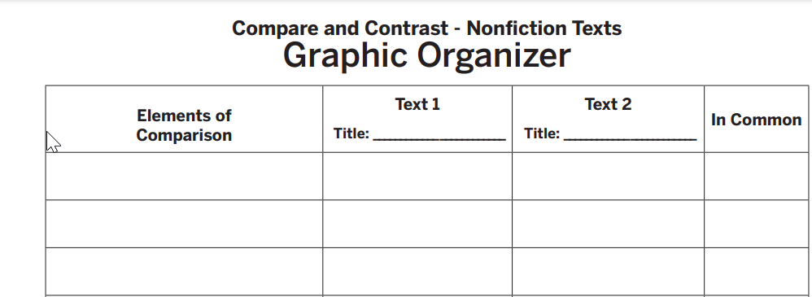
Read the two paragraphs below. Then complete the chart to identify at least 2 similarities and one difference.
Read the two thesis statements below. Put a star next to the best thesis statement.
Annotate the best thesis statement to show your reasoning.
Graphic Organizer: https://reading.amplify.com/educator/resources/pdf/v1/mCLASS/572_Compare_and_Contrast_Texts.pdf

Example 4
- Read the two paragraphs below. Then, write a summary of their similarities and differences.
- Complete the multiple-choice question below by circling the best thesis statement.
- Write your own thesis statement based on the comparisons you identified in question 1.

Success Criteria | Assessment Example 3 | Assessment Example 4
Assessment is aligned with learning target(s) and measures appropriate levels of rigor based on learning target (aligned to and requires attention to the most important content) | - Not Met  Reasoning: | - Met  Reasoning:
Assessment is fair and transparent (matches expectations of learning focus, not a “gotcha”) | - Not Met  Reasoning: | - Met  Reasoning:
Assessment is practical (time, resources, student numbers) | - Not Met  Reasoning: | - Met  Reasoning:
Assessment is cognitively engaging (why and how) | - Not Met  Reasoning: | - Not Met  Reasoning:
U-Debate (also called U-Shaped Discussion)

The U-Debate is a strategy that can be used to give students the opportunity to evaluate information, make decisions, and agree and disagree with one another as they come to a deeper understanding of a topic. The strategy is most useful when there is a debatable topic – a topic with either no right or wrong answer or a nuanced right or wrong answer.

To engage students in a U-Debate, consider arranging the seats in a U shape. Alternatively, if you do not want to rearrange seats, you can use three walls of the room. Pose a topic and ask students to move according to their response to the topic. If they agree, they move to one side of the seating arrangement or room. If they disagree, they move to the opposite side. If they are undecided, the sit or stand between the two sides in the bottom of the U shape. Provide students on opposite sides of the U to explain their reasoning and engage with one another. Invite students to move locations as they are persuaded one way or another.

