Unit 5: Planning for and with Assessments

Lesson 5.03: Best Practices for Formal and Informal Formative Assessment

Lesson at Glance
Warm-Up (5 mins)  - Bellringer (5) | Instruction (15 mins)  - Introduction to Best Practices for Formal and Informal Summative Assessments (15 mins) | Application (25 mins)  - Practice 1: Bellringer Analysis (8 mins)  - Practice 2: Partner Analysis (12 mins)  - Exit Ticket (5 mins)

TEKS | 3 | The student explores the teaching and training profession. The student is expected to:  - summarize and apply pedagogical knowledge and skills needed by teaching and training professionals;
 | 6 | The student plans and develops effective instruction. The student is expected to:  - describe principles and theories that impact instructional planning;
 | 8 | The student assesses teaching and learning. The student is expected to:  - describe the role of assessment as part of the learning process;  - analyze the assessment process;
Objectives | - Identify use of a variety of assessments in a lesson plan  - Analyze how different types of formative assessments are used in a lesson
Rationale/  Summary | Formative assessments are a foundation of effective instruction. To be used effectively, formative assessments should be used throughout a lesson both formally and informally and should create a portfolio of data with which to analyze student learning. In this lesson, students will learn more about best practices for implementing formative assessments including the many decisions teachers make based on formative assessment data.
Formative Assessment and Exemplar Response | Read the scenario below. Identify and analyze the assessments the teacher uses. Use the graphic organizer to guide your analysis.  See 5.3 Exit Ticket – Answer Key for exemplar response.
Vocabulary | Formal Assessment |  | Structured instructional activities within the lesson in which students and teachers assess the progress of student’s learning to help in the learning process (practice sets, homework, fluency assessment)
Vocabulary | Informal Assessment |  | Quick conversational or observation-based checks for understanding (thumbs up, white boards, first to 5, feedback on students’ verbal response)
Vocabulary | Pacing |  | The timing of instruction that includes how fast to move through new material and when to shift from one lesson segment to another
Vocabulary | Reteaching |  | Teaching material in a new way when necessary
Vocabulary | Remediation |  | Teaching content again to students who did not learn it the first time; filling in gaps
Vocabulary | Strategic Grouping |  | Placing students in small groups with purpose and intentionality based on reteaching needs

Est Time | Instructional Activities (including formative assessments) | Materials
5 mins | Bellringer: Read the scenario located on your student guide. As you read, look for formative assessments the teacher uses. Underline every instance of a formative assessment that you see.
15 mins | Introduction to Best Practices for Formal and Informal Formative Assessments  T: We will come back to your bellringers in a minute. First, let us review what we have learned so far. What are the two types of assessment about which we have learned?  S: Formative and summative.  T: And what are the characteristics of effective assessment?  S: Aligned to learning targets and appropriate level of rigor (focuses on the most important content), fair and transparent, practical, and cognitively engaging.  T: Today we are going to begin learning more about formative assessments. In addition to the characteristic of all effective assessments there are additional considerations teachers should be aware of to determine when, how, and why to use formative assessments. (Review best practices with students using the PPT.  S: (Take notes on student guide.)  T: A lesson plan should include a variety of activities to create a “portfolio” of assessments based on a learning target rather than a single snapshot (UbD, Wiggins and McTighe) and they should be used throughout a lesson, not just at the end. How does this practice support students and align with the Simple Memory model and the principles of teaching?  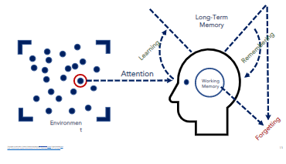  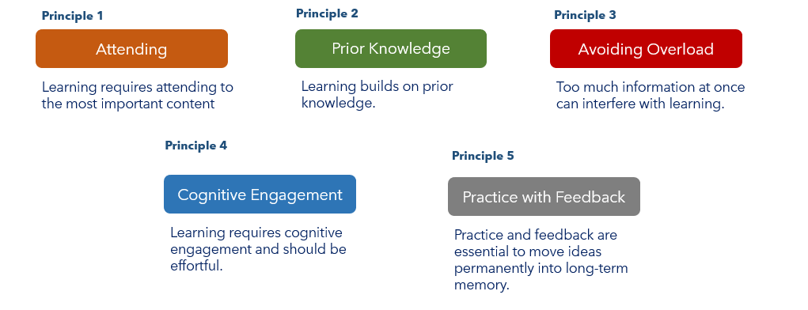  S: At the beginning of a lesson, it provides opportunities to engage prior knowledge. Throughout a lesson it provides repeated opportunities for practice over time. It provides multiple opportunities for the teacher to provide feedback. It can remind students of the most important content.  T: That is right. At the beginning of a lesson, it activates prior knowledge so students can connect new information to what they already know. For the teacher, assessment at the beginning of a lesson helps them know what students already know and what they do not know. That allows the teacher to make strategic decisions to help students avoid overload by not going too fast.  T: As assessment provides practice over time for students, it also helps the teacher continue to make strategic decisions through the course of the lesson and always informs their next steps. When a teacher collects data about student learning, they analyze that data to make several decisions. (Provide notes on strategic decisions and key terms using the PPT.) Those decisions include:  - Pacing: Should I move faster or slower? Should I review the material again or are students ready to move forward?  - Reteaching: Do I need to reteach part or all this lesson? How do I know? Do I need to reteach part of all the lesson to all students or a small group?  - Remediation and Enrichment: Do some students need remediation to learn background knowledge they should but do not have? Do some students need to go deeper faster because they already know the material?  - Strategic Grouping: Based on who understands the lesson and who doesn’t, how can I group students to support one another? How can I group students so that I can reteach portions or all the lesson only to those students who need it? How will I enrich the new learning for students who are ready to move on? How might I pair students for peer teaching and support?  T: One other consideration is whether an assessment is formal or informal. (Review definitions of formal and informal formative assessment using the PPT. Provide examples of each.)
8 mins | T: Let us look back at your bellringer and see how Ms. Fisher did. Follow along with the graphic organizer as we analyze Ms. Fisher’s assessments. (Model the first analysis for students using a think-aloud.) Ms. Fisher’s lesson began with a True/False bellringer. Through the bellringer, she collected information about what students already knew about main idea and she also collected information about misconceptions they had. Based on the data she collected, Ms. Fisher could make decisions about pacing by skipping information students already knew. She could also tailor the information she provided about main idea by specifically pointing out and explaining misconceptions, focusing her teaching on what students needed to learn.  S: (Complete graphic organizer as modeled.)  T: Now it is your turn. Who can tell me the next formative assessment Ms. Fisher used? (Continue discussion of the bellringer based on the answers in the student guide.)
9 mins | Practice 2: Partner Analysis  T: Now that we have done one together, it is your turn to do one with a partner. Read the scenario on your practice guide and identify the formative assessments in the lesson. Then, complete the graphic organizer to analyze how the teacher might use the formative assessments to support planning and decision-making. (Move students into pairs.)  S: (Complete the activity with their partner.)  T: (Circulate to support analysis as students work.)
3 mins | - T: (Address any common confusion or mistakes identified during partner work.)  - T: Why are assessments essential for instruction?  S: They give students practice over time and provide data to the teacher to make important instructional decisions.
5 mins | - S: (Complete the exit ticket.) | Exit Ticket

