Unit 5: Planning for and with Assessments
Lesson 5.05: Introduction to Strategic Questioning

Lesson at Glance
Warm-Up (10 mins)  - Bellringer (10) | Instruction (16 mins)  - Introduction to Strategic Questioning (16) | Application (19 mins)  - Practice 1 – Question Evaluation Part I (12)  - Exit ticket (7)

TEKS | 3 | The student explores the teaching and training profession. The student is expected to:  (B) summarize and apply acquired pedagogical knowledge and skills needed by teaching and training professionals;
 | 6 | The student plans and develops effective instruction. The student is expected to:  - Describe principles and theories that impact instructional planning;  - Demonstrate lesson planning to meet instructional goals.
Objectives | - Understand the characteristics of effective questions.  - Evaluate questions according to the characteristics of effective questions
Rationale/  Summary | Questioning is a key tool for formative assessment. Whether teachers are creating questions for informal or formal assessments, teachers need to know how to create questions at various levels of difficulty and how to sequence them for effective scaffolding. In this lesson, students will be introduced to a tool to help them plan for and evaluate questions that will become a key component of their assessment strategy for any lesson.
Formative Assessment and Exemplar Response | Review the lesson objective and related lesson below. Evaluate each question based on the first two criteria for effective questions. If a question does not fit both criteria, revise or make suggestions for improvement.  See Exit Ticket Answer Key for Exemplar Response
Vocabulary

Est Time | Instructional Activities (including formative assessments) | Materials
5 mins | Bellringer: Read the scenario and complete the activity below.  The goal of your 4th grade science class today is to teach students to analyze data to describe the relationship between characteristics (category of descriptions, like color) and traits (distinct description, like red). The following are two questions from your lesson:  What is one characteristic of this tomato?  How would you describe the relationship between characteristics and traits? Provide an example using tomatoes.  Analyze these two questions from your lesson using the guiding questions below.  What is similar about these questions?  What is different about these questions?  How would you describe the thinking required by each question?  Where in the lesson would you expect to find each question and why?
5 mins | T: (Use Basketball Questioning to engage students in a discussion about the bellringer.) What did you notice that was similar about the two questions?  S: (Respond to the question.)  T: What did you notice that was different?  S: (Respond to the question.)  T: What else might someone add about the differences?  S: (Respond to the question.)  T: (Continue eliciting responses until all ideas have been shared.)  T: Now let’s talk about question 3. What kind of thinking was required by each question? (Utilize the Basketball Questioning technique to ask students to agree or disagree with one another’s responses, add to one another’s responses, etc., until all ideas have been shared.  S: (Respond to initial question and follow-up questions.)  T: What about the last question? Where in the lesson would you expect to find these questions? (Utilize the Basketball Questioning technique to ask students to agree or disagree with one another’s responses, add to one another’s responses, etc., until all ideas have been shared.  S: (Respond to initial question and follow-up questions.)
6 mins | Introduction to Strategic Questioning  T: Assessments – whether they are formal or informal, formative or summative – depend on the teacher’s ability to ask effective questions in a strategic manner. Let’s look at the characteristics of effective questions. Please take notes in your student guide as we take notes on the first two characteristics.  S: (Take notes on characteristics, examples, and non-examples in their student guide.)  - Be meaningful and understandable to students (succinct)  Example: What is one characteristic of this tomato?  Nonexample: Given this specimen that you see in front of you, what qualities would you attribute to this delectable fruit?  - Focus on the most important content.  Example: What is one word that describes this tomato?  Nonexample: Do you like tomatoes? Why or why not?
12 mins | Practice 1: Question Evaluation – Part I  T: Before we look at two more characteristics of effective questions, let’s do a little practice with these first two. Take a few minutes on your own to complete the Practice 1 activity on your student guide. You will have a chance to share your answers with a partner in a few minutes.  S: (Work independently to complete Practice 1.)  T: Now it’s time to find a partner and share your thinking. Stand up, hands up, pair up. Once you have a partner, find a spot to sit and discuss. See if you can come to consensus on your responses.  S: (Find a partner and discuss.)  T: Let’s review the answers. There were two questions that met both criteria. Which ones were they?  S: (Offer responses.)  T: (Ask follow up questions as necessary to ensure students can identify the two effective questions.)  S: (Respond to follow up questions.)  T: Now let’s look at what was wrong with the other questions. Who’d like to volunteer to talk us through one of the ineffective questions?  S: (Volunteer responds.)  T: (Ask follow-up questions to the volunteer and the whole class to ensure class agreement and hear options for improving the question.)  S: (Share responses and ideas for revision.)  T: (Complete the process until all ineffective questions have been revised.)
10 mins | Introduction to Strategic Questioning  T: There are two more characteristics of effective questions. (Use PPT to review final characteristic.)  - Align to the level of thinking required in the learning target.  Example: Ending the tomato lesson with the question – How would you describe the relationship between characteristics and traits?  Nonexample: Ending the tomato lesson with the questions – What is a characteristic? What is a trait?  - Increase in complexity and demand as learning progresses.  Example: varying question types throughout the lesson while steadily increasing to get to the highest complexity required by the learning target  Nonexamples: Keeping questioning at the same level of complexity throughout a lesson, starting with the hardest questions at the beginning of a lesson.  S: (Take notes on student guides.)  T: Notice that the first two characteristics we discussed referred to individual questions. These two characteristics refer to questions sets. Not all questions need to align to the level of thinking required in the learning target because questions should increase in complexity and demand as learning progresses.  T: Let’s return to our principles of teaching based on the science of learning. (Display principles slide on PPT.) How do these principles help you understand why not all questions should align to the level of thinking in the learning target and why questions should increase in complexity and demand as learning progresses, eventually aligning to the level of thinking in the learning target?  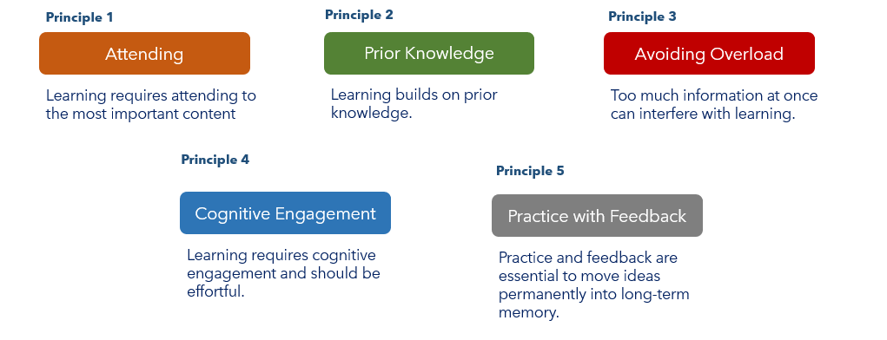  S: (Review the principles and suggest responses.) Beginning with easier questions will help a teacher avoid cognitive overload. Easier questions are those that might elicit prior knowledge which helps a teacher understand what to teach and helps students make connections. Harder questions are cognitively engaging so it is important to be sure you include those. Questions that are focused on the learning targets help student attend to the most important content of the lesson.  T: (Continue to use the Basketball Questioning technique to elicit and deepen student responses until all ideas have been shared.)
7 mins | S: (Complete the exit ticket.) | Exit Ticket

