Unit 5: Planning for and with Assessments

Lesson 5.07: Effective Question Delivery

Lesson at Glance
Warm-Up (5 mins)  - Bellringer | Instruction (11 mins)  - Bellringer Debrief (1 min)  - Introduction to Question Delivery and Response (10 mins) | Application (29 mins)  - Fishbowl Setup and Stretch it Practice (7 mins)  - Fishbowl Practice and Evaluation (12 mins)  - Debrief (5 mins)  - Exit ticket (5 mins)

TEKS | 3 | The student explores the teaching and training profession. The student is expected to:  (B) summarize and apply pedagogical knowledge and skills needed by teaching and training professionals;
 | 6 | The student plans and develops effective instruction. The student is expected to:  (D) describe principles and theories that impact instructional planning;
Objectives | - Identify the characteristics of effective question delivery and response.  - Define and apply wait time when delivering questions.  - Practice and evaluate question delivery and response.
Rationale/  Summary | While developing effective questions is important for instruction, effective delivery of questions and response to student answers is key. In this lesson, students will learn the success criteria for engaging students in questioning verbally and will begin practicing this skill with their peers.
Formative Assessment and Exemplar Response | - What are the three characteristics of effective question delivery?  - Based on today’s practice and the fishbowl activity, what do you think will be the easiest characteristic for you to master? The hardest? Explain your reasoning.
Vocabulary | Wait time |  | A period between when a teacher poses a question and when students are given the opportunity to answer

Est Time | Instructional Activities (including formative assessments) | Materials
5 mins | Bellringer: Sort and evaluate the following questions based on the Question Matrix. What does your sorting tell you about the set of questions? How might the teacher revise the set if necessary? | Student Guide  PPT
1 min | T: Based on your question sort, how would you evaluate the questions used in this lesson?  S: The questions do progress over time from What is to Why to How Would and How Can. The questions do not ask about the character’s change over time.  T: What questions might the teacher add to meet the final criteria?  S: The teacher could add questions like: How is Stanley at the end of the story like or unlike Stanley at the beginning of the story? Why has Stanley changed? Which change in Stanley was the biggest change? How might you support your answer with evidence?
10 mins | Introduction to Question Delivery and Response  T: A teacher can collect data about student understanding by using effective questions in a discussion. Classroom discussions can be whole group, small group, or with an individual student. Either way, the teacher uses verbal questioning to gauge understanding of lesson content in the moment.  T: Let’s start by defining the success criteria for effective delivery of questions and effective response to student answers. Please take notes in your student guide. (Use the PPT to review success criteria.)  T: One key component of effective question delivery is wait time. Wait time is a period between when a teacher poses a question and when students are given the opportunity to answer. Wait time provides an opportunity for all students to consider the answer (not only the fastest thinkers) and can improve the quality of responses. Teachers should wait at least five seconds between the time they ask a question and the time they call on or allow a student to answer.  T: What is wait time? (Count to five before calling on a student to respond. Visibly show your counting with your fingers.)  S: (Define wait time.)  T: What happens if a teacher doesn’t include wait time in their questioning?  S: The fastest students always answer the question. The responses aren’t well thought out.  T: Sometimes wait time can feel uncomfortable. Let’s practice together. (Divide students into small groups of 3–4.) Each person will ask a question, wait five seconds, then call on someone for an answer.  T: On the PowerPoint, I have provided a list of questions for you to ask the group. Each person should select one to ask to the group. If someone chooses the one you were going to select, please use a different question.  T: (Display on PowerPoint)  - How do you find the area of a rectangle?  - What are the names of the planets in our galaxy?  - What are the roles of the three branches of government?  - What is the Greatest Common Factor of 16 and 24?  - Explain the steps of the water cycle?  - What are the seven continents on Earth?  S: (Take turns asking a question and waiting 5 seconds before responding.)  T: (Stop after all students have asked a question) How did that feel?  S: (Answers will vary).)  T: It takes practice and attention to effectively use wait time. . Practice with one more round of questions.  S: (Take turns asking a question and waiting 5 seconds before responding.) .)  T: How did it feel knowing that you had more time to think about your answer before responding?  S: (Answers will vary.)  T: Another criterion for effective question delivery is the delivery of the question to as many students as possible. There are a few ways a teacher can do this. One way is to ask the question first and then call on a student by name. What happens when a teacher calls on a student first and then asks the question?  S: Only the student called on thinks about the response, other students tune out.  T: Another way a teacher is to call on students who do not volunteer. If a teacher only calls on those students who volunteer to respond, they are not directing their questions to as many students as possible. A teacher should pay attention to who is not volunteering to respond and should be sure to include those students by calling on them directly.  T: The final technique we will learn is related to our final success criteria: Respond to “stretch it” and deepen thinking. You have already learned a technique that provides opportunity for multiple students to answer the same question by agreeing, disagreeing, adding on, and providing reasoning. The technique was called “Stretch It” (Lesson 4.10). Turn and talk to your neighbor about what you remember about this technique.  S: (Turn and talk.)  T: (Monitor responses. If students seem to remember, move on. If students need review of the strategy, review the strategy with them before moving on.)  T: When do you think it is most effective for a teacher to call on more than one student to answer the same question?  S: When there are multiple possible answers. When answers provided are only partially correct or possibly wrong, when there are opportunities to add on to and deepen a response or disagree with a response even though it may not be wrong. | Student Guide  PPT
7 minutes | Practice Setup: Fishbowl  T: Now that you’ve seen it in action, it’s time to practice together. Let’s set our scenario first. Who will read aloud the practice scenario in your student guide? (Call on a volunteer.)  S: (Reads the scenario.)  Students are learning about the life cycle of butterflies. The goal for this lesson is for students to observe stages of the butterfly life cycle to compare how the body parts of butterflies and caterpillars help them survive. The teacher plans questions using the artifact below.  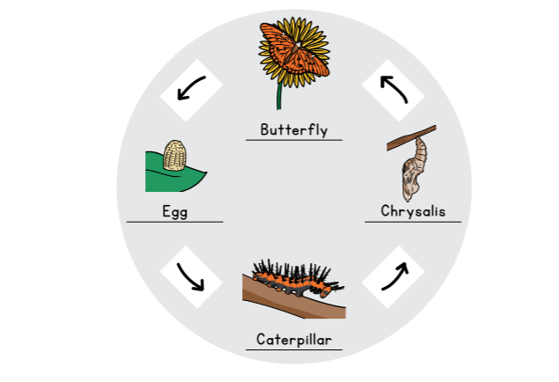  The teacher’s first question is: What do you notice about the difference between each of the stages?  T: Thank you. Now, turn and talk with a neighbor. With your neighbor, you will anticipate responses students might give to the first question and brainstorm “stretch-it” questions the teacher might use to continue the discussion. Keep in mind that the goal of the lesson is for students to compare how the body parts of butterflies and caterpillars help them survive. If you are in an even row, turn to your right to find your partner. You have 4 minutes to brainstorm.  S: (Brainstorm with partners.) | Student Guide  PPT
12 mins | Fishbowl Activity  T: We are going to engage in a fishbowl activity. I need one volunteer to play the role of the teacher and 4 volunteers to be students.  S: (Volunteer for teacher and student roles.)  T: Our fishbowl volunteers are going to come up to the front of the room and role play the question and answer discussion about the stages of the butterfly life cycle and the body parts that help them survive at each stage.  S: (Volunteers move to front of room.)  T: While they role play, everyone else will complete the evaluation chart in their student guide. Everyone ready? The role play will last 10 minutes. I’m going to set my timer. (Set timer.) Volunteers, you may begin.  S: (Volunteers role play the scenario. Other students record observations in their student guide.)
5 mins | Debrief  T: Thank you to the volunteers, especially the teacher! Let’s debrief the experience.  T: I’m going to start with the teacher. (Call on the student who played the teacher.) What was easy for you?  S: (Response will vary.)  T: What was hard?  S: (Response will vary.)  T: Thank you for taking the risk to play the teacher and show your classmates an example. Let’s hear from them. What did the teacher do well?  S: (Responses will vary.)  T: What could they improve?  S: (Responses will vary.)  T: What did the observers notice about how the teacher asked and responded to questions?  S: (Answers will vary.)  Delivering questions can be challenging. Tomorrow, you will all have a chance to practice. As a part of today’s exit ticket, you will think about what will be easy for you and what will be hard.
5 mins | S: (Complete the exit ticket.) | Exit Ticket

